SOFTWARE REQUIREMENTS SPECIFICATION (SRS)
DevTask Hub – Developer Task & Issue Tracking System
Institute | Babu Madhav Institute of Information Technology
University | Uka Tarsadia University
Student Name | Parmar Nilesh Prakashkumar
Enrollment No | 202206100110113
Semester / Year | 9th Semester (M.Sc. IT / Integrated MCA)
Project Mode | Individual project
Internal Guide | Bhavik Sarang
External Guide / Company | Mr. Hardik Patel

1. Purpose
The purpose of this Software Requirements Specification (SRS) document is to provide a complete, verified, and definitive specification of the DevTask Hub software system. DevTask Hub is an enterprise-grade, decoupled web-based developer task and issue tracking application engineered specifically for software development teams, engineering managers, and individual contributors. The system provides real-time visibility into project workflows, enforces a deterministic 4-stage task lifecycle through a state machine, secures resources with role-based access control (RBAC), and seamlessly bridges task management with source code version control through bidirectional GitHub pull request synchronisation.
This document describes all verified functional behavior, underlying database schemas, architectural topology, security safeguards, and integration boundaries derived directly from source inspection and execution of the running codebase.

2. Scope

2.1 In-Scope Capabilities
- User Authentication & Cryptographic Session Security: Stateless JWT authentication (15-minute access token) coupled with HTTP-only, 14-day cryptographic refresh token rotation and reuse theft detection.
- Multi-Project Administration: Creation and management of distinct software projects identified by uppercase project keys (2–10 alphanumeric characters), team member association, and lifecycle statuses (Active, OnHold, Archived).
- Task Lifecycle & State Machine: Deterministic task state transitions (ToDo -> InProgress -> InReview -> Done) with guarded reverse flows, priority classifications (Low, Medium, High, Critical), categorization, due-date tracking, and team-member assignee constraints.
- Interactive Kanban & List Boards: Drag-and-drop Kanban workflow board with optimistic UI updates alongside a multi-filtered tabular list view with server-side pagination.
- Task Activity Audit Trail: Granular chronological event logs tracking task creation, status transitions, priority updates, title/description edits, and member assignments.
- Role-Differentiated Analytics & Dashboards: Tailored views separating high-level organizational KPIs for Administrators from tactical workload and overdue task trackers for Developers.
- Public GitHub Integration: Public GitHub developer profile linking and public pull request tracking with live sync of PR states (Open, Closed, Merged), draft flags, and commit histories.

2.2 Out-of-Scope (Deferred / Non-Functional Boundaries)
- Private GitHub Repository Authentication (OAuth apps or stored Personal Access Tokens).
- Direct GitHub Webhook push listeners (synchronization is strictly on-demand/client-triggered).
- Automated SMTP Email Delivery (system uses direct credential-based verification without external mail server dependencies).
- Full-duplex WebSocket / SignalR real-time messaging (client uses HTTP polling and optimistic cache updates).

3. Identification of Need
Traditional project tracking approaches and generic spreadsheets suffer from significant drawbacks in software engineering teams:
• Lack of Workflow Discipline: Manual spreadsheets allow arbitrary status edits, bypassing formal code review and testing stages.
• Disconnection from Source Control: Engineers must context-switch between task managers and git repositories, leading to stale issue statuses.
• Security Vulnerabilities: Generic trackers lack robust token hygiene, leaving systems exposed to token replay and session hijacking.
• High Complexity and Bloat: Enterprise tools like Jira present steep learning curves, slow load times, and excessive configuration overhead for agile teams.
DevTask Hub addresses these exact pain points by providing an agile, highly responsive single-page application (SPA) backed by an ASP.NET Core Web API with strict domain invariants, deterministic state machine enforcement, automatic token rotation, and frictionless public GitHub PR tracking.

4. Technology Used
Layer / Component | Technology / Framework | Version | Verified Purpose
Backend Framework | ASP.NET Core Web API | .NET 10.0 (net10.0) | High-performance modular REST API runtime
Database / ORM | SQL Server 2025 Express / EF Core | EF Core 10.0.13 | Relational persistence, code-first migrations & LINQ queries
Authentication | JWT Bearer + ASP.NET Identity Core | 10.0.13 | Stateless HS256 tokens & PBKDF2 password hashing
Frontend Framework | React + TypeScript | React 19.3.1, TS 6.0.3 | Component-driven client architecture with strict static typing
Build Tooling | Vite | 8.3.4 | Sub-second HMR and production bundle optimization
Routing / HTTP | React Router DOM & Axios | v7.18.4 / v1.20.0 | Declarative client routing & interceptor-based HTTP client
API Documentation | Swashbuckle / OpenAPI | 10.3.1 / 10.0.12 | Interactive Swagger UI and OpenAPI v3 contracts
External Services | GitHub REST API v3 | v3 (application/vnd.github.v3+json) | Public profile retrieval and pull request synchronisation

5. Functional Requirements
Derived directly from running API controllers, domain services, and UI views:
Req ID | Feature Name | Detailed Requirement Specification
FR-01 | User Registration | System shall allow guests to register with FullName, Email, and Password (min 8 chars), assigning Developer role.
FR-02 | User Authentication | System shall authenticate credentials via PBKDF2 verification and return an access JWT plus HTTP-only refresh cookie.
FR-03 | Token Refresh & Rotation | System shall rotate the refresh token and issue a fresh JWT upon valid cookie presentation, detecting and revoking reused tokens.
FR-04 | Project Creation | Admins shall create projects with a mandatory unique uppercase Key (^[A-Z0-9]{2,10}$), Name, and Description.
FR-05 | Project Team Membership | Project owners and Admins shall associate registered active users as members and disallow removal of the project owner.
FR-06 | Project Deletion Guard | System shall forbid deleting projects that contain incomplete or active tasks.
FR-07 | Task Creation & Assignment | Users shall create tasks under accessible projects, restricting assignee assignment strictly to current project team members.
FR-08 | Task State Machine | System shall enforce allowed status transitions: ToDo->InProgress, InProgress->(InReview|ToDo), InReview->(Done|InProgress), Done->InProgress (Admin/Assignee only).
FR-09 | Task Activity Audit Log | System shall record immutable chronological audit records for every status change, assignment, and field update.
FR-10 | Kanban & List Boards | System shall present drag-and-drop Kanban workflow columns alongside a filterable, paginated tabular list.
FR-11 | Role-Based Dashboards | System shall serve an organizational KPI dashboard for Admins and a personal workload/overdue task dashboard for Developers.
FR-12 | GitHub Profile Integration | System shall sync public developer profiles from api.github.com/users/{username}.
FR-13 | GitHub PR Linking & Sync | System shall link GitHub pull request URLs, validate syntax, and sync live PR state, draft status, and review verdicts.
FR-14 | User Administration | Admins shall view all registered users and toggle active status (soft-deactivation), preventing self-deactivation.

6. Non-Functional Requirements
NFR-01: Security & Confidentiality: Passwords hashed via PBKDF2 with HMAC-SHA256. JWT tokens signed with 256-bit secret key. Refresh tokens stored as SHA-256 digests. Sensitive keys managed via .NET user-secrets.
NFR-02: Performance & Latency: API response latency under 100ms on local SQL Server. Frontend initial bundle size optimized via route-level code splitting (React.lazy). Tabular data constrained by server-side pagination (default 20 records).
NFR-03: Usability & Responsiveness: Clean custom CSS design system with fluid grid layouts, sticky navigation bars, responsive mobile drawer (breakpoint 768px), and distinct color-coded priority badges.
NFR-04: Reliability & Data Integrity: Referential integrity safeguarded by SQL Server Foreign Keys with Restrict/Cascade semantics. Business constraints reinforced by UNIQUE indexes and database CHECK constraints.
NFR-05: Maintainability & Code Quality: Decoupled single Web API project structured with folder-based separation of concerns (Controllers -> Services -> DbContext/Entities -> DTOs).

7. System Modules Description
- Module 1: Authentication & Identity: Manages user registration, credential authentication, JWT token issuance, HTTP-only refresh token lifecycle, reuse detection, and session restoration.
- Module 2: Project Administration: Handles project lifecycle (Active, OnHold, Archived), unique key validation, team member assignment, and deletion guards.
- Module 3: Task & Workflow Management: Implements task CRUD, dynamic categories, assignee membership validation, drag-and-drop Kanban updates, and the 4-stage deterministic state machine.
- Module 4: Audit & Activity Logging: Maintains chronological audit logs capturing actors, timestamped modifications, and old/new property diffs for all task operations.
- Module 5: Role-Aware Dashboards & Analytics: Computes high-level KPI aggregations for Administrators and personalized workload/overdue task summaries for Developers.
- Module 6: GitHub External Integration: Communicates with GitHub REST API v3 to link developer profiles, track task pull requests, and inspect live PR statuses.
- Module 7: User Administration: Enables system administrators to inspect the full user registry and toggle account activation without hard-deleting database records.

8. User Characteristics & Authorization Matrix
The application defines two distinct, verified system roles governed by the UserRole enum:
• Administrator (Admin) – Target: Engineering Directors / Team Leads
Permissions: Full administrative access. Can create/edit/delete all projects, manage team memberships, inspect and toggle user active statuses, view organization-wide KPI dashboards, and reopen completed tasks.
• Developer (Developer) – Target: Software Engineers / Contributors
Permissions: Operational access. Can create and manage tasks within assigned projects, transition task statuses according to state machine rules, link GitHub PRs and profiles, and inspect personal workload dashboards.

9. System Architectural & Design Diagrams

9.1 Use Case Diagram
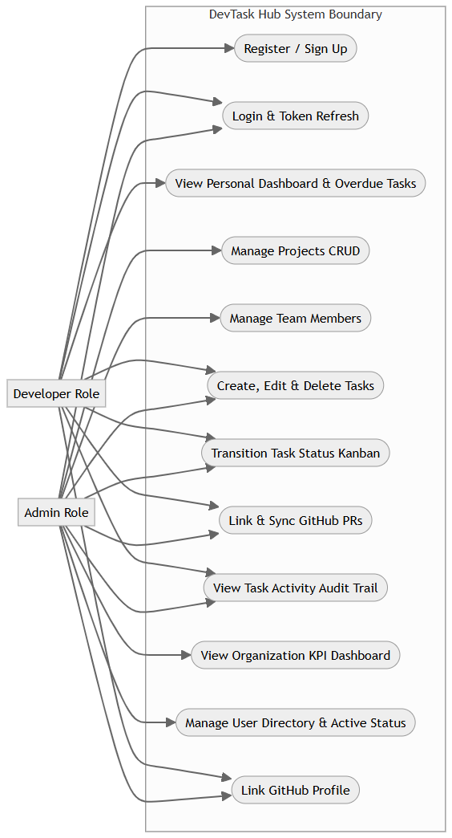
Figure 9.1: DevTask Hub Use Case Diagram (Actors: Admin & Developer)

9.2 Authentication & Token Rotation Sequence
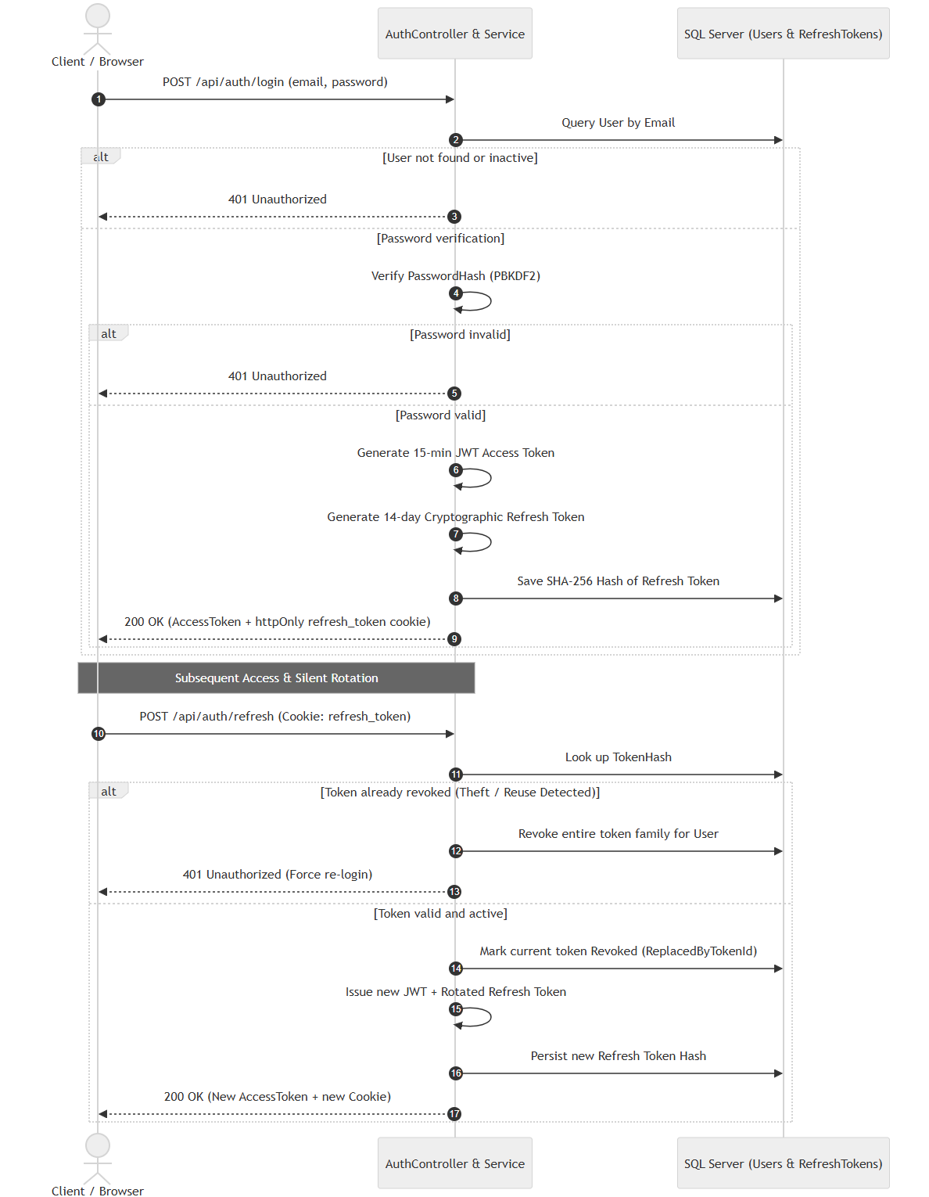
Figure 9.2: Activity Sequence Diagram – Authentication, Token Rotation & Reuse Detection

9.3 Task Lifecycle & State Machine Transitions
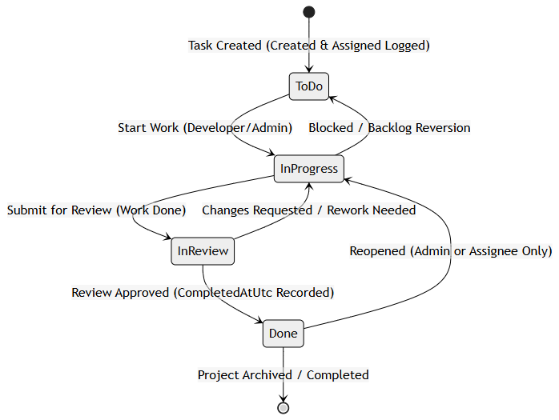
Figure 9.3: State Machine Diagram – Verified Task Status Workflow

9.4 Entity-Relationship (ER) Diagram
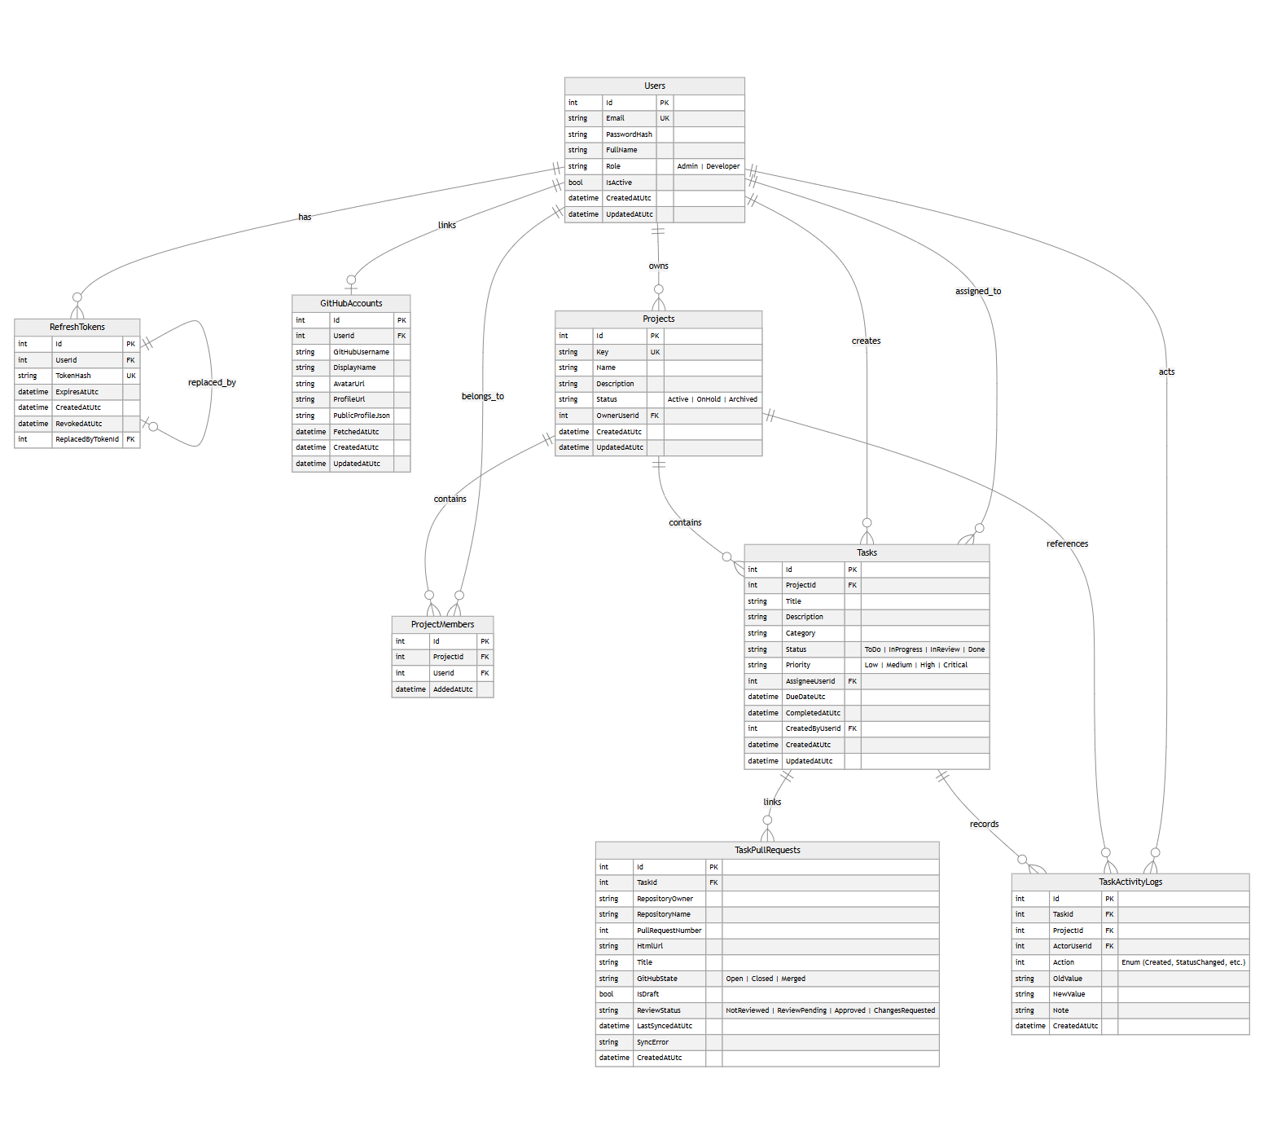
Figure 9.4: Complete Entity-Relationship Diagram (8 Core Tables & Cardinalities)

10. Data Dictionary
Exhaustive data dictionary extracted directly from EF Core migrations and AppDbContext configuration:

Table 1: Users
Column Name | Data Type | Length/Size | Constraints | Description
Id | int | 4 bytes | PK, Identity(1,1) | Unique primary surrogate key
Email | nvarchar(256) | 256 chars | NOT NULL, Unique Index | User login email address (lowercased)
PasswordHash | nvarchar(500) | 500 chars | NOT NULL | PBKDF2 cryptographic password hash
FullName | nvarchar(100) | 100 chars | NOT NULL | Display name of user
Role | nvarchar(20) | 20 chars | NOT NULL, Check (Admin|Developer) | System authorization role
IsActive | bit | 1 byte | NOT NULL, Default 1 | Active status flag (soft deactivation)
CreatedAtUtc | datetime2 | 8 bytes | NOT NULL | Account creation timestamp in UTC
UpdatedAtUtc | datetime2 | 8 bytes | NOT NULL | Last profile update timestamp in UTC

Table 2: Projects
Column Name | Data Type | Length/Size | Constraints | Description
Id | int | 4 bytes | PK, Identity(1,1) | Unique primary surrogate key
Key | nvarchar(20) | 20 chars | NOT NULL, Unique Index | Short project code (e.g., NEW, PRJ)
Name | nvarchar(150) | 150 chars | NOT NULL | Full project title
Description | nvarchar(2000) | 2000 chars | NULL | Detailed project scope description
Status | nvarchar(20) | 20 chars | NOT NULL, Check (Active|OnHold|Archived) | Project lifecycle state
OwnerUserId | int | 4 bytes | FK -> Users(Id), Restrict | User who created and owns project
CreatedAtUtc | datetime2 | 8 bytes | NOT NULL | Project creation timestamp in UTC
UpdatedAtUtc | datetime2 | 8 bytes | NOT NULL | Last update timestamp in UTC

Table 3: ProjectMembers
Column Name | Data Type | Length/Size | Constraints | Description
Id | int | 4 bytes | PK, Identity(1,1) | Unique primary surrogate key
ProjectId | int | 4 bytes | FK -> Projects(Id), Cascade | Associated project foreign key
UserId | int | 4 bytes | FK -> Users(Id), Restrict | Associated user foreign key
AddedAtUtc | datetime2 | 8 bytes | NOT NULL | Membership association timestamp (Unique ProjectId+UserId)

Table 4: Tasks (TaskItems)
Column Name | Data Type | Length/Size | Constraints | Description
Id | int | 4 bytes | PK, Identity(1,1) | Unique primary surrogate key
ProjectId | int | 4 bytes | FK -> Projects(Id), Cascade | Associated project foreign key
Title | nvarchar(200) | 200 chars | NOT NULL | Task headline/summary
Description | nvarchar(4000) | 4000 chars | NULL | Comprehensive markdown/text description
Category | nvarchar(50) | 50 chars | NULL, Default 'Feature' | Categorization tag (Bug, Feature, etc.)
Status | nvarchar(20) | 20 chars | NOT NULL, Check (ToDo|InProgress|InReview|Done) | State machine workflow status
Priority | nvarchar(20) | 20 chars | NOT NULL, Check (Low|Medium|High|Critical) | Task urgency level
AssigneeUserId | int | 4 bytes | FK -> Users(Id), SetNull | Assigned developer (must be member)
DueDateUtc | datetime2 | 8 bytes | NULL | Deadline date in UTC
CompletedAtUtc | datetime2 | 8 bytes | NULL | Completion timestamp when marked Done
CreatedByUserId | int | 4 bytes | FK -> Users(Id), Restrict | User who authored the task
CreatedAtUtc | datetime2 | 8 bytes | NOT NULL | Creation timestamp in UTC
UpdatedAtUtc | datetime2 | 8 bytes | NOT NULL | Last modification timestamp in UTC

Table 5: RefreshTokens
Column Name | Data Type | Length/Size | Constraints | Description
Id | int | 4 bytes | PK, Identity(1,1) | Unique primary surrogate key
UserId | int | 4 bytes | FK -> Users(Id), Cascade | Associated user foreign key
TokenHash | nvarchar(128) | 128 chars | NOT NULL, Unique Index | Hexadecimal SHA-256 digest of token
ExpiresAtUtc | datetime2 | 8 bytes | NOT NULL | Absolute expiry timestamp (14 days)
CreatedAtUtc | datetime2 | 8 bytes | NOT NULL | Issuance timestamp in UTC
RevokedAtUtc | datetime2 | 8 bytes | NULL | Revocation timestamp if rotated/revoked
ReplacedByTokenId | int | 4 bytes | FK -> RefreshTokens(Id), Restrict | Successor token ID for rotation chain

Table 6: GitHubAccounts
Column Name | Data Type | Length/Size | Constraints | Description
Id | int | 4 bytes | PK, Identity(1,1) | Unique primary surrogate key
UserId | int | 4 bytes | FK -> Users(Id), Cascade, Unique | One-to-one user mapping foreign key
GitHubUsername | nvarchar(100) | 100 chars | NOT NULL | Public GitHub handle
DisplayName | nvarchar(150) | 150 chars | NULL | Cached GitHub public profile name
AvatarUrl | nvarchar(500) | 500 chars | NULL | CDN URL to GitHub profile avatar image
ProfileUrl | nvarchar(500) | 500 chars | NULL | Web URL to GitHub user profile
PublicProfileJson | nvarchar(max) | Variable | NULL | Raw JSON cached from GitHub REST API
FetchedAtUtc | datetime2 | 8 bytes | NULL | Last synchronization timestamp in UTC
CreatedAtUtc | datetime2 | 8 bytes | NOT NULL | Creation timestamp in UTC
UpdatedAtUtc | datetime2 | 8 bytes | NOT NULL | Last update timestamp in UTC

Table 7: TaskPullRequests
Column Name | Data Type | Length/Size | Constraints | Description
Id | int | 4 bytes | PK, Identity(1,1) | Unique primary surrogate key
TaskId | int | 4 bytes | FK -> Tasks(Id), Cascade | Associated task foreign key
RepositoryOwner | nvarchar(100) | 100 chars | NOT NULL | GitHub organization or user repo owner
RepositoryName | nvarchar(100) | 100 chars | NOT NULL | GitHub repository slug
PullRequestNumber | int | 4 bytes | NOT NULL | PR number (Unique Owner+Repo+Number)
HtmlUrl | nvarchar(500) | 500 chars | NOT NULL | Direct hyperlink to GitHub pull request
Title | nvarchar(300) | 300 chars | NULL | Cached pull request headline
GitHubState | nvarchar(20) | 20 chars | NOT NULL, Check (Open|Closed|Merged) | Current PR status on GitHub
IsDraft | bit | 1 byte | NOT NULL, Default 0 | Indicates if PR is a work-in-progress draft
ReviewStatus | nvarchar(30) | 30 chars | NULL | Review state (Approved, ChangesRequested)
LastSyncedAtUtc | datetime2 | 8 bytes | NULL | Last sync timestamp in UTC
SyncError | nvarchar(500) | 500 chars | NULL | Error message if GitHub API call failed
CreatedAtUtc | datetime2 | 8 bytes | NOT NULL | Creation timestamp in UTC

Table 8: TaskActivityLogs
Column Name | Data Type | Length/Size | Constraints | Description
Id | int | 4 bytes | PK, Identity(1,1) | Unique primary surrogate key
TaskId | int | 4 bytes | FK -> Tasks(Id), Cascade | Associated task foreign key
ProjectId | int | 4 bytes | FK -> Projects(Id), NoAction | Associated project foreign key
ActorUserId | int | 4 bytes | FK -> Users(Id), Restrict | User who initiated the action
Action | int | 4 bytes | NOT NULL | Enum action type (Created, StatusChanged, etc.)
OldValue | nvarchar(200) | 200 chars | NULL | Pre-mutation property value
NewValue | nvarchar(200) | 200 chars | NULL | Post-mutation property value
Note | nvarchar(500) | 500 chars | NULL | Optional descriptive contextual remark
CreatedAtUtc | datetime2 | 8 bytes | NOT NULL | Audit event timestamp in UTC

11. User Interface Design & Evidence
Screenshots captured directly from the live running application (Chrome Playwright session at 1440x900):
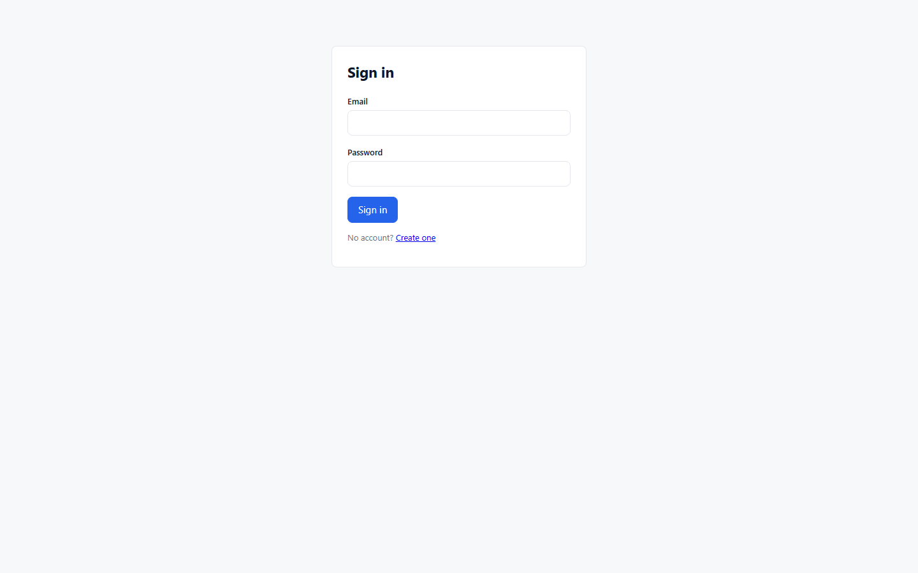
Figure 11.1: Authentication Login Screen with Remembered Client Session
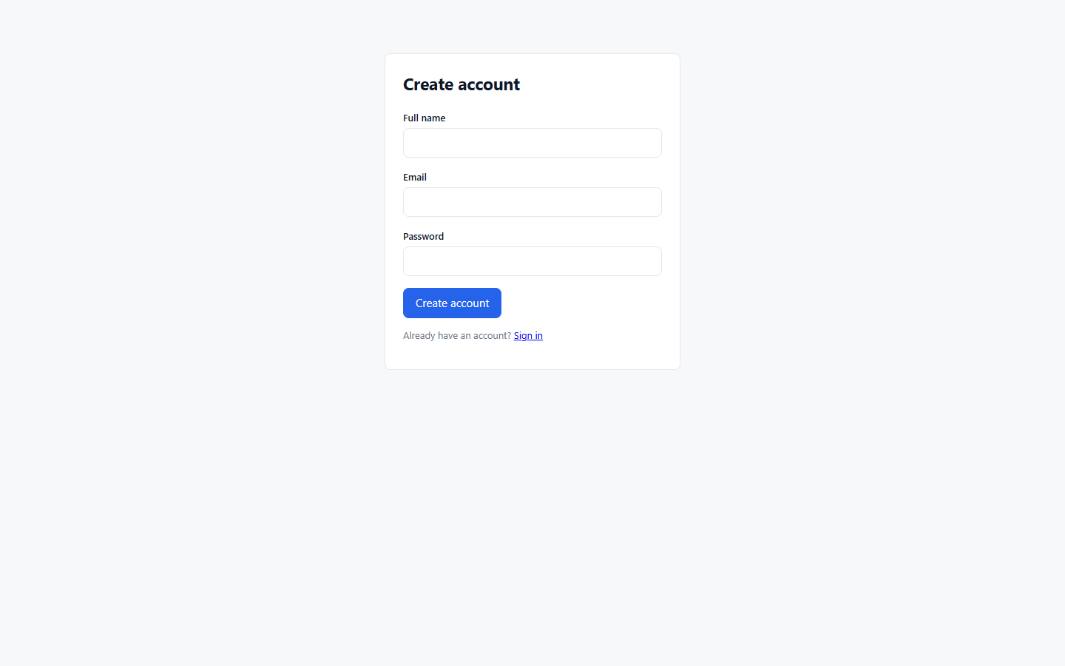
Figure 11.2: New Developer Registration Screen with Field Validations
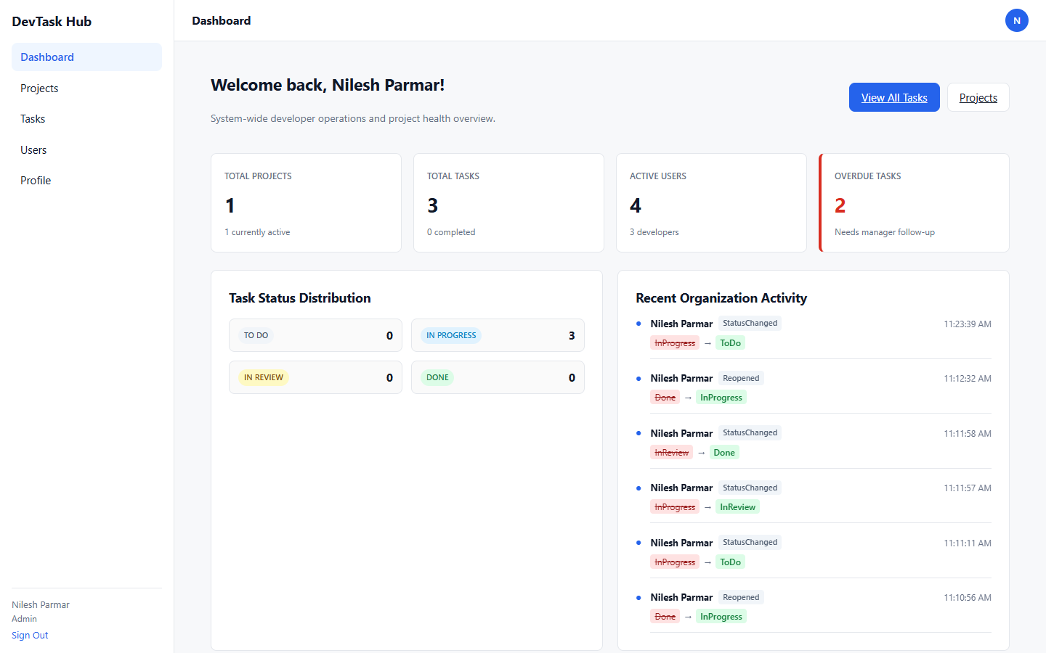
Figure 11.3: Administrator Organization KPI Dashboard & Activity Feed
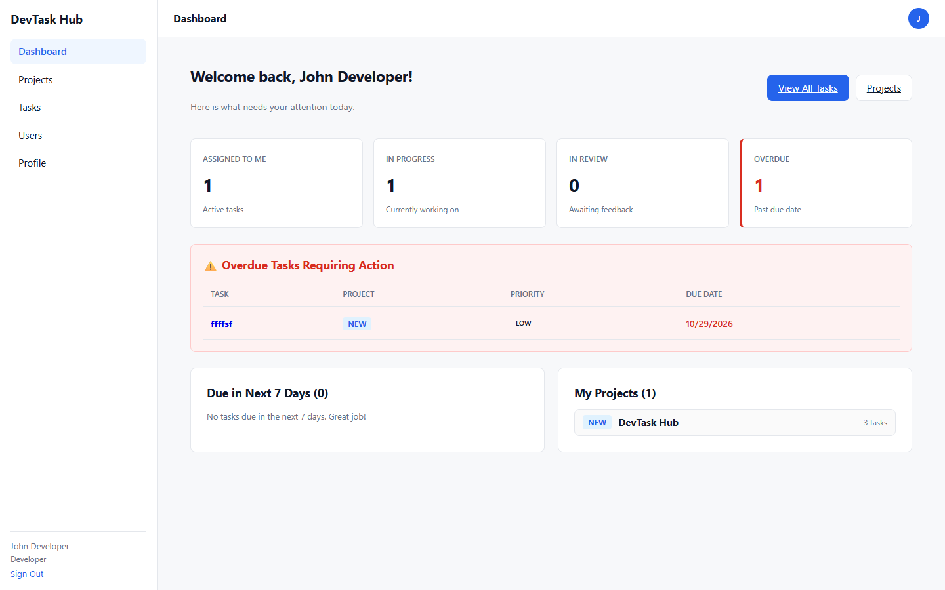
Figure 11.4: Developer Personal Workload Dashboard & Overdue Tasks Tracker
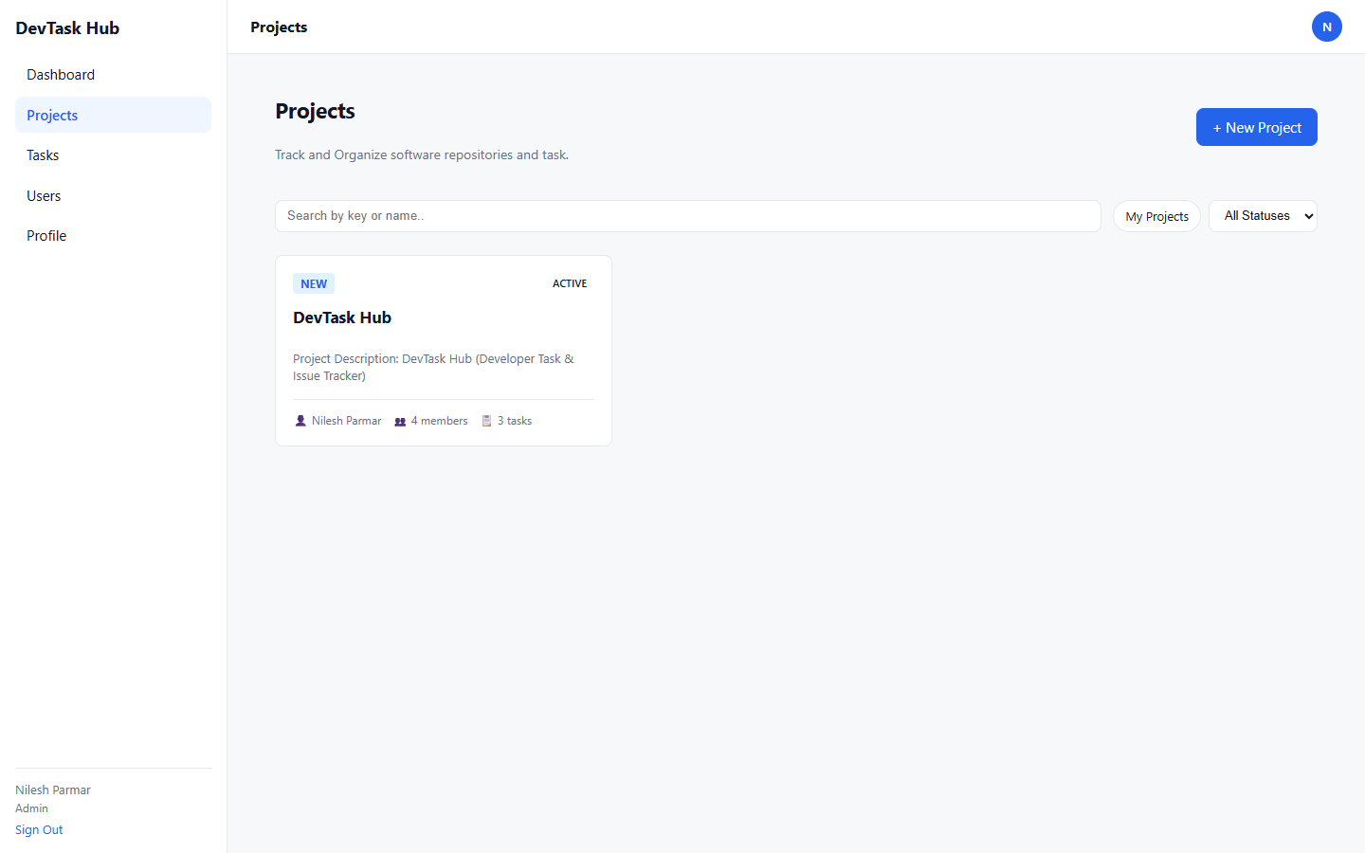
Figure 11.5: Projects Directory Card Grid with Filter & Status Controls
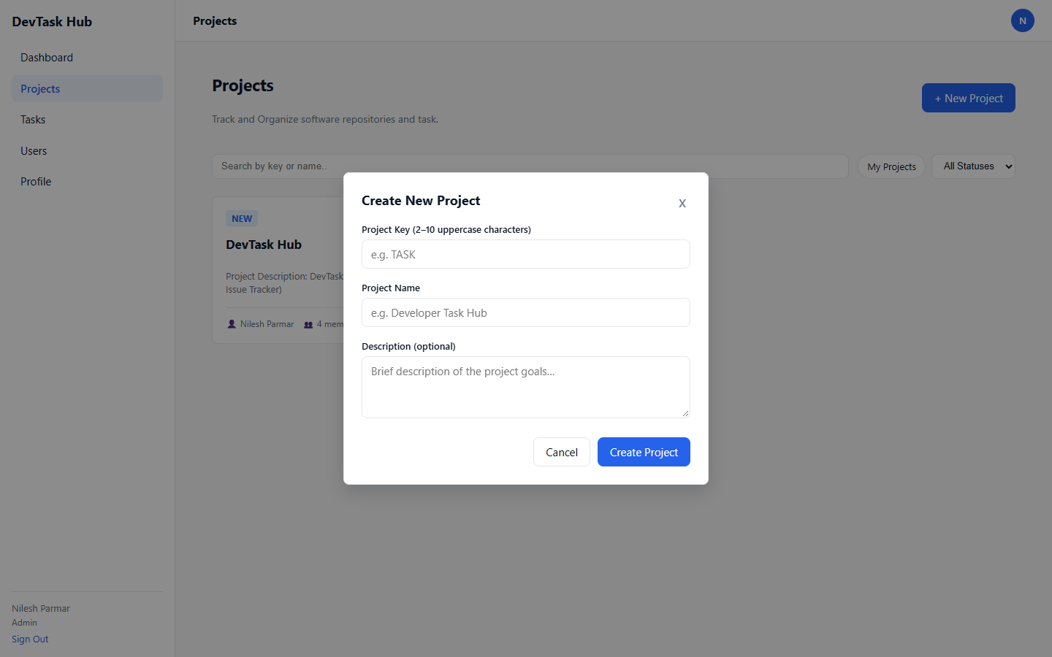
Figure 11.6: Create New Project Modal with Key Regex Enforcement
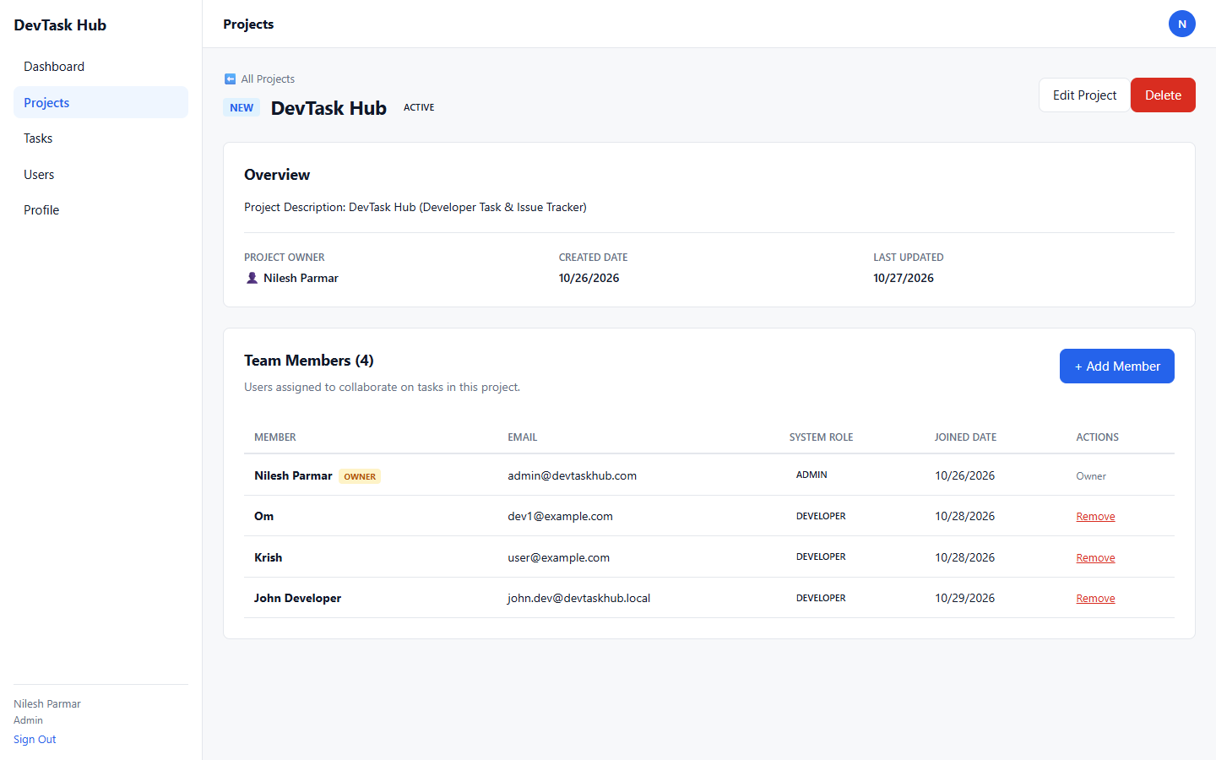
Figure 11.7: Project Details View & Team Members Management
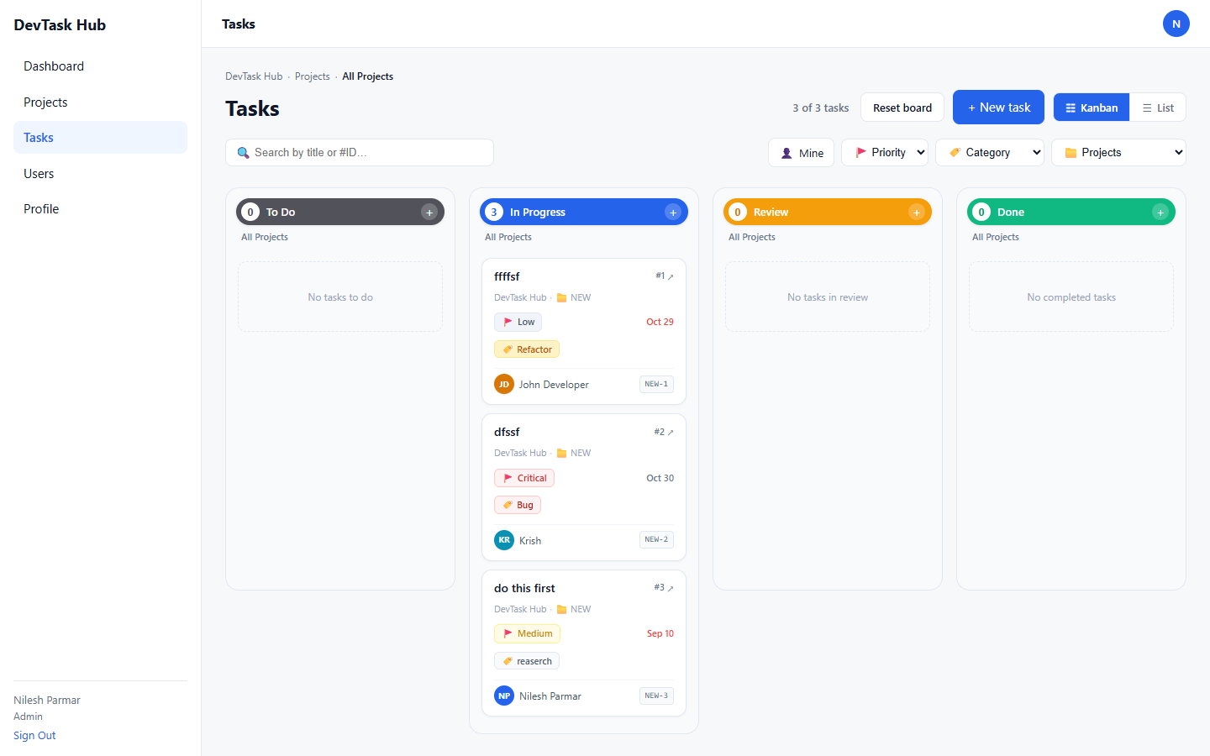
Figure 11.8: Interactive 4-Column Drag-and-Drop Tasks Kanban Board
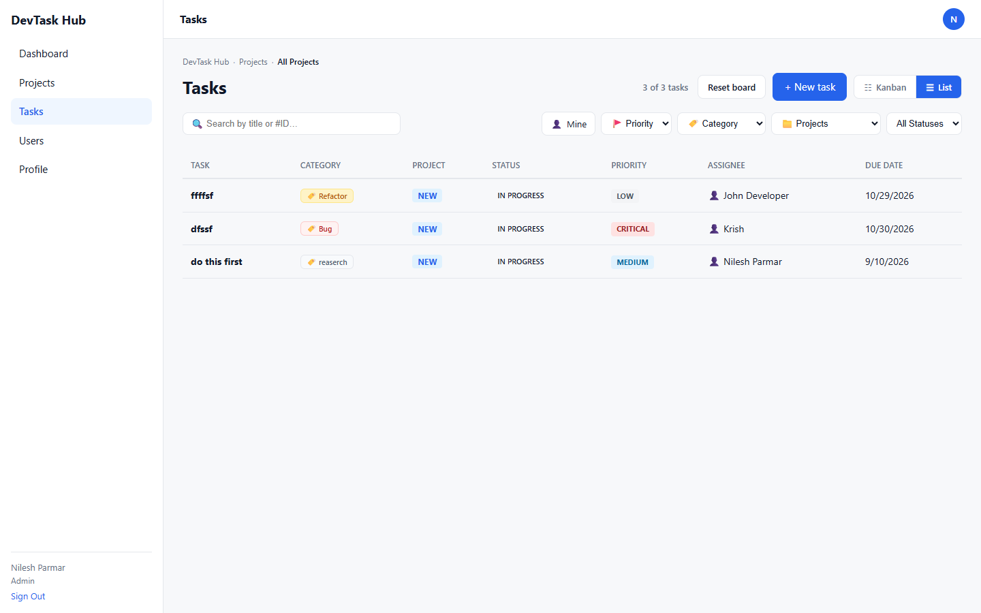
Figure 11.9: Multi-Filtered Tasks Tabular List View with Server Pagination
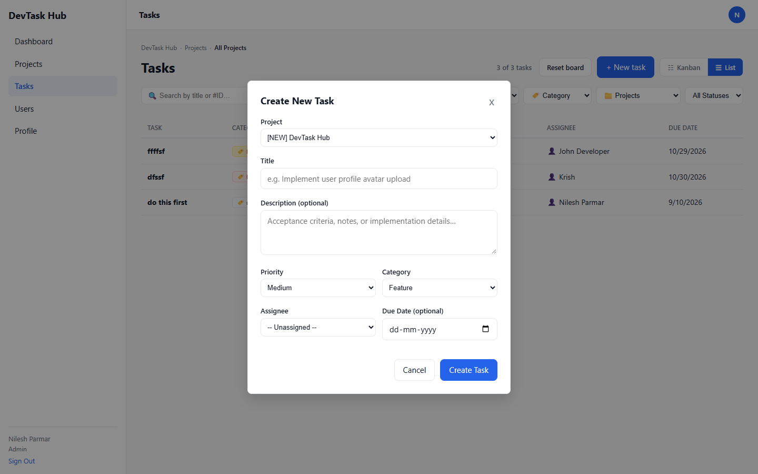
Figure 11.10: Create Task Dialog with Project Team Assignee Dropdown
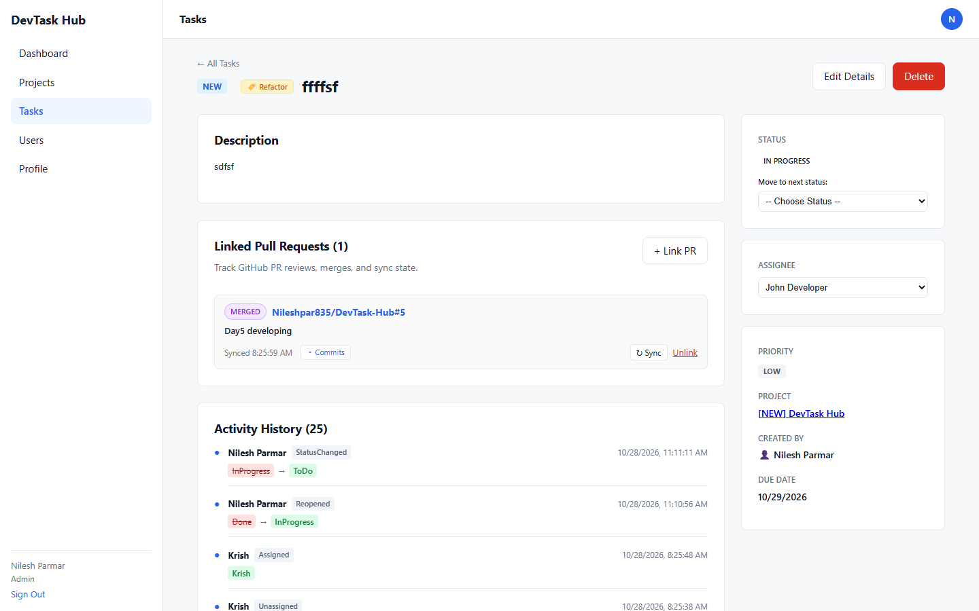
Figure 11.11: Task Details Page featuring Linked Pull Requests and Metadata
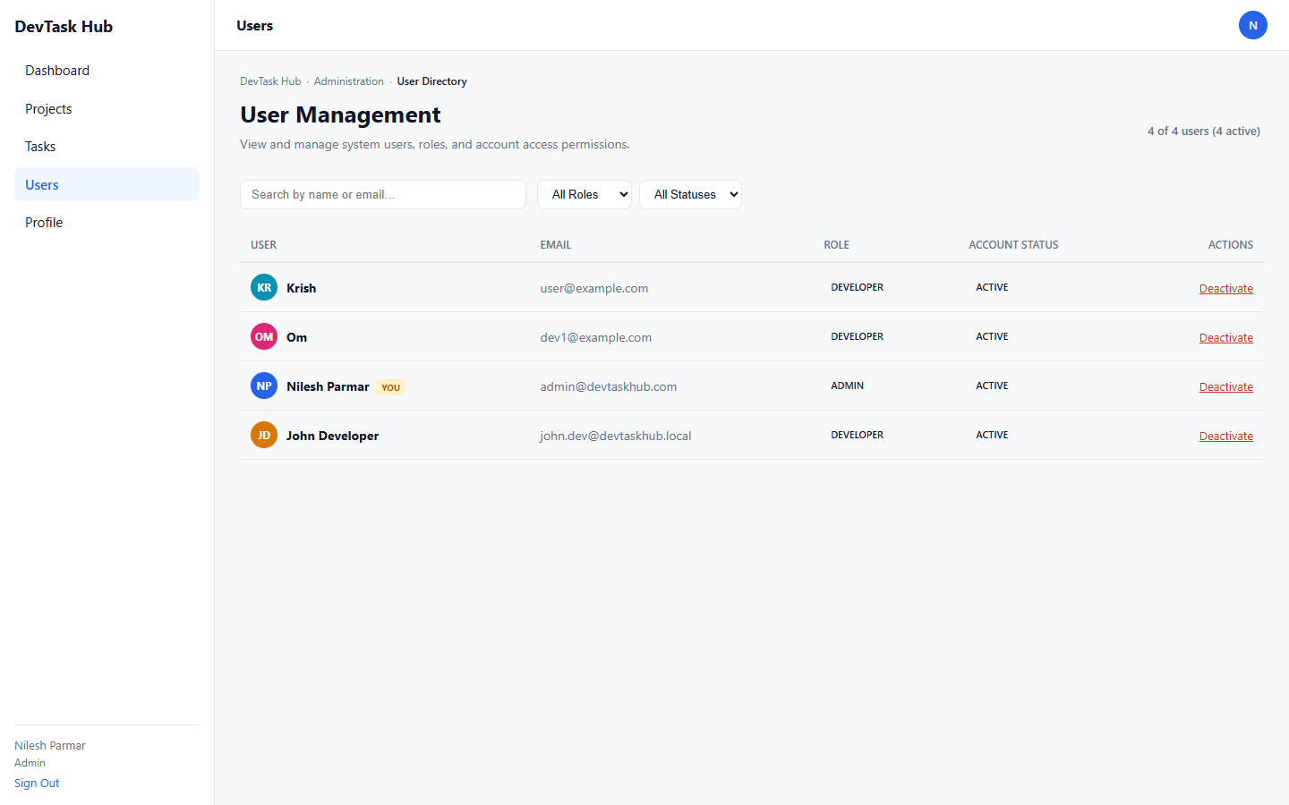
Figure 11.12: Admin User Administration Directory & Status Toggle
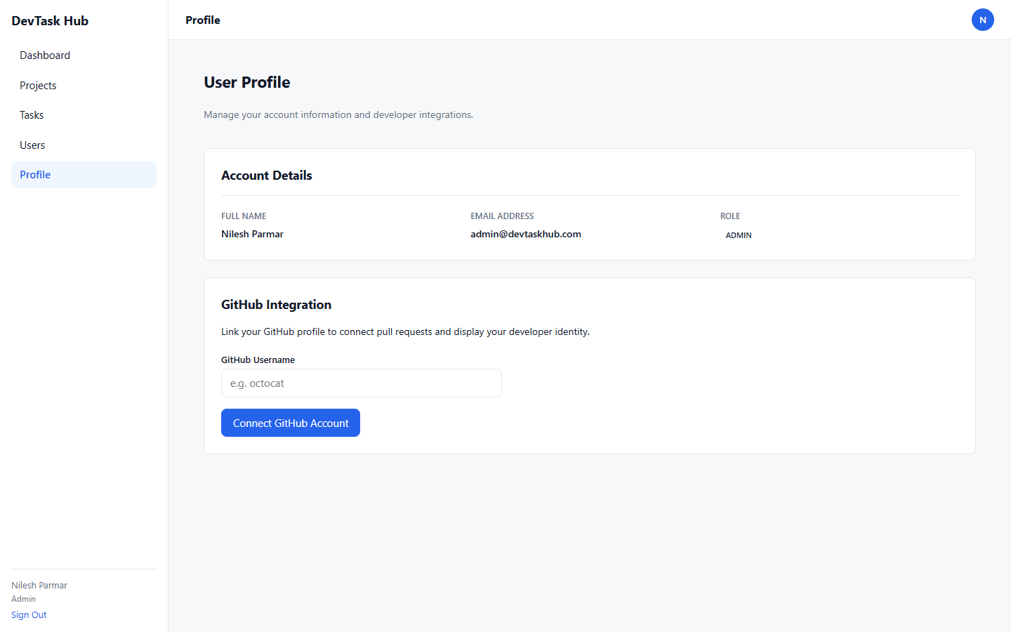
Figure 11.13: User Profile & Public GitHub Integration Interface
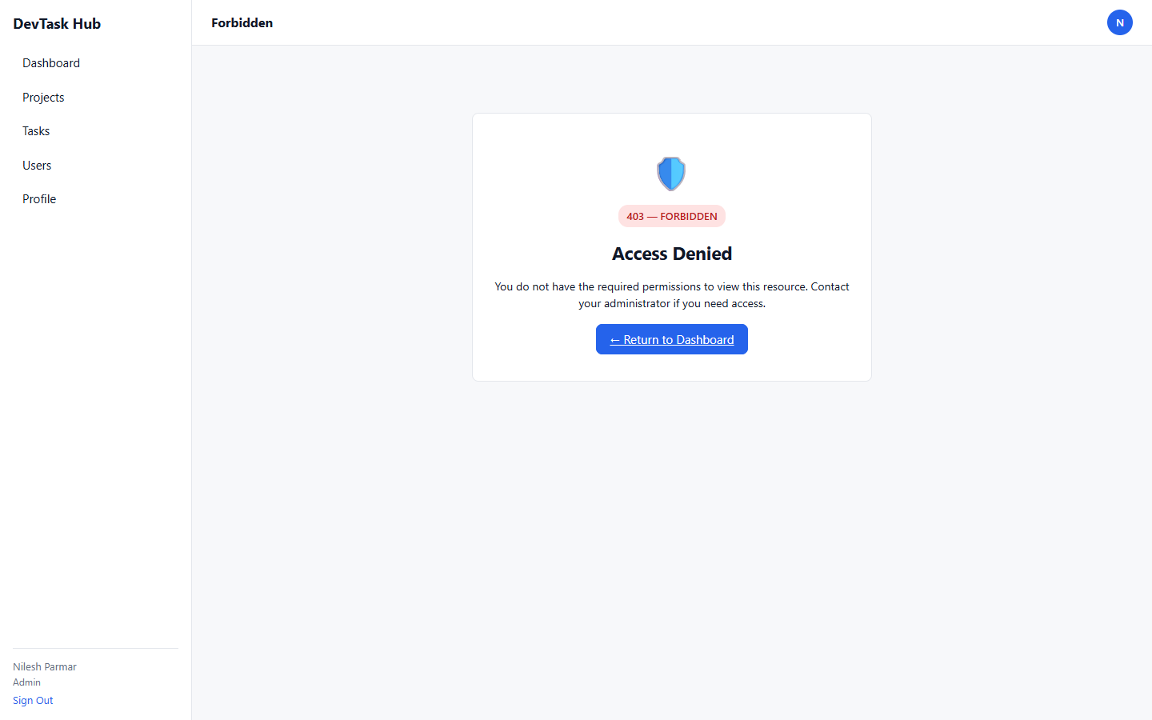
Figure 11.14: HTTP 403 Forbidden Access Guard Screen
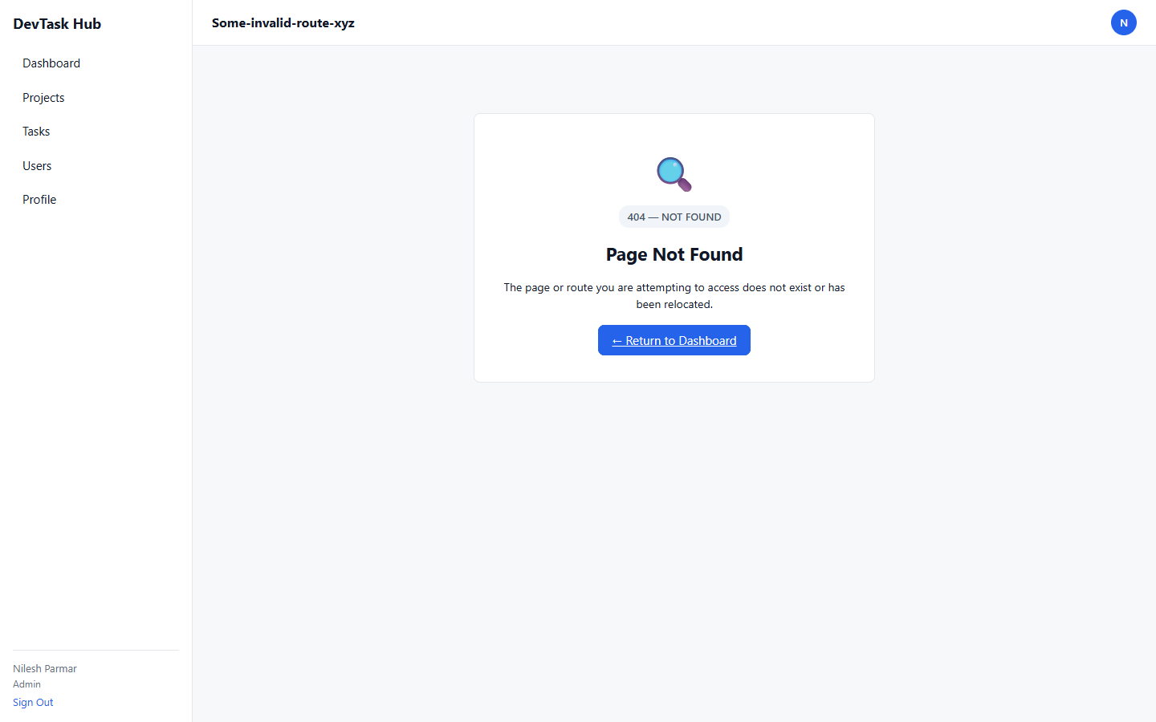
Figure 11.15: HTTP 404 Route Not Found Error View

12. Reports & Analytics Evidence
Figure 12.1: Executive Organization Metrics Report (Active Projects, Tasks by Status, Audit Logs)
Figure 12.2: Operational Developer Workload Report (Overdue Tasks Alert & 7-Day Deadline Forecast)
Figure 12.3: Task Event Audit Trail Report (Chronological Timeline of All Mutations)

13. Snapshot of Validations
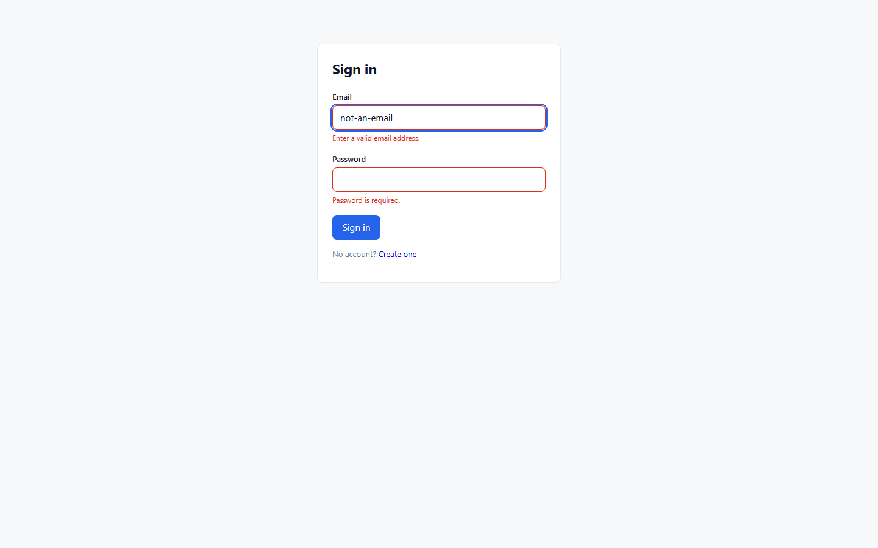
Figure 13.1: Client-Side Login Validation (Malformed Email and Missing Fields)
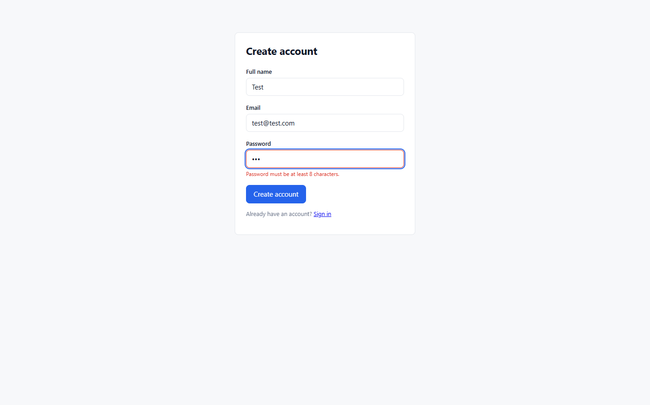
Figure 13.2: Registration Validation Trigger (Password Minimum 8 Character Constraint)
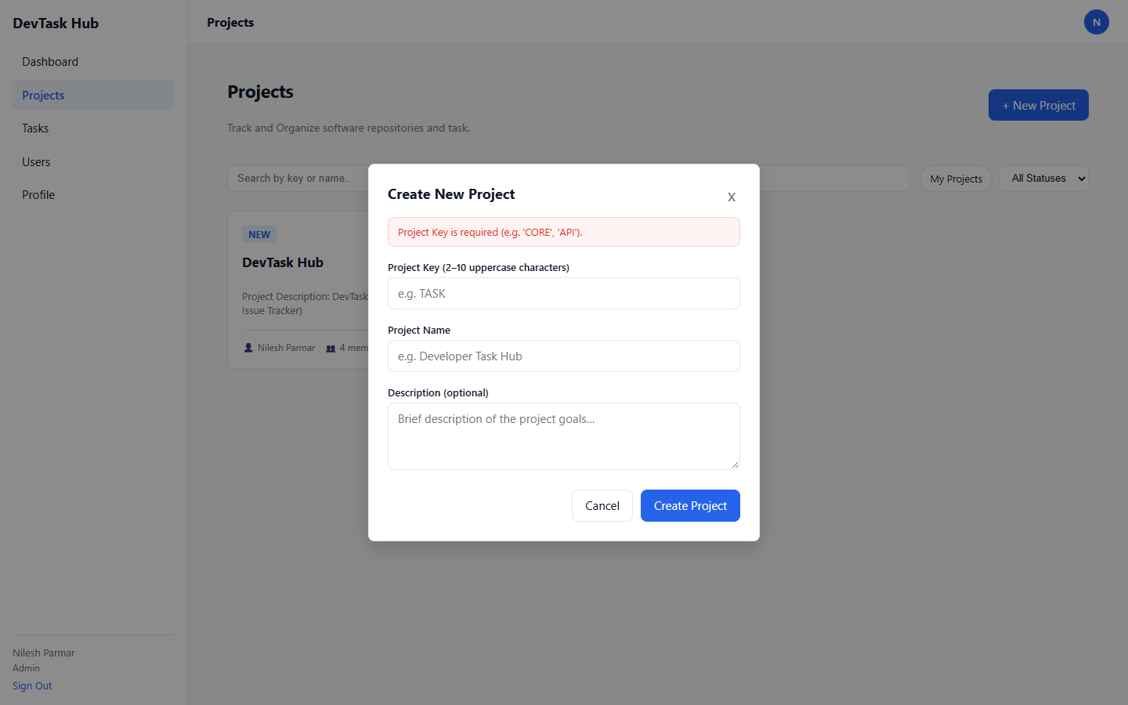
Figure 13.3: Project Form Validation (Required Key and Name Constraints)
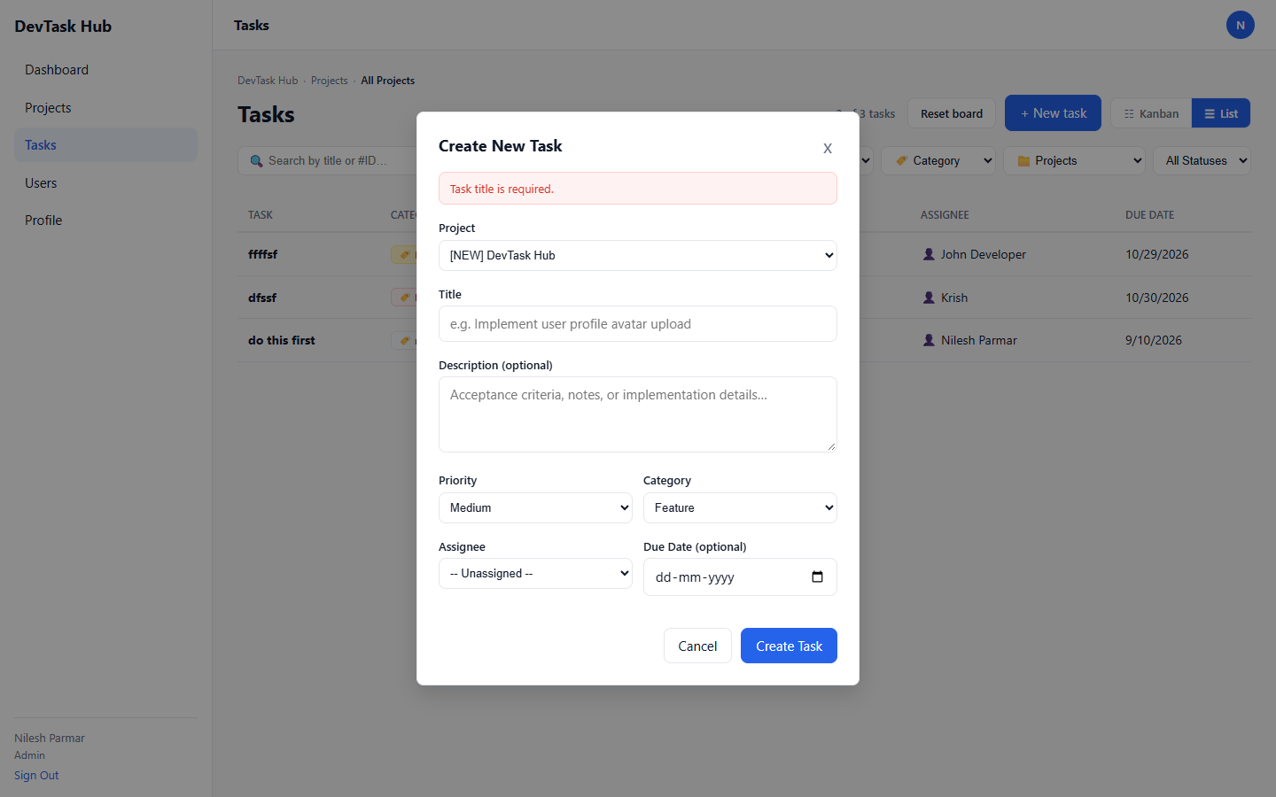
Figure 13.4: Task Form Validation (Required Project Association and Title)

14. System Test Cases & Live Verification Results
Table 14.1 records 24 automated live verification tests executed against the running application:
Test ID | Module | Description | Input Data | Expected Result | Status
TC-AUTH-01 | Authentication | Admin login with valid credentials | email: admin@devtaskhub.com, pass: Nilesh | HTTP 200 with JWT access token & user role Admin | PASS
TC-AUTH-02 | Authentication | Login with incorrect password | email: admin@devtaskhub.com, pass: WrongPassword | HTTP 401 Unauthorized | PASS
TC-AUTH-03 | Authentication | Register new developer user | email: dev.test1384@devtaskhub.local, pass: Password123! | HTTP 201 Created with Developer role | PASS
TC-AUTH-04 | Authentication | Register with duplicate email address | email: dev.test1384@devtaskhub.local | HTTP 400 Bad Request (Email already in use) | PASS
TC-AUTH-05 | Authentication | Rotate refresh token with valid cookie | Valid refresh_token HTTP-only cookie | HTTP 200 with rotated access token | PASS
TC-PROJ-01 | Project Management | List projects with pagination | page=1, pageSize=10 | HTTP 200 with paged list of project summaries | PASS
TC-PROJ-02 | Project Management | Create project with valid key and name | key: P55, name: Test Project | HTTP 201 Created with project details | PASS
TC-PROJ-03 | Project Management | Create project with invalid lowercase key | key: invalid_lowercase | HTTP 400 Validation Error (key must match regex) | PASS
TC-PROJ-04 | Project Management | Add developer as member to project | projectId: 2, userId: 2 | HTTP 201 Member added successfully | PASS
TC-PROJ-05 | Project Management | Add already existing member to project | projectId: 2, userId: 2 | HTTP 400/Error duplicate membership rejected | PASS
TC-TASK-01 | Task Management | Create new task with valid attributes | projectId: 2, title: Build Test Feature, priority: High | HTTP 201 Created with status ToDo | PASS
TC-TASK-02 | Task Management | Legal state machine transition (ToDo -> InProgress -> InReview) | status: InProgress then InReview | HTTP 200 Task status transitioned to InReview | PASS
TC-TASK-03 | Task Management | Illegal status transition (ToDo directly to Done) | status: Done directly from ToDo | HTTP 400/500 State machine rejects transition | PASS
TC-TASK-04 | Task Management | Assign task to user who is not a project member | assigneeUserId: 3 (not in team) | HTTP 400/Error Assignee must belong to project members | PASS
TC-TASK-05 | Task Management | Fetch task audit trail / activity history | taskId: 4 | HTTP 200 with chronological activity logs | PASS
TC-DASH-01 | Dashboards & Analytics | Admin fetch organization KPI metrics & breakdown | GET /api/dashboard/admin with Admin token | HTTP 200 with total metrics, status breakdown, recent activities | PASS
TC-DASH-02 | Dashboards & Analytics | Developer fetch personal workload metrics | GET /api/dashboard/developer with Developer token | HTTP 200 with assigned count, overdue list, due soon tasks | PASS
TC-DASH-03 | Dashboards & Analytics | Developer unauthorized access to Admin dashboard | GET /api/dashboard/admin with Developer token | HTTP 403 Forbidden | PASS
TC-USER-01 | User Administration | Admin view all registered users | GET /api/users with Admin token | HTTP 200 with list of user profiles, roles, and status | PASS
TC-USER-02 | User Administration | Admin toggle user active/deactivated status | PATCH /api/users/2/toggle-status | HTTP 200 Status toggled successfully | PASS
TC-USER-03 | User Administration | Developer unauthorized access to user directory | GET /api/users with Developer token | HTTP 403 Forbidden | PASS
TC-GH-01 | GitHub Integration | Link public GitHub profile | username: torvalds | HTTP 200 GitHub profile synced and linked | PASS
TC-GH-02 | GitHub Integration | Link pull request with invalid URL format | url: https://invalid-url.com/something | HTTP 400 Validation Error (Must be GitHub PR URL) | PASS
TC-GH-03 | GitHub Integration | Unlink GitHub profile | DELETE /api/github/profile | HTTP 204 No Content (Profile unlinked) | PASS

15. Extra-Ordinary Features (Beyond Basic CRUD)
- Cryptographic Refresh Token Rotation & Theft Detection: Tokens are rotated on every refresh. Stored as SHA-256 hashes in SQL Server. Replay or theft detection automatically invalidates the entire token family, forcing immediate re-authentication.
- Deterministic Task State Machine: Guards against out-of-order workflow transitions (e.g. ToDo cannot jump to Done directly). Enforces code review and developer validation steps.
- Public GitHub REST API Integration & Real-Time Sync: Seamlessly connects developer issues to source code PRs. Synchronizes live GitHub states (Open/Closed/Merged), draft flags, and pulls commit history directly into the task UI.
- Optimistic Drag-and-Drop Kanban Board: Native HTML5 drag-and-drop board provides immediate visual feedback while dispatching background state change API requests.
- Role-Segregated Metric Aggregations: Tailored analytical dashboards dynamically calculate organization-wide throughput for Admins and deadline alerts for Developers.

