How to do clip audio files, using Wavepad sound editor

Here is a figure of the first view of wavepad software:

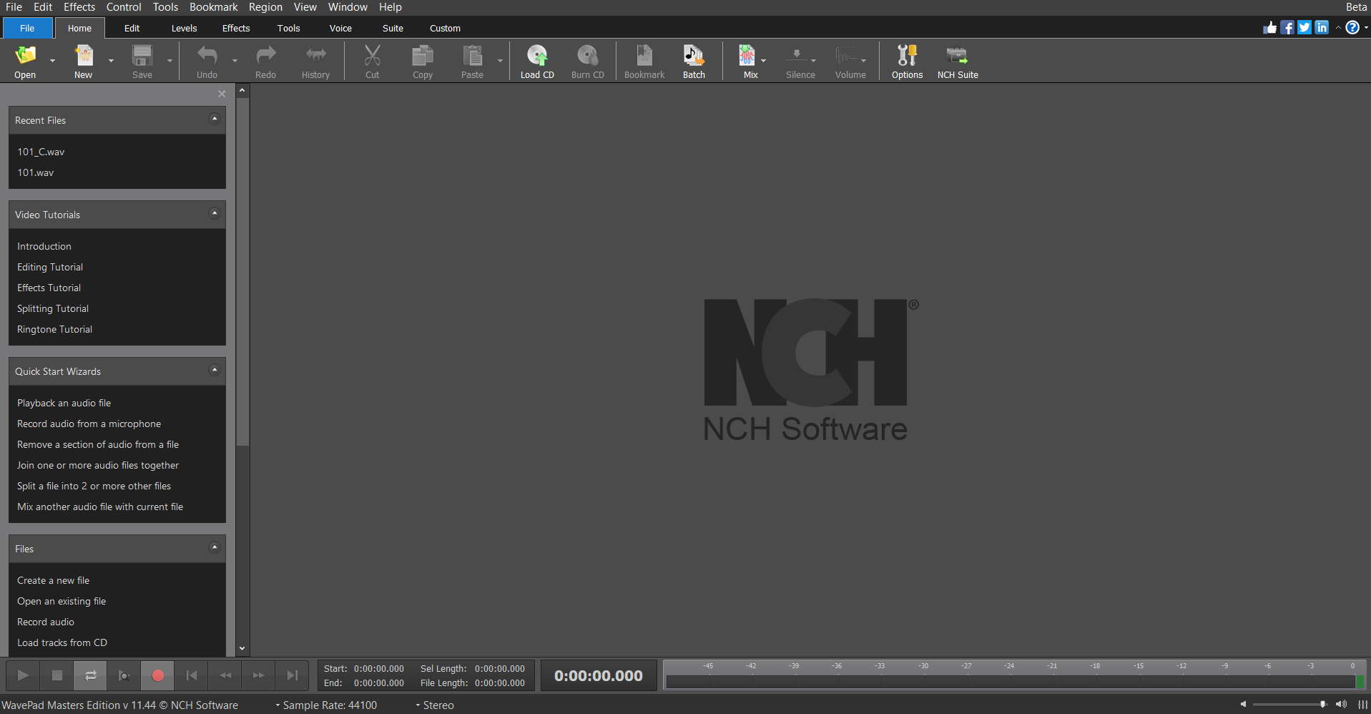

To open an audio “.wav” file, the Open icon on the top left is used. As an example:

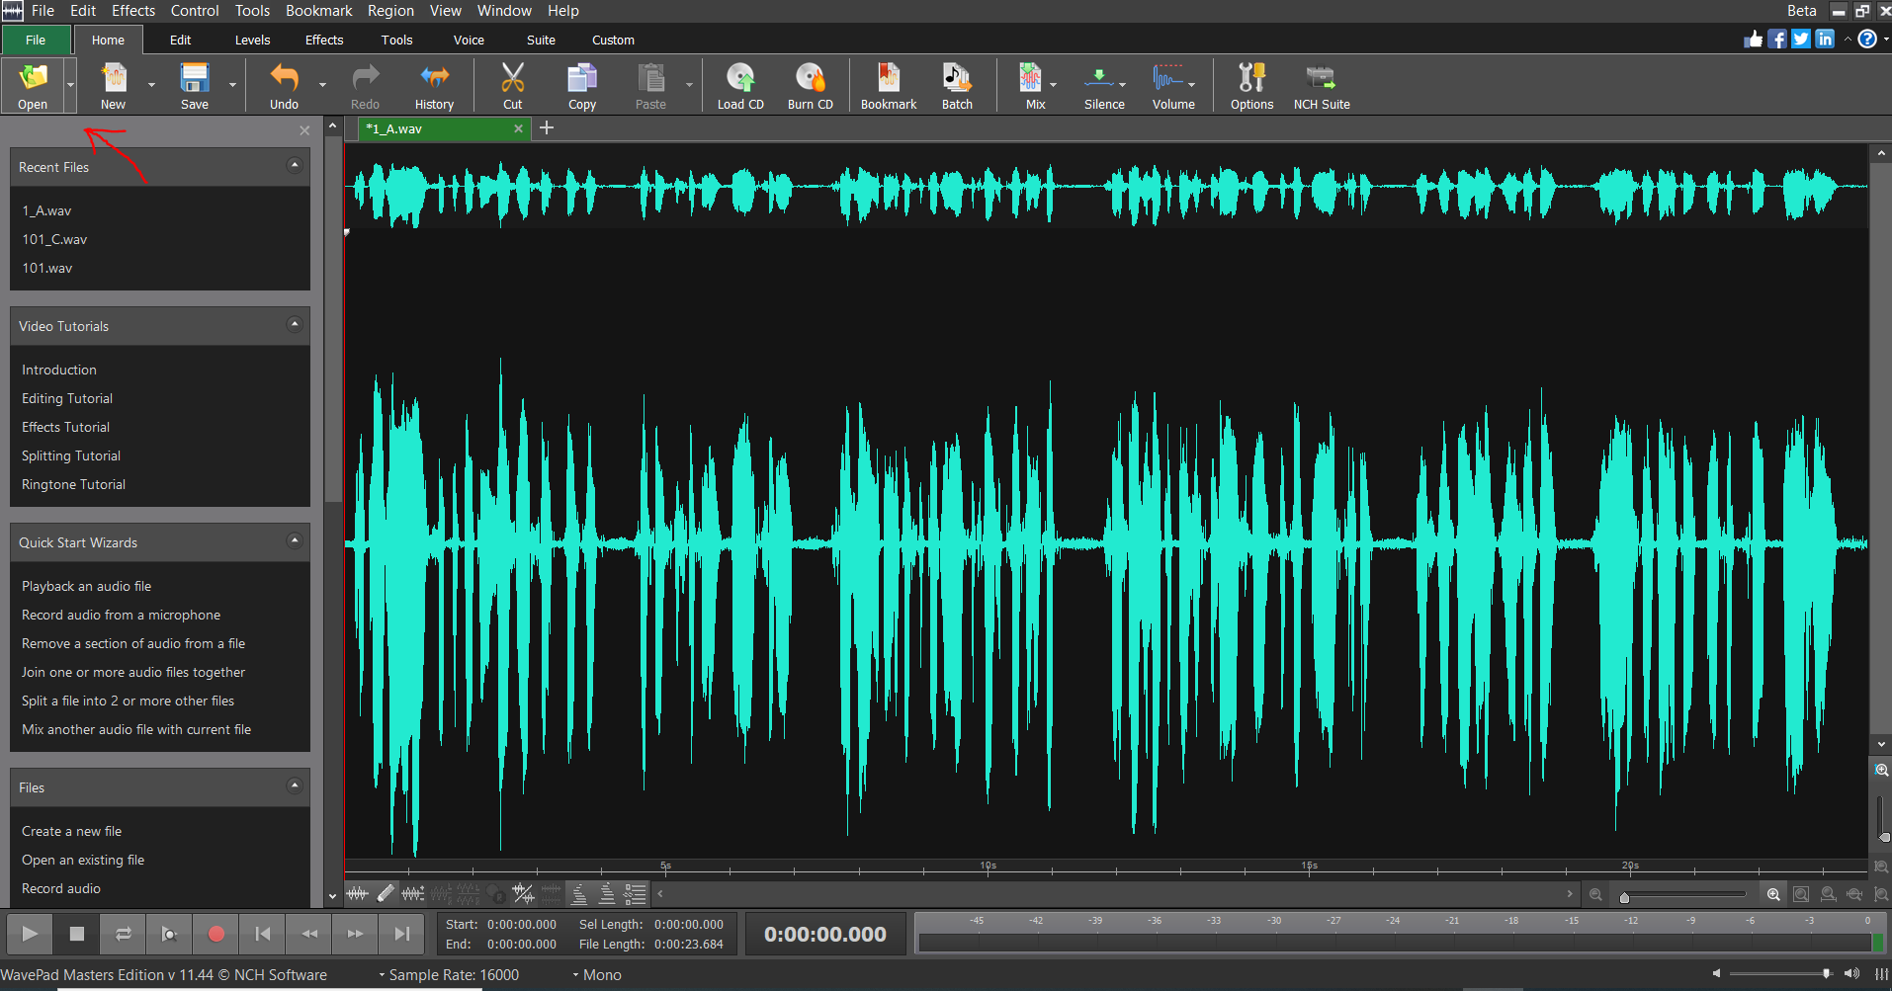

Now, by playing the audio, we can understand the area of each word. Then using curser, the area of each word can be selected and using Copy icon on the top, the selected area is copied:

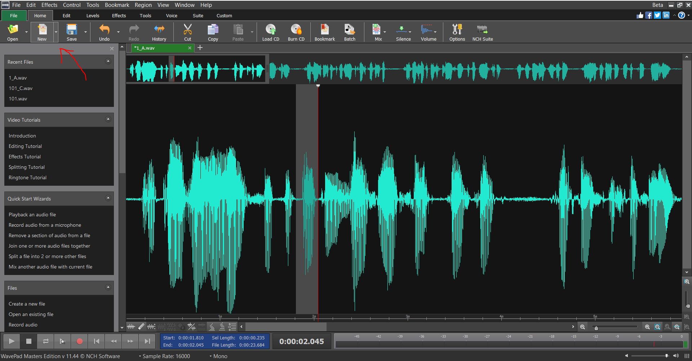

Then by opening a new file using New icon, we can paste the selected audio in the new file:

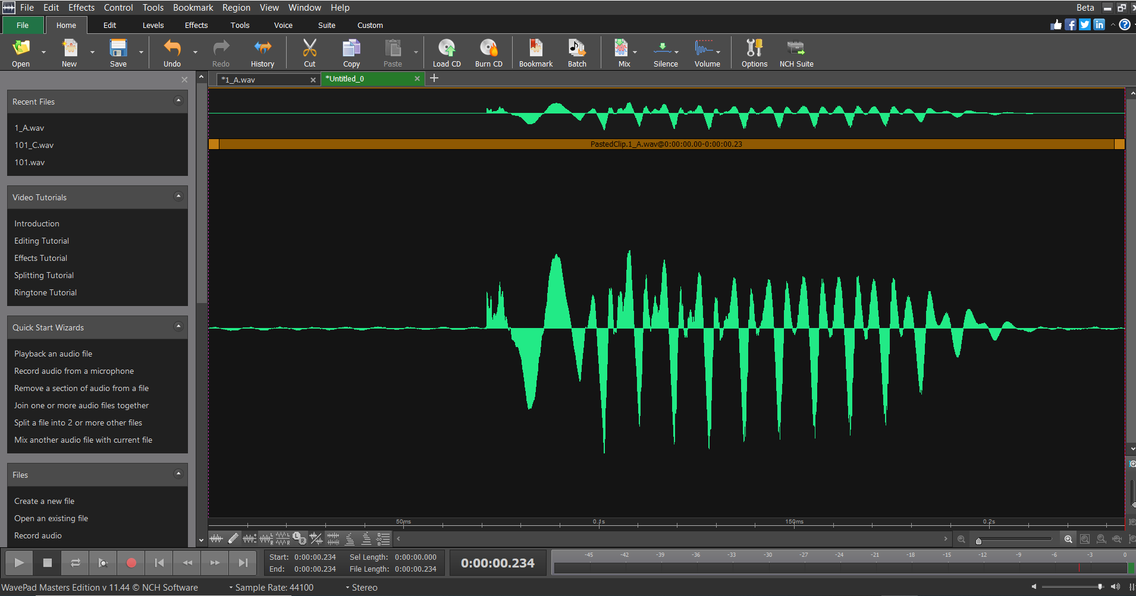

finally by CTRL+S the “.wav” file can be saved in a specific directory:

