

**Tribhuvan University**

**Faculties of Humanities and Social Science**

**A TYPING SPEED TEST**

**A PROJECT REPORT**

**Submitted to**

**Department of Computer Application**

**Himalaya Darshan College**

***In partial fulfillment of requirement for the Bachelors in Computer Application***

**Submitted by**

**Archana Kumari Mandal (6-2-1073-71-2020)**

**Nilima Sardar (6-2-1073-84-2020)**

Under the Supervision of

**Er. Santosh Sah**



**Tribhuvan University Faculty of Humanities and Social Sciences**

**Himalaya Darshan College**

# Supervisor’s Recommendation

I hereby recommend that the report prepared under my supervision by Archana Kumari Mandal and Nilima Sardar entitled **“TYPING SPEED TEST”** in partial fulfillment of the requirements for the degree of Bachelor of Computer Application is recommended for the final evaluation.

**-----------------------------**

**SIGNATURE**

Er.Santosh Sah

**SUPERVISOR**

Project Coordinator

Department of IT

Himalaya Darshan College



**Tribhuvan University**

**Faculty of Humanities and Social Science**

**Himalaya Darshan College**

# LETTER OF APPROVAL

This is to certify that this project prepared by Archana Kumari Mandal, Nilima Sardar entitled **“TYPING SPEED TEST”**  in partial fulfillment of the required degree of Bachelor in Computer Application has been evaluated. In our opinion, it is satisfactory in the scope and quality as a project for the required degree.

|  |  |
| --- | --- |
| Er Santosh Sah  Project Supervisor  Lecturer Department of IT  Himalaya Darshan College | Er. Sumit Kumar Shah  HOD, IT  Himalaya Darshan College |
| Kushal Niroula  Project Coordinator  Himalaya Darshan College | External Examiner |

# ABSTRACT

The Typing Speed Test project aims to provide users with a platform to assess and enhance their typing skills. This web-based application offers a user-friendly interface for testing typing speed, measuring accuracy, and providing real-time feedback. Leveraging technologies such as PHP, MySQL, and JavaScript, the system generates random sentences for users to type, calculating words per minute (WPM) and accuracy. It offers multiple language options and difficulty levels to cater to a wide user base. The Typing Speed Test project contributes to improving users' typing proficiency while offering a seamless and engaging experience.

**Acknowledgement**

The success of this project required guidance and supervision. We would like to express our sincere gratitude to Supervisor **Er. Santosh Sah** for guiding me throughout the planning and development phase of the system.

We also want to thank, Head of IT Department**, Er. Sumit Kumar Shah** for creating the required academic environment which made our task appreciable.

We perceive as this opportunity as a big milestone as a career development. We will strive to use gained knowledge in the best possible way, and work on further improvement, in order to attain desired career objectives. Hope to co-operation with all of you in the future.

Table of Contents

Supervisor’s Recommendation i

LETTER OF APPROVAL ii

ABSTRACT iii

Acknowledgement iv

List of Abbreviation viii

List of Figures ix

List of Table x

Chapter: 1 Introduction 1

1.1. Introduction 1

1.2. Problem Statement 1

1.3. Objectives 2

1.4. Scope and limitation 2

1.5. Development Methodology 3

1.6 Roles 4

1.7 Report Organization 5

Chapter 2: Background Study and Literature Review 6

2.1 Background Study 6

2.2 Literature Review 6

Chapter 3: System Analysis and Design 7

3.1 System Analysis 7

3.1.1. Requirement Analysis: 7

3.1.1.1 Functional requirements: 7

3.1.1.2 Non-Functional Requirements: 9

3.1.2. Feasibility Analysis: 9

3.1.2.1 Technical feasibility: 9

3.1.2.2 Operational feasibility: 9

3.1.2.3 Economic feasibility: 9

3.1.2.4 Schedule 10

3.1.3 Data Modeling (Entity Relationship) 11

3.1.4 Process Modelling 12

3.1.4.1 Context Diagram 12

3.1.4.2 Level 1 DFD 13

3.2. System design 14

3.2.1 Architectural design 14

3.2.2 Database Schema 15

3.2.3 Interface Design(UI Interface) 16

Chapter 4: Implementation and Testing 21

4.1 Implementation 21

4.1.1. Tools Used 21

Front End Tools 21

Back End Tools 21

4.1.2 Implementation details of modules 23

4.2 Testing 23

4.2.1 Unit Testing: 23

4.2.2. System Testing: 27

Chapter 5: Conclusion and Future Recommendation 30

5.1 Outcome and Lesson Learnt 30

5.2 Conclusion 30

5.3 Future Recommendation 30

APPENDIX: 31

SYSTEM SCREENSHOTS 31

References 37

# List of Abbreviation

ER – Entity Relationship

DFD – Data Flow Diagram

UI – User Interface

VS code – Visual Studio code

HTML –Hyper Text Markup Language

CSS – Cascading Style Sheets

AJAX - Asynchronous JavaScript and XML

XML –Extensive Markup Language

PHP – Hypertext Preprocessor

MySQL –Structured Query Language

# List of Figures

Figure 1.1: Iterative Waterfall Method ……………….………………………………3

Figure 3.1: Use Case Diagram .........................................................…………………. 8

Figure 3.2: Gantt Chart ....................................................................……. …………..10

Figure 3.3: ER Diagram ...................................................................………………... 11

Figure 3.4: Context Diagram ...........................................................…………………12

Figure 3.5: Level 1 DFD ..................................................................……..,………….13

Figure 3.7: Architectural Design.......................................................………………...14

Figure 3.8: Schema Design ...............................................................………………...15

Figure 3.9: Home Page UI ...............................................................…………………16

Figure 3.10: Registration Page UI .....................................................….…………….17

Figure 3.11: Login Page UI ..................................................................………………18

Figure 3.12: Typing Test Page UI .....................................................….…………...19

Figure 3.13: Achievement Page UI ………...................................………….……..…20

# 

# List of Table

Table 1.1: Role ....................................................................………...……………….. 4

Table 1.2: Outline of the Report………………………………...…………………….5

Table 4.2.1.1: Test Case 001-Registration Form ..............................................…….. 23

Table 4.2.1.2: Test Case 002-Login Form ........................................................……...23

Table 4.2.1.3: Test Case 003-Typing Test Page………….........................…………..24

Table 4.2.1.4: Test Case 004-Achievement Page ………..........................…………..25

Table 4.2.1.5: Test Case 005-Time Spent Page …………......................…...………..25

Table 4.2.2.1: Test Case 005-Time Spent Page …..…............................…...………..27

Table 4.2.2.2: Test Case 005-Time Spent Page …..…............................…...………..28

# Chapter: 1 Introduction

## 1.1. Introduction

The purpose of this project is to create an interactive Typing Speed Test that can be used to assess and improve typing speed and accuracy. The need for this Test arises from the fact that typing skills are essential in today's digital age, and many people could benefit from improving their typing speed and accuracy.

A Typing Speed Test can be a valuable tool for anyone looking to improve their typing skills, whether for personal or professional reasons. By providing customizable difficulty levels Typing Speed Test can make typing instruction more effective and enjoyable for learners of all ages and skills levels.

## 1.2. Problem Statement

In today's digital age, it is more important than ever to be able to type quickly and accurately. Typing skills are essential for success in college, work, and everyday life. However, many people struggle with their typing skills. The problems that may arise to being slow typist are:

* Reduced productivity: Slow typists take longer to complete tasks that require typing, such as writing emails, creating documents, or coding. This can lead to reduced productivity and missed deadlines.
* Increased stress: Slow typists may feel stressed or anxious when they have to type quickly, which can lead to errors and mistakes. This can further slowdown their typing speed and make it even more difficult to complete tasks.
* Frustration: Slow typists may become frustrated when they have to type quickly, which can lead to them giving up on tasks or making more mistakes. This can impact their overall productivity and satisfaction with their work.
* Limited job opportunities: Some jobs require a certain level of typing speed, such as data entry or customer service. Slow typists may be at a disadvantage when applying for these types of jobs.

So, this project (Typing Speed Test) can be a useful tool for anyone looking to improve their typing skills, whether for personal or professional purposes. [1]

## 1.3. Objectives

The major objective behind developing the Typing Speed Test:

* To help user to type faster.
* To help user track their progress.
* To help user to retrieve and display user achievements.

## 1.4. Scope and limitation

**Scope**

The project aims to create a fully functional and interactive web application that allows users to test their typing speed and accuracy. This involves designing and implementing the necessary functionalities and user interfaces to facilitate the typing test.

**Limitation**

* While the application may offer randomly generated texts, some users might eventually memorize them, affecting the reliability of the test.
* Without user accounts or profiles, users may not have a way to typing test page and to save and track their test results over time.

## 1.5. Development Methodology

The method used to develop the system includes an iterative waterfall model, dataflow, and logical, entity-relationship diagram. The iterative waterfall model allows for feedback and changes to be made at any point in the process. This makes it a more flexible and adaptable approach to software development.

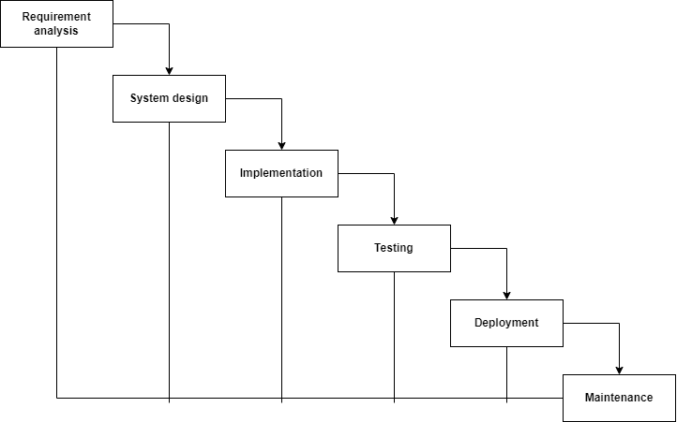

**Fig 1.1: Iterative Waterfall Model**

## 1.6 Roles

**Table 1.1- Roles**

|  |  |
| --- | --- |
| **Name** | **Specified task** |
| Archana Kumari Mandal | System analysis, Front end development |
| Nilima Sardar | System design, Back end development, testing. |

## 1.7 Report Organization

This paper also includes charts/diagrams to illustrate the system architecture and design. Furthermore, it contains information regarding the tools and technologies used to build the system.

**Table 1.2- Outline of the Report**

|  |  |
| --- | --- |
| **Introduction** | Introduction,  Problem Statement,  Objective,  Scope and Limitations,  Development Methodology,  Report Organization |
| **Requirement and Feasibility**  **Analysis** | Background Study,  Literature Review |
| **Methodology** | Requirement Analysis,  Feasibility Analysis,  System Design |
| **Implementation and Testing** | Tools and Technology,  Test Cases |
| **Conclusion and Recommendations** | Lessons Learnt,  Conclusion,  Future Recommendations |

# Chapter 2: Background Study and Literature Review

## 2.1 Background Study

In today's digital world, knowing how to type quickly and accurately is essential. The Typing Speed Test System is a tool that helps assess and improve your typing skills. It's not just about speed; it's also about typing without making mistakes. This system is useful for students and professionals, making them more efficient in their work. Some jobs even require excellent typing skills.

The Typing Speed Test System is not just for adults; it's also great for kids to learn how to type. .

## 2.2 Literature Review

1. Nitro Type: This website offers a typing game where you race against other players to type out a sentence. The faster you type, the faster your car goes, making it a fun and engaging game.[2]
2. Type Fu: This software offers a range of typing speed games and exercises to help improve your typing skills. The software also provides feedback on your typing speed and accuracy.[3]
3. TypeShala: TypeShala provides various lessons and exercises to help users improve their Nepali typing speed and accuracy, and it also includes features such as typing games and typing tests.[4]

All these above websites can get repetitive over time, especially if user use it for hours on end. To overcome this, instead of using a fixed set of sentences, we will use a pool of diverse sentences which can be created from various sources. This can be done by importing content from external sources, such as news articles, books, or websites.

# Chapter 3: System Analysis and Design

## 3.1 System Analysis

In this phase plans are made regarding to the developing process of the proposed system. The study of functional and non-functional requirements are done.

## 3.1.1. Requirement Analysis:

The requirement that is essential for the development of the proposed system is functional and non-functional requirements. Its various parameters are based on a feasibility study and so on.

### 3.1.1.1 Functional requirements:

The functional requirements of a Typing Speed Test will be as follows:

* The Test will allow users to type text at their own place.
* The Test will display the text that the user is typing, as well as their typing speed and accuracy.
* The Test will allow users to compete against themselves.

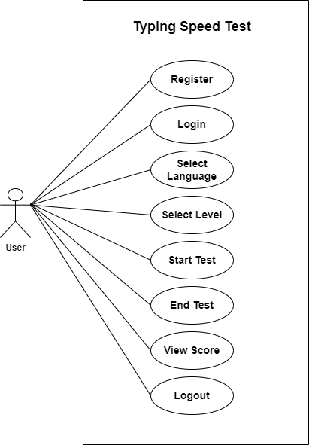

**Figure 3.1: Use Case Diagram of Typing Speed Test**

The above diagram illustrates 2 actors:

**User**- Here, the user needs to register first and then login with user name and password and start Test, view their own scores.

### 

### 3.1.1.2 Non-Functional Requirements:

It defines the criteria according to which the system must work.

1. Usability:

The Test will have a user-friendly interface, easy-to-understand instructions, and easy navigation.

1. Performance:

The Test will load quickly and have minimal lag time.

1. Security:

The Test will be secure and protected against unauthorized access. Users will have to authenticate using the email and password.

1. Maintainability:

The Test will be easy to maintain, with clear documentation and code structure. Top of Form

## 3.1.2. Feasibility Analysis:

The feasibility study will evaluate the technical, operational, and economic feasibility of the proposed system.

### 3.1.2.1 Technical feasibility:

The technologies associated with this project are Front end: HTML, CSS, and JavaScript.Back-end PHP and MySQL.

### 3.1.2.2 Operational feasibility:

The proposed system will be easy to use, and users will be trained on how to use the system. The Test will have instruction manual and easy navigation.

### 3.1.2.3 Economic feasibility:

Economic analysis is referred to as cost/benefits analysis. The system which is going to be developed does not require any additional hardware and software. As the interface of the system is developed using the existing resources and technologies available. So, this system is economically feasible.

### 3.1.2.4 Schedule

Here is the Gantt chart showing the probability of a project to be completed within its schedule time limits by a planned week.

|  |  |  |  |  |  |  |  |  |  |
| --- | --- | --- | --- | --- | --- | --- | --- | --- | --- |
| **Weeks Work** | **1** | **2** | **3** | **4** | **5** | **6** | **7** | **8** | **9** |
| **Planning** |  |  |  |  |  |  |  |  |  |
| **Requirements Gathering** |  |  |  |  |  |  |  |  |  |
| **Design** |  |  |  |  |  |  |  |  |  |
| **Implementation** |  |  |  |  |  |  |  |  |  |
| **Testing** |  |  |  |  |  |  |  |  |  |
| **Documentation** |  |  |  |  |  |  |  |  |  |

**Fig 3.2: Gantt chart**

## 3.1.3 Data Modeling (Entity Relationship)

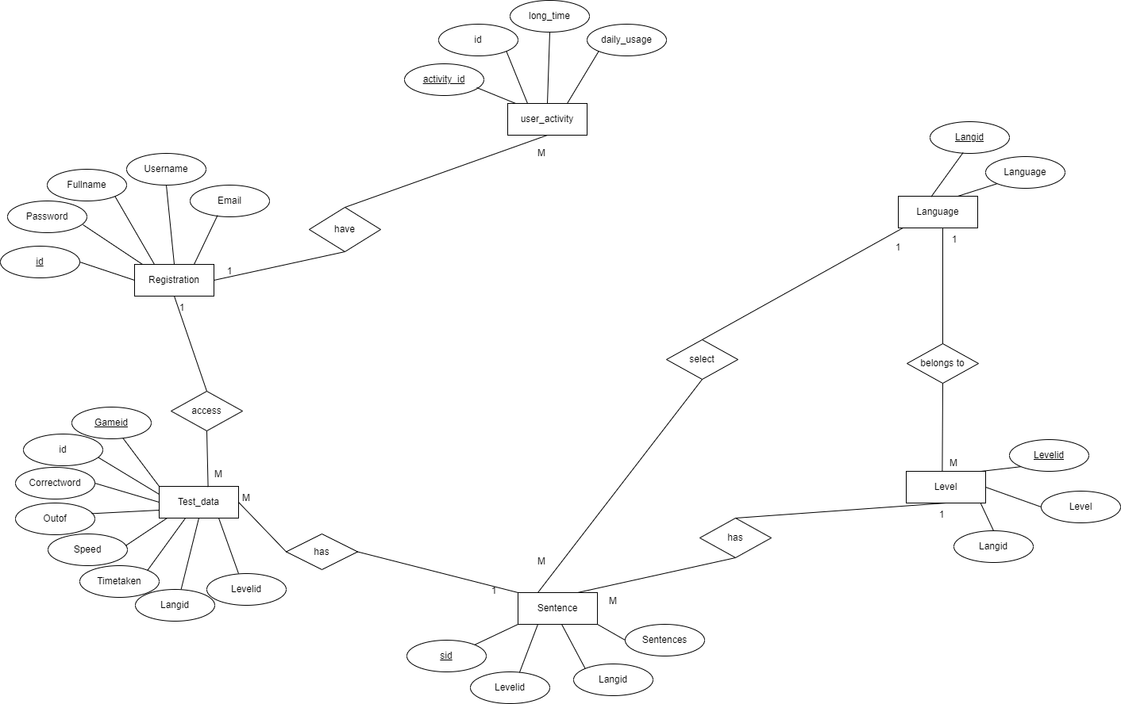

**Fig 3.3: ER-Diagram**

## 3.1.4 Process Modelling

For process modeling of Typing Speed Test, context diagram and DFD up to level 1 are as follows:

### 3.1.4.1 Context Diagram

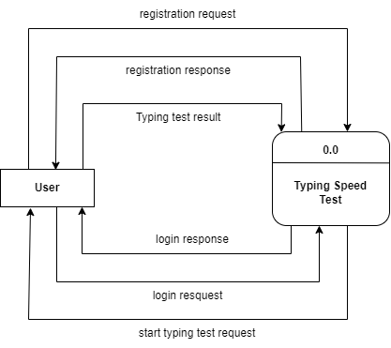

**Figure 3.4: Context Diagram of Typing Speed Test**

### 3.1.4.2 Level 1 DFD

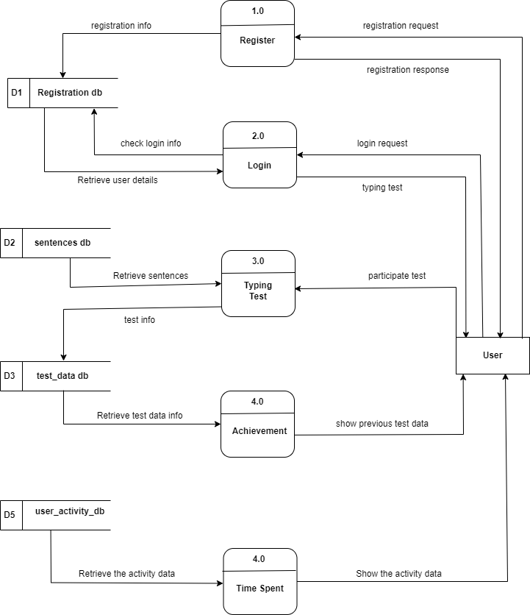

**Figure 3.5: Level 1 DFD of Typing Speed Test**

## 3.2. System design

The system design will specify the architecture and components of the typing speed test application. It will involve creating a system flow chart, which outlines the system's functional components and how they interact with each other.

### 3.2.1 Architectural design

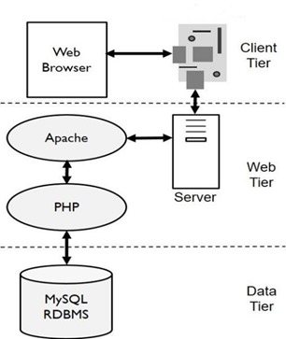

**Figure 3.7: Architectural Design**

### 3.2.2 Database Schema

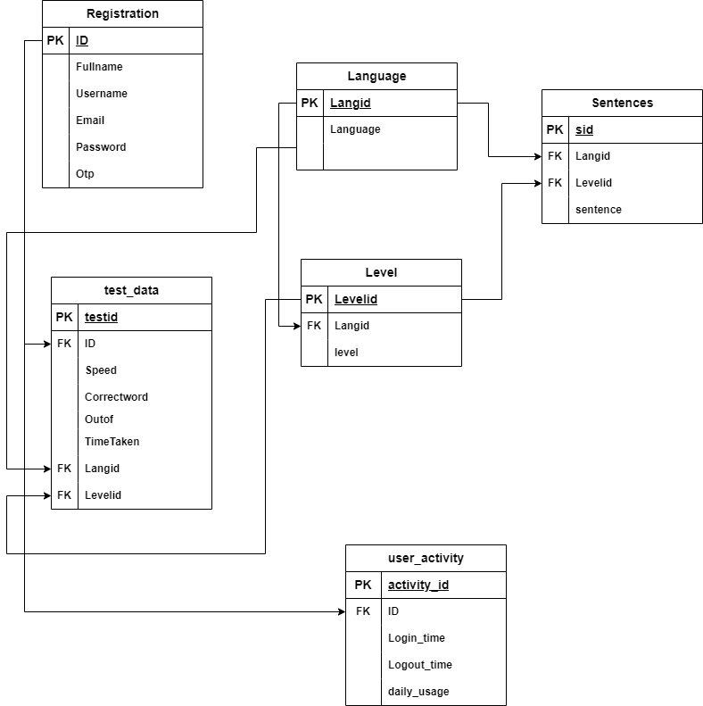

**Figure 3.8: Database Schema Design**

### 3.2.3 Interface Design (UI Interface)

The interface design for all the major pages of Typing Speed Test are shown as follows:

#### 3.2.3.1 Home Page UI

The user interface for home page of Typing Speed Test is shown below:

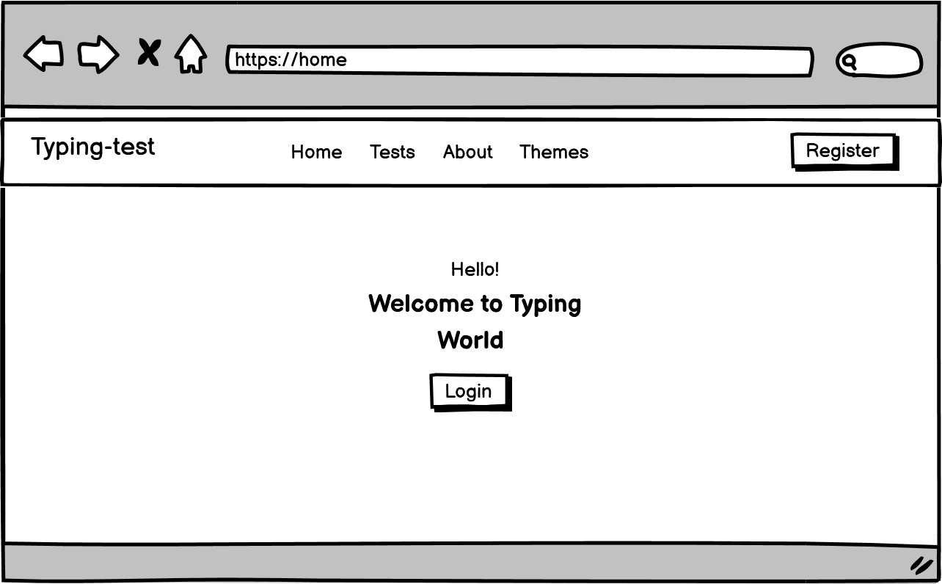

**Figure 3.9: Home page UI of Typing Speed Test**

#### 3.2.3.2 User Registration Page UI

The user interface for registration page of Typing Speed Test is shown below:

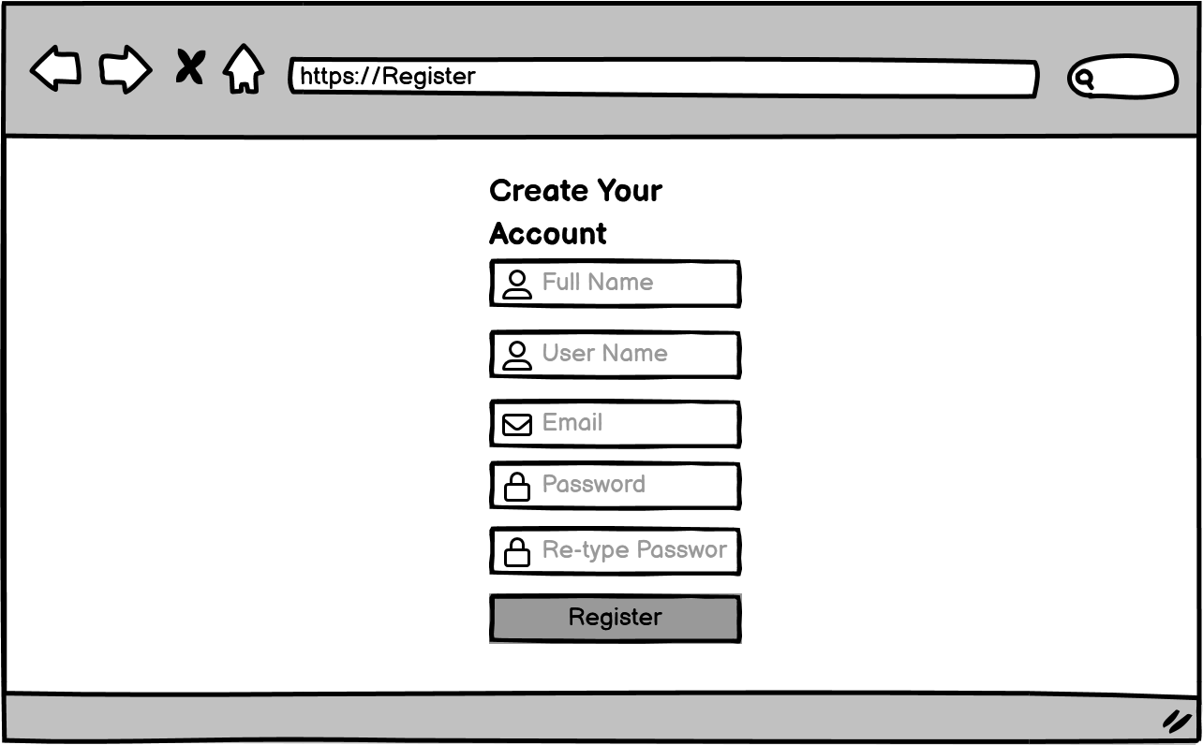

**Figure 3.10: Registration page UI of Typing Speed Test**

#### 3.2.3.3 Login Page UI

The user interface Login page of Typing Speed Test is shown:

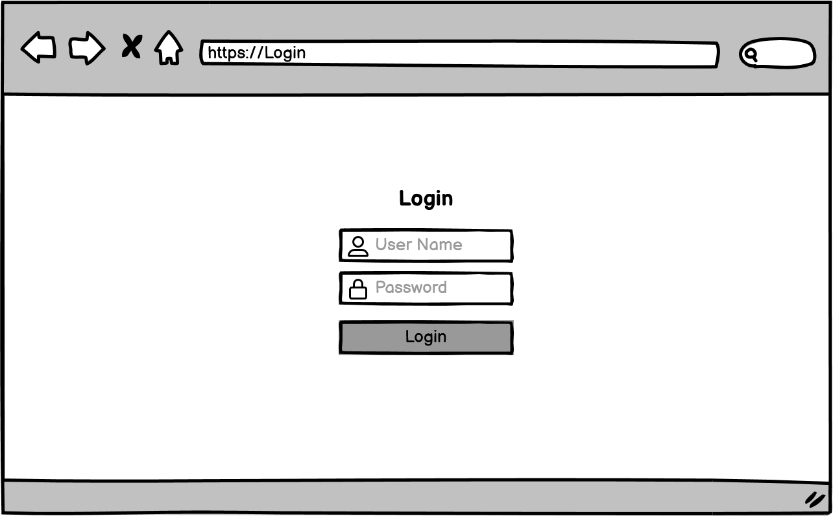

**Figure 3.11: Registration page UI of Typing Speed Test**

#### 3.2.3.4 Typing Test Page UI

The user interface for Typing Test page of Typing Speed Test is shown:

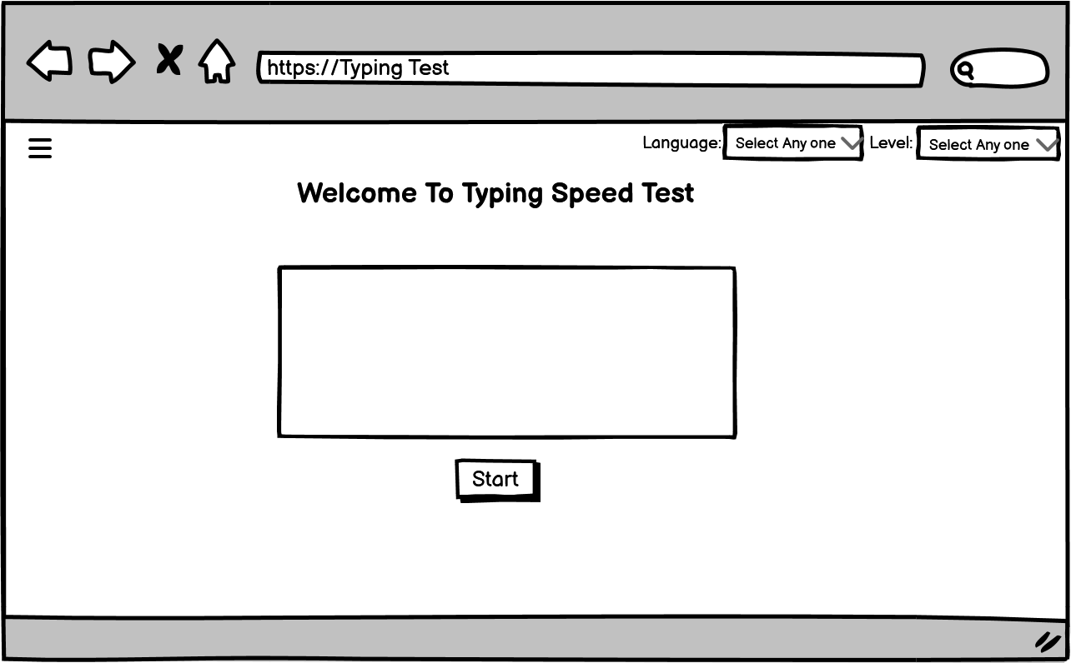

**Figure 3.12: Typing Test page UI of Typing Speed Test**

#### 3.2.3.5 Achievement Page UI

The user interface for Achievement page of Typing Speed Test is shown:

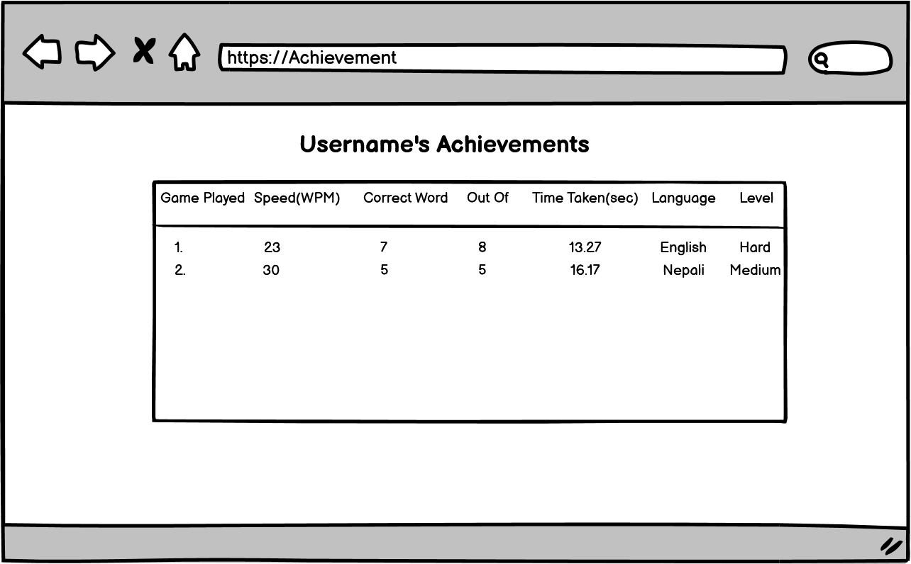

**Figure 3.13: Achievement page UI of Typing Speed Test**

# Chapter 4: Implementation and Testing

## 4.1 Implementation

In this phase working of the overall system is checked. It deals with the complete process

of building and implementing it. It focuses on the technical aspects of the system starting

with identifying the necessary components and building the relevant relationship among

subsystems for the smooth and efficient operation of the system.

### 4.1.1. Tools Used

For the implementation of the Typing Speed Test System, a selection of tools was carefully chosen to ensure efficiency and robust development. These tools include:

### Front End Tools

* **HTML 5(Hyper Text Mark-up Language):**

HTML is used to provides a structured way to organize content on a webpage

* **CSS 3(Cascading Styling Sheet):**

CSS is used for describing the presentation of a document written in a HTML. CSS3 is the latest version of CSS, and it introduces several new features and enhancements compared to its predecessors (CSS1 and CSS2).

* **JavaScript:**

It is used to manipulate the DOM allows for real-time content updates, while asynchronous programming and Ajax support enhance seamless data exchange between the browser and server.

### Back End Tools

* **PHP**

In Typing Test, PHP is used for the back-end and for making dynamic web pages. It is used for server side scripting purpose to add connectivity to the database and also used to encrypt the data, validate the user data, confirm user to go to certain pages, login pages. It also includes add, update and delete the data from the database.

**Server**

**APACHE SERVER**

In Typing Test, Apache server is used to run php files and creating fast and dynamic web pages.

**Database**

**MYSQL**

MySQL is use for storing all the information required to the database in Typing Test. It is used for performing CRUD operation such as create, delete and update data from the database as requested by the user.

**4.1.1.1 CASE Tool**

**Draw.io** - We employed draw.io, a web-based diagramming tool, as our Computer-Aided Software Engineering (CASE) tool to create flowcharts, diagrams, and visual representations of the system's architecture and design.

**Font Awesome 4.7.0**

Font Awesome 4.7.0 includes a comprehensive library of icons covering a wide range of categories, including general web-related icons, user interface elements, social media icons, and more. These icons are designed to be visually consistent and easily recognizable in Typing Test.

**VS-code**

This is used to write code of Typing Test.

### 4.1.2 Implementation details of modules

**User Interface Module:** This module is responsible for presenting the typing tests to users. It was implemented using HTML, CSS, and JavaScript to create an engaging and responsive user interface. JQuery was used for client-side interactivity.

**Backend Server Module:** The backend server module, developed in PHP, handles the core logic of the system. It manages user accounts, stores test data, calculates typing speed and accuracy, and generates reports. SQL is used to interact with the database for data retrieval and storage.

## 4.2 Testing

### 4.2.1 Unit Testing:

Unit Testing deals with the procedure of testing for the small modules of the programs.

**Table 4.2.1.1: Test Case 001 - Registration form**

|  |  |  |  |
| --- | --- | --- | --- |
| TC-001 | Description | Expected Result | Test Result |
| 1 | Enter valid form field details | Alert "Registered successfully"; redirect to login page. | Successful |
| 2 | Invalid details | Display validation error | Successful |

**Table 4.2.1.2: Test Case 002 - Login form**

|  |  |  |  |
| --- | --- | --- | --- |
| TC-002 | Description | Expected Result | Test Result |
| 1 | Enter valid email address and password | Redirect to the Typing Speed Test page | Successful |
| 2 | Invalid email and password | Display error result | Successful |

**Table 4.2.1.3: Test Case 003 – Typing Test page**

|  |  |  |  |
| --- | --- | --- | --- |
| TC-003 | Description | Expected Result | Test Result |
| 1 | Visit the page while logged in | Displays the  Typing Speed Test page with user's username | Successful |
| 2 | Visit the page while logged out | Redirects to the login page with a "You are logged out" alert | Successful |
| 3 | Click the "Start" button | Enables the text area for typing and displays a random sentence | Successful |
| 4 | Type the sentence and click "Done" | Disables the text area, calculates and displays typing speed | Successful |
| 5 | Click the "Done" button without typing | Disables the text area, displays 0 typing speed, and the time taken | Successful |
| 6 | Select a language from the dropdown | Updates the available levels in the level dropdown | Successful |
| 7 | Select a level from the dropdown | Retrieves sentences for the selected language and level | Successful |
| 8 | Enter valid typing | Calculates typing speed and displays it along with other information | Successful |

**Table 4.2.1.4: Test Case 004 – Achievement Page**

|  |  |  |  |
| --- | --- | --- | --- |
| TC-004 | Description | Expected Result | Test Result |
| 1 | Visit the page while logged in | Displays the Achievements page with the user's username. | Successful |
| 2 | Visit the page while logged out | Redirects to the login page with a "You are logged out" alert. | Successful |
| 3 | Display achievements for a logged-in user | Displays achievements in a tabular format with the user's achievement data. | Successful |
| 4 | No achievements available for the user | Displays a message indicating no achievements available. | Successful |

**Table 4.2.1.5: Test Case 005 – Time Spent Page**

|  |  |  |  |
| --- | --- | --- | --- |
| TC-005 | Description | Expected Result | Test Result |
| 1 | Visit the page while logged in | Displays the "Time Spent" page with user's time usage data chart. | Successful |
| 2 | Visit the page while logged out | Redirects to the login page with a "You are logged out" alert. | Successful |
| 3 | Load and display time usage data | Retrieves the user's daily usage data for the past week and displays it in a chart. | Successful |
| 4 | Daily usage displayed as seconds | Displays daily usage times in seconds, with a corresponding bar chart. | Successful |
| 5 | Daily usage displayed as minutes and hours | Displays daily usage times in minutes (min) and hours (hr), if the duration exceeds 60 seconds or 3600 seconds. | Successful |
| 6 | Daily usage displayed as seconds | Displays daily usage times in seconds, even when it exceeds 60 seconds but doesn't reach 3600 seconds. | Successful |
| 7 | Bars on the chart are properly sized and labeled | The bars on the chart correspond to daily usage values, and labels show the days of the week. | Successful |
| 8 | Hovering over a bar highlights it and displays usage time | Hovering over a bar in the chart changes its color, shows the usage time, and changes the cursor to a pointer. | Successful |

### 4.2.2. System Testing:

**- Table 4.2.2.1: Typing Speed Test HOME PAGE**

|  |  |  |  |  |  |
| --- | --- | --- | --- | --- | --- |
| Test Case ID | Test Scenario | Steps to Reproduce | Expected Result | Actual Result | Status |
| 1 | Load Homepage | Open URL in the browser | Homepage loaded | Homepage loaded | Pass |
| 2 | Navigation Menu | Click on each menu link | Respective page load correctly | Respective page load correctly | Pass |
| 3 | Registration Link | Click on "Registration link" | Redirect to the registration page | Redirect to the registration page | Pass |
| 4 | Login Link | Click on "Login link" | Redirect to the login page | Redirect to the login page | Pass |

**Table 4.2.2.2: TEST PAGE**

|  |  |  |  |  |  |
| --- | --- | --- | --- | --- | --- |
| Test Case ID | Test Scenario | Steps to Reproduce | Expected Result | Actual Result | Status |
| 1 | Button Behavior - Start | Click the "Start" button | Text area is enabled, random sentence appears, typing timer starts | Text area is enabled, random sentence appears, typing timer starts | Pass |
| 2 | Button Behavior - Done | Click the "Done" button | Text area is disabled, typing timer stops, final speed and accuracy displayed | Text area is disabled, typing timer stops, final speed and accuracy displayed | Pass |
| 3 | Language and Level Selection | Change language and level | Sentences change, correct keyboard layout appears, level dropdown populates correctly | Sentences change, correct keyboard layout appears, level dropdown populates correctly | Pass |
| 4 | Keyboard Interaction | Type characters in the text area | Corresponding keys on virtual keyboard are highlighted | Corresponding keys on virtual keyboard are highlighted | Pass |
| 5 | Error Handling | Type incorrect characters | Incorrect characters highlighted, error count accurate | Incorrect characters highlighted, error count accurate | Pass |
| 6 | Typing Speed Calculation | Complete typing a sentence and click "Done" | Typing speed and correct words displayed correctly | Typing speed and correct words displayed correctly | Pass |
| 7 | Timer Display | Verify timer during typing | Timer displays elapsed time correctly | Timer displays elapsed time correctly | Pass |
| 8 | Database Interaction | Simulate storing data in the database | Data correctly sent to the server for storage | Data correctly sent to the server for storage | Pass |
| 9 | Nepali Keyboard | Highlight the keys | Keys should be highlight according to the sentences. | Random keys are highlighted | Fail |

# Chapter 5: Conclusion and Future Recommendation

## 5.1 Outcome and Lesson Learnt

There have been several improvements in our programming language and writing skills as well as our time management skills while doing this project. It was difficult at the beginning because it was our first project and everything was new. Although it is our first project it turned out to match all the expectations. A lot was learned about proper time management as the project had to be submitted before the deadline along with the documentation. Although it is expectedly good, some new features to this system could be added in the upcoming days to make it more user friendly and efficient.

## 5.2 Conclusion

The Typing Speed Test System is designed and developed with the primary goal of assisting users in enhancing their typing skills. By providing a reliable and user-friendly platform, we have met this objective. However, the development process doesn't end here; there is substantial potential for further improvement and expansion.

## 5.3 Future Recommendation

1. Enhance User Interface.
2. Leaderboards and Competitions.
3. Time Slots Management:

Implement features for timed typing tests, allowing users to set their own time limits and track their progress over time.

1. Multi-Language Support:

Expanding language support would make the application more accessible to a global user base.

# APPENDIX:

## SYSTEM SCREENSHOTS

* + **System Overviews**

**Index Page**

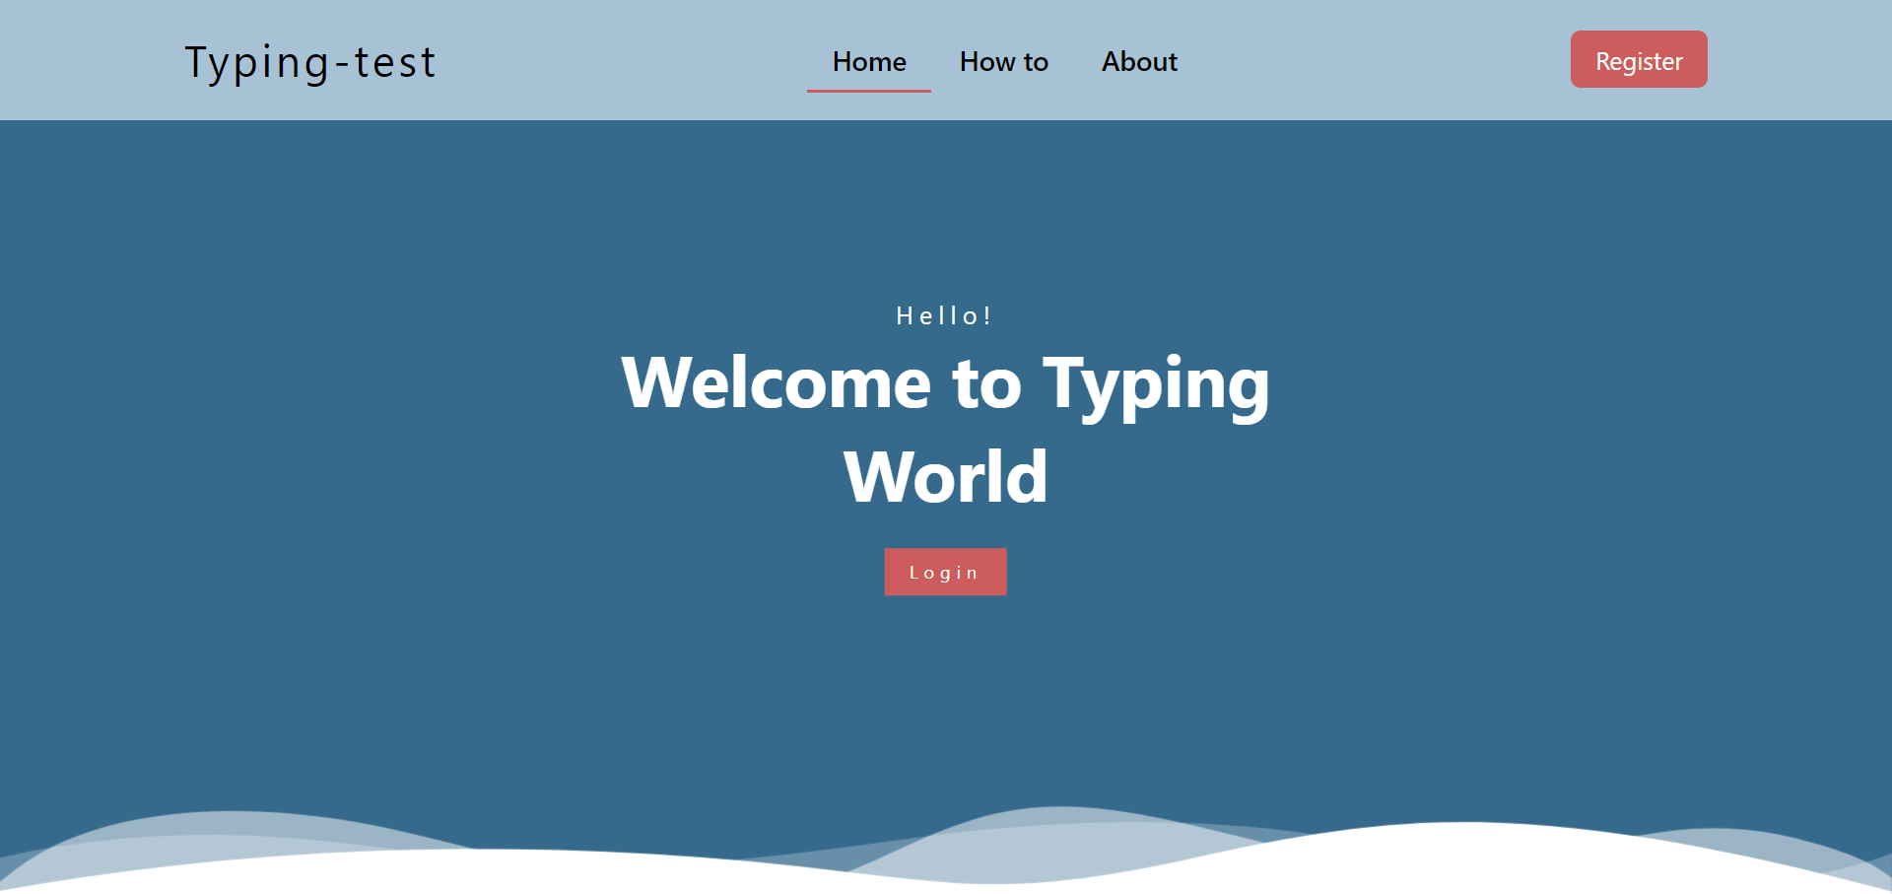

**Signup**

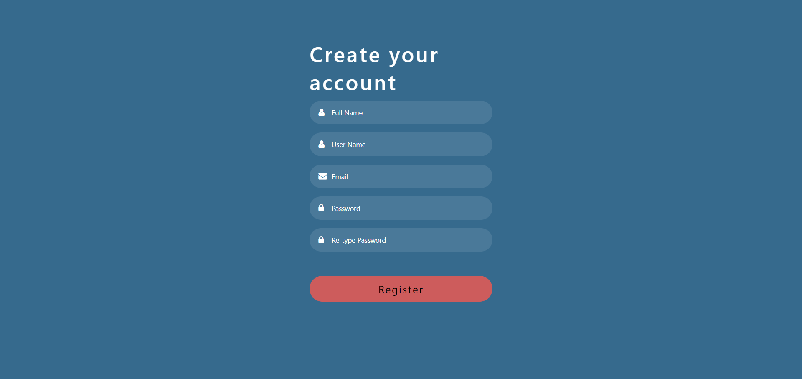

**Login**

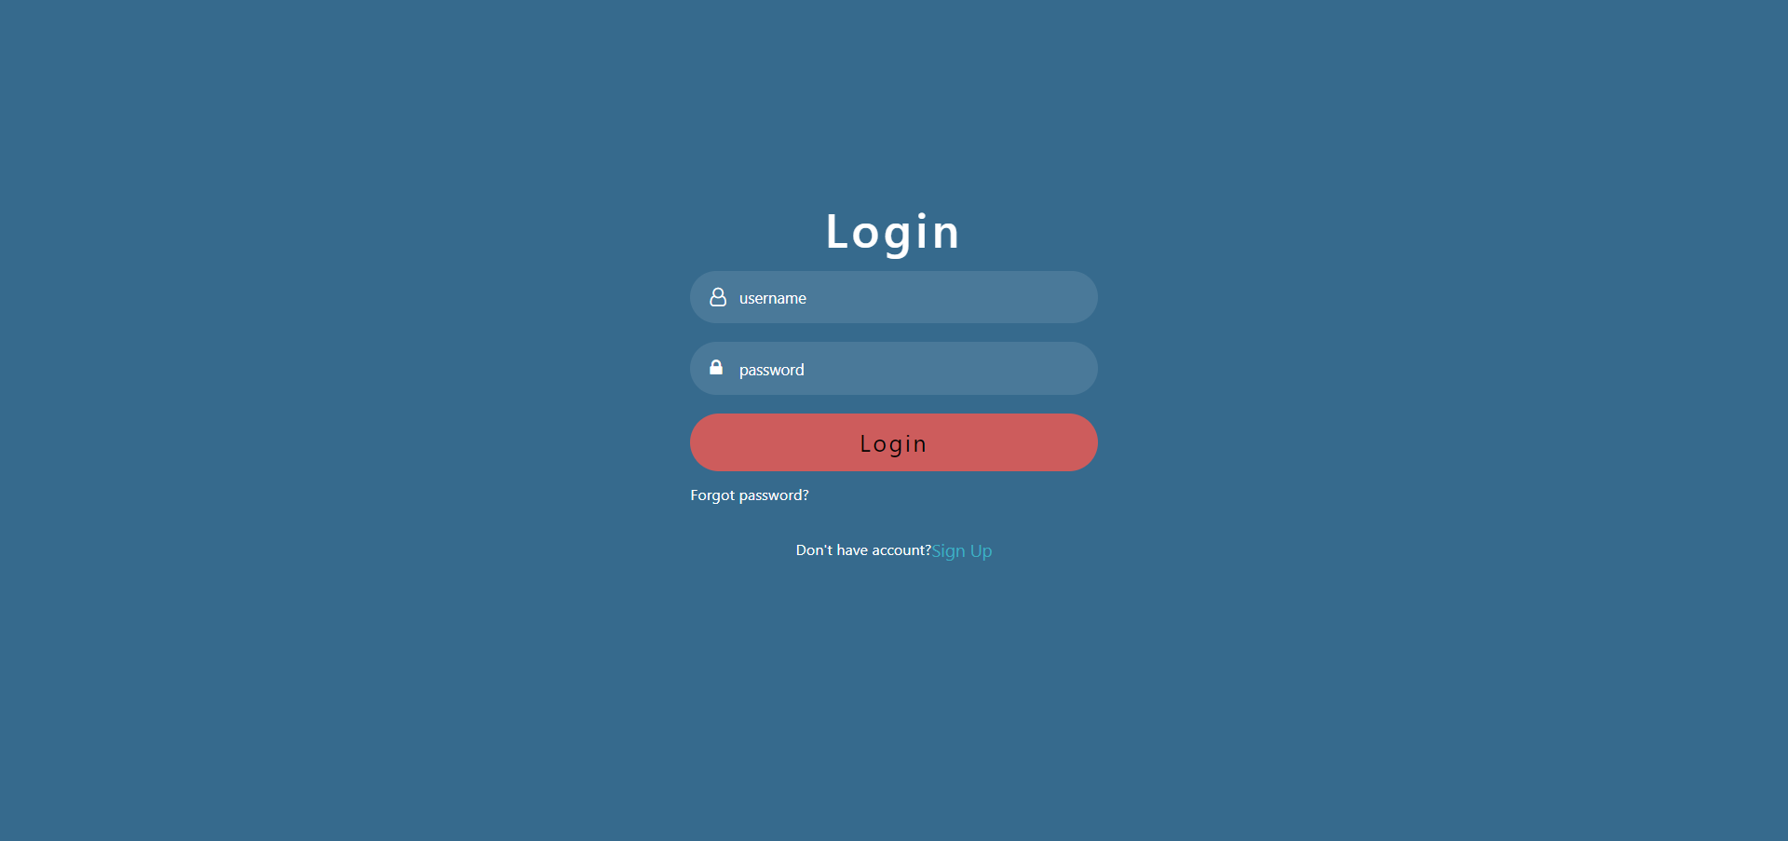

**Test Page**

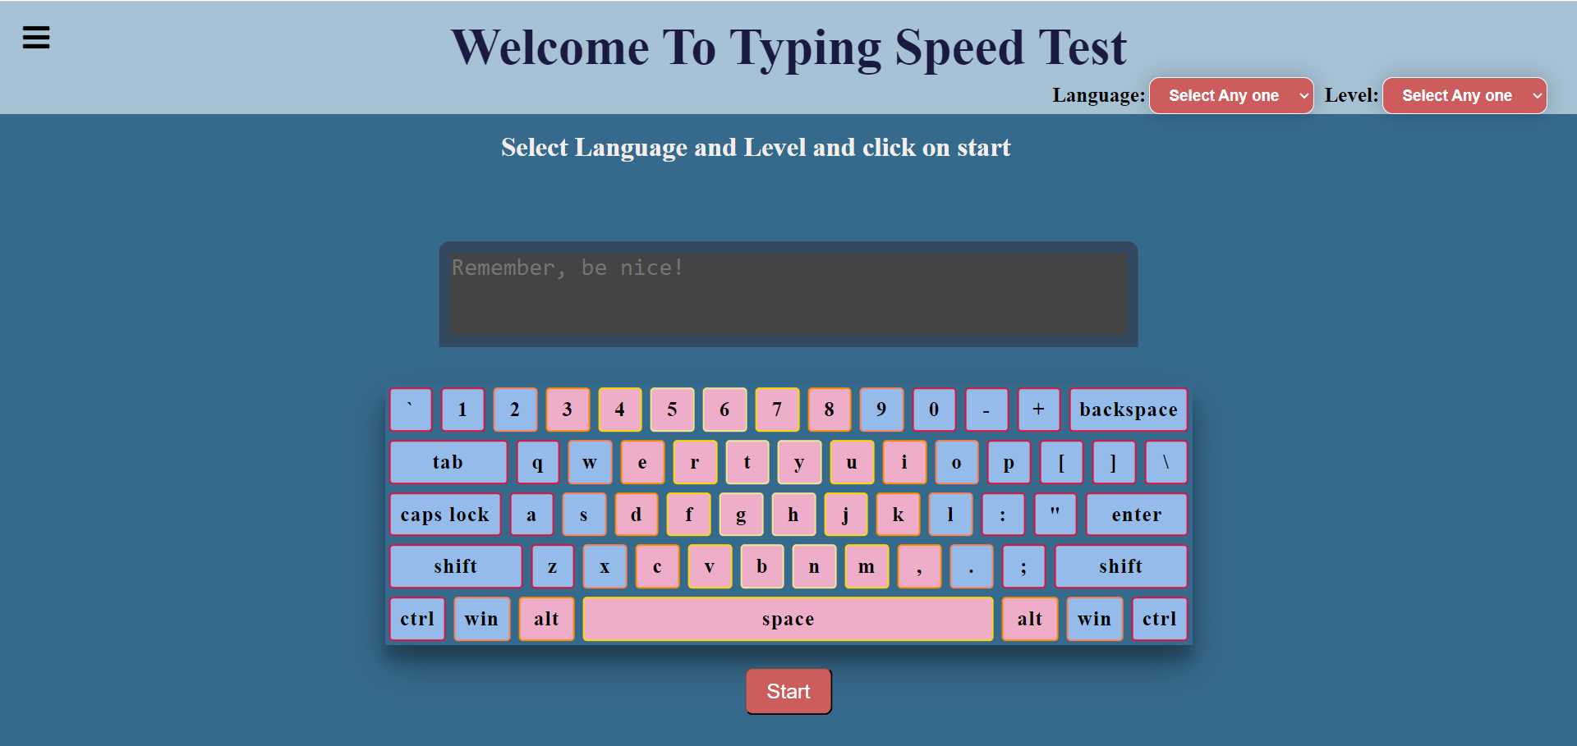

**Menu**

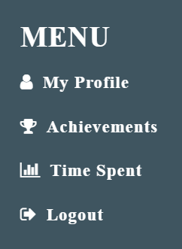

**Achievements Page**

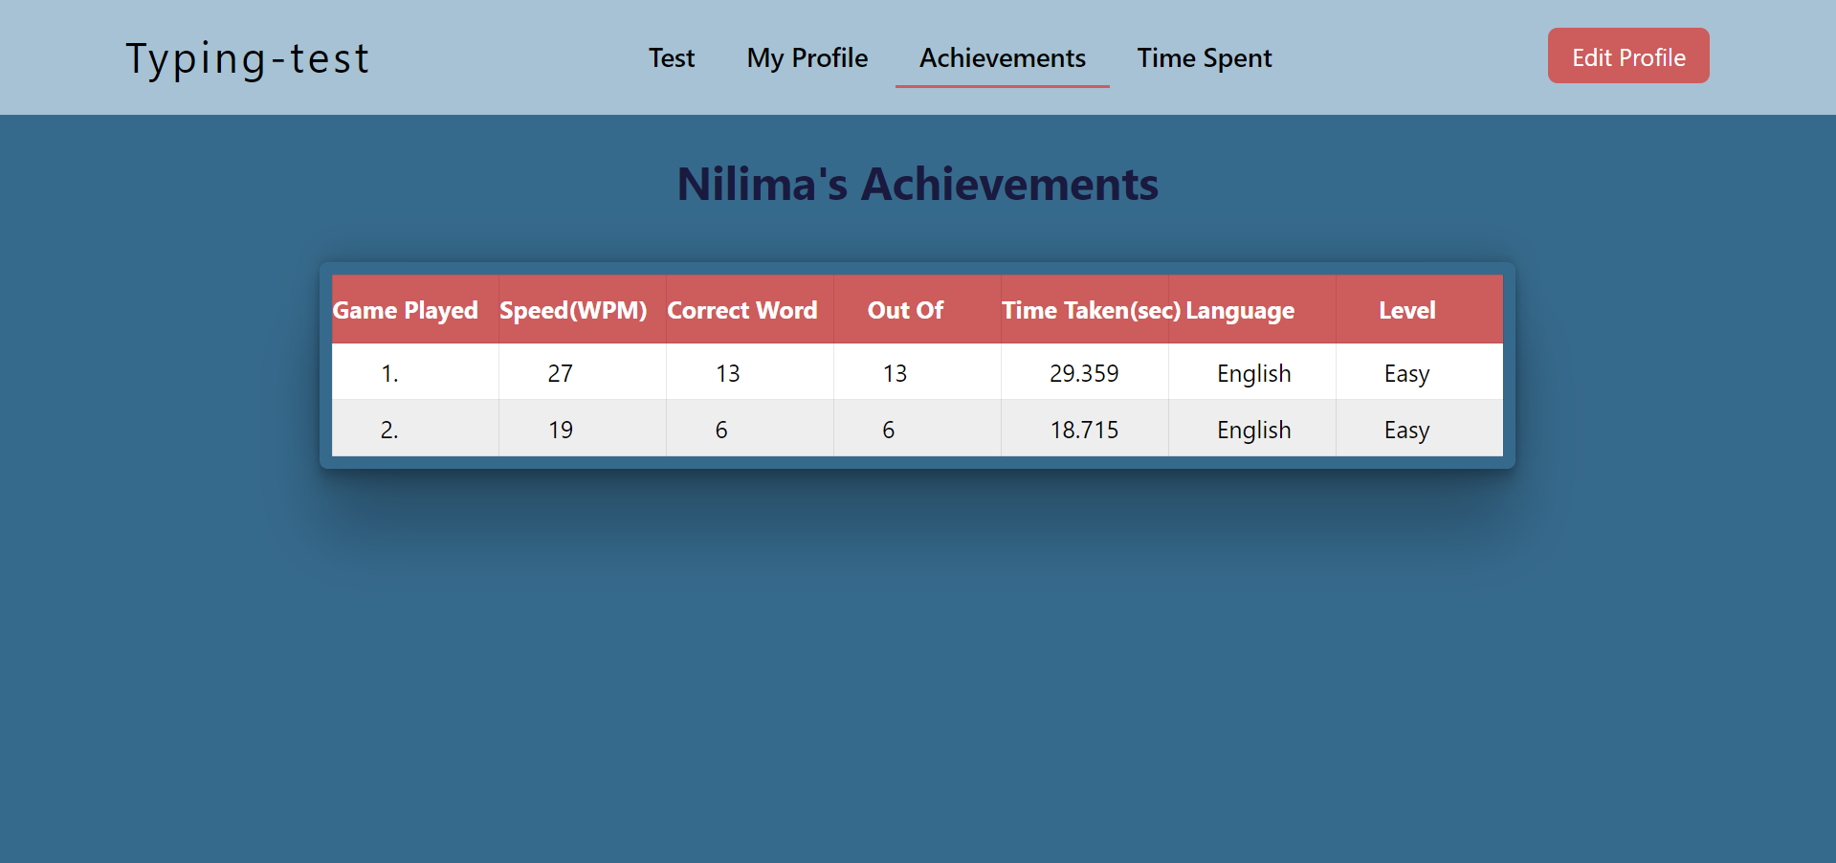

# References

[1] Allouane, Y. (2021) *Troubleshooting typing problems and what you can do about them*, *FasterCapital*. Available at: https://fastercapital.com/content/Troubleshooting-Typing-Problems-and-What-You-can-do-about-Them.html (Accessed: 15 May 2024).

[2] Butler, A. (2011) *Competitive typing game: Race your friends*, *Nitro Type*. Available at: https://www.nitrotype.com/ (Accessed: 10 May 2024).

[3] Fojut, J. (2012) *Learn how to type faster*, *Type Fu*. Available at: https://type-fu.com/ (Accessed: 10 May 2024).

[4] Brothers, M. (2018) *Typeshala: Online typeshala for nepali typing practice*, *Online Typeshala*. Available at: https://typeshala.typingkeyboards.com/ (Accessed: 10 May 2024).