Joget installation steps for Windows

1.Run the setup file joget-setup-x.x.x.exe to launch the Setup Wizard.
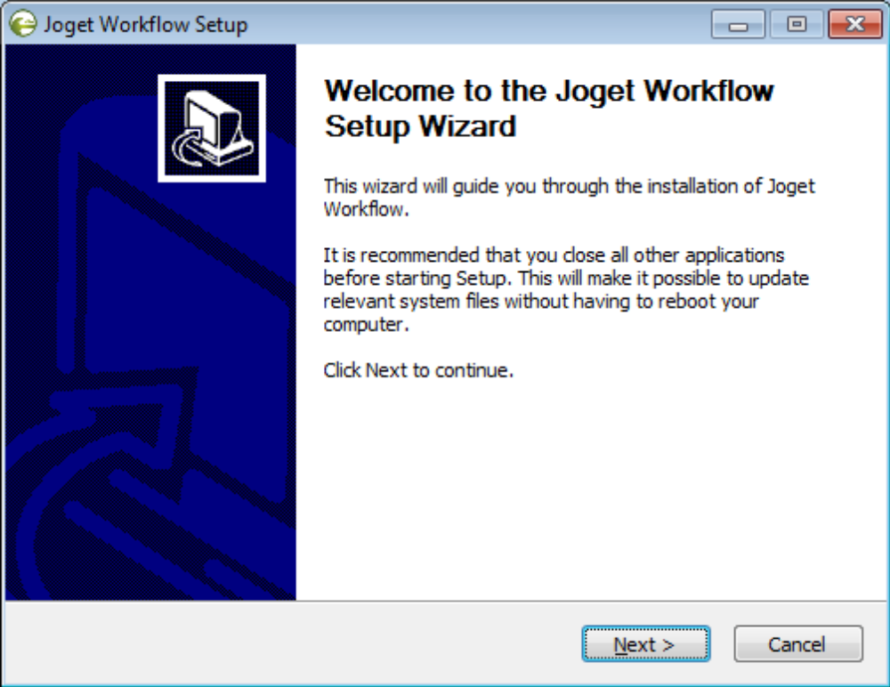

2. Click on Next on the Introduction page, I Agree on the License page, and Next on the
Components page.
3. Change the Destination folder if required, then, click on Install. Once the installation is
complete, click on Finish.
4. To start the Joget Server, go to Start Menu > Programs > Joget Workflow and click on
the green Start Joget Server icon under Joget Workflow. The startup might take some
time, so please wait until the message "INFO: Server startup in XXXX ms" appears
(XXXX represents the time taken for the startup). Do not close the command window.
5. Go to Start Menu > Programs > Joget Workflow and click on App Center. This will
launch the App Center in a web browser.
6. To stop the Joget Server, go to Start Menu > Programs > Joget Workflow and click on
T he red Stop Joget Server icon under Joget Workflow

Introducing Apps and the App Center
Introducing Apps
1. Joget Workflow apps can range from a simple database-driven app, to a complex
approval process, or even a full-fledged solution (e.g. CRM) which incorporates
workflow, data management and reporting.
2. The App Center is the default landing page in Joget v5 which displays a grid of
published apps. To access the App Center, use a web browser to access the Joget server at
http://localhost:8080/jw (Replace localhost and 8080 with the appropriate server host and
port if necessary)
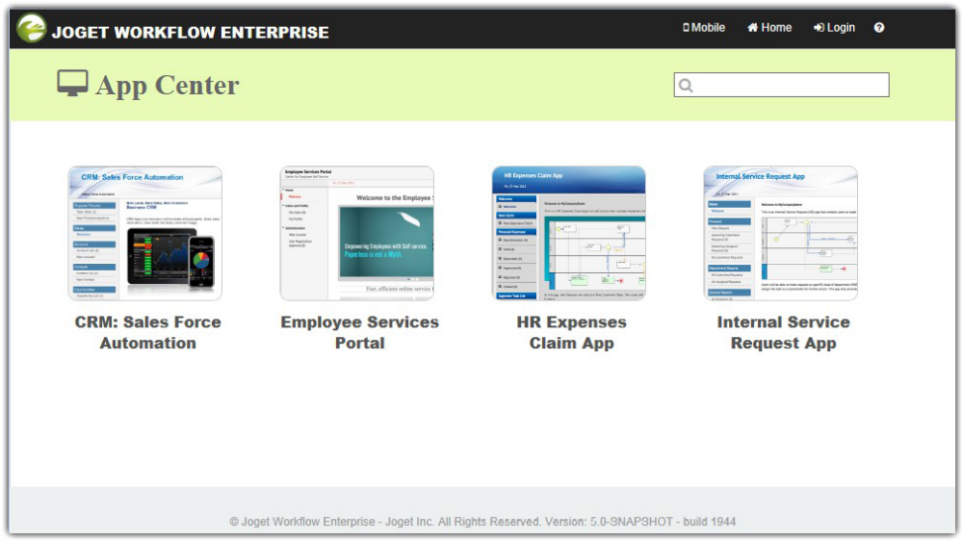
3. Click on the Login link on the top right to login as a user. Each user may have access to
different apps depending on permissions.

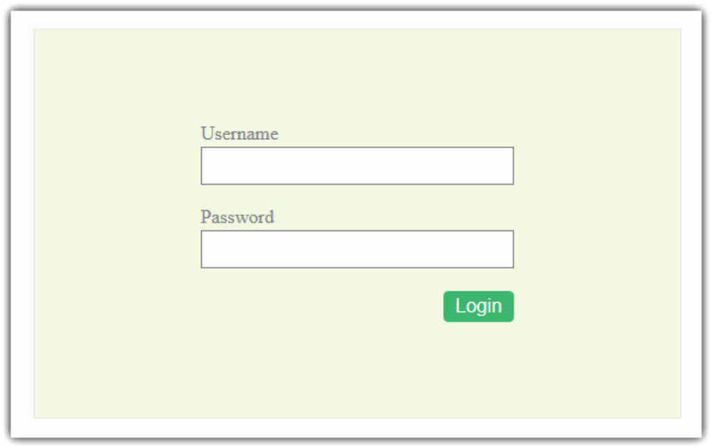
Administrator:
Username: admin
Password: admin

Designing a New App
1. In the Admin Bar, click on All Apps.
2. In the All Apps window, click on the Design New App button along the top.
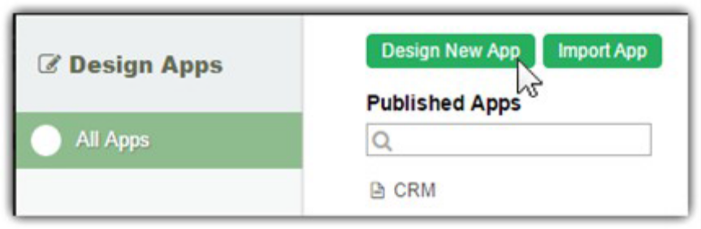
3. Key in the details of the new app.
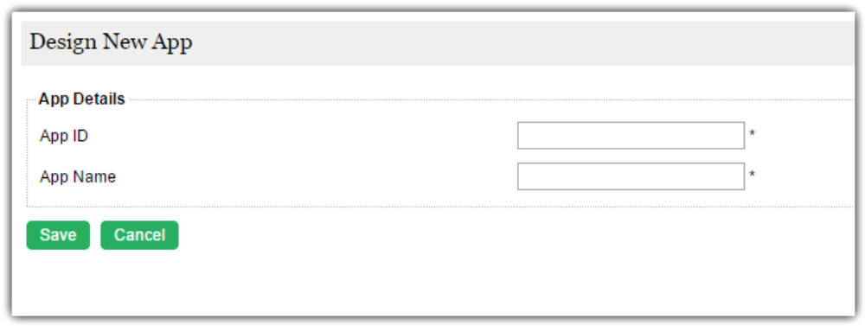
App ID: A short and unique ID for each app (no spaces) e.g. travelRequest
App Name: A descriptive name e.g. Travel Request
4. Click on Save. The app will be created and you will be brought to the App design page.

Designing a Form
1. In the App design page, click on the Create New Form button along the top.

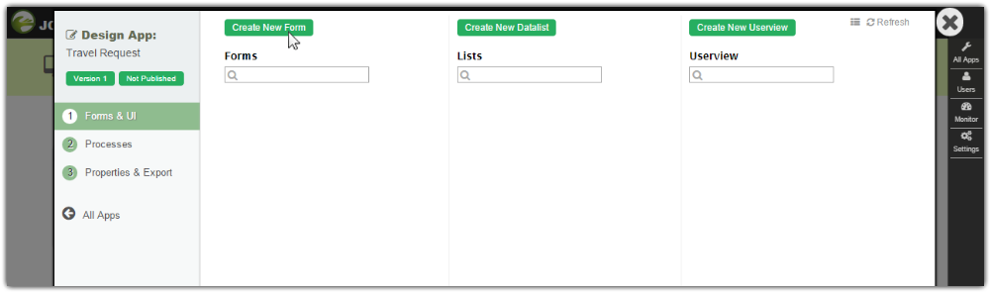

2. Key in the details of the new form.
Form ID: A short and unique ID for each form (no spaces) e.g. travelRequestForm
Form Name: A descriptive name e.g. Travel Request Form
Table Name: The database table name to store the form data e.g. travel_requests. Note
that different forms can share data by pointing to the same table name.

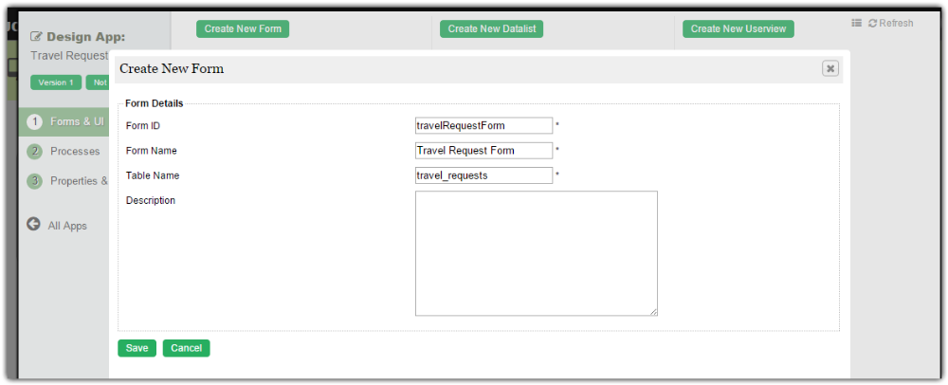
3. Click on Save to save the form and launch the Form Builder in a new window. If your
browser blocks the popup, click on the form name to launch it.
22
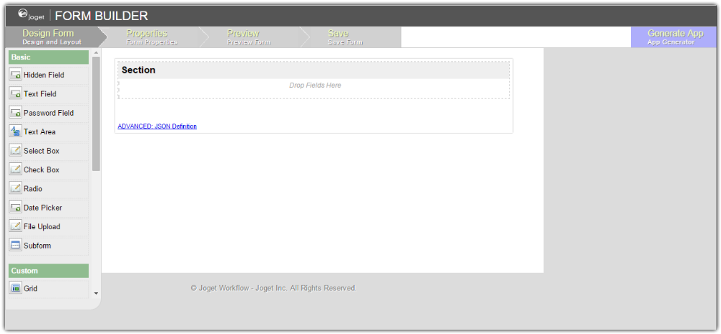
4. The first step in the Form Builder is the Design Form page. On the left is the palette
containing available form elements. In the middle is the canvas containing one or more
sections, and each section may contain one or more columns.
5. When you mouseover a section header (or any form element), buttons appear giving you
options.
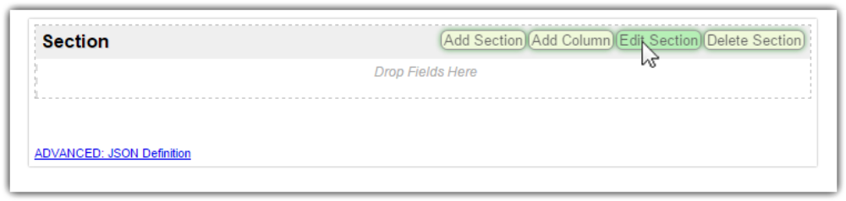
6. Click on Edit Section. This opens a Property Editor showing properties that you can
modify. Each form element has different properties that can be configured.
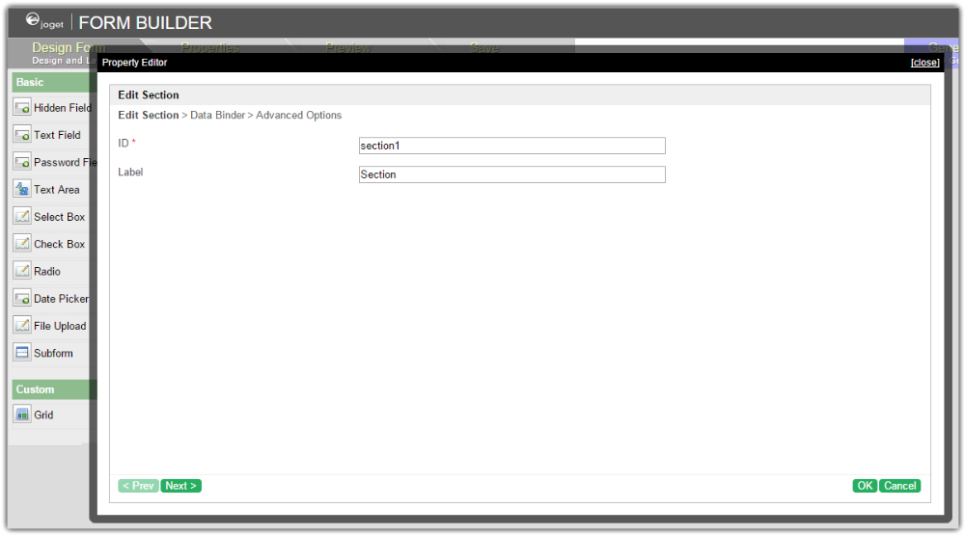
7. Click on the OK at the bottom to save the property changes.
8. You can add sections using Add Section, and move sections around by dragging.
9. Drag form elements from the palette into any section.

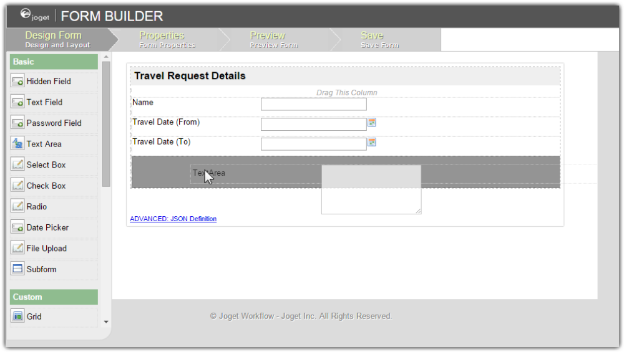
10. Hover any form element to see the Edit and Delete options. Click on Edit to modify the
form element properties.
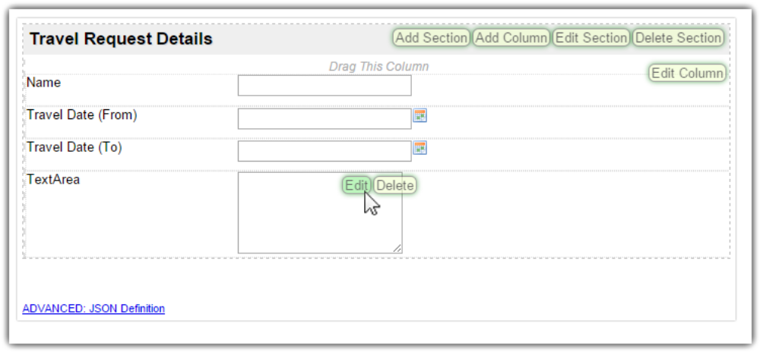
11. At any time, you may preview the form by clicking on the large Preview button at the
12. Once you have finished designing the form, click on the large Save button at the top and
you will receive confirmation that the form is saved. You may then continue to design the
form, or close the Form Builder window.

Designing a List
1. In the App design page, click on the Create New Datalist button along the top.
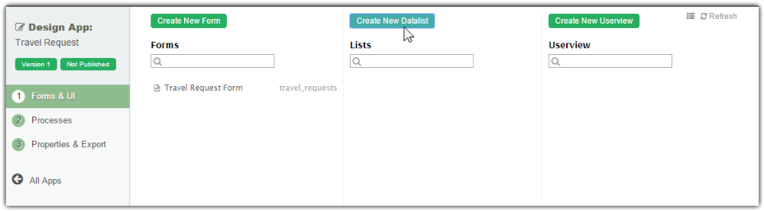
2. Key in the details of the new list.
ID: A short and unique ID for each list (no spaces) e.g. travelRequestList
Name: A descriptive name e.g. Travel Request List
Description: Optional description.
3. Click on Save to save the list and launch the List Builder in a new window. If your
browser blocks the popup, click on the list name to launch it.
4. The first step in the List Builder is the Source page. Here, you can

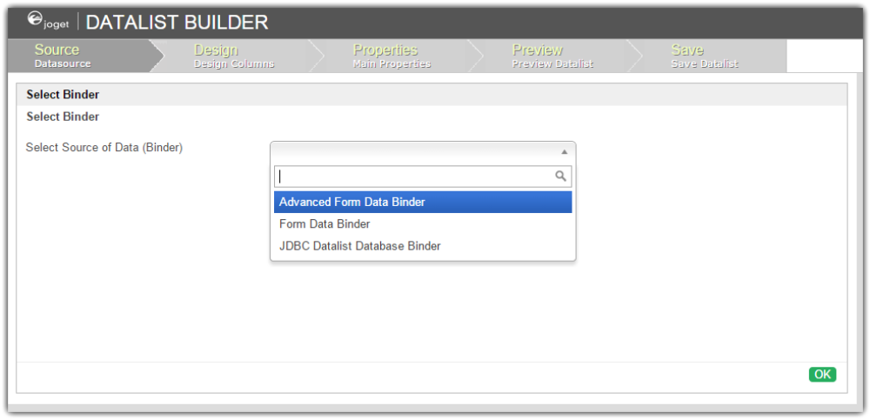
5. Select Form Data Binder. This binder populates a list based on data captured from Joget
forms. Once you select the binder, choose a form then click OK at the bottom.

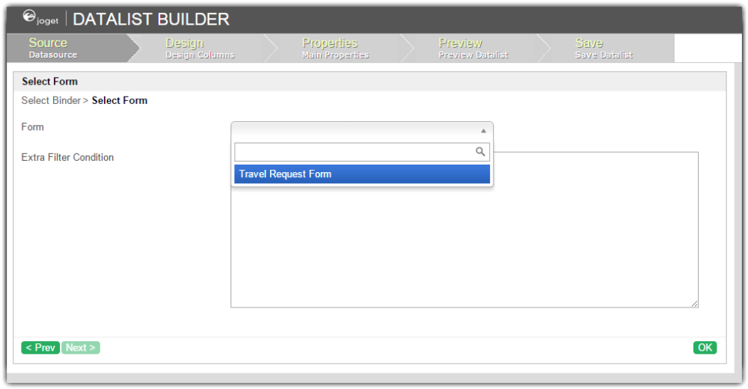
6. This brings you to the Design page. Here, all available columns provided by the binder
are listed in the palette on the left. Drag the desired columns into the canvas in the
middle.

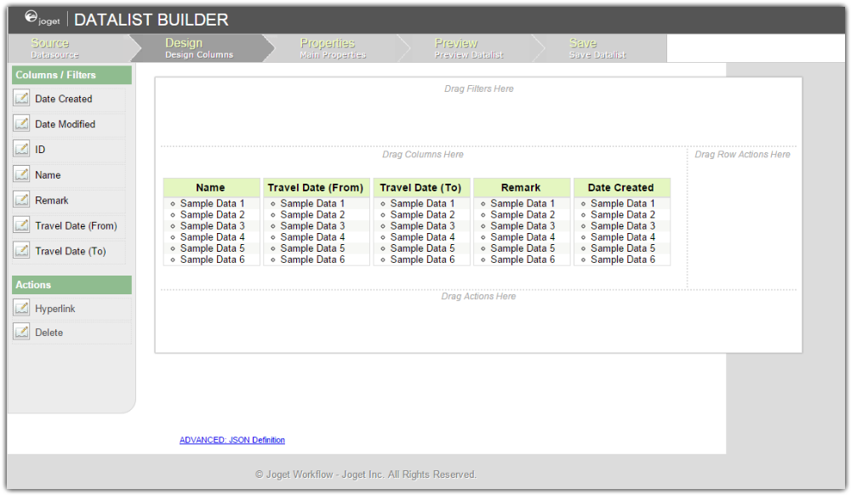
7. When you hover over a column, buttons appear giving you options to edit or delete the
column. Clicking on Properties opens a Property Editor showing properties that you can
modify.
8. At any time, you may preview the list by clicking on the large Preview button at the top.
9. Once you have finished designing the list, click on the large Save button at the top and
you will receive confirmation that the list is saved. You may then continue to design the
list, or close the List Builder window.

Designing a Userview
1. In the App design page, click on the Create New Userview button along the top.
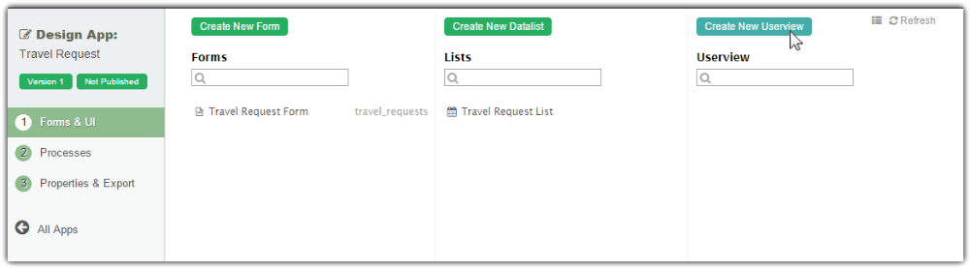
2. Key in the details of the new userview and click on the Save button.
ID: A short and unique ID for each userview (no spaces) e.g. travelPortal
Name: A descriptive name e.g. Travel Portal
Description: Optional description.

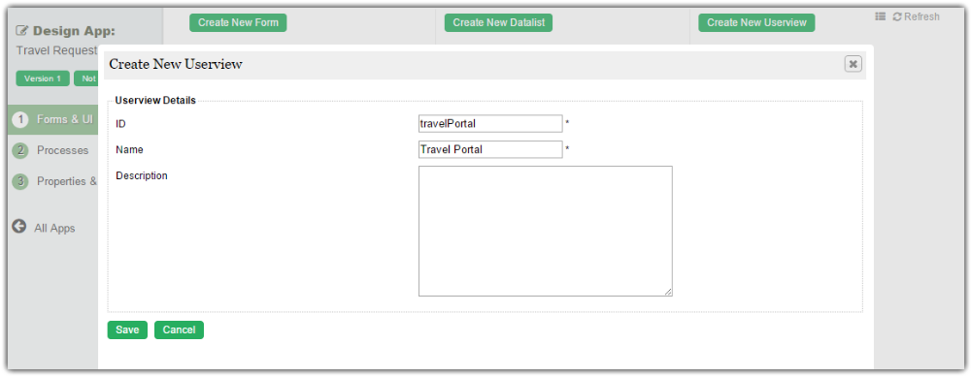

3. Click on Save to save the userview and launch the Userview Builder in a new window.
If your browser blocks the popup, click on the form name to launch it.
4. The first step in the Userview Builder is the Design Userview page. On the left is the
palette containing available menu elements. In the middle is the canvas containing the
userview header, footer and one or more menu categories.

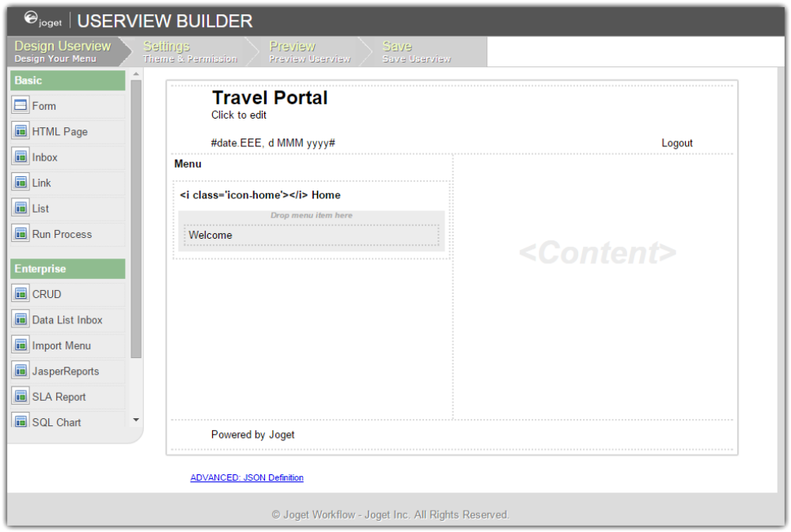
5. When you hover over the canvas Menu, a button will appear giving you the option to
Add Category.
6. You can click any category name to edit it, and drag categories up and down.
7. Drag menu elements from the palette into any category.
8. Hover over any category or menu element to see the available options.

9. Click on Properties button to modify each menu element’s properties.
10. At any time, you may preview the userview by clicking on the large Preview button at
the top.
11. Once you have finished designing the userview, click on the large Save button at the top
and you will receive confirmation that the userview is saved. You may then continue to
design the userview, or close the Userview Builder window.
12. Before a userview can be accessed by a normal user, the app needs to be published. To do
that, click on the Not Published or Versions link on the left in the App design page.

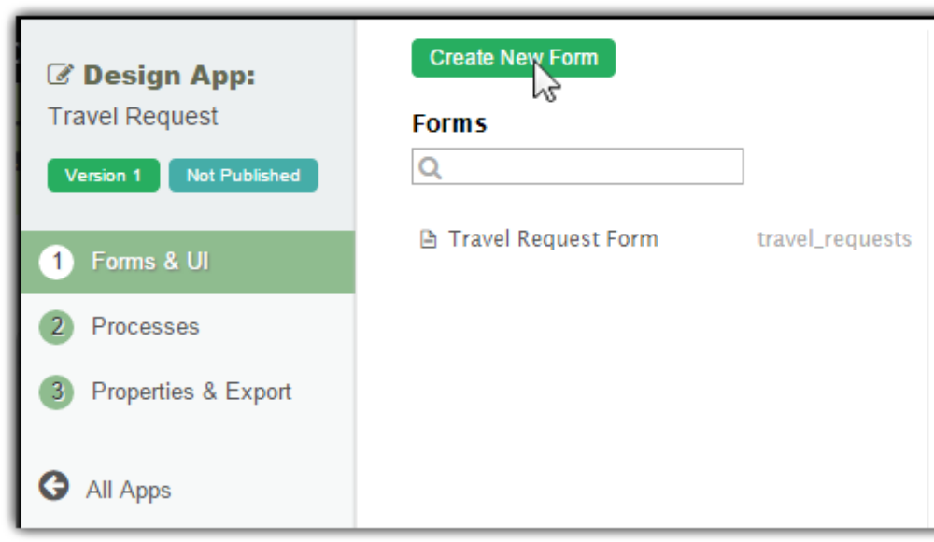
13. A popup displays all versions of the app. Select the radio button next to the latest version
and click on the Publish button. Once an app is published, its userviews will be available
in the App Center.

