A report on
Conversational AI for Supply Chain Management
by
Gudpale Nilkant [72232554B]

1. Executive Summary
This report details the design, architecture, and implementation of the Conversational AI for Supply Chain Management, a project developed to solve critical data accessibility and decision-making bottlenecks in inventory management. The system leverages a sophisticated AI agent, powered by a Retrieval-Augmented Generation (RAG) pipeline, to provide supply chain managers with instant, on-demand access to complex inventory data and key performance indicators through a natural language interface.

The core of the project is a tool-following LangChain agent that can intelligently perform tasks such as data retrieval, Economic Order Quantity (EOQ) calculation, and reorder point analysis. The entire application is encapsulated in a robust Flask API and containerized with Docker, ensuring scalability, reliability, and ease of deployment. The final result is a powerful tool that transforms a slow, manual data analysis process into an interactive dialogue, significantly reducing query times and empowering managers to make faster, more informed, data-driven decisions.

2. Introduction
2.1. Problem Statement
In a typical supply chain environment, vital inventory data is often stored in structured formats like CSV files or databases. Accessing this data and deriving actionable insights (e.g., calculating optimal order quantities) is a manual, time-consuming process that requires the intervention of a data analyst. This creates a significant bottleneck, delaying critical decisions and hindering the ability of supply chain managers to respond agilely to changing market conditions.

2.2. Project Objective & Scope
The primary objective of this project was to democratize inventory data. The goal was to build an end-to-end system that allows non-technical users to query complex datasets and receive instant, accurate answers using plain English.

The scope of the project included:
- Developing a data ingestion pipeline to process and prepare structured supply chain data.
- Building an intelligent AI agent capable of both retrieving information and performing complex calculations.
- Exposing the agent's capabilities through a clean, well-documented REST API.
- Ensuring the entire application is reproducible and easily deployable using modern DevOps practices.

3. System Architecture
The application is built on a modular, four-tiered architecture designed for scalability and maintainability. Each layer has a distinct responsibility, ensuring a clean separation of concerns. The flowchart below illustrates the journey of a user query through the system.

Data Layer (The Foundation): This layer is responsible for making the raw data intelligent. It involves ingesting the CSV data, transforming each row into a text document, generating vector embeddings using a Sentence-Transformer model, and storing them in a ChromaDB vector store. This creates a semantic knowledge base.

Agent Layer (The Brain): This is the core logic of the application. It features a LangChain agent powered by the Gemma model (via Groq). The agent uses a set of custom-built tools to understand user intent and execute specific tasks like data retrieval or calculations.

Service Layer (The Gateway): A Flask-based REST API acts as the central communication hub. It exposes a /api/query endpoint that receives user requests, orchestrates the agent's workflow, and returns the final response in a structured JSON format.

Deployment Layer (The Package): The entire application is containerized using Docker. A Dockerfile defines the environment, dependencies, and runtime instructions, ensuring the application can be deployed consistently across any platform.

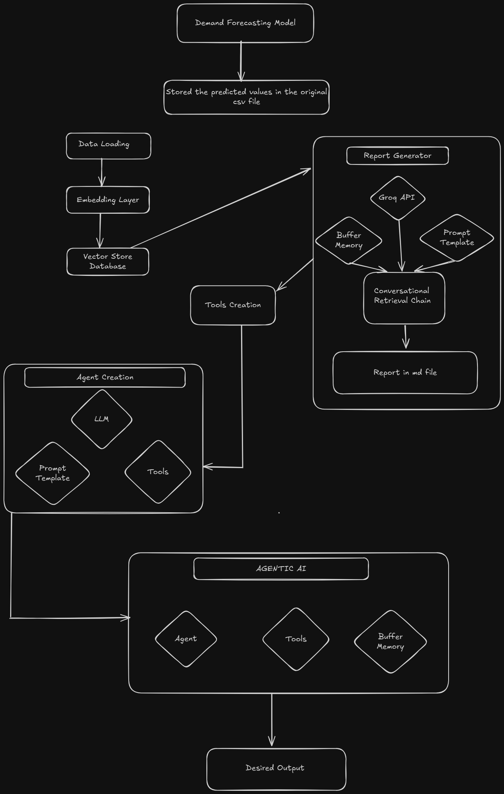
4. Core Components & Technologies
Component | Modules | Technology | Purpose
Data Ingestion | text_splitter.py | pandas | Loads and processes the initial CSV data.
Embedding Generation | Embedding.py | Langchain_community,  Sentence-transformers | Converts textual data into semantic vector embeddings.
Vector Storage | Vectorstore.py | chromadb | Creates and manages the vector database for efficient similarity searches.
Agent & Tooling | groq_model.py,  Tools2.py | Langchain,  Langchain-groq | Implements the core tool following agent, custom tools (EOQ, Reorder Point) and reasoning logic.
API Service | app.py | Flask API | Exposes the system’s functionality via RESTful API.
Deployment | Dockerfile,  requirements.txt | Docker,  Gunicorn | Packages the application into a portable container and scalable deployment.

5. Results & Business Impact
The project successfully achieved its objectives, delivering a powerful tool with significant business value.

Drastic Efficiency Gains: The time required to answer complex inventory queries was reduced from a manual process taking hours or days to an automated one taking less than 5 seconds.

Empowerment of Business Users: Supply chain managers are no longer dependent on data analysts for routine data needs. They are empowered to self-serve, leading to faster and more frequent data-driven decision-making.

Enhanced Inventory Optimization: Instant access to critical metrics like EOQ and reorder points enables managers to optimize purchasing, reduce holding costs, and minimize the risk of stockouts.

Scalable and Maintainable Asset: The modular, containerized architecture makes the application a scalable and maintainable asset. It is easy to debug, update, and extend with new tools or data sources in the future.

7. Conclusion & Future Work
The Conversational AI for Supply Chain Management project demonstrates the transformative potential of applying modern AI techniques to traditional business problems. By creating an intelligent, tool-using agent, we have successfully converted a static dataset into an interactive and dynamic resource.

Potential future enhancements for this project include:

Integration with Live Databases: Connecting the agent directly to live inventory databases (e.g., SQL) for real-time data access.

Proactive Alerting: Adding functionality for the agent to proactively monitor inventory levels and send alerts when reorder points are reached.

Multi-modal Capabilities: Allowing users to upload sales reports or charts for the agent to analyze.

Advanced Analytics: Developing more sophisticated tools for demand forecasting or supplier performance analysis.

This project serves as a strong foundation for building a comprehensive, AI-driven "co-pilot" for supply chain management.

