Project 3

FINA 6333 – Spring 2024

Team 36

# Introduction

In this analysis, we delve into several distinct investment portfolio strategies to assess their risk-return tradeoffs and overall performance across different economic scenarios. The portfolios evaluated include the traditional All-Equity and 60/40 Portfolios, alongside more specialized strategies such as Harry Browne’s Permanent Portfolio and Ray Dalio’s All Weather Portfolio, and a customized portfolio tailored to specific investor preferences. Each portfolio is examined for its growth potential, income generation, and resilience during market fluctuations.

Through a detailed assessment, we aim to determine the mean-variance efficiency of these portfolios, both historically and in the present-day context, using the principles of Modern Portfolio Theory (MPT). This comprehensive review also includes strategic recommendations for enhancing each portfolio’s performance, considering factors such as asset allocation, market trends, and investor risk tolerance. The objective is to equip investors with the insights needed to optimize their investment approaches, ensuring they are well-suited to withstand diverse financial climates and meet long-term financial goals.

# Import necessary Packages  
  
import pandas as pd  
import seaborn as sns  
import numpy as np  
import matplotlib.pyplot as plt  
import pandas_datareader as pdr  
plt.style.use('ggplot')

# Load histretSP csv file  
  
df = pd.read_csv(filepath_or_buffer='histretSP.csv', index_col='Year').fillna(0)

# 1. All-equity portfolio  
portfolios = pd.DataFrame()   
portfolios['All Equity portfolio'] = df['S&P 500']

# 2. Traditional 60/40 portfolio, which became common in 1926 and consists of the following:  
  
portfolios['Traditional 60/40'] = 0.60*df['S&P 500'] + 0.4*df['T-Bond']

# 3 Harry Browne’s permanent portfolio, which he proposed in about 1980 and consists of the following:  
# 1. 25% equity  
# 2. 25% long-term Treasury bonds  
# 3. 25% Treasury bills (i.e., cash)  
# 4. 25% gold  
  
portfolios['Harry Browne portfolio'] = df[['S&P 500', 'T-Bond','T-Bill','Gold']].sum(axis=1).div(4)

# 4. Ray Dalio’s all seasons portfolio, which he proposed in about 2014 and consists of the following:  
# 1. 30% equity  
# 2. 40% long-term Treasury bonds  
# 3. 15% intermediate Treasury bonds  
# 4. 7.5% commodities  
# 5. 7.5% gold  
  
colums = ['S&P 500', 'T-Bond','Gold']  
weights = [0.30,0.55,0.15,]  
portfolios['Ray Dalio portfolio'] = 0  
for i in range(len(weights)):  
 portfolios['Ray Dalio portfolio'] = portfolios['Ray Dalio portfolio'] + (df[colums[i]]*weights[i])

# 5. Another portfolio that build from the asset class returns using max sharpe optimization  
  
# Function to calculate portfolio performance  
def portfolio_performance(weights, mean_returns, cov_matrix):  
 returns = np.dot(mean_returns, weights)  
 std_dev = np.sqrt(np.dot(weights.T, np.dot(cov_matrix, weights)))  
 return std_dev, returns  
  
# Function to generate random portfolios  
def portfolios_simulation(iterations, mean_returns, cov_matrix, risk_free_rate):  
 assets = len(mean_returns)  
 results = np.zeros((3, iterations))  
 weights_df = np.zeros((iterations, assets))  
 for i in range(iterations):  
 weights = np.random.random(assets)  
 weights /= np.sum(weights)  
 weights_df[i] = weights  
 portfolio_std_dev, portfolio_return = portfolio_performance(weights, mean_returns, cov_matrix)  
 results[0, i] = portfolio_std_dev  
 results[1, i] = portfolio_return  
 results[2, i] = (portfolio_return - risk_free_rate) / portfolio_std_dev  
 return results, weights_df  
  
# Function to select optimal portfolios  
  
def portfolio_selection(mean_returns, cov_matrix, iterations, risk_free_rate):  
 results, weights = portfolios_simulation(iterations, mean_returns, cov_matrix, risk_free_rate)  
 max_sharpe = np.argmax(results[2])  
 max_sharpe_weights = pd.DataFrame(weights[max_sharpe], index=mean_returns.index, columns=['allocation'])  
 max_sharpe_weights['allocation'] = (max_sharpe_weights['allocation'] * 100).round(2)  
 min_vol = np.argmin(results[0])  
 min_vol_weights = pd.DataFrame(weights[min_vol], index=mean_returns.index, columns=['allocation'])  
 min_vol_weights['allocation'] = (min_vol_weights['allocation'] * 100).round(2)  
 return max_sharpe_weights,min_vol_weights  
  
# Generating Optimal portfolio  
mean_returns = df.mean()  
cov_matrix = df.cov()  
iterations = 100000  
risk_free_rate = df['T-Bond'].mean()  
  
weights1 , weights2 = portfolio_selection(mean_returns, cov_matrix, iterations, risk_free_rate)  
portfolios['own portfolio'] = np.dot(df,weights1/100)

# Plotting weights of optimal portfolio  
  
plt.figure(figsize=(10,8))  
plt.pie(weights1['allocation'],labels=df.columns.to_list(),shadow=True,autopct='%1.1f%%',startangle=180)  
plt.title('Max sharpe portfolio weights')  
plt.axis('equal')  
plt.show()

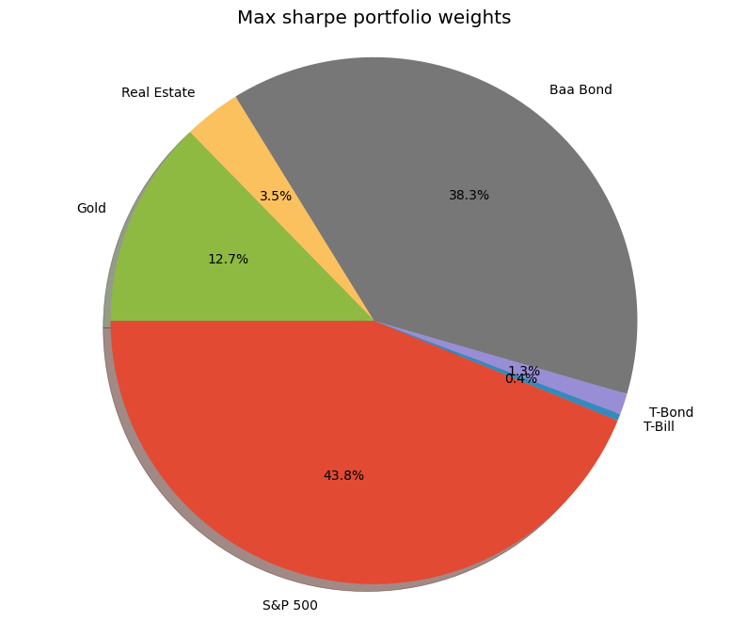

#### Weight Distribution

The pie chart shows the asset allocation of a portfolio optimized for the maximum Sharpe ratio, which is a measure of risk-adjusted return. Here’s an analysis of the weights:

* T-Bond (43.8%): High weight suggests focus on stability and income, indicating a conservative investment approach.
* Baa Bond (38.3%): Significant allocation to moderate-risk bonds implies a balance between safety and yield.
* Gold (12.7%): Reflects a defensive strategy against inflation and market volatility.
* Real Estate (3.5%): Small allocation aims to add income and growth potential while maintaining low overall risk.
* T-Bill (1.3%): Minimal weight shows a preference for liquidity and capital preservation.
* Others (0.4%): Suggests a negligible exposure to potentially higher-risk or alternative assets.

# Summary Statistic of all five portfolio  
  
summary_stat = portfolios.describe()  
rf = df['T-Bill'].mean()  
summary_stat.loc['sharpe'] = (summary_stat.iloc[1]-rf)/summary_stat.iloc[2]  
summary_stat.loc['kurtosis'] = portfolios.kurtosis()  
summary_stat.loc['skewness'] = portfolios.skew()  
summary_stat

|  | All Equity portfolio | Traditional 60/40 | Harry Browne portfolio | Ray Dalio portfolio | own portfolio |
| --- | --- | --- | --- | --- | --- |
| count | 96.000000 | 96.000000 | 96.000000 | 96.000000 | 96.000000 |
| mean | 0.116578 | 0.089382 | 0.066023 | 0.071528 | 0.088329 |
| std | 0.195508 | 0.122245 | 0.073081 | 0.078316 | 0.103993 |
| min | -0.438375 | -0.273261 | -0.153678 | -0.171664 | -0.277241 |
| 25% | -0.011935 | 0.010629 | 0.019806 | 0.020378 | 0.024126 |
| 50% | 0.145211 | 0.109187 | 0.061195 | 0.069289 | 0.104128 |
| 75% | 0.259666 | 0.168961 | 0.112247 | 0.119626 | 0.158541 |
| max | 0.525633 | 0.328539 | 0.389483 | 0.265171 | 0.302160 |
| sharpe | 0.425527 | 0.458073 | 0.446601 | 0.487036 | 0.528348 |
| kurtosis | 0.045841 | 0.080462 | 3.512914 | 1.025759 | 0.944296 |
| skewness | -0.437842 | -0.406241 | 0.608008 | -0.130753 | -0.704804 |

# Function to plot efficient frontier  
  
def efficient_frontiers(mean_returns, cov_matrix, iterations, risk_free_rate):  
 results, _ = portfolios_simulation(iterations, mean_returns, cov_matrix, risk_free_rate)  
  
 max_sharpe = np.argmax(results[2])  
 sigma_S, ret_S = results[0][max_sharpe], results[1][max_sharpe]  
 r = results[1,np.argmax(results[2])]  
  
 min_vol = np.argmin(results[0])  
 sigma_min, ret_min = results[0][min_vol], results[1][min_vol]  
  
 cml_x = np.linspace(0,max(results[0]), num=100)  
 cml_y = risk_free_rate + (r-risk_free_rate) / sigma_S * cml_x  
 plt.scatter(results[0], results[1], c=results[2], cmap='magma', marker='o')  
 plt.colorbar(label='Sharpe ratio')  
 plt.scatter(sigma_S, ret_S, marker='*', color='r', s=500, label='Maximum Sharpe ratio')  
 plt.scatter(sigma_min, ret_min, marker='*', color='g', s=500, label='Minimum volatility')  
 plt.plot(cml_x,cml_y,label = 'Capital market line')  
 plt.title('Simulated Portfolio Optimization based on Efficient Frontier')  
 plt.xlabel('Annual Volatility')  
 plt.ylabel('Annual Returns')  
 plt.legend(labelspacing=0.8)

### All-Equity Portfolio - Pros, Cons and Suggestion for Improvements

#### Pros:

1. High potential for growth and capital appreciation.
2. Benefits from economic expansions and market upswings

#### Cons:

1. High volatility, with substantial risk during market downturns.
2. Requires a high risk tolerance due to potential for large losses.

#### Suggestions for Improvement

##### Risk Management:

* + Incorporate derivatives for downside protection.

##### Sector Diversification:

* + Spread investments across different sectors to mitigate sector-specific risks.

# efficiency and role of assets in Traditional 60/40 portfolio  
  
data_trditional = df[['S&P 500','T-Bond']]  
mean_returns = data_trditional.mean()  
cov_matrix = data_trditional.cov()  
iterations = 100000  
risk_free_rate = df['T-Bond'].mean()  
  
weights1 , weights2 = portfolio_selection(mean_returns, cov_matrix, iterations, risk_free_rate)  
weights = pd.DataFrame(weights1).rename(columns={'allocation':'Max sharpe'})  
weights['Min volatility'] = weights2  
print(weights)

Max sharpe Min volatility  
S&P 500 100.0 13.61  
T-Bond 0.0 86.39

#### Comment:

* The optimization process for the Traditional 60/40 portfolio yields two contrasting allocations: the Max Sharpe ratio portfolio directs a full 100% into S&P 500 stocks for maximum risk-adjusted returns, completely forgoing T-Bonds, while the Min Volatility portfolio takes a conservative approach, allocating only 13.61% to S&P 500 stocks and 86.39% to T-Bonds, prioritizing stability over returns. This stark divergence in allocation underscores the inherent trade-off between pursuing higher returns and maintaining lower risk in portfolio construction.

plt.figure(figsize=(10,8))  
efficient_frontiers(mean_returns, cov_matrix, iterations, risk_free_rate)  
plt.scatter(summary_stat.loc['std','Traditional 60/40' ],summary_stat.loc['mean', 'Traditional 60/40'],color = 'blue',marker='*',s=500,label = 'Traditional 60/40')  
plt.title('Traditional 60/40' + ' Optimization based on Efficient Frontier')  
plt.legend()  
plt.show()

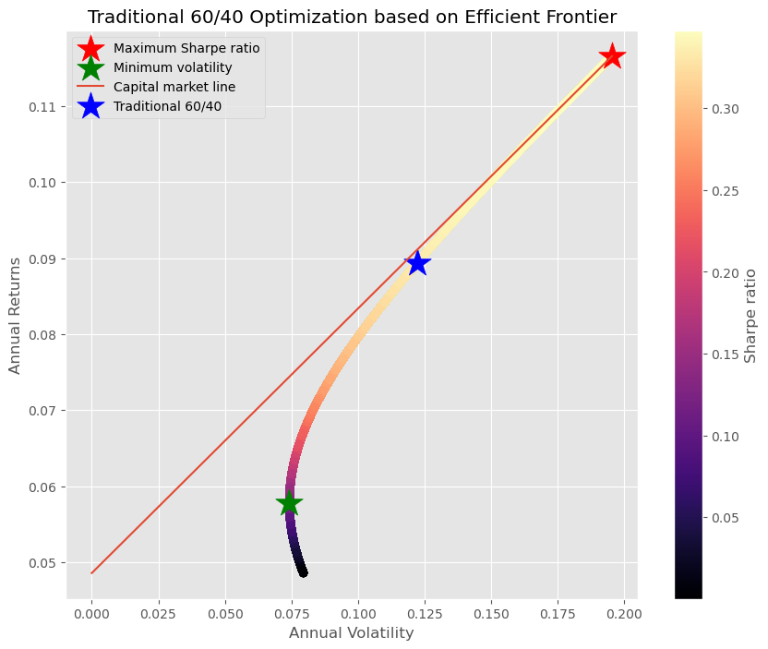

#### Comment:

* The plot illustrates an Efficient Frontier, mapping the expected return against the volatility of various portfolio combinations. The Maximum Sharpe Ratio portfolio, marked with a red star, indicates the most favorable risk-adjusted return. In contrast, the portfolio with the Minimum Volatility is denoted by a green star, signifying the lowest risk option available. The Traditional 60/40 portfolio, marked by a blue star, is shown to be less efficient, as it does not lie on the Efficient Frontier. The Capital Market Line, drawn in red, touches the Efficient Frontier at the Maximum Sharpe Ratio, representing the ideal combination of risk-free and risky assets. The color gradient across the frontier likely indicates varying levels of the Sharpe Ratio, with warmer colors suggesting higher values.

### Traditional 60/40 Portfolio - Pros, Cons and Suggestion for Improvements

#### Pros:

1. Provides a balanced approach with reduced volatility through bond holdings.
2. Offers a mix of growth (from equities) and income (from bonds).

#### Cons:

1. Potential underperformance in strong bull markets due to bond allocation.
2. Susceptible to interest rate risks, which can affect the bond portion negatively.

#### Suggestions for Improvement

##### Dynamic Allocation:

* + Adjust the ratio based on market conditions to optimize returns.

##### Quality Focus:

* + Invest in high-quality bonds and blue-chip stocks to enhance stability.

# efficiency and role of assets in Harry Browne’s portfolio  
  
data_harry_browne = df[['S&P 500', 'T-Bond','T-Bill','Gold']]  
mean_returns = data_harry_browne.mean()  
cov_matrix = data_harry_browne.cov()  
iterations = 100000  
risk_free_rate = df['T-Bond'].mean()  
weights1 , weights2 = portfolio_selection(mean_returns, cov_matrix, iterations, risk_free_rate)  
weights = pd.DataFrame(weights1).rename(columns={'allocation':'Max sharpe'})  
weights['Min volatility'] = weights2  
print(weights)

Max sharpe Min volatility  
S&P 500 73.85 3.88  
T-Bond 4.99 5.33  
T-Bill 0.11 90.36  
Gold 21.06 0.43

#### Comment:

* In the optimization for Harry Browne’s portfolio, the Max Sharpe ratio strategy suggests an aggressive stance with 73.85% allocated to S&P 500 stocks and 21.06% to gold, with minimal weightings in T-Bonds and T-Bills, at 4.99% and 0% respectively. This implies an expectation of higher risk-adjusted returns from equities and gold. Conversely, the Min Volatility strategy is extremely conservative, heavily favoring T-Bills at 90.36%, with only modest allocations to S&P 500 stocks, T-Bonds, and gold. This conservative mix is designed to minimize portfolio fluctuations rather than maximize returns, reflecting a strategy that prioritizes stability in uncertain market conditions.

plt.figure(figsize=(20,8))  
  
data_1 = df[['S&P 500', 'T-Bond','T-Bill','Gold']].loc[1928:1980]  
mean_1 = data_1.mean()  
cov_1 = data_1.cov()  
port_ret = portfolios['Harry Browne portfolio'].loc[1928:1980]  
  
plt.subplot(121)  
efficient_frontiers(mean_1, cov_1, iterations, risk_free_rate)  
plt.scatter(port_ret.mean(),port_ret.std(),color = 'blue',marker='*',s=500,label = 'Harry Browne portfolio')  
plt.title('Harry Browne portfolio' + ' proposed 1980')  
plt.legend()  
  
  
plt.subplot(122)  
efficient_frontiers(mean_returns, cov_matrix, iterations, risk_free_rate)  
plt.scatter(summary_stat.loc['std','Harry Browne portfolio' ],summary_stat.loc['mean', 'Harry Browne portfolio'],color = 'blue',marker='*',s=500,label = 'Harry Browne portfolio')  
plt.title('Harry Browne portfolio' + ' Now')  
plt.legend()  
plt.show()

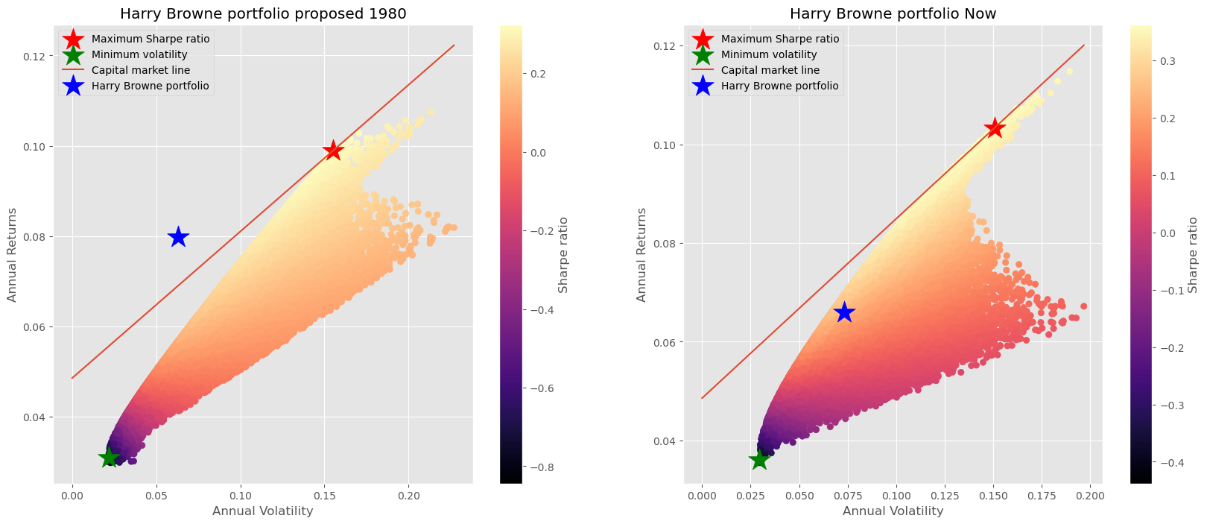

#### Comment:

* The side-by-side plots display the Efficient Frontier for Harry Browne’s portfolio during two different periods: its inception around 1980 and the present day. The Maximum Sharpe Ratio and Minimum Volatility portfolios are indicated in both scenarios, showing how their locations have shifted over time. The traditional Harry Browne portfolio, marked by a blue star, has moved in relation to the frontier, indicating changes in its relative efficiency. The Capital Market Line demonstrates the ideal performance given a risk-free rate, and the color gradient, likely representing the Sharpe Ratio, shows how the risk-adjusted return varies across different portfolios. The changes between the two periods may reflect shifts in market dynamics, underlying asset correlations, and volatility, highlighting the importance of periodically reviewing and adjusting portfolio strategies to maintain efficiency.

### Harry Browne’s Permanent Portfolio - Pros, Cons and Suggestion for Improvements

#### Pros:

1. Designed to perform reliably across various economic conditions.
2. Provides stability and simplicity in asset management.

#### Cons:

1. Can underperform during strong economic growth phases.
2. The conservative structure may limit potential returns.

#### Suggestions for Improvement

##### Tactical Adjustments:

* + Slightly increase stock or gold allocation during expected growth or inflationary periods.

##### Efficiency Enhancement:

* + Use ETFs for better liquidity and lower costs in gold and bond investments.

# efficiency and role of assets in Ray Dalio’s all seasons portfolio  
  
data_ray_dalio = df[['S&P 500', 'T-Bond','Gold']]  
mean_returns = data_ray_dalio.mean()  
cov_matrix = data_ray_dalio.cov()  
iterations = 100000  
risk_free_rate = df['T-Bond'].mean()  
weights1 , weights2 = portfolio_selection(mean_returns, cov_matrix, iterations, risk_free_rate)  
weights = pd.DataFrame(weights1).rename(columns={'allocation':'Max sharpe'})  
weights['Min volatility'] = weights2  
print(weights)

Max sharpe Min volatility  
S&P 500 77.21 12.96  
T-Bond 0.03 74.68  
Gold 22.75 12.37

#### Comment:

* The weights displayed represent two portfolio strategies: one for maximizing the Sharpe ratio and the other for minimizing volatility. For the Max Sharpe ratio, the portfolio heavily favors S&P 500 stocks (77.21%), followed by a substantial allocation to gold (22.75%), with a negligible weight in T-Bonds (0.03%). This suggests a preference for growth and inflation hedging over income and indicates a bullish outlook on equities and gold. On the other hand, the Min Volatility strategy is dominated by T-Bonds (74.68%), with only modest exposures to S&P 500 stocks (12.96%) and gold (12.37%), reflecting a defensive posture that prioritizes stability and reduced risk. These allocations demonstrate a strategic balance between seeking higher returns and mitigating risks based on different investment objectives.

plt.figure(figsize=(20,8))  
  
data_1 = df[['S&P 500', 'T-Bond','Gold']].loc[1928:2014]  
mean_1 = data_1.mean()  
cov_1 = data_1.cov()  
port_ret = portfolios['Ray Dalio portfolio'].loc[1928:2014]  
  
plt.subplot(121)  
efficient_frontiers(mean_1, cov_1, iterations, risk_free_rate)  
plt.scatter(port_ret.mean(),port_ret.std(),color = 'blue',marker='*',s=500,label = 'Harry Browne portfolio')  
plt.title('Harry Browne portfolio' + ' proposed 2014')  
plt.legend()  
  
plt.subplot(122)  
efficient_frontiers(mean_returns, cov_matrix, iterations, risk_free_rate)  
plt.scatter(summary_stat.loc['std','Ray Dalio portfolio' ],summary_stat.loc['mean', 'Ray Dalio portfolio'],color = 'blue',marker='*',s=500,label = 'Ray Dalio portfolio')  
plt.title('Ray Dalio portfolio' + ' Now')  
plt.legend()  
plt.show()

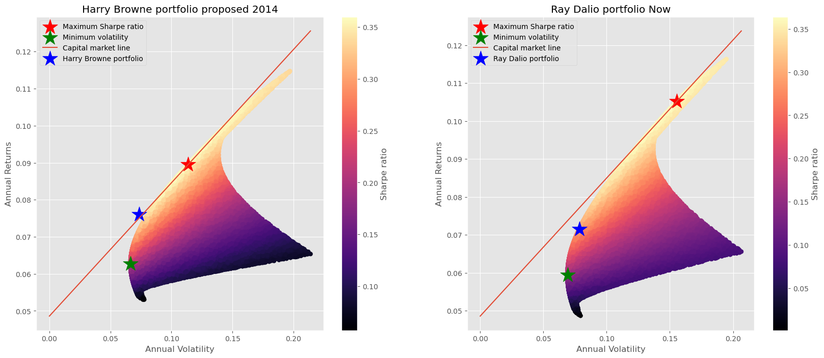

#### Comment:

* The displayed plots offer a visual comparison between Harry Browne’s portfolio, as proposed in 2014, and Ray Dalio’s current portfolio, with their positioning against the efficient frontier serving as a benchmark for optimal investment strategies. The efficient frontier represents the best possible returns for a given level of risk, with the Maximum Sharpe ratio marking the most favorable risk-adjusted returns and the Minimum Volatility point indicating the least risky portfolio. Neither Harry Browne’s nor Ray Dalio’s portfolios coincide with the Maximum Sharpe ratio, highlighting that their strategies prioritize other factors, such as stability or risk parity, over pure return maximization. The Capital Market Line intersection suggests the theoretical best outcome of mixing the market portfolio with a risk-free asset. These visualizations serve as a testament to the complex interplay of risk, return, and investor preference in portfolio design, showcasing how strategic choices reflect different investment goals and market conditions.

### Ray Dalio’s All Weather Portfolio - Pros, Cons and Suggestion for Improvements

#### Pros:

1. Designed to achieve steady returns across different economic cycles.
2. Utilizes risk parity to manage asset allocation effectively.

#### Cons:

1. Complexity in maintaining the balance among various asset classes.
2. Might generate moderate returns compared to more aggressive portfolios.

#### Suggestions for Improvement

##### Rebalancing Strategy:

* + Implement a systematic rebalancing strategy to maintain intended asset allocation..

##### Alternative Investments:

* + Introduce real estate or private equity to further diversify and stabilize returns.

# efficiency and role of assets in own portfolio.  
  
data = df  
mean_returns = data.mean()  
cov_matrix = data.cov()  
iterations = 100000  
risk_free_rate = df['T-Bond'].mean()  
plt.figure(figsize=(10,8))  
efficient_frontiers(mean_returns, cov_matrix, iterations, risk_free_rate)  
plt.scatter(summary_stat.loc['std','own portfolio' ],summary_stat.loc['mean', 'own portfolio'],color = 'blue',marker='*',s=500,label = 'own portfolio')  
plt.title('own portfolio' + ' Optimization based on Efficient Frontier')  
plt.legend()  
plt.show()

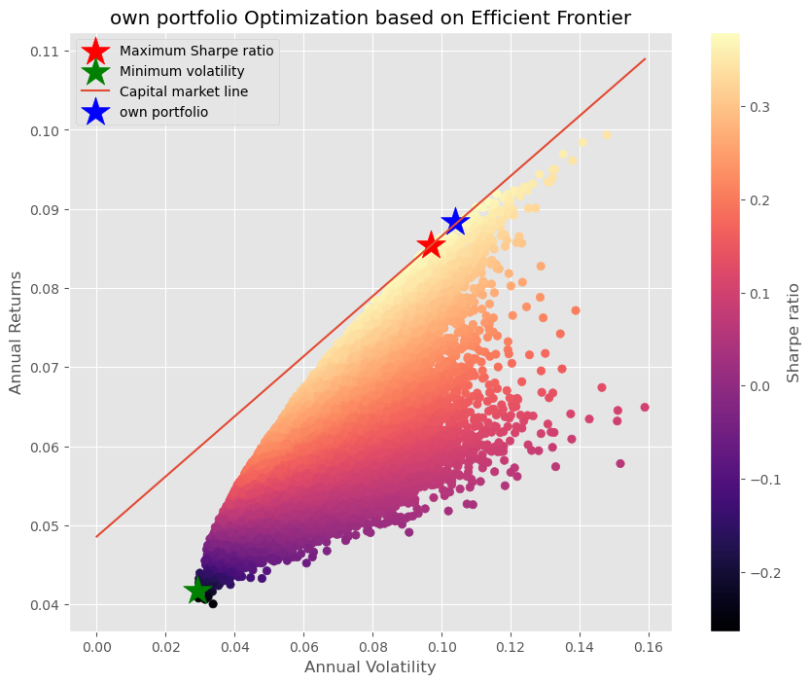

#### Comment:

* The plot conveys the positioning of an individual’s own portfolio in relation to the optimal portfolios on the efficient frontier, which indicates the best possible risk-return combinations. The personal portfolio, marked by a blue star, is not on the efficient frontier, suggesting there is room to improve either the returns for the given level of risk or to reduce the risk for the given level of return. The red star marks the Maximum Sharpe Ratio portfolio, indicating the most efficient portfolio in terms of risk-adjusted returns, while the green star represents the portfolio with the Minimum Volatility, emphasizing safety. The Capital Market Line (CML) suggests the idealized linear return profile a portfolio could have if combined with a risk-free asset. The plot overall demonstrates that there may be more strategically favorable allocations achievable for the individual, as their current portfolio is not maximizing the potential returns for its risk level.

### Own Portfolio - Pros, Cons and Suggestion for Improvements

#### Pros:

1. Tailored specifically to individual financial goals and risk preferences.
2. Highly adaptable to changes in personal circumstances and market conditions.

#### Cons:

1. Requires significant investment knowledge and active management.
2. Potential higher costs due to frequent adjustments and possibly complex strategies.

#### Suggestions for Improvement

##### Continuous Review:

* + Regularly assess the portfolio’s performance against benchmarks and adjust accordingly.

##### Advanced Analytics:

* + Use advanced analytics and machine learning techniques to predict trends and optimize allocation.

plt.figure(figsize=(10,8))  
plt.style.use('ggplot')  
plt.plot((1+portfolios).cumprod(),label = portfolios.columns.to_list())  
plt.grid(True)  
plt.title('Cumulative returns of portfolios')  
plt.ylabel('Cumulative returns')  
plt.xlabel('Years')  
plt.legend()  
plt.show()

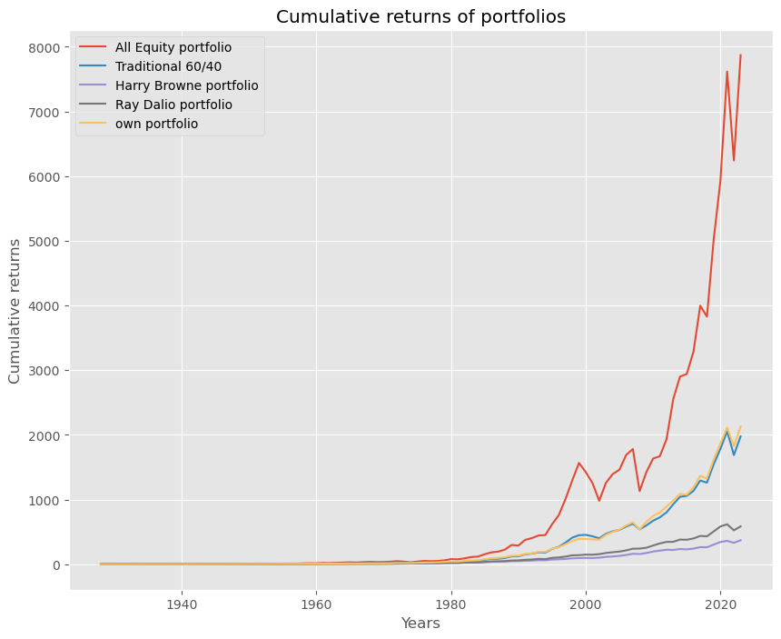

plt.figure(figsize=(10,8))  
sns.kdeplot(portfolios)  
plt.title('Krenal density plot of portfolios')

Text(0.5, 1.0, 'Krenal density plot of portfolios')

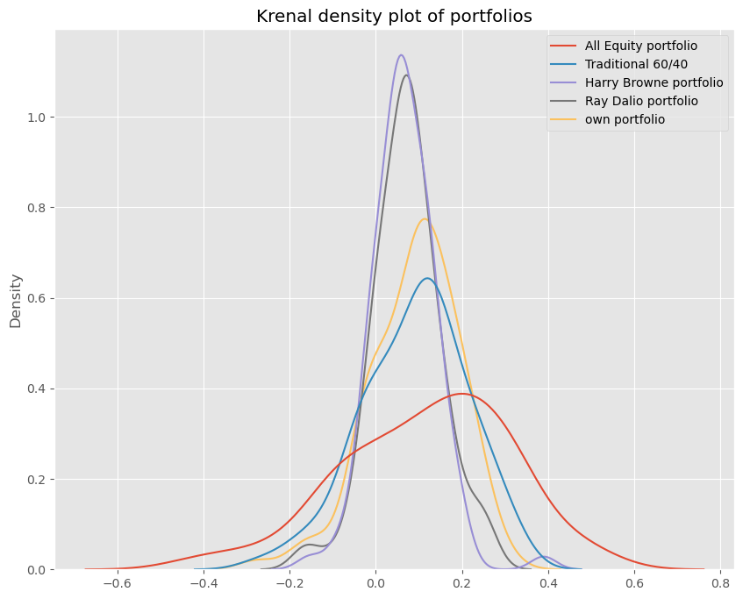

plt.figure(figsize=(10,8))  
plt.scatter(summary_stat.iloc[2],summary_stat.iloc[1],marker = '*', s = 300)  
for i, txt in enumerate(summary_stat.columns):  
 plt.annotate(txt, (summary_stat.iloc[2, i], summary_stat.iloc[1, i]))  
plt.xlabel('Volatilty of Annual Returns')  
plt.ylabel('Mean of Annual Returns')  
plt.title('Risk-return tradeoff of portfolio')  
plt.show()

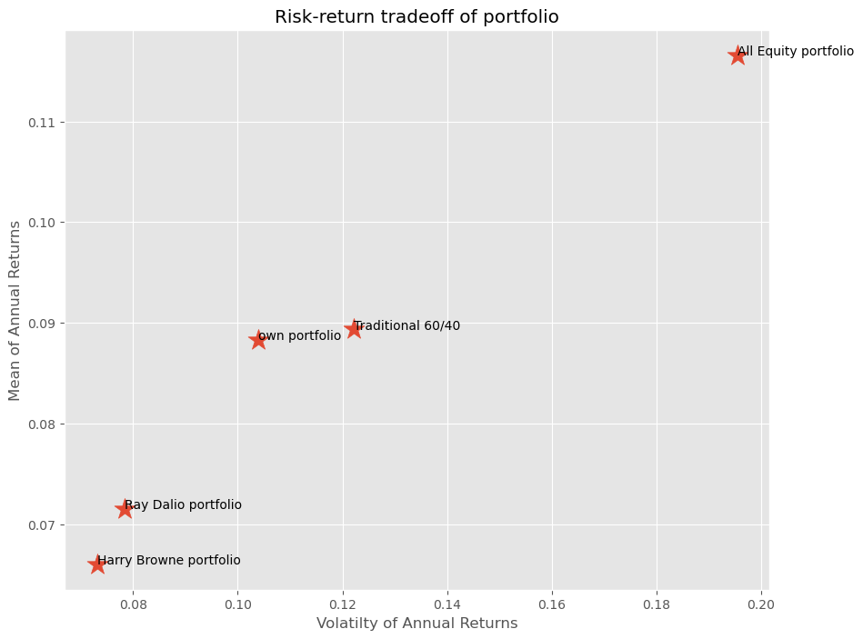

## Pros and Cons of Each Asset Class and Their Roles in Each Portfolio

#### A) Stocks

#### Pros:

* High potential returns, capital growth.

#### Cons:

* Volatile, can lose significant value quickly.

#### Role:

* Growth engine in portfolios.

#### B) Bonds

#### Pros:

* Provide steady income, less volatile than stocks.

#### Cons:

* Low returns in low interest rate environments, price drops when rates rise.

#### Role:

* Stability and income in portfolios.

#### C) Gold

#### Pros:

* Hedge against inflation and currency devaluation.

#### Cons:

* Does not produce income, unpredictable price swings.

#### Role:

* Safety and diversification.

#### D) Cash

#### Pros:

* Liquidity, least risky.

#### Cons:

* Low or no returns, inflation risk.

#### Role:

* Safety and liquidity.

#### E) Commodities

#### Pros:

* Diversification; potential hedge against inflation.

#### Cons:

* Can be highly volatile; influenced by external factors like weather and geopolitical events.

#### Role:

* Diversification and potential inflation hedge.

## Mean-Variance Efficiency Analysis

#### Are the Portfolios Mean-Variance Efficient Now?

* + All-Equity Portfolio: This portfolio is unlikely to be mean-variance efficient currently due to its lack of diversification. It is exposed primarily to equity market risks and might not offer the best risk-return trade-off compared to more diversified portfolios.
  + Traditional 60/40 Portfolio: Historically popular for its balance, this portfolio may no longer be as mean-variance efficient in the current low-interest-rate environment where bond yields are lower, affecting the risk-return profile adversely.
  + Harry Browne’s Permanent Portfolio: Designed to perform reliably across various economic conditions due to its diversified asset allocation (stocks, bonds, cash, and gold), this portfolio could still be near mean-variance efficiency. It is structured to mitigate risks across different market scenarios.
  + Ray Dalio’s All Weather Portfolio: Focused on risk parity and diversified across asset classes including stocks, various types of bonds, and commodities, this portfolio is designed to remain mean-variance efficient by adjusting to economic changes and maintaining a stable risk-return balance.
  + Customized Portfolio: The efficiency of this portfolio depends on its specific design and alignment with current market conditions. If well-optimized and regularly adjusted for recent economic data and market trends, it can be mean-variance efficient.

#### Were the portfolios mean-variance efficient when they were proposed?

* + Each of the mentioned portfolios was likely considered mean-variance efficient or close to efficient under the market conditions and the investment theory prevailing at the time they were proposed.
  + For instance, the traditional 60/40 portfolio (60% stocks, 40% bonds) has been a staple recommendation for many retail investors due to its relative simplicity and historically good performance, balancing stocks’ growth potential with bonds’ stability.
  + Innovative portfolios like Ray Dalio’s All Weather and Harry Browne’s Permanent Portfolio were designed to perform across different economic conditions, aiming to provide stability and decent returns irrespective of market cycles.
  + These designs reflect an approach to achieving efficiency under a broader range of scenarios rather than just optimizing for return and volatility.
  + Over time, as market dynamics and asset performance change, what was once considered mean-variance efficient may no longer hold as the optimal set of portfolios.

## Proposal for a Risk-Averse Investor

For a risk-averse investor, the proposal should focus on creating a portfolio that minimizes risk while still providing reasonable returns. Here are key components and strategies to consider when designing such a portfolio:

#### 1. Asset Allocation

* Heavy Allocation to Bonds: Prefer bonds, especially high-quality government and corporate bonds, which generally offer lower risk compared to stocks.
* Consider Short to Medium Term Maturities: These are less sensitive to interest rate changes than long-term bonds, reducing volatility.
* Include Cash or Cash Equivalents: Such as money market funds, which provide liquidity and preserve capital.

#### 2. Diversification

* Broad Diversification Across and Within Asset Classes: This helps to reduce risk by not being overly exposed to any single economic event or market downturn.
* Incorporate Diversified Income Sources: Such as dividend-paying stocks, real estate investment trusts (REITs), and fixed-income securities to spread out potential risks.

#### 3. Risk Management

* Use of Fixed Income Ladders: Staggering the maturity of fixed-income investments to manage interest rate risks and ensure liquidity.
* Consider Inflation-Protected Securities: Such as Treasury Inflation-Protected Securities (TIPS) to guard against inflation risk.
* Regular Rebalancing: Adjust the portfolio to maintain intended asset allocation, which can drift over time due to varying performance across assets.

#### 4. Conservative Investment Options

* Index Funds or ETFs for Equity Exposure: These provide broad market exposure, reducing the risk of individual stock selections, while still allowing for potential growth.
* Avoid or Limit Exposure to High-Volatility Stocks and Sectors: Focus on sectors known for stability like utilities or consumer staples.

#### 5. Technological and Managerial Tools

* Robo-Advisors: Can be used for automated rebalancing and risk assessment, often at a lower cost than traditional financial advisors.
* Professional Financial Advice: A financial advisor specializing in risk management can provide personalized advice based on the individual’s risk tolerance and financial goals.

#### 6. Alternative Investments

* Consider Low-Volatility Funds: These funds aim to reduce volatility by investing in stocks that historically have had lower price swings.
* Limited Use of Alternative Assets: Such as gold or other commodities as a hedge against market volatility and economic downturns, although they should be used sparingly given their own risk profiles.

#### 7. Stress Testing and Scenario Analysis

* Conduct Regular Stress Tests: To see how the portfolio might perform under various adverse conditions.
* Scenario Planning: Helps in understanding potential impacts on the portfolio from various financial environments and economic events.

Implementing these strategies can help construct a portfolio that is better suited for a risk-averse investor, focusing on preservation of capital, liquidity, and achieving steady, albeit potentially lower, returns. This approach minimizes exposure to high-risk assets and emphasizes stability and risk management.

## Limitations of the Analysis

#### Data Dependency:

* Reliance on historical data that may not predict future conditions.

#### Model Assumptions:

* Mean-variance optimization assumes rational markets and normal distribution of returns.

#### Dynamic Markets:

* Market conditions change rapidly, requiring continuous adjustment of strategies.

#### Personal Biases:

* Personal or cognitive biases in choosing and managing investments.