**Testing scenarios:**

**T1 - Similar looking objects (appearance-based ambiguity test)**

**Place the T1 test demo (screenshots of all algorithms depicting appearance-based ambiguity instances)**

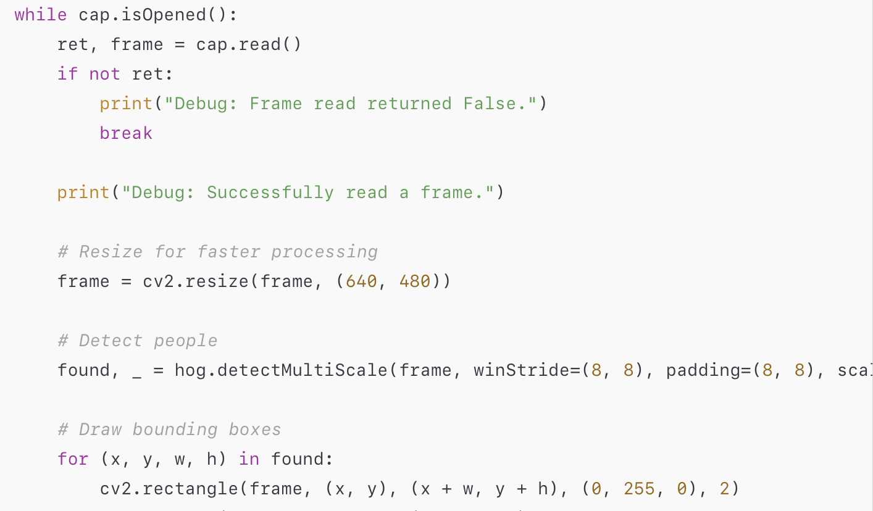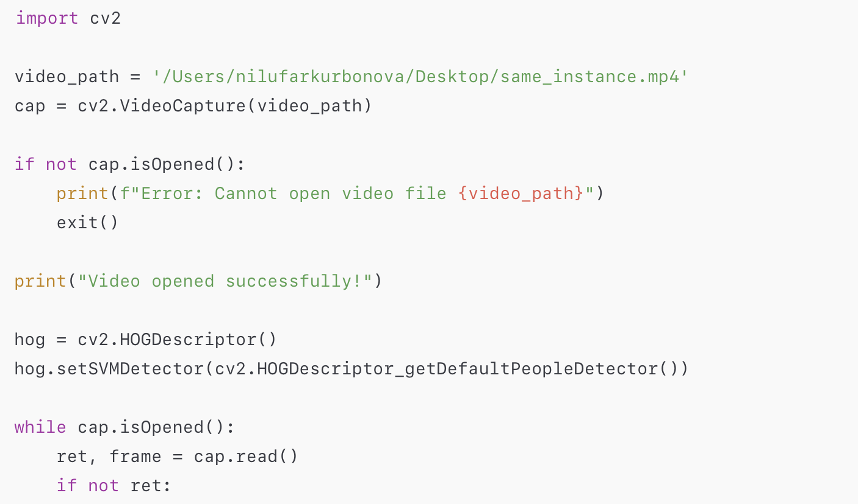

**T2 - Shortest possible objects (scale-based ambiguity test)**

**Place the T2 test demo (screenshots of all algorithms depicting scale-based ambiguity instances)**

