Json server

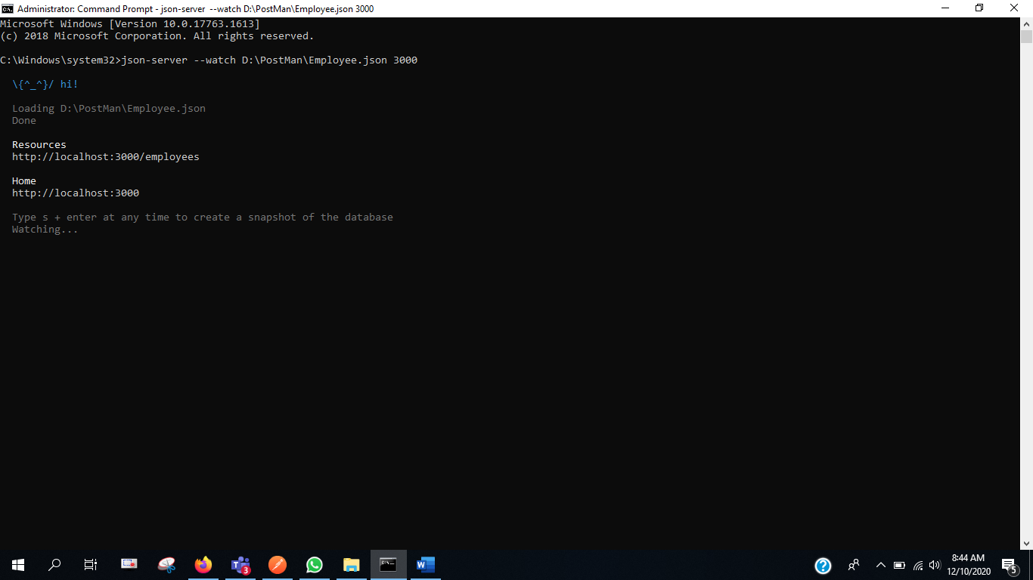

To Start Json Server

npm install -g json-server

json-server --watch D:\PostMan\Employee.json 3000  
  
Refer to Post  
<https://medium.com/@Raghwendra.sonu/data-driven-testing-with-postman-using-csv-and-json-files-c4f112015eb3>

Cls – to clear command

npm install -g newman

newman run D:\PostMan\PostmanProject01.postman_collection.json

newman run D:PostMan\DataDrivenTestEmployee.postman_collection.json -d D:\PostMan\urls.json

newman run D:PostMan\DataDrivenTestEmployee.postman_collection.json -e D:\PostMan\Environment.json

