Week One

Solutions Due by Friday, October 20th

1. Tuesday's high temperature was 4° higher than the high on Monday. Wednesday's high was 6° cooler than the high on Monday. If Tuesday's high was 22°, what was the high on Wednesday?


2. Claire takes a square piece of paper and folds it in half four times without unfolding, making an
isosceles right triangle each time. After unfolding the paper to form a square again, the creases on the
paper would look like:
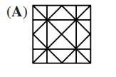 | 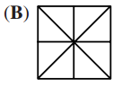 | 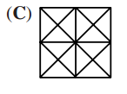 | 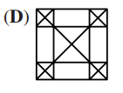 | 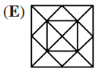

3. John and Mary play a two-person game in which the winner gains 2 points and the loser loses 1 point.
If Juan won exactly 3 games and Mary had a final score of 5 points, how many games did they play?

4. On a game show you choose between three boxes hoping to win a new FIDGET SPINNER. Two of the boxes are empty, the other contains the spinner.

After you choose a box, the host opens one of the other boxes to show that it is empty. You can now choose to stick with your original box or switch to the last unopened box.

Should you stick? Should you switch? Does it not matter? Convince me!

5. Blackjack: a Two-player game.

Player one and player two take turns raising 1, 2, 3, 4 or 5 fingers, and players keep track of the running total. For example, if you start the game with 4, and the next player plays 3, then the total is now 7, and player one plays again. The player to land on 21 is the winner.

What is the best strategy to win in this game? Does player one or player two have an advantage?

