Week Two

Solutions due Friday, October 27th


1. At the chocolate store, one chocolate costs $3. One day the store had a deal: “buy two chocolates, get one for free”. I decided to get 48 chocolates. How much did I spend?
2.  Sarah fills the bottom row of this figure with natural numbers of her choosing. Each other box is filled with the sum of the two boxes underneath. What is the maximum number of odd numbers that can appear in the finished diagram? | 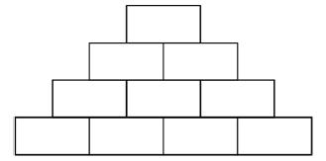

3.  In the picture, the big triangle is equilateral and has area 9. The lines are parallel to the triangle's sides and divide the triangle's sides into three equal parts. What is the area of the shaded part? | 

4. A bar is made of two grey cubes and one white cube glued together as shown:



Which of the following cubes can be built from nine of these bars?

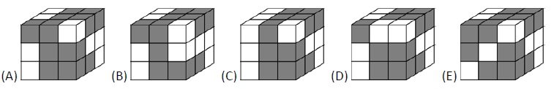

5. Blackjack: Repeat! Danger! Some solutions handed in last week, but none correct/complete!

Player one and player two take turns raising 1, 2, 3, 4 or 5 fingers, and players keep track of the running total. For example, if you start the game with 4, and the next player plays 3, then the total is now 7, and player one plays again. The player to land on 21 is the winner.

What is the best strategy to win in this game? Does player one or player two have an advantage?
Week Two

Solutions due Friday, October 27th

1. At the chocolate store, one chocolate costs $3. One day the store had a deal: “buy two chocolates, get one for free”. I decided to get 48 chocolates. How much did I spend?
2.
Sarah fills the bottom row of this figure with natural numbers of her choosing. Each other box is filled with the sum of the two boxes underneath. What is the maximum number of odd numbers that can appear in the finished diagram?

3.
In the picture, the big triangle is equilateral and has area 9. The lines are parallel to the triangle's sides and divide the triangle's sides into three equal parts. What is the area of the shaded part?

4. A bar is made of two grey cubes and one white cube glued together as shown:

Which of the following cubes can be built from nine of these bars?

5. Blackjack: Repeat! Danger! Some solutions handed in last week, but none correct/complete!

Player one and player two take turns raising 1, 2, 3, 4 or 5 fingers, and players keep track of the running total. For example, if you start the game with 4, and the next player plays 3, then the total is now 7, and player one plays again. The player to land on 21 is the winner.

What is the best strategy to win in this game? Does player one or player two have an advantage?

