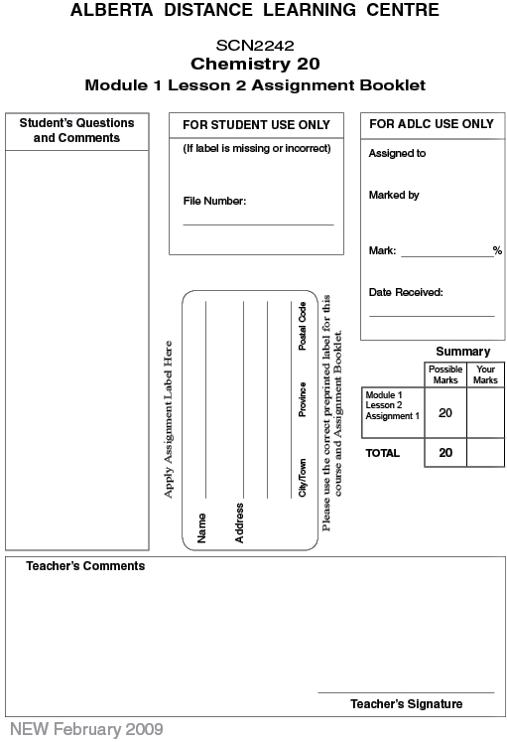
Module 1: Lesson 2 ASSIGNMENT

This Module 1: Lesson 2 Assignment is worth 20 marks. The value of each assignment and each question is stated in the left margin.

(20 Marks) | Lesson 2 Assignment: Ionic Compounds

(10 marks) | 1. | Fill in the table with the required information. The first one is done for you.
  Atoms Combined | Formula of Ions Involved | Chemical Formula | Name of Compound
  Na and Cl | Na⁺ and Cl– | NaCl | sodium chloride
  Ca and Cl
  K and Br
   | Fe³⁺ and OH–
   |  |  | aluminium sulfide
   |  |  | nickel(II) cyanide
   |  | Ga₂(SO₄)₃ • 18H₂O
   |  | Cu₃N₂
   | Mg²⁺ and O^{2–}
  Al and O
   |  | AuBO₃

(10 marks) | 2. | Complete the following table.
  Element | Electro-  negativity | Group Number | Number of Valence Electrons | Number of Bonding Electrons | Number of Lone Pairs of Electrons
   | 1.3 |  | 2
   | 3.2
   | 1.6 | 13
   | 0.9 | 1
   | 1.9 |  |  | 4
  S
   | 3.0 |  | 5
  Ar
  P

Once you have completed all of the questions, submit your work to your teacher.

