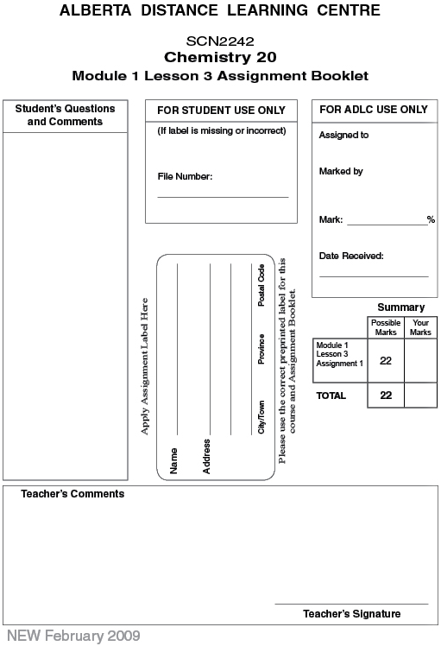

(22 Marks) | Lesson 3 Assignment: Molecular Elements and Compounds

(6 marks) 1. Provide the name for each of the following compounds.

- CO₂(g) -

- NH₃(g) -

- P₄O₆(s) -

- Cl₂(g) -

- H₂O₂(l) -

- NI₃(s) -

(6 marks) 2. Provide the correct chemical formula for each of the following compounds
.
- bromine -

- sulfur trioxide -

- sulphur -

- methanol -

- phosphorus -

- sucrose -

(10 marks) 3. Use the periodic table to calculate the electronegativity difference for each pair of elements. Determine whether each compound is non-polar covalent, polar covalent, or ionic.

A. the bond between Mg and F atoms in MgF₂

-

B. the bond between H and S atoms in H₂S

-

C. the bond between Al and O atoms in Al₂O₃

-

D. the bond between Br atoms in Br₂

-

E. the bond between N and H atoms in NH₃

-

Once you have completed all of the questions, submit your work to your teacher.

