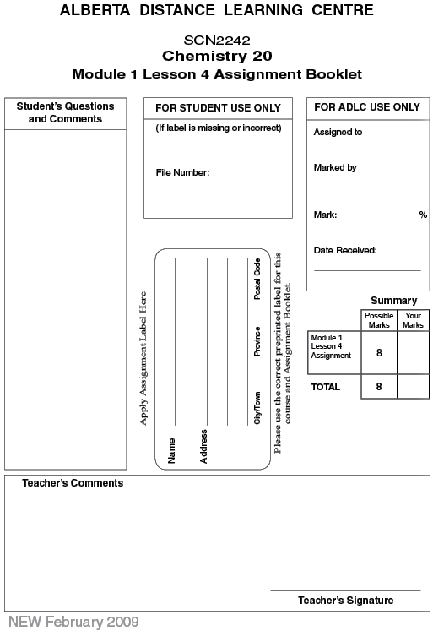

(8 Marks) | Lesson 4 Assignment: The Particle Model

(1 Marks) 1. Order the changes in order of energy released from greatest (#1) to smallest (#3).

chemical -

nuclear -

phase -

(1 Marks) 2. Match the term with the correct description or definition from list below:

chemical
nuclear
phase

a change of a substance from one physical state to another

-

involves the rearrangement of particles that affect the bonds within a particle

-

involves the rearrangement of sub-atomic particles within an atom

-

(1 mark) | 3. | Select all of the chemical changes.  - The fuel in a nuclear reactor changes and produces heat.  - Propane is burned in a barbeque.  - A car battery is charged by the alternator.  - The refrigerant in a freezer changes from a liquid to a gas.  - Water freezes to ice on a lake.  - A puddle dies up in the sunlight.  - The rocket engine in the space shuttle burns hydrogen and oxygen gases.  - Cells in a plant leaf produce glucose from carbon dioxide and water.

(1 mark) | 4. | Select all of the physical changes.  - The fuel in a nuclear reactor changes and produces heat.  - Propane is burned in a barbeque.  - A car battery is charged by the alternator.  - The refrigerant in a freezer changes from a liquid to a gas.  - Water freezes to ice on a lake.  - A puddle dies up in the sunlight.  - The rocket engine in the space shuttle burns hydrogen and oxygen gases.  - Cells in a plant leaf produce glucose from carbon dioxide and water.

(1 mark) | 5. | Select all of the endothermic changes.  - Water on a pond freezes to form ice.  - Propane is burned in a barbeque.  - A drop of water evaporates.  - Cells in a plant leaf produce glucose from carbon dioxide and water.  - The refrigerant in a freezer changes from a liquid to a gas.

(1 mark) | 6. | Select all of the exothermic changes.  - Water on a pond freezes to form ice.  - Propane is burned in a barbeque.  - A drop of water evaporates.  - Cells in a plant leaf produce glucose from carbon dioxide and water.  - The refrigerant in a freezer changes from a liquid to a gas.

(1 mark) | 7. | Select all of the processes that involve changes in intramolecular bonds.  - Water on a pond freezes to form ice.  - Propane is burned in a barbeque.  - A drop of water evaporates.  - Cells in a plant leaf produce glucose from carbon dioxide and water.  - The refrigerant in a freezer changes from a liquid to a gas.

(1 mark) | 8. | Select all of the processes that involve changes in intermolecular bonds.  - Water on a pond freezes to form ice.  - Propane is burned in a barbeque.  - A drop of water evaporates.  - Cells in a plant leaf produce glucose from carbon dioxide and water.  - The refrigerant in a freezer changes from a liquid to a gas.

Once you have completed all of the questions, submit your work to your teacher.

