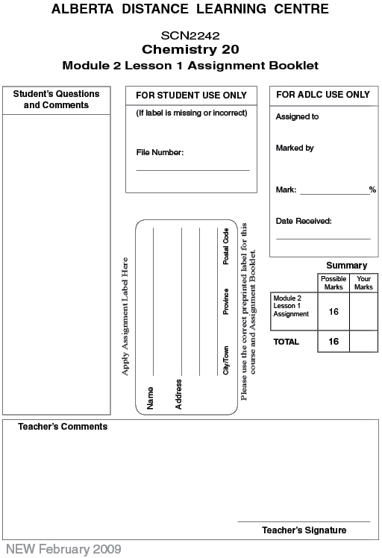

(16 Marks) | Lesson 1 Assignment: Bonding Theory and Lewis Formulas

(3 Marks) | 1. | Draw the Lewis symbols for the first three elements of group 2 on the periodic table. How are these elements similar?

Answer:

(3 Marks) | 2. | Draw the Lewis symbols for the first three elements of group 17 on the periodic table. How are these elements similar?

Answer:

(4 Marks) | 3. | Draw the Lewis formula and structural diagram for the following molecular elements.

 | a. | iodine

Answer:

 | b. | nitrogen

Answer:

(6 Marks) | 4. | Draw the Lewis formula and structural diagram for the following molecular compounds.

 | a. | hydrogen sulfide, H₂S

Answer:

 | b. | hydrogen cyanide, HCN

Answer:

 | c. | methanol, CH₄O

Answer:

Once you have completed all of the questions, submit your work to your teacher.

