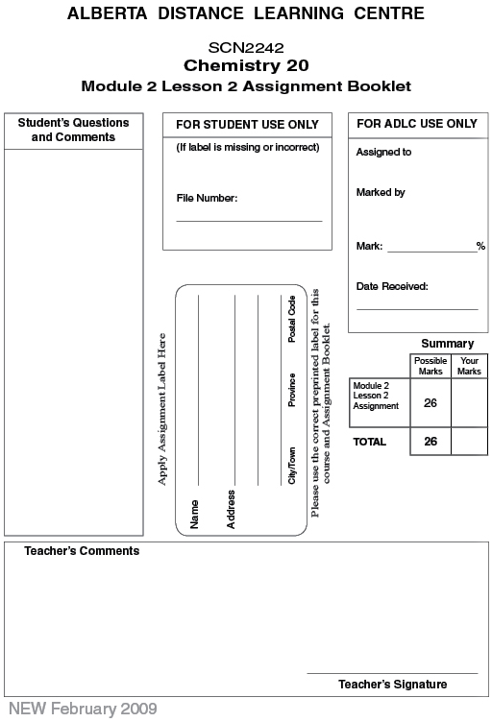

(26 Marks) | Lesson 2 Assignment: Molecular Shapes and VSEPR Theory

(21 Marks) | 1. | For each compound, draw the Lewis formula and stereochemical formula. Identify its VSEPR geometry.

 | a. | BeCl₂

Answer:

 | b. | PF₃

Answer:

 | c. | BBr₃

 | d. | SiBr₄

 | e. | HCN

 | f. | CH₂O

Answer:

 | g. | CS₂

Answer:

 | 2. | Cubane C₈H₈(s) is a cubic-shaped hydrocarbon with a carbon atom at each corner of the cube.  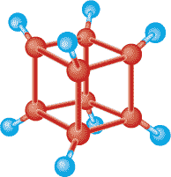  Cubane is very unstable. Some researchers have been seriously injured when crystals of the compound exploded while being scooped out of a bottle. Not surprisingly, cubane has been the subject of some research as an explosive.

(2 Marks) | a. | According to the VSEPR theory, what should be the shape around each carbon atom? What shape is associated with this bond angle?

Answer:

(1 Mark) | b. | If you assume an ideal cubic shape, what are the actual bond angles around each carbon?

Answer:

(2 Marks) | c. | Explain how your answers to questions 2.a. and 2.b. suggest why this molecule is so unstable.

Answer:

Once you have completed all of the questions, submit your work to your teacher.

