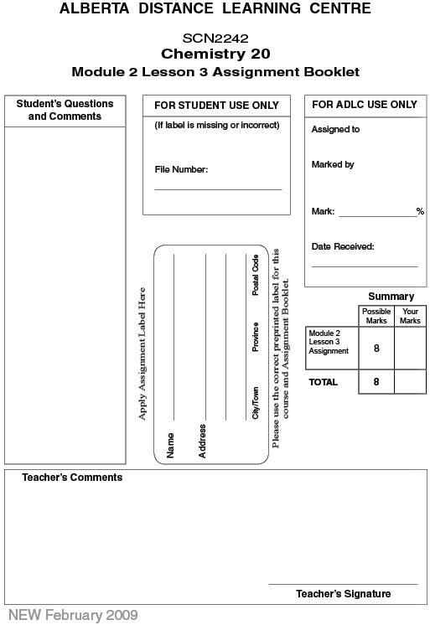

(8 Marks) | Lesson 3 Assignment: Molecular Polarity

(6 Marks) | 1. | For each compound, draw stereochemical formula showing the dipoles.

 | a. | oxygen difluoride

Answer:

 | b. | boron tribromide

Answer:

 | c. | carbon disulfide

 | d. | chlorine

 | e. | methanol

 | f. | carbon tetrafluoride

(2 Marks) | 2. | There are five unknown liquids: A, B, C, D, and E. Each liquid is poured in a thin stream and a charged rod is brought close to each stream. Liquids A, C, and D are attracted to the charged rod; and liquids B and E are not attracted to the charged rod. Which liquids are composed of polar molecules? Explain your answer.

Answer:

Once you have completed all of the questions, submit your work to your teacher.

