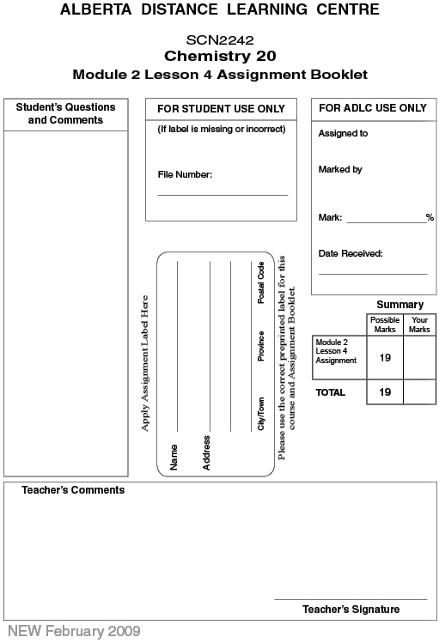

(19 Marks) | Lesson 4 Assignment: Intermolecular Forces

(2 Marks) | 1. | Complete the table with the information and data you collected from the Lab: Boiling Points of Hydrocarbons.
  Hydrocarbon | Chemical Formula | Number of Electrons | Boiling Temperature (°C)
  pentane
  hexane
  heptane
  octane
  nonane

(2 Marks) | 2. | Draw a graph of number of electrons in each compound (horizontal axis) versus boiling temperature (vertical axis).

(1 Mark) | 3. | Explain whether the data, when graphed, supports the hypothesis stated in the background information section of this investigation.

Answer:

(4 Marks) | 4. | Complete Lab Exercise 3. A, "Boiling Points and Intermolecular Forces," on  page 110 of your textbook. Draw a graph as explained in the Analysis of the Evidence.

(1 Mark) | 5. | Use the graph of the data to demonstrate how the hypotheses describing London forces and dipole-dipole could have been developed and supported by this evidence. Identify where the hypothetical trends are not being demonstrated and which compounds are involved.

Answer:

(5 Marks) | 6. | Complete the following table. The first row has been done for you.
  Molecule | Structural  Formula | Shape | Polarity | Types of Intermolecular  Forces
  HBr |  | linear | polar | dipole-dipole
  NF₃
  GeH₄
  NI₃
  CF₄
  HF

(2 Marks) | 7. | Three compounds of carbon, hydrogen, and oxygen exist: C₃H₇OH, C₃H₅ (OH)₂, and C₃H₆(OH)₃.  Rank the three compounds from lowest to highest boiling points using a prediction of the intermolecular forces exhibited by these three compounds. Explain your answer.

Answer:

(2 Marks) | 8. | Given the gases methane, CH₄(g), and oxygen difluoride, OF₂(g), predict which of the two will be more soluble in water. Explain your answer.

Answer:

Once you have completed all of the questions, submit your work to your teacher.

