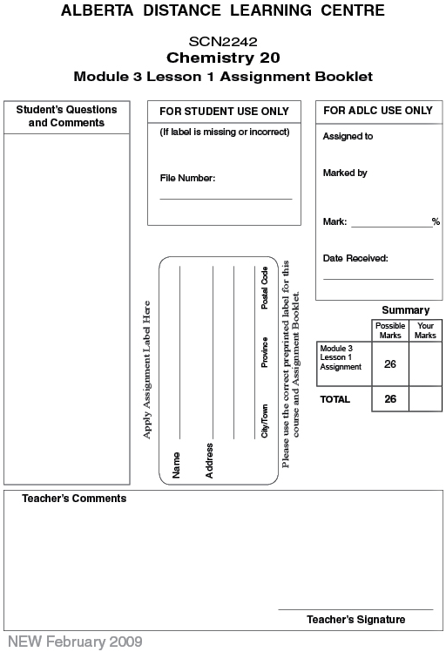

Lesson 1 Assignment: Properties of Gases and Boyle's Law

Part 1: Lab: Boyle’s Law

Record your data from the investigation in the table below.

Propane |  | Butane
Volume (mL) | Pressure (kPa) | Volume (mL) | Pressure (kPa)

Procedure 1 - Propane

 | 1. | According to Boyle's law, pressure is inversely proportional to volume. Prepare a graph of the data for propane with [1/volume] (units=1/mL) on the X-axis and pressure (kPa) on the Y-axis. Draw a straight line through the data points.

 | 2. | Does your experimental data verify Boyle's law? Explain.

 | 3. | What pressure would the gas sample have at a volume of 75 mL? At 300 mL?

 | 4. | List two sources of possible error that could influence your results.

Procedure 2 - Butane

 | 1. | According to Boyle's law, pressure is inversely proportional to volume. Prepare a graph of the data for butane with [1/ volume] (units = 1/mL) on the x-axis and pressure (kPa) on the y-axis. Draw a straight line through the data points.

 | 2. | Does your experimental data verify Boyle's law? Explain.

 | 3. | What pressure would the gas sample have at a volume of 75 mL? At 300 mL?

 | 4. | How do the results for butane compare with those for propane? Does each gas obey Boyle's law? Use the data contained on the graph to justify your answer.

Part 2

 | 1. | A 10.0-g sample of carbon monoxide, a poisonous gas produced by the incomplete combustion of hydrocarbons, occupies 15.0 L at a pressure of 200 kPa. The volume occupied by the carbon monoxide when the pressure is increased to 700 kPa is  - 1.16 L  - 4.05 L  - 4.29 L  - 52.5 L

 | 2. | A student filled a balloon with a gas at a pressure of 100.0 kPa and determines its volume to be 1.44 L. Calculate the volume of the balloon if the pressure increases to 112.3 kPa.  - 1.04 L  - 1.28 L  - 1.44 L  - 1.61 L

 | 3. | The pressure of a fixed mass of gas is increased from 100 kPa to 400 kPa at a constant temperature. The new volume of the gas is  - one-half the original volume  - two times the original volume  - four times the original volume  - one-fourth the original volume

 | 4. | In Vancouver, where the air pressure is 101 kPa, a child is given a 2.0-L balloon. The family then drives to Banff, which is 1386 m above sea level and the air pressure is only 87 kPa. If the temperature is the same in both places, the volume of the balloon in Banff is  - 1.7 L  - 2.0 L  - 2.3 L  - 4.0 L

 | 5. | Multiply each measurement by the appropriate conversion factor to change from one unit to another.

 | a. | Convert 0.68 bars into units of kPa.

 | b. | Convert 209 kPa into units of atm.

 | c. | Convert 550 torr into kPa.

 | 6. | A sample of gas is initially at a pressure of 5.2 atm and has a volume of 2.8 mL. Determine the new volume if the pressure of the gas is increased to 8.0 atm.

 | 7. | A sample of gas has a volume of 2.4 L. Determine the new volume of the gas if the pressure is halved.

 | 8. | A sample of gas has a volume of 7.5 L. Determine the new volume of the gas if the pressure is increased by a factor of 5.

Once you have completed all of the questions, submit your work to your teacher.

