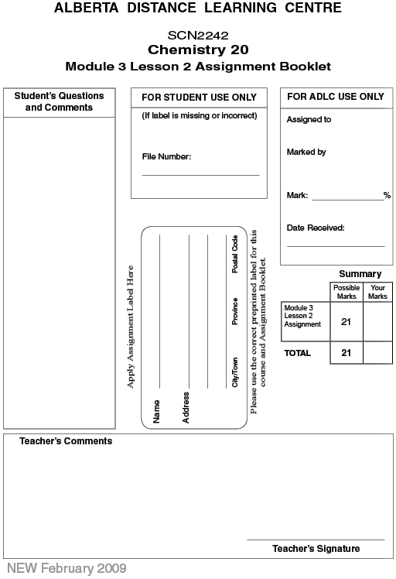

Lesson 2 Assignment: Kelvin Temperature, Charles' Law, and the Combined Gas Law

Part 1: Lab: Charles’ Law

Data

Record the data collected from the investigation. (1 mark)

Gas | Temperature (k) | Volume (mL)
Methane
Butane

Procedure 1

 | 1. | Prepare a graph of the data for methane with temperature (in kelvin) on the x-axis and volume (mL) on the y-axis. (0.75 marks)

Answer:
Insert a copy of your graph here.

 | 2. | Draw a straight line through the data points. (0.25 marks)

Answer:

 | 3. | Does your experimental data verify Charles' law? (1 mark)

Answer:

 | 4. | What volume would the gas sample occupy at 50 °C and at 120 °C? (2 marks)

Answer:

 | 5. | List two sources of possible error if you had done the activity in a real lab. (1 mark)

Answer:

Procedure 2

 | 1. | Prepare a graph of the data for butane with temperature (in kelvin) on the x-axis and volume (mL) on the y-axis. (0.75 marks)

Answer:
Insert a copy of your graph here.

 | 2. | Draw a straight line through the data points. (0.25 marks)

Answer:

 | 3. | Does your experimental data verify Charles' law? (1 mark1/1)

Answer:

 | 4. | What volume would the gas sample occupy at 50 °C and at 120 °C? (2 marks)

Answer:

Part 2

 | 1. | As the temperature of a fixed volume of a gas decreases, the pressure will (1 mark)  - increase  - decrease  - not change  - vary inversely

Answer:

 | 2. | The boiling point of liquid nitrogen is –196°C. An equivalent temperature in the Kelvin scale is (1 mark)  - –196 K  - 77 K  - 153 K  - 273 K

Answer:

 | 3. | The scientist who is credited with the statement "At constant pressure, the volume of a gas is directly proportional to the kelvin temperature" is (1 mark)  - Boyle  - Dalton  - Charles  - Avogadro

Answer:

 | 4. | A weather balloon on the ground has a volume of 200 L at 25.0°C when filled with helium to a pressure of 100 kPa. The volume of the balloon at 9000 m, where the temperature is –50.0°C and the pressure is 19.5 kPa, is (1 mark)  - 1.35 mL  - 29.6 L  - 51.2 L  - 768 L

Answer:

 | 5. | A 2.0-L helium tank at a pressure of 15.0 MPa in a room kept at 22ºC is used to blow up balloons. The balloons, once blown up, have a volume of 2.0 L and maintain a pressure of 115 kPa without breaking. The maximum number of balloons that can be filled with this tank is (1 mark)  - 100  - 130  - 260  - 380

Answer:

 | 6. | Read the following list of conditions and temperatures.  - The boiling point of water is 373 K.  - On a very hot day, the temperature can reach 313 K.  - On a very cold day, the temperature can reach 0 K.  - Normal body temperature is 310 K.  The conditions listed with accurate temperatures are (1 mark)  - I and IV  - I, II, and III  - I, II, and IV  - II, III, and IV

Answer:

 | 7. | A gaseous fluorocarbon is used as a coolant in refrigerators. If a fixed volume of this gas has a pressure of 700 kPa at 227°C, its pressure at 27°C is (1 mark)  - 83 kPa  - 4.2 × 10² kPa  - 1.2 × 10³ kPa  - 5.9 × 10³ kPa

Answer:

 | 8. | A gas has a volume of 2.1 L at SATP. What will be the volume of the gas if the temperature is cooled to –30.5°C and the pressure is held constant? (1 mark)

Answer:

 | 9. | A gas has a volume of 3.4 L. What is the new volume if the temperature is doubled? (1 mark)

Answer:

 | 10. | A gas has a volume of 4.5 L at STP. If the conditions are changed to SATP, what is the new volume of the gas? (1 mark)

Answer:

 | 11. | A metal container contains a gas that is fixed in volume. If the pressure is initially 650 mm Hg and the temperature is increased from 480 K to 700 K, what is the new pressure? (1 mark)

Answer:

Once you have completed all of the questions, submit your work to your teacher.

