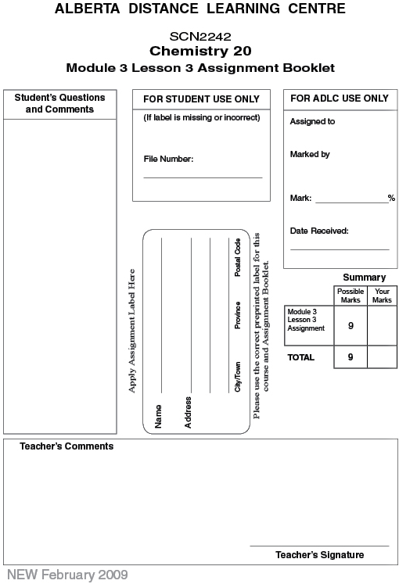

Lesson 3 Assignment: Properties of Gases and Boyle's Law

 | 1. | Hydrogen cyanide gas is produced industrially by the reaction  2 CH₄(g) + 3 O₂(g) + 2 NH₃(g) → 2 HCN(g) + 6 H₂O(g)  What volumes of O₂(g) and NH₃(g) are needed to react with 8.0 L of CH₄(g) at STP?  - 12 L of O₂(g) and 4 L of NH₃(g)  - 8 L of O₂(g) and 12 L of NH₃(g)  - 12 L of O₂(g) and 8 L of NH₃(g)  - 4 L of O₂(g) and 8 L of NH₃(g)

 | 2. | Use the following balanced equation to answer the question.  2 H₂(g) + O₂(g) → 2 H₂O(g)  If 10.0 L of hydrogen reacted with 5.0 L of oxygen, the volume of water vapour formed is  - 2 L  - 5 L  - 10 L  - 15 L

 | 3. | Three 1.0-L flasks contain He(g), N₂(g), and H₂S(g), all at the same temperature and pressure. Which statement indicates the relative number of molecules in the flasks?  - The flask of He(g) contains the most molecules.  - The flask of N₂(g) contains the most molecules.  - The flask of H₂S(g) contains the most molecules.  - All three flasks contain the same number of molecules.

 | 4. | Hydrogen sulfide gas is combusted with oxygen gas to produce sulfur dioxide gas and water vapour. If there is 48.4 L of oxygen available, what volume of hydrogen sulfide gas may be combusted if the pressure and temperature are held constant?

 | 5. | Butane gas is combusted to produce carbon dioxide and water vapour. If 5.50 mol of butane are reacted, how many moles of water vapour are produced?

 | 6. | Ammonia is produced from its elements in a formation reaction. If 8.90 × 10²⁴ molecules of ammonia are produced, how many molecules of hydrogen were used?

Once you have completed all of the questions, submit your work to your teacher.

