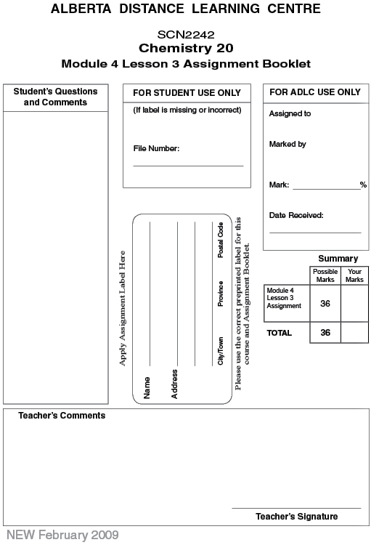

Lesson 3 Assignment: Solubility

Part 1: Lab: Shower of Lead(II) Iodide

Answer the following questions based on the video “Shower of Lead(II) Iodide.

 | 1. | What is the purpose of this experiment? (2 marks)

Answer:

 | 2. | Fill in the following table showing the results of the lab. (6 marks)
  Temperature (ºC) | Mass of Solute (g)

Analysis and Conclusion

 | 3. | When the Erlenmeyer flask is brought to 100ºC and the solid settles, the hot saturated solution is transferred to a test tube. What assumption is being made about the hot saturated solution? Why must the pipette be warm in completing the transfer? (3 marks)

Answer:

 | 4. | Why are the test tubes left to sit for one hour? (1 mark)

Answer:

 | 5. | What trend exists between temperature and amount of residue? (1 mark)

Answer:

 | 6. | Do the crystals form differently based on cooling speed? (2 marks)

Answer:

 | 7. | Does cooling rate affect solubility? (2 marks)

Answer:

Part 2

 | 1. | For each of the following, determine whether the statement is true or false. For those that are false, write a brief sentence indicating the required correction.

 | a. | A saturated solution of NaCl(s) can be filtered to remove the dissolved solute.

Answer:

 | b. | Liquids that do not dissolve in water, such as oil, are said to be immiscible with water.

Answer:

 | c. | Pressure is a major factor in the solubility of solids, liquids, and gases in water.

Answer:

 | d. | Calcium sulfate is an insoluble solid written CaSO₄(s). Even though this compound has the state (s), some of it will dissolve in water.

Answer:

 | e. | Water must be included in a correctly written dissociation equation.

Answer:

 | f. | Elemental gases are relatively insoluble in water and should be given the state (g).

Answer:

 | 2. | The solubility of oxygen gas is 0.007 g/100 mL at STP conditions. How much oxygen gas is dissolved in the following situations?

 | a. | 0.007 g of O₂(g) is bubbled in 100 mL of water

Answer:

 | b. | 0.008 g of O₂(g) is bubbled in 100 mL of water

Answer:

 | c. | 0.050 g of O₂(g) is bubbled in 300 mL of water

Answer:

 | 3. | Complete the dissociation equations for each of the following substances in water. Make sure you balance the equations.

 | a. | Ag₂S(s) →

Answer:

 | b. | CH₃OH(l) →

Answer:

 | c. | Ba(OH)₂(aq) →

Answer:

 | d. | N₂(g) →

Answer:

 | 4. | A cup of coffee has sugar accumulated at the bottom of the cup. Will adding more sugar make the coffee sweeter? Is it possible to make the coffee taste sweeter without adding more sugar?

Answer:

 | 5. | Based on your knowledge of solubility, make a prediction on how global warming will affect ocean life.

Answer:

 | 6. | When a saturated solution of salt is filtered, the residue is collected and removed. The filtrate is allowed to sit and evaporate, and a white residue forms at the bottom of the flask.  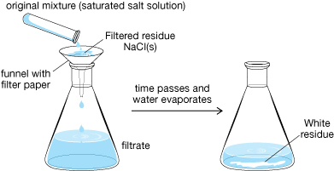  Explain the chemical principles behind this observation.

Answer:

Once you have completed all of the questions, submit your work to your teacher.

