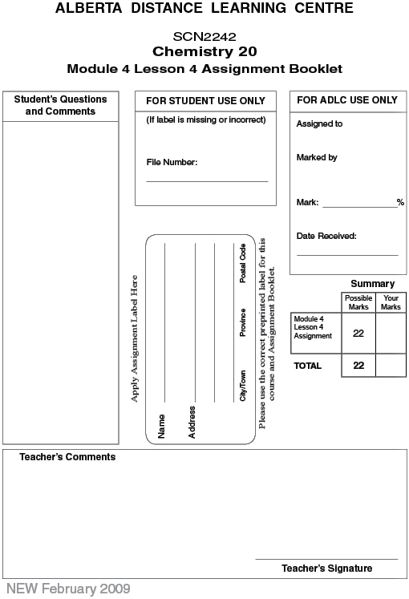
 | 1. | A 180 mL disinfectant solution contains 85 mL of isopropyl alcohol. Determine the V/V concentration of this solution. (1 mark)

Answer:

 | 2. | 72 mL of methanol is poured into 350 mL of water. Determine the V/V concentration of this solution. (1 mark)

Answer:

 | 3. | If 114 g of sucrose is dissolved in water to make a 950 mL solution, determine the W/V concentration of the solution. (1 mark)

Answer:

 | 4. | A solution contains 7.8% W/V ethanol. Express this in units of g/mL. (1 mark)

Answer:

 | 5. | A 0.51 kg solution contains 87 mg of potassium iodide. Calculate the W/W concentration of this solution. (1 mark)

Answer:

 | 6. | 5.8 g of lithium bromide is dissolved in water to make a 270 L solution. Express the concentration in ppm. (1 mark)

Answer:

 | 7. | 0.30 kg of magnesium sulfate is dissolved in water to make a 92 kg solution. Express the concentration in ppm. (1 mark)

Answer:

 | 8. | Express 46 ppm as a W/W concentration. (1 mark)

Answer:

 | 9. | 185 μg of lithium bromide is dissolved in water to make a 32 L solution. Express the concentration in ppb. (1 mark)

Answer:

 | 10. | Convert 155 ppb to ppm. (1 mark)

Answer:

 | 11. | Determine the volume of methanol required to prepare 2.4 L of a 38% V/V solution. (2 marks)

Answer:

 | 12. | The maximum mass of sugar a diabetic can have is 10 g. Determine the volume of juice they can drink with a sugar concentration of 11% W/V. (2 marks)

Answer:

 | 13. | A starfish contains 131 ppb mercury. How much mercury is in a 760 g starfish?  (2 marks)

Answer:

Use the following information to answer the next 3 questions.
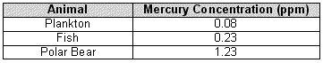

 | 14. | What is the mass of mercury in a 250 g fish? (2 marks)

Answer:

 | 15. | What is the mass of mercury in a 900 kg polar bear? (2 marks)

Answer:

 | 16. | Briefly explain what may be causing the observed trend in mercury concentration observed in the table. (2 marks)

Answer:

Once you have completed all of the questions, submit your work to your teacher.

