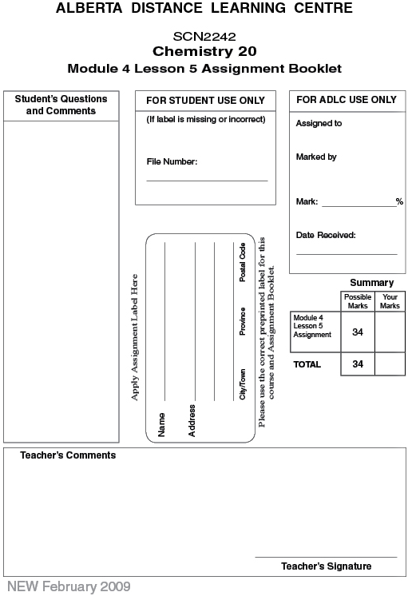

Lesson 5 Assignment:

 | 1. | Determine the amount concentration of 0.27 moles of magnesium sulfate dissolved in a 180 mL solution. (1 marks)

Answer:

 | 2. | Determine the amount concentration of 2.6 x 10¯² g of magnesium chloride dissolved in 45 mL of solution. (2 marks)

Answer:

 | 3. | Determine the amount concentration of 1.7 g of iron(III) chloride dissolved in 62 mL of solution. (2 marks)

Answer:

 | 4. | What mass of ammonium phosphate is present in 1.80 L of a 145-mmol/L solution? (2 marks)

Answer:

 | 5. | What volume is required to make a 0.48 mol/L solution with 24 g of sodium hydroxide? (2 marks)

Answer:

 | 6. | Determine the amount concentration of the iron ions and sulfate ions in a 0.62 mol/L solution of iron(III) sulfate. (3 marks)

Answer:

 | 7. | Determine the amount concentration of potassium ions and dichromate ions in a solution made by dissolving 44.7 g of potassium dichromate to make a volume of 205 mL. (5 marks)

Answer:

 | 8. | What mass of aluminium chloride must be dissolved to make 45.0 L of solution with a chloride ion concentration of 0.210 mol/L. (4 marks)

Answer:

 | 9. | 18 mL of a 0.055 mol/L sulfuric acid solution is diluted up to 30 mL. What is the new concentration of the acid? (2 marks)

Answer:

 | 10. | 0.300 L of distilled water is added to 200 mL of a 1.60 mol/L solution of nitric acid. What is the new concentration of the acid? (2 marks)

Answer:

 | 11. | What volume of distilled water must be added to 105 mL of 0.600 mol/L sulfuric acid solution in order to dilute it to a concentration of 0.400 mol/L? (2 marks)

Answer:

 | 12. | Calculate the mass of solid sodium hydroxide (lye) that is required to make 300 mL of a 10.0 mol/L solution. (2 marks)

Answer:

 | 13. | A concentrated sulfuric acid solution is available in a lab. A 100 mL solution with a concentration of 0.75 mol/L is required. Write out the prelab and procedure for making this solution. (4 marks)

Answer:

Once you have completed all of the questions, submit your work to your teacher.

