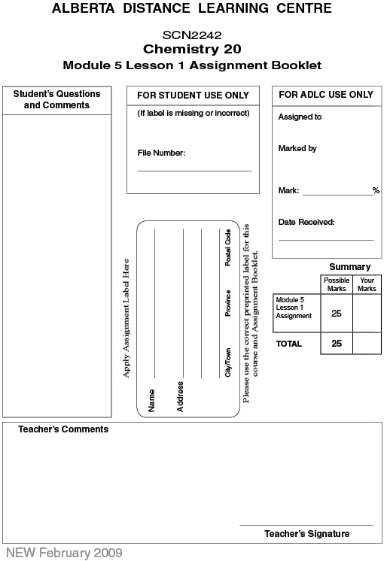

Lesson 1 Assignment: Properties of Acids and Bases

- Use the results of the litmus tests to categorize the solutions in the following table.
(4 marks)

Acids | Bases | Neutral

 | 2. | Explain the purpose of testing the apparatus using distilled water before testing each of the solutions. (1 mark)

 | 3. | Evaluate the use of the conductivity apparatus in this experiment. (1 mark)

 | 4. | Some of the litmus tests took a long time to develop, such as the test for CaO(aq). Suggest an improvement to the experimental design that would fix this problem.

 | 5. | Are there any solutions that do not seem to fit Arrhenius’s theory of acids and bases? Explain.

 | 6. | Evaluate Arrhenius’s theory based on the evidence gathered in this lab.

 | 7. | For each of the following, determine whether the statement is true or false. For those that are false, write a brief sentence indicating the required correction.

 | a. | The prefix hydro- is used to indicate that an acid has hydrogen.

 | b. | A conductivity apparatus is not that useful in separating acids from bases because both solutions conduct electricity.

 | c. | The hydronium ion contains a water molecule bonded to a hydrogen ion.

 | d. | Arrhenius’s original theory of acids does not explain why compounds like carbon dioxide are acids in solution.

 | e. | The modified Arrhenius theory is much better than Arrhenius’s original theory at predicting the products of an acid reacting with water.

 | 8. | Write equations that show how each of the following substances reacts with water.

 | a. | Hydrogen fluoride gas reacts with water to form an acidic solution.

 | b. | Solid sodium hydrogen sulfite reacts with water to form an acidic solution.

 | c. | Solid sodium oxide, Na₂O(s), reacts with water to form a basic solution.

 | d. | Solid sodium phosphate (Na₃PO₄) dissociates in water to form a basic solution.

 | e. | Solid potassium hydroxide reacts with water to form a basic solution.

Once you have completed all of the questions, submit your work to your teacher.

