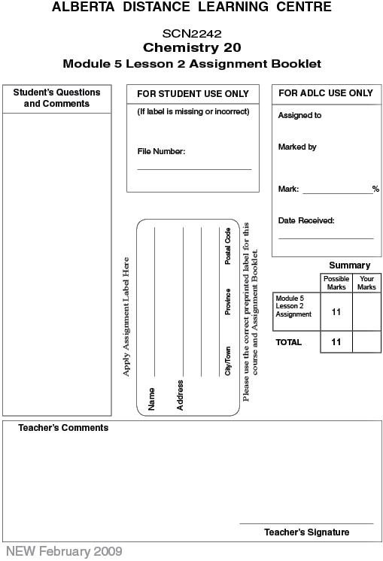

Lesson 2: Assignment: Calculating pH and pOH

 | 1. | Determine the hydronium-ion concentration for a solution that has a pH of 0.17.  (2 marks)

 | 2. | A solution of perchloric acid has a concentration of 3.00 × 10⁻⁴ mol/L. Determine the pH of this solution. (2 marks)

 | 3. | A solution has a pOH of 4.5. Determine the hydroxide-ion concentration. (2 marks)

 | 4. | A solution of strontium hydroxide has a concentration of 8 × 10⁻² mol/L. Determine the pOH of this solution. (2 marks)

 | 5. | Compare the magnitude of the hydroxide-ion concentration of a solution that has a pOH of 2.65 with that of a second solution that has a pOH of 4.65. (3 marks)

Once you have completed all of the questions, submit your work to your teacher.

