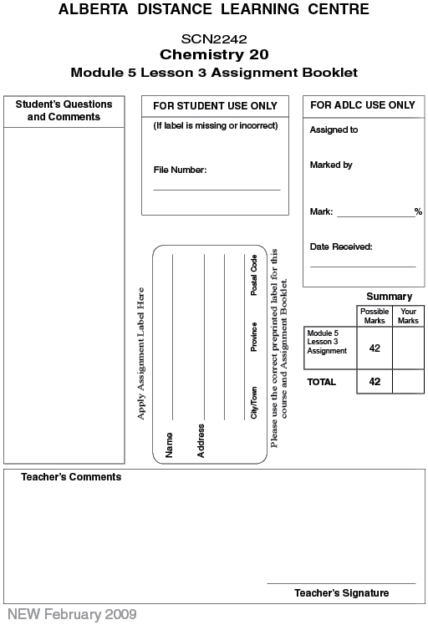

Lesson 3: Assignment: Strength of Acids and Bases

Part 1: Lab: Comparing Two Acids

Analysis

1. Use the data collected from the virtual lab "Comparing Two Acids" to make a list of similarities and differences between ethanoic acid and hydrochloric acid. Discuss conductivity, pH, and reactivity with magnesium in your list. (3 marks)

Part 2

 | 2. | Barium hydroxide, Ba(OH)₂(aq), is used to clean acid spills.

 | a. | What is the classification of this solution? (1 mark)

 | b. | Using a balanced chemical equation, provide a reason for your classification of Ba(OH)₂(aq) in question 6.a. (2 marks)

 | c. | On the basis of your classification, predict the result of a conductivity test for a solution containing Ba(OH)₂(aq). (1 mark)

 | 3. | Oxalic acid, HOOCCOOH(aq), is found in rhubarb leaves.

 | a. | What is the classification of this solution? (1 mark)

 | b. | On the basis of your classification, predict the pH of a solution containing oxalic acid. (1 mark)

 | c. | On the basis of your classification, predict the result of a conductivity test for a solution containing oxalic acid. (1 mark)

 | d. | Write two balanced chemical equations to show the ionization reactions that occur when oxalic acid is in aqueous solution. (2 marks)

 | e. | Compare the relative amount of hydronium produced by each of the ionization reactions written in question 3.d. (1 mark)

 | 4. | Sodium dihydrogen phosphate, NaH₂PO₄(aq), has a pH of 8.2.

 | a. | What is the classification of this solution? (1 mark)

 | b. | Write two balanced chemical equations to explain the observed pH for a solution containing NaH₂PO₄(aq). (1 mark)

 | c. | Suppose the pH was not given. Is there a different set of reactions you could have written and a different interpretation? (2 marks)

 | 5. | List both empirical and theoretical differences between strong and weak bases.  (4 marks)

 | 6. | Two solutions are compared with respect to the pH:  Solution 1: 0.100-mol/L Na2CO3(aq)  Solution 2: 0.100-mol/L KOH(aq)  Explain why these two solutions will have different pH values. (2 marks)

 | 7. | Write balanced chemical equations that show the changes that occur when the following substances are placed in an aqueous solution. Predict the approximate pH for each resulting solution.

 | a. | CN⁻(aq) (2 marks)

 | b. | HNO₃(aq) (2 marks)

 | c. | H₂SO₃(aq) (3 marks)

 | 8. | Each of the following solutions has a concentration of 0.1 mol/L. Compare the hydronium-ion concentration and pH in each pair, and explain why they are different.

 | a. | H₂SO₄(aq) vs. H₂SO₃(aq) (3 marks)

 | b. | H₂S(aq) vs. NH₃(aq) (3 marks)

 | 9. | Each of the following solutions has a concentration of 0.1 mol/L. Compare the hydroxide ion concentration and pH in each pair, and explain why they are different.

 | a. | OCl⁻(aq) vs. KOH(aq) (3 marks)

 | b. | Sr(OH)₂(aq) vs. Ba(OH)₂(aq) (3 marks)

Once you have completed all of the questions, submit your work to your teacher.

