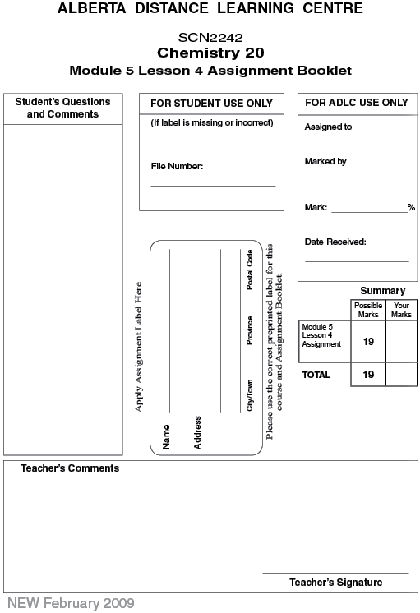

Lesson 4 Assignment: Multi-step pH and pOH Calculations

 | 1. | 5.15 g of HCl(g) is dissolved in water to make a 210-mL solution. Calculate the pH of the resulting solution. (4 marks)

 | 2. | Calculate the mass of strontium hydroxide required to make a 450-mL solution with a pOH of 4.00. (5 marks)

 | 3. | A 150-mL strontium hydroxide solution with a pH of 8.23 is diluted by adding 750 mL of water. Determine the pH of the diluted solution. (5 marks)

 | 4. | 5.0 mL of 0.60 mol/L HI(aq) is mixed with 10.0 mL of water.

 | a. | Calculate the hydronium-ion concentration and pH of the resulting solution.  (2 marks)

 | b. | If 1.0 mL of the diluted solution is added to 9.0 mL of deionized water, calculate the resulting pH of the solution. (2 marks)

 | c. | Suppose 1.0 mL of the solution from part b is added to 9.0 mL of pure water. Predict the resulting pH without doing any calculations. (1 Mark)

Once you have completed all of the questions, submit your work to your teacher.

