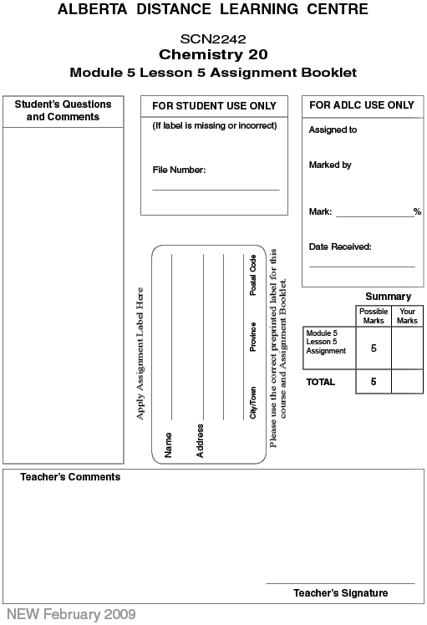

Lesson 5 Assignment: Indicators

Lab: Measuring pH Using Indicators

Analysis

 | 1. | Use the data to estimate the pH of solutions A, B, and C. (3 marks)

 | 2. | Explain how you arrived at your estimation. (1 mark)

 | 3. | State a reason why using indicators only results in an estimation of the pH of the three solutions. (1 mark)

Once you have completed all of the questions, submit your work to your teacher.

