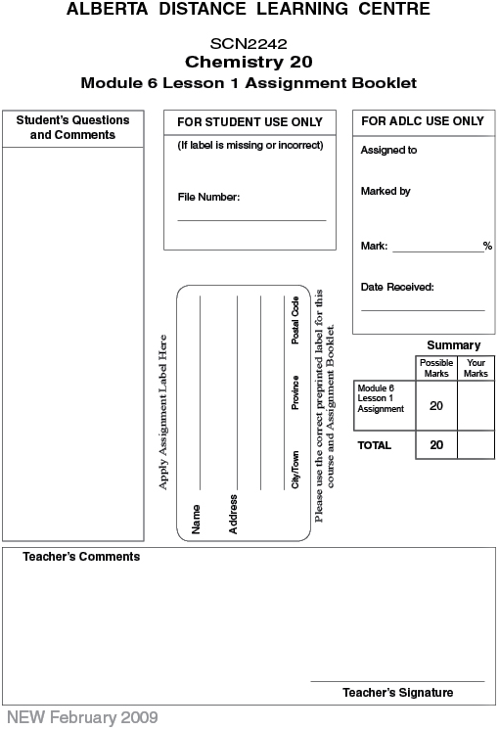

Lesson 1 Assignment: Chemical Equations

 | 1. | Translate the following descriptions into balanced chemical equations. Classify each reaction according to its reaction type.

 | a. | Aqueous solutions of calcium hydroxide and hydrochloric acid are mixed, producing aqueous calcium chloride and water. (2 marks)

 | b. | Solid lead(IV) oxide decomposes to its elements. (2 marks)

 | c. | Propane, C₃H₈(g), combusts in the presence of oxygen to produce carbon dioxide and water vapour. (2 marks)

 | 2. | Complete the following reactions. Ensure each reaction is balanced. (5 marks)
 |  | a. | NaCl(aq) + Ba(s) →
 |  | b. | Al(s) + H₂SO₄(aq) →
 |  | c. | Mg(s) + O₂(g) →

 | 3. | A student mixed a solution of aqueous calcium hydroxide with a solution of phosphoric acid. A precipitate developed.  Write a net ionic equation for this system. Identify any spectator ions present in the system. (3 marks)

 | 4. | Summarize your learning in this lesson by providing an answer to each of the focus questions listed in the table. You may use clear and descriptive examples in your answer. (6 marks)
  Focus Question | Answer
  What information about a chemical system is contained within a balanced chemical equation?
  What information about a chemical system is not contained within a balanced chemical equation?
  What is conservation of mass and how is it demonstrated in a balanced chemical equation?

Once you have completed all of the questions, submit your work to your teacher.

