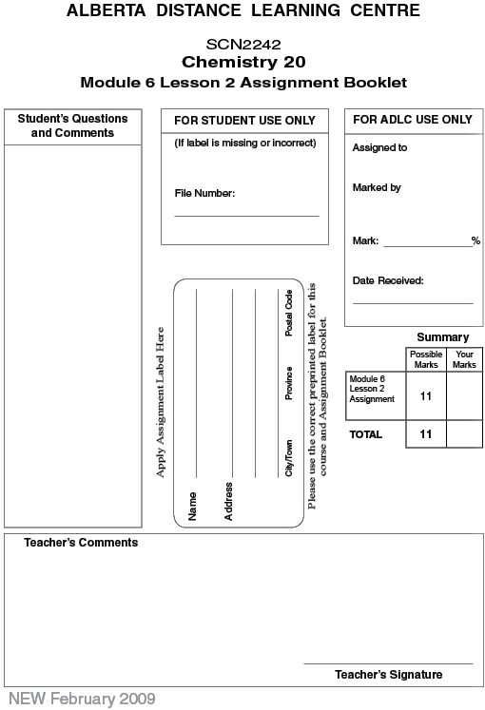

Lesson 2 Assignment: Gravimetric Stoichiometry

Lab: Decomposition of Malachite

 | 1. | Complete the following table.
  Predicted mass of copper(II) oxide that will remain when 2.00 g of malachite undergoes decomposition when heated.
  (3 marks)
  a. mass of an empty Erlenmeyer flask (g) (1 mark)
  b. mass of the Erlenmeyer flask with malachite (g)
  (1 mark)
  Subtract (a) from (b) to obtain the mass of malachite (g).
  (1 mark)
  c. mass of Erlenmeyer flask with CuO (g) after the malachite completely decomposed (1 mark)
  Subtract (a) from (c) to obtain the mass of CuO produced (g) (1 mark)

 | 2. | Calculate a percent difference using the predicted mass and the experimental mass. (2 marks)

 | 3. | Do the results of the experiment support the predictions made using the stoichiometric method? (1 mark)

Once you have completed all of the questions, submit your work to your teacher.

