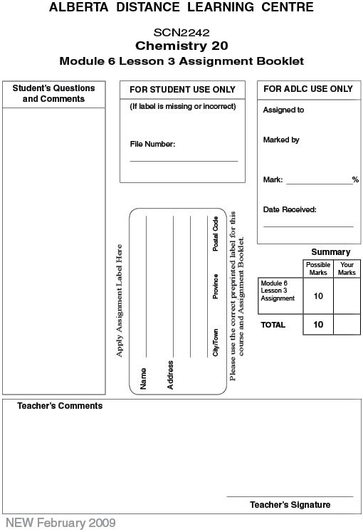

Lesson 3 Assignment: Gas Stoichiometry

Lab: Producing Hydrogen

Analysis

 | 1. | Use the mass of magnesium, the temperature, and atmospheric pressure to predict the volume of hydrogen of gas that will be produced by the reaction. (3 marks)

 | 2. | Use the measured and predicted volumes of hydrogen to calculate a percentage yield and a percentage difference for the experiment. Comment on the relationship between the values obtained for the percentage yield and percentage difference you calculated for this experiment. (3 marks)

Case Study: Producing Hydrogen for Fuel Cells

 | 3. | Based on the stoichiometry of the reactions given on the previous page, what are the ratios of hydrogen to starting material for each of the three processes? (1 mark)

 | 4. | For the production of hydrogen and any other industrial technological process, what are the three main criteria that are used to judge the process? (1 mark)

 | 5. | A source of hydrogen is an important issue if hydrogen fuel cells are going to become useful in automobiles. What perspectives are mentioned in the case study? What important perspective is missing? (2 marks)

Once you have completed all of the questions, submit your work to your teacher.

