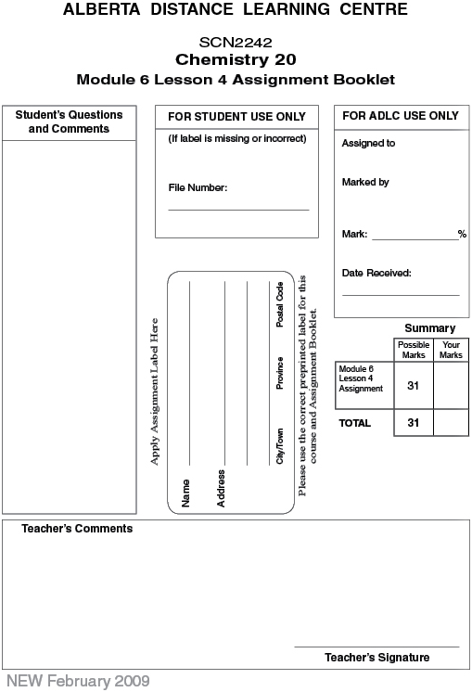

Lesson 4 Assignment: Solution Stoichiometry

Lab: Analysis of Silver Nitrate

 | 1. | Complete the following table.
  Step 1: volume of silver nitrate solution (1 mark)
  Step 7: mass of filter paper (1 mark)
  Step 11: mass of dry silver and filter paper (1 mark)
  Calculate the mass of dry silver produced. (1 mark)
  Calculate the number of moles of dry silver. (1 mark)
  Calculate the amount concentration of the silver nitrate solution. (1 mark)

 | 2. | A technician mixes a solution containing silver nitrate with a solution containing sodium chromate. 2.89 g of precipitate is produced. Calculate the mass of silver nitrate present in the first solution. (3 marks)

 | 3. | A solution containing chromium(III) chloride is analyzed using a reaction with zinc. If 11.5 g of zinc react, what mass of chromium(III) chloride was present in the solution tested? (3 marks)

 | 4. | What volume of oxygen at STP is needed to completely burn 15.0 g of methane in a Bunsen burner? (3 marks)

 | 5. | In a hydrogen fuel cell, hydrogen and oxygen gases react to produce water vapour. What volume of hydrogen at 40 °C and 150 kPa can be burned in a fuel cell using 300 L of oxygen gas measured under the same conditions? (3 marks)

 | 6. | Ammonium sulfate fertilizer is manufactured by having sulfuric acid react with ammonia. In the laboratory, a reaction was done using 50.0 mL of sulfuric acid with 24.4 mL of a 2.20-mol/L ammonia solution. What was the concentration of the sulfuric acid solution? (3 marks)

 | 7. | 1.63 g of precipitate is collected from a reaction of a silver nitrate solution with 10.0 mL of hydrochloric acid. Calculate the concentration of a hydrochloric acid solution. (3 marks)

 | 8. | A 5.95-g sample of AgNO₃(s) is reacted with a solution of BaCl₂(aq). 4.00 g of precipitate were collected. Calculate the percentage yield for the reaction. (3 marks)

 | 9. | 6.32 g of potassium chlorate reacts according to the following reaction:  KClO₃(s) → KCl(s) + O₂(g)

 | a. | Balance the reaction equation given. (1 mark)

 | b. | Determine the mass of oxygen produced by the reaction. (2 marks)

 | b. | Determine the volume of oxygen produced by the reaction at 105 kPa and 300 K. (1 mark)

Once you have completed all of the questions, submit your work to your teacher.

