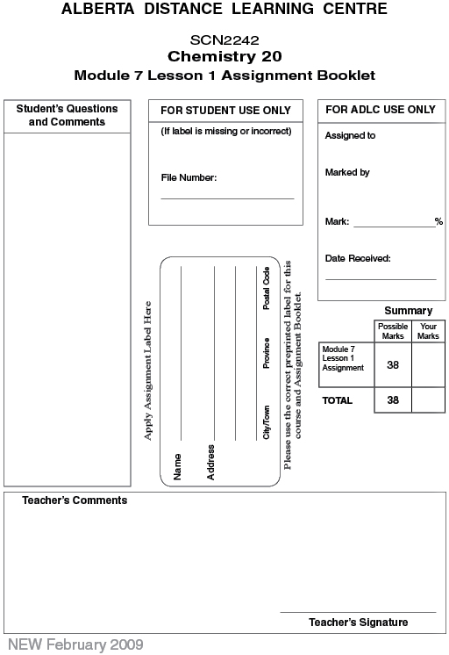

Lesson 1 Assignment: Limiting Reagents

Lab: Chemical Analysis Using a Graph

 | 1. | Read “Lab Exercise 8.A: Chemical Analysis Using a Graph” on page 317 in your textbook. You may also find the information about this reaction on page 318 useful in completing your analysis. After you have read the lab, answer the following questions to complete your analysis.

 | a. | Write the balanced chemical equation for the reaction described in this lab exercise. (2 marks)

 | b. | Identify the limiting reagent and the excess reagent in this lab. (1 mark)

 | c. | What is observed when the two reacting solutions are mixed? Describe a test that could be performed to ensure that the reactions performed were complete. (2 marks)

 | d. | Make a graph of the data shown in “Table 1.” In this lab, the manipulated variable is the mass of Pb(NO₃)₂ reacting.  Use your graph to predict the mass of PbI₂(s) that will be produced from a solution containing 2.5 g of Pb(NO₃)₂(s). (2 marks)

 | 2. | 25.0 mL of 0.150-mol/L KBr(aq) is mixed with excess Pb(NO₃)₂(aq).

 | a. | Write the balanced chemical equation for this reaction. (1 mark)

 | b. | Calculate the number of moles of the limiting reagent. (1 mark)

 | c. | Predict the number of moles of precipitate. (1 mark)

 | d. | Calculate the mass of precipitate. (1 mark)

 | 3. | 3.00 L of methane, CH₄(g), is combusted with 5.50 L of oxygen gas. Assume SATP conditions.

 | a. | Write the balanced chemical equation. (1 mark)

 | b. | Determine the number of moles of each reactant. (1 mark)

 | c. | Predict the limiting reagent and the excess reagent. (1 mark)

 | d. | When the reaction is complete, the atmospheric conditions change. Calculate the volume of CO₂(g) produced if the atmospheric pressure is now 102.1 kPa and the temperature is 22.0 °C. (1 mark)

 | 4. | A 12.0-g piece of copper reacts with 40.0 g of silver nitrate dissolved in solution. What mass of silver will be formed from this reaction? (4 marks)

 | 5. | A laboratory technician measures 1.60 g of CuCl₂(s) and prepares a solution. When the solution is complete, a 150-mg piece of Al(s) is placed into the solution and left to react. Calculate the mass of copper produced when the reaction is complete. (4 marks)

 | 6. | A 150-mL sample of a 0.600-mol/L calcium nitrate solution is mixed with 1.00 L of 0.500-mol/L NaOH(aq). Calculate the mass of precipitate produced in the reaction.  (4 marks)

 | 7. | Approximately 9.10 g of lead(II) acetate is weighed out and placed in a 400-mL solution of 0.150-mol/L sodium hydroxide. Calculate the mass of precipitate produced in this reaction. (4 marks)

 | 8. | Using Stoichiometry to Save the Apollo 13 Astronauts  The solution to the problem of carbon dioxide accumulating in the Apollo 13 spacecraft required the development of a new way to use equipment already aboard the spacecraft. In the lunar module, there was not enough LiOH(s) available to react with all of the CO₂(g) produced by three astronauts because it was designed for only two people. The ingenious design that used scrubbers intended for one part of the spacecraft to be used in another part allowed the NASA engineers to ensure the safety of the astronauts.  How did NASA determine the quantity of lithium hydroxide necessary to operate the carbon dioxide scrubber system? Was a knowledge of stoichiometry required?  The carbon dioxide scrubbers used in the Apollo missions were canisters containing lithium hydroxide. Air in the spacecraft was circulated through the cylinders, allowing a reaction between lithium hydroxide and carbon dioxide to take place.  2 LiOH(s) + CO₂(g) → Li₂CO₃(s) + H₂O(l)  Use the following information to answer the questions that will help you determine the mass of lithium hydroxide necessary for the duration of the mission:  - An average adult at rest exhales 0.50 L of air with each breath and takes approximately 15 breaths per minute.  - Approximately 4.5% of exhaled air is carbon dioxide.  - Assume that conditions in the Apollo 13 lunar module were at SATP.  - The Apollo 13 mission lasted for 3.7 days after the oxygen tank exploded.  - Assume lithium hydroxide reacts completely with carbon dioxide gas.  (7 marks)

What volume of carbon dioxide would the three astronauts exhale in one minute?
What volume of carbon dioxide would the three astronauts exhale in one hour?
What volume of carbon dioxide would the three astronauts exhale in one day?
What volume of carbon dioxide would the three astronauts exhale in 3.7 days, the total time of the mission after the oxygen tank exploded?
What amount, in moles, of carbon dioxide was produced by the astronauts?
What amount of LiOH was required to react with all of the carbon dioxide?
What mass of LiOH was required for the mission?

Once you have completed all of the questions, submit your work to your teacher.

