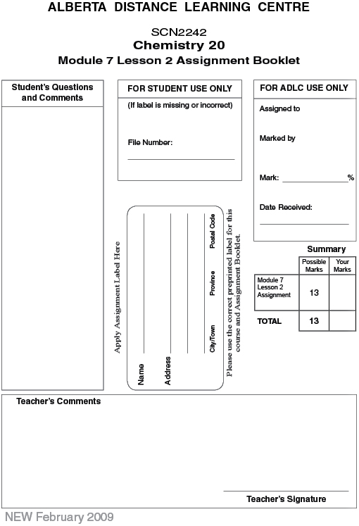

Lesson 2 Assignment: Titration Analysis

Lab: Titration of an Acid with a Base

 | 1. | a. | Write the balanced chemical equation for the reaction described in this lab. (1 mark)

 | b. | From the sample data in the lab, which trials are to be selected for averaging? (1 mark)

 | c. | What is the average volume of titrant to be used from the sample data?  (1 mark)

 | d. | What is the average amount of titrant, in moles, used? (1 mark)
 | e. | What is the average amount of HI, in moles, in the sample? (1 mark)

 | f. | What is the concentration of the acid tested? (1 mark)

Lab: Determining the Quantity of Vitamin C in Fruit Juice

 | 2. | a. | Read the background information and procedure for this investigation. Compare and contrast this procedure with the titration you performed earlier. (2 marks)

 | b. | Use the data to calculate the average number of moles of ascorbic acid present in the titrated samples. (2 marks)

 | c. | The volume of juice tested was 10.00 mL. What amount of ascorbic acid would be ingested if the entire juice box (200 mL) was consumed? (1 mark)

 | d. | Calculate the mass of ascorbic acid in the juice box. (1 mark)
 | e. | Compare this value to the mass of vitamin C you expected in the juice box. (1 mark)

Once you have completed all of the questions, submit your work to your teacher.

