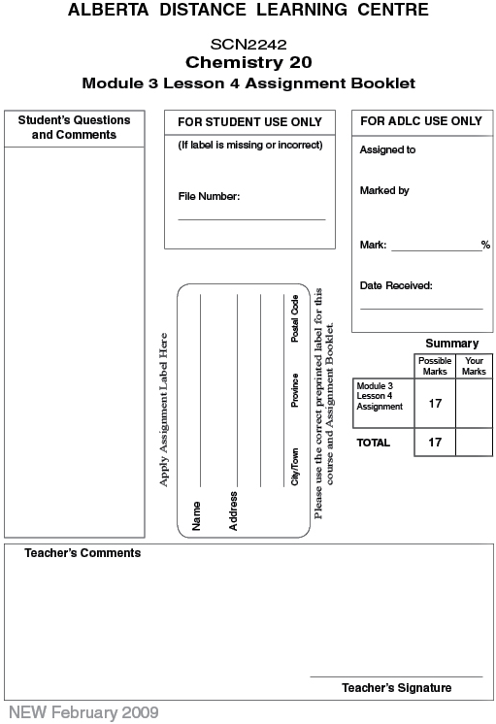

Lesson 4 Assignment: Molar Volume and the Ideal Gas Law

Part 1: Lab: Molar Volume of a Gas

Data

Record the data collected from the experiment in the table below.

Mass of zinc used (g)
Molecular weight of zinc (g/mol)
Volume of 6 mol/L HCL (mL)
Initial pressure inside flask
Maximum pressure reached during the experiment
Initial temperature inside flask
Maximum temperature reached during the experiment
Final pressure in the gas piston at the conclusion of the experiment
Volume of gas collected in the piston

Analysis

 | 1. | Calculate the following:

 | a. | moles of zinc reacted

 | b. | moles of hydrogen produced

 | 2. | - Zinc reacts with HCl to produce hydrogen in a one to one ratio. Based on your calculated number of moles of zinc reacted and the experimental number of moles of hydrogen produced, what is the experimental error in this lab?
 |  | b. | In your opinion, is the percentage error acceptable? What may have been a source of error in this experiment? How does this compare to your hypothesis?
 | Part 2

 | 1. | Hydrogen gas can be used in weather balloons because of its low density. The volume occupied by 3.00 mol of hydrogen at SATP is  - 6.23 L  - 67.2 L  - 73.6 L  - 74.4 L

 | 2. | A 2.50-L balloon contains 0.100 mol of air at 115 kPa pressure. The temperature of the air in the balloon is  - 30°C  - 73°C  - 100°C  - 346°C

 | 3. | Examine the following statements made by students.  - Pressure is directly proportioned to temperature when all other variables are held constant.  - Pressure is directly proportioned to volume when all other variables are held constant.  - Volume is directly proportioned to temperature when all other variables are held constant.  - The number of moles is directly proportioned to volume when all other variables are held constant.  Which statements apply to ideal gases?  - I and II  - II and III  - I and III  - I, III, and IV

 | 4. | Chlorine, a poisonous yellow gas, can be produced by mixing vinegar and bleach for a cleaning solution. The volume occupied by 150 g of chlorine at –12.5°C and 98.5 kPa is  - 46.5 L  - 47.4 L  - 52.5 L  - 93.0 L

 | 5. | Carbon dioxide gas is sometimes used to carbonate beverages. A sample of carbon dioxide occupies a volume of 180 mL at 35.0°C and 88.9 kPa. The volume occupied by the gas at STP is  - 140 mL  - 155 mL  - 178 mL  - 181 mL

 | 6. | Helium gas is contained in a tank with a pressure of 12.4 MPa. If the temperature inside the tank is 32.8°C and the volume of the tank is 18.0 L, determine the mass of helium in the tank.

 | 7. | If 77.60 g of nitrogen gas are produced in a reaction, what is the volume if the temperature is 48°C and the pressure is 99.5 kPa?

Once you have completed all of the questions, submit your work to your teacher.

