Module 7: Lesson 3 ASSIGNMENT

Lesson 1 Assignment: Titration Curves and Selecting Indicators

 | 1. | Place a copy of the titration curve you have drawn here. (5 marks)

Use the following diagram to answer question 2.

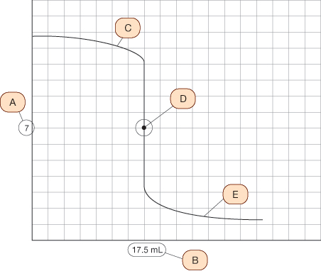

 | 2. | a. | Explain the significance of each point or region in the following titration curve. (5 marks)

 | b. | For the titration curve shown, suggest a possible titrant and test solution. Use features of the titration curve to justify your answer. (2 marks)

 | 3. | Use the following titration curve to answer question 3.

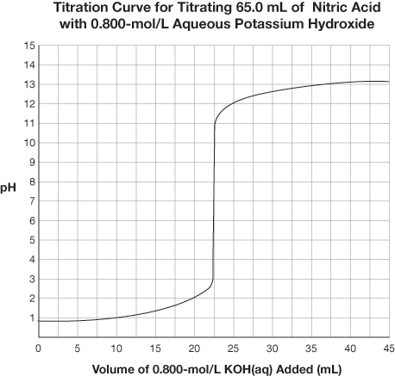

 | a. | Identify the volume of titrant used to reach the equivalence point for the titration. (1 mark)

 | b. | Identify the pH at the equivalence point for the titration. (1 mark)

 | c. | Identify a suitable indicator for the titration. (1 mark)

 | d. | Identify the colour change that signifies the endpoint for the titration using the indicator selected in question 3.c. (1 mark)

 | e. | Determine the concentration of the nitric acid solution analyzed in the titration.  (3 marks)

Titration Analysis of ASA

Purpose

You will analyze data from a titration experiment similar to that performed on page 345 of your textbook. The manufacturer of the pain reliever claims that each pill contains 325 mg of acetylsalicylic acid (ASA).

Read “Investigation 8.6: Titration Analysis of ASA” on page 345 of your textbook.

Materials

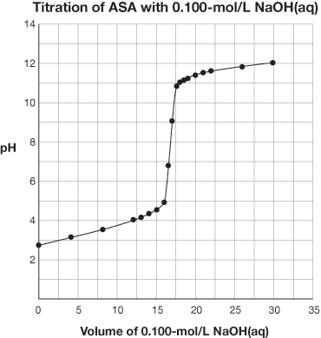

Observations

Titration of dissolved ASA with 0.100-mol/L NaOH(aq)
Trial | 1 | 2 | 3 | 4
Final Burette Reading (mL) | 17.1 | 33.7 | 50.6 | 67.1
Initial Burette Reading (mL) | 0.3 | 17.1 | 33.7 | 50.6
Volume of NaOH(aq) Added (mL) | 16.8 | 16.6 | 16.9 | 16.5

Analysis

 | 4. | Use the titration curve for ASA to justify the selection of phenolphthalein as the indicator used in this experiment. (1 mark)

 | 5. | Use the data collected to calculate the average mass of ASA in the tablets tested.  (3 marks)

Once you have completed all of the questions, submit your work to your teacher.

