Horizontal Text

0.00
0
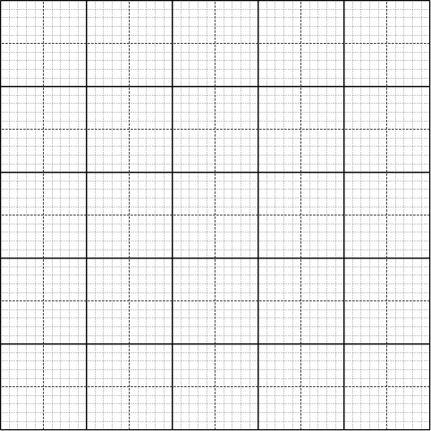
Vertical Text
0.00
0.00
0.00
0.00
0.00
0.00
0.00
0.00
0.00
Horizontal Text

Vertical Text
Horizontal Text
Data Points
0.00

0.00

Instructions for Completion of Graphs
- Textboxes for axes and scale values have been placed on the graph for you. All you have to do is drag over the text and place in appropriate values for the data you are plotting. These boxes can be expanded in case you want longer words in there for a bar graph.
- If there is a need to move any data points or textboxes around , use the up ↑ down ↓ , left ← right → arrows on the keyboard to move the selected object into the appropriate position. Holding down control (Ctrl) key while pressing the above keys will allow for fine position adjustments for exact placement of symbols.
- You can drag data points from the toolbox and roughly place them at the correction location on the graph and then use the keys as in ii. Above for exact placement. This is also true if you need to add text boxes to the graph.
- You can double-click on a data point or textbox in order to change the textboxes borders or their shading , This would include the option of no borders or shading. When you double-click a box will be displayed which include the option to change the borders or shading among many other options.
- The final step in completing your graph will be plotting an appropriate straight line or even a number of straight lines if you wish. Click on the line and drag it to the graph. If you right click the line, you can copy it there and add any number of lines that you wish. Once the line is on the graph, drag each end to exactly where you want it.
- If you want a curve, click inside the graph, then click “AutoShapes” in the tool bar, then go to lines and then click on the curve. Once you have that, click once at each point in turn and a smooth curve will be drawn to connect all dots. Double click when you are done. (On a word document, the menu bar at the top has a number of different icons. Toward the right is a zoom bar which may have "100%" written there. Three places to the left of this (at least on my computer) is an icon called "Drawing" when your arrow is on it. Click on that and the tool bar should show up at the bottom.)
- If you want a bar graph, click inside the graph, then click on the rectangle in the drawing tool bar and then place your rectangle with the proper width and height on the graph. Then click inside the graph again and make the next rectangle, etc.
- When you copy and paste your graph, please highlight everything from the title to the place where it says “Graph Tool Box” so that your teacher can write inside your graph if necessary to show how a slope is obtained for example.
- If your attempt to draw a straight line seems to be incorrect, you can simply select the line, delete it and try again. If you have any problems constructing a graph email me and I’ll get back to you.

