Registration Number: 2019/ICTS/140
Subject: TICT 4253(P) – Intelligent Systems
Name: N.F. Nilofa Banu
Course: Department of Information and Communication Technology, university of Vavuniya

- Problem Description

In Sri Lanka’s IT industry, salaries differ based on job role, skills, and experience. Many job seekers do not know what salary to expect for a specific position, and employers also face difficulty in deciding suitable salary ranges. There is no easy system that gives quick and accurate salary predictions.

This project develops a machine learning model that predicts IT job salaries using job details such as role, technical skills, soft skills, and experience. The system helps users estimate expected salaries and supports better career and hiring decisions.

- Methodology

- Exploratory Data Analysis (EDA)
EDA was performed to understand the structure of the dataset. Summary statistics were generated, handle missing values duplicate rows and Outlier were identified, and salary distribution was visualized using histograms.
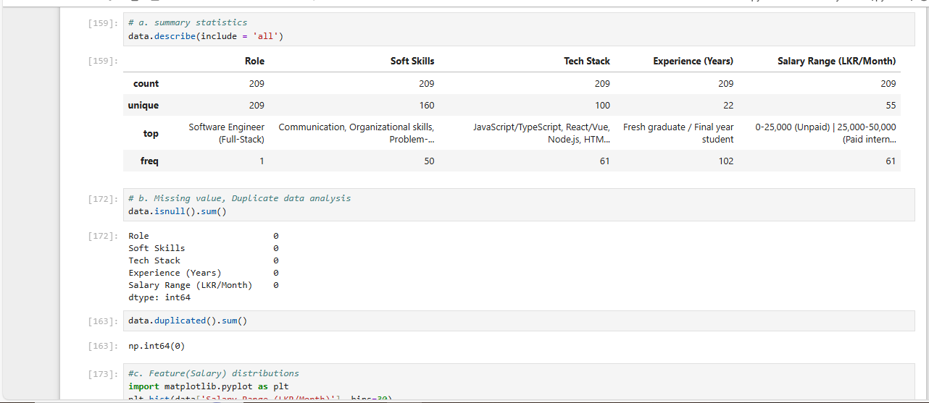

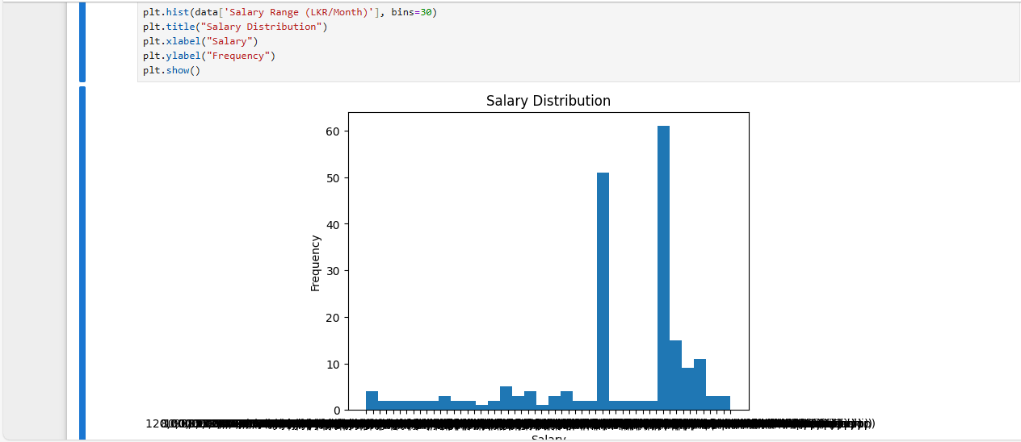
Figure 2 - Sales histogram
Figure 1 - EDA
- Data Preprocessing
Data preprocessing involved removing single value columns and duplicate records, handling missing values using the mean for numeric features and mode for categorical features, and encoding all categorical variables using OneHotEncoder; feature scaling was not applied as the dataset contains only categorical features.

- Model Development
The dataset was split into training and testing sets using a 70:30 ratio. A Random Forest Regressor was selected due to its ability to handle nonlinear relationships and mixed feature types.

- Model Evaluation
The model performance was evaluated using Mean Absolute Error (MAE), Mean Squared Error (MSE), Root Mean Squared Error (RMSE), and R² Score.

- Results and interpretation
The model achieved an MAE of 5678.085, RMSE of 15415.6139, and an R² score of 0.94541. The high R² value indicates that the model explains approximately 94% of the variance in salary, demonstrating strong predictive capability.

- discussion
The results show that job role, experience, and technical skills have a strong effect on salary. The Random Forest model performed well because it can learn complex patterns in the data. However, the predictions may not always be perfect since the dataset size is limited.

