**FAKE NEWS DETECTION USING NLP IN ARTIFICIAL INTELLIGENCE**

**TEAM MEMBER**

**au820421205045: NILOFERNISHA N**

**Phase-4 SUBMISSION DOCUMENT**

**Project: Fake News Detection**

**Phase 4: *Development Part 2***

**PROBLEM STATEMENT**

Continue using NLP techniques to train a classification model in order to develop the false news detection model. Training and assessing models for text preprocessing and feature extraction

**GIVEN DATASET**

**Dataset Link:**<https://www.kaggle.com/datasets/clmentbisaillon/fake-and-real-news-dataset>

**real.csv**

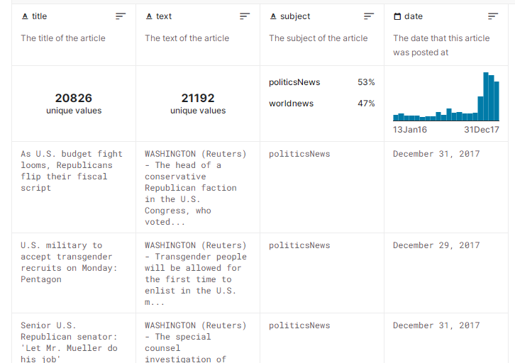

**fake.csv**

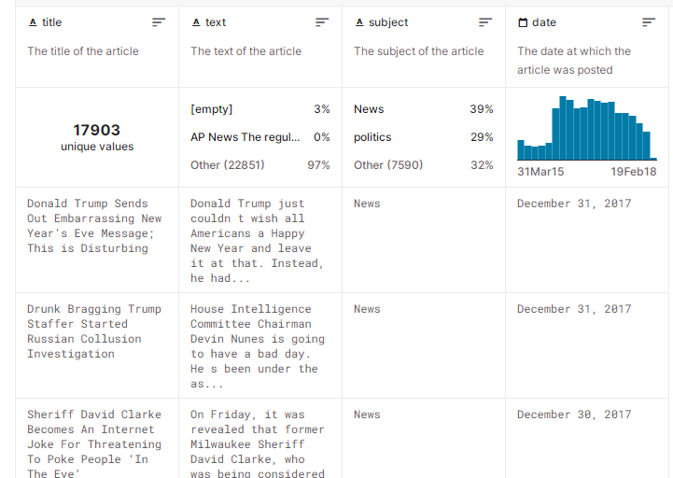

**IMPORTING LIBRARIES**

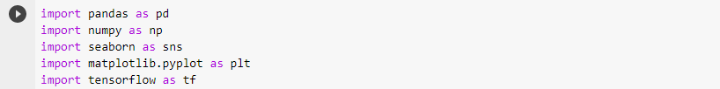

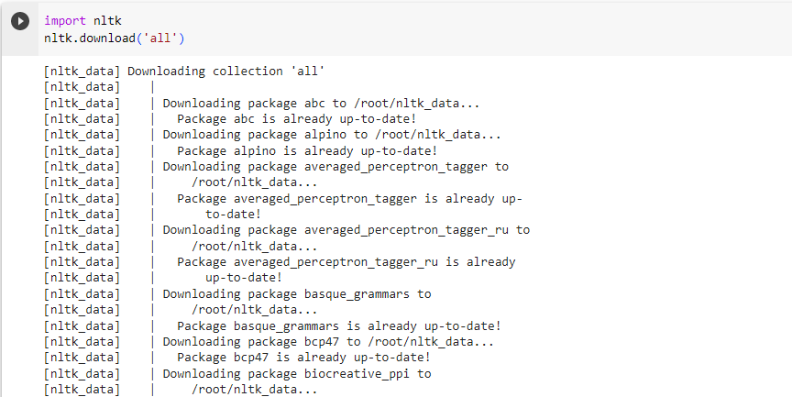

**OUTPUT:**

OP.PNG

**LABELING:**

**PROGRAM:**

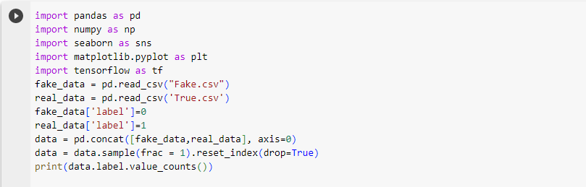

**OUTPUT:**

P3.PNG

**DATA CLEANUP**

Cleaning up data in fake news detection using natural language processing (NLP) is a critical step in building an effective model for identifying fake news.

**PROGRAM:**

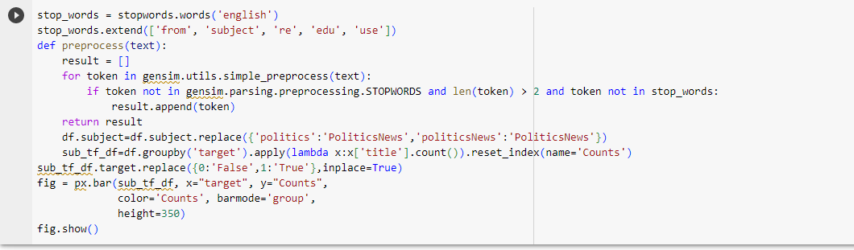

**OUTPUT:**

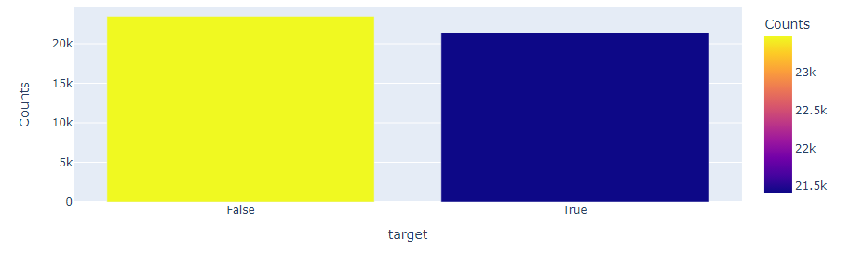

**TEXTPREPROCESSING**

Detecting fake news using Natural Language Processing (NLP) techniques is a critical task, requiring text preprocessing to clean and transform raw text into a format suitable for analysis. Key steps include:

1. **Lowercasing:**

Convert all text to lowercase to ensure uniformity and avoid treating words with different cases as different entities.

1. **Tokenization:**

It is a crucial process that breaks text into individual words or tokens, enabling further processing like removing stop words and punctuation.

1. **Stop Words Removal:**

It removes common words from a text, reducing noise and focusing analysis on essential content.(eg., 'and', 'the', 'is', etc. )

1. **Lemmatization and stemming:**

These are techniques that reduce words to their base or root form, ensuring that different forms of the same word are treated the same.

1. **Vectorization:**

It is the process of converting preprocessed text data into numerical format for machine learning models, using techniques like bag-of-words, TF-IDF, and word embeddings like Word2Vec or GloVe.

1. **Removing URLs and Email Addresses:**

Fake news articles often contain irrelevant URLs or email addresses, which can be removed to enhance the focus on the textual content.

1. **Feature engineering:**

It involves extracting relevant text features like n-grams, TF-IDF, and word embeddings to capture contextual information and word relationships.

**MODEL TRAINING**

1. **DATA COLLECTION AND PREPARATION:**

The study involves collecting and preparing a diverse dataset of labeled news articles, including both genuine and fake news, and preprocessing it for NLP analysis.

1. **DATA SPLITTING:**

Data splitting involves dividing preprocessed data into training and testing sets to enable the model to learn patterns from training data and assess its performance on unseen data.

1. **HYPERPARAMETER TUNING:**

The model's performance can be enhanced by fine-tuning its hyperparameters using techniques like grid search or random search to find the optimal combination.

1. **VALIDATION ON TEST SET:**

The final model must be validated on a testing dataset to ensure its generalizability and robustness, and any unsatisfactory results should be addressed**.**

1. **CONTINUOUS IMPROVEMENT:**

The model's performance is continuously monitored and improved through regular updates, incorporating new data to enhance accuracy and reliability over time.

1. **MODEL DEPLOYMENT:**

The trained model is deployed in the production environment for real-time fake news detection, and its performance is monitored and retrained periodically to adapt to data trends.

**PROGRAM:**

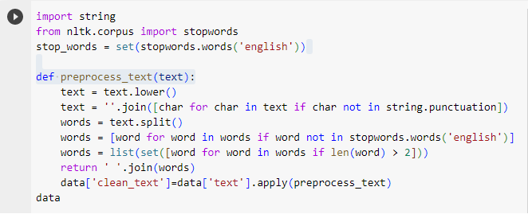

**OUTPUT:**

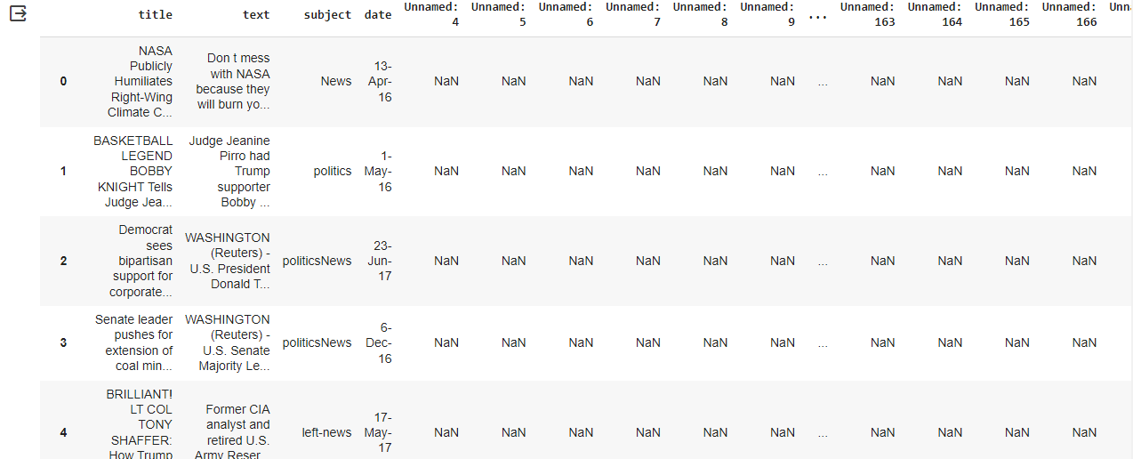

**WORDCLOUD FOR REAL NEWS**

**PROGRAM:**

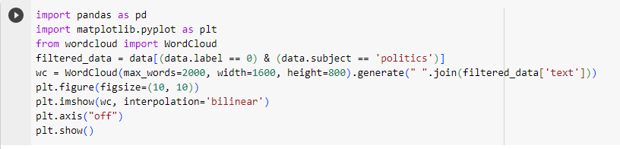

**OUTPUT:**

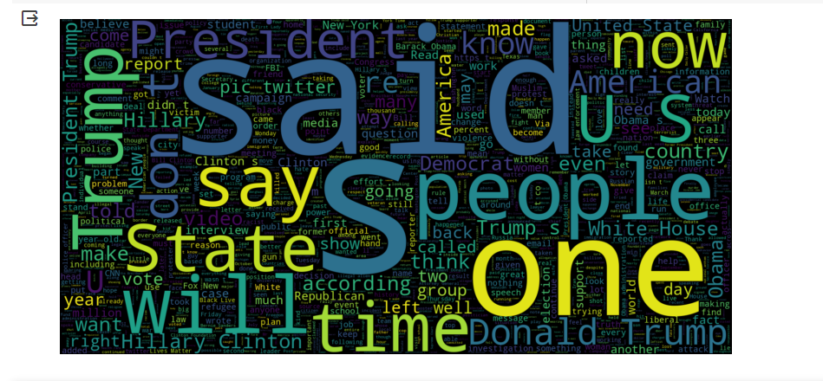

**WORLDCLOUD FOR FAKENEWS**

**PROGRAM:**

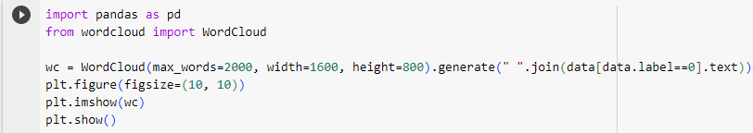

**OUTPUT:**

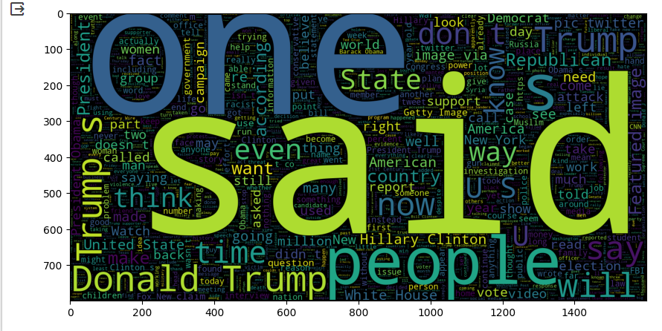

**DATA VISUALIZATION**

**PROGRAM**

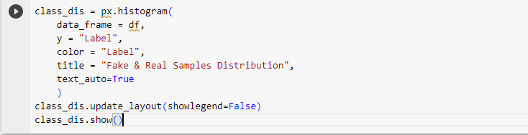

**OUTPUT:**

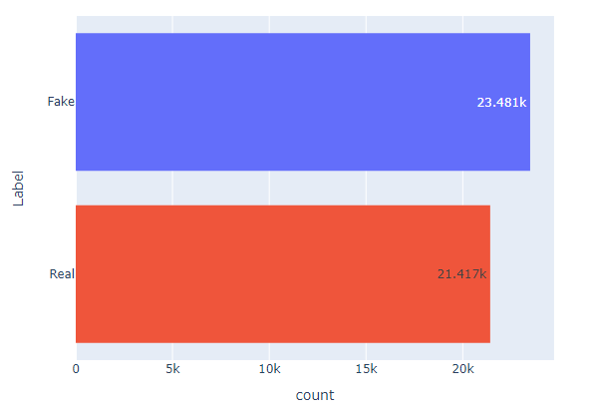

**FEATURE EXTRACTION**

Feature extraction is a crucial step in constructing machine learning models for fake news detection using Natural Language Processing (NLP), capturing essential information to distinguish genuine and fake news.

**EVALULATION**

Evaluation of fake news detection using NLP is crucial for assessing model performance and effectiveness in distinguishing genuine and misleading information using various metrics and techniques.

1. **ACCURACY:**

The model's overall accuracy, which represents the ratio of correctly classified articles to the total dataset, may not be sufficient in an imbalanced dataset.

1. **PRECISION AND RECALL:**

The study calculates precision, indicating the proportion of accurately identified fake news articles, and recall, indicating the proportion of truly fake articles in the dataset.

1. **CONFUSION MATRIX:**

The confusion matrix provides a comprehensive view of a model's performance and helps identify types of errors made by it.

1. **CROSS VALIDATION:**

Cross-validation techniques like k-fold cross-validation ensure consistent model performance across different dataset subsets, reducing overfitting risk and ensuring consistent performance across different datasets.

1. **BIAS AND FAIRNESS ANALYSIS:**

The analysis of the model's bias and fairness is crucial to ensure it does not exhibit any biases towards specific groups or topics, and its predictions are fair and unbiased.

**SPECIFICITY AND SENSITIVITY**

Calculate specificity (true negative rate) and sensitivity (true positive rate) to measure the proportion of genuine and fake news articles in a dataset.

**CLASSIFICATION REPORT:**

**PROGRAM:**



**OUTPUT:**

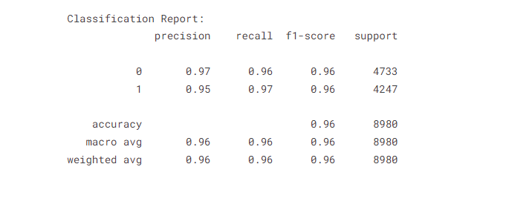

**CONCLUSION**

The use of Natural Language Processing (NLP) in detecting fake news is a promising method to combat misinformation. It uses text preprocessing techniques and feature extraction methods to capture linguistic nuances and contextual cues, requiring regular evaluation and refinement for accuracy.