ART 3870 PROJECT SUBMISSION

NAME: Niloofar Khodabakhsh
NET ID: pt4897
COURSE: YEAR (2017)/ QUARTER (FA, WI, SP) /SECTION (01, 02)

Project Title: Long scrolling Website

Project URL on github.com: https://github.com/Nilook/art3870-w17/tree/master/longscrolling
Project URL on github.io: https://nilook.github.io/art3870-w17/longscrolling/index.html

Project Sketches: 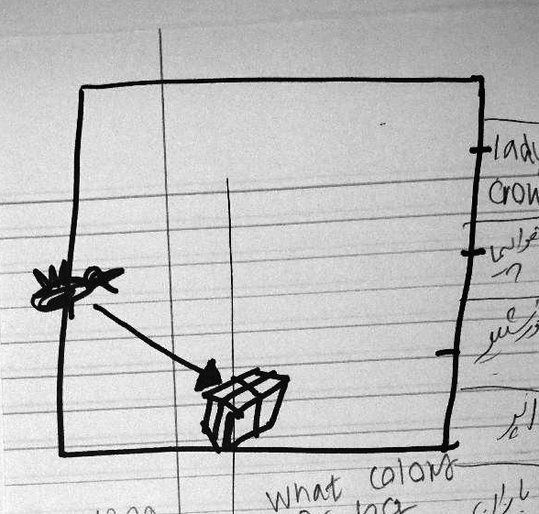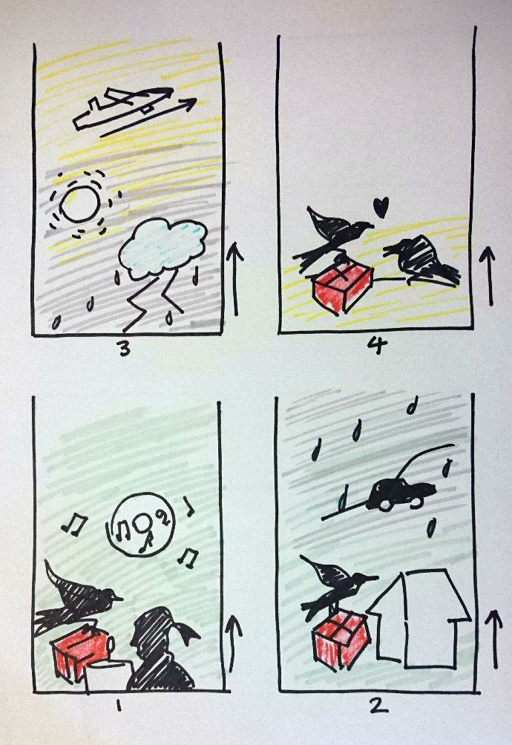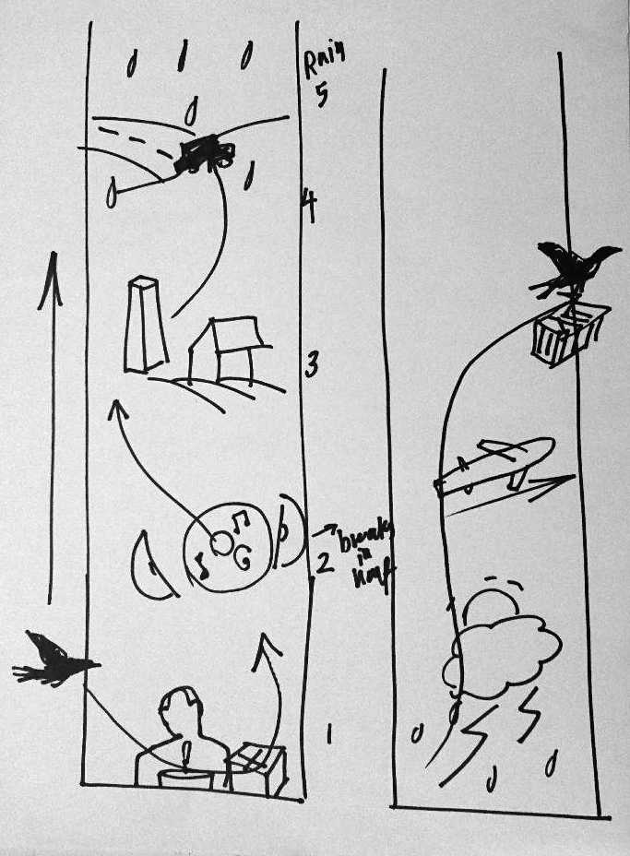
Project Screenshots:
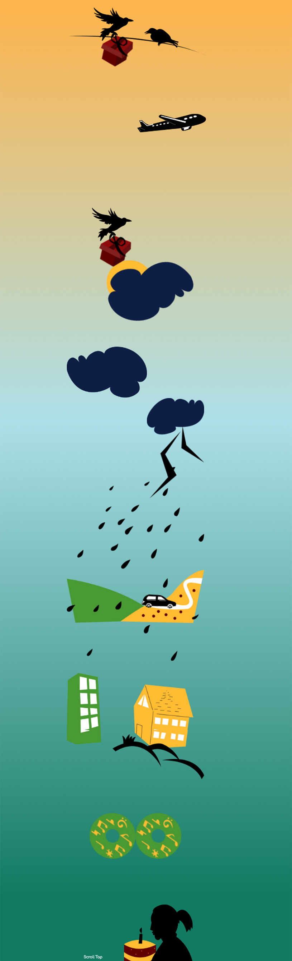
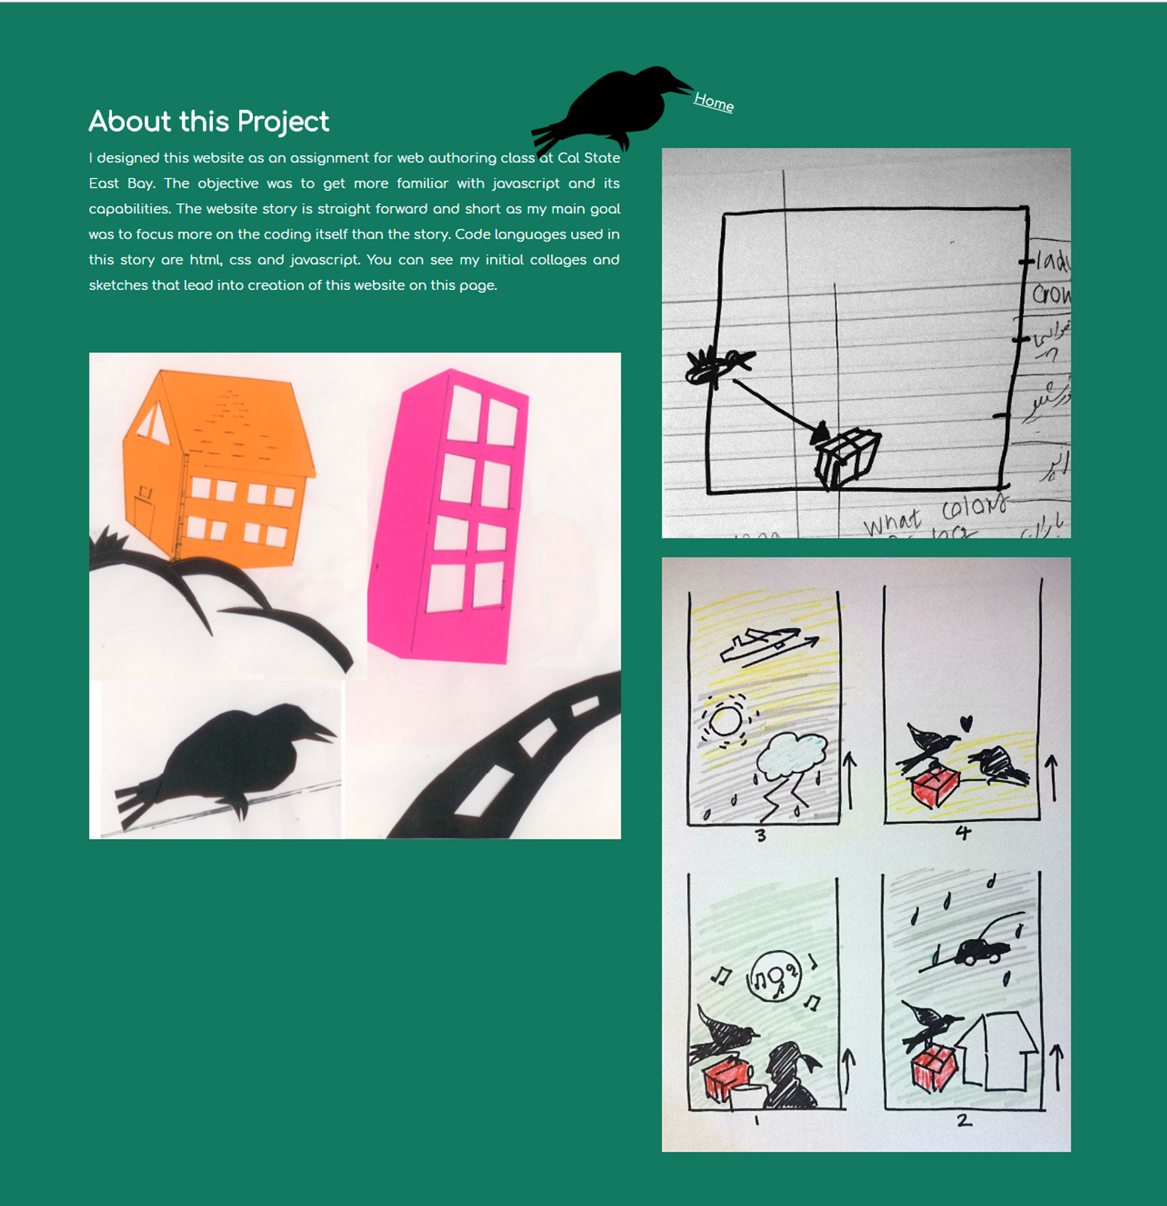

Project Design considerations:
(Explain 3 of your major design decisions)

- I tried to limit my color choice for background yet I intended to create different feeling for different elements by changing the background color. So I ended up using three colors: greenblue, light blue and orange.

- I kept the design of the illustrations as simple and less complicated as possible to get the attention of the viewer more on the story itself than to the elements.

- I chose to high contrast between the colors in illustrations and in the background since I thought it matches the content.

Project Reflection:
(250 words – reflective writing –What was the most challenging part? What was the most exciting part now that the project is done? What did you learn in this assignment, what is your biggest takeaway?)

This project, like animation project, opened my eyes to how creative websites can look like with the use of JS and CSS. It was also a good opportunity to improve storytelling skills.
What I learned in this assignment was a bit of JS. I also gained some confidence in writing the JS code myself. It helped me improve my CSS skills, too. My biggest takeaway of this project, though, is neither JS nor CSS. When I started this project and was looking for ideas I changed my mind a lot. Started with an idea, did some work and again changed to another one and so on. I was trying to find the “perfect” idea that suits the concept of assignment.What happened was that not only I didn’t find the perfect idea but also I ended up doing the assignment in a rush to meet the deadline. Not that it was my first time postponing things with having the idea of perfection in mind, but this project was indeed an alert for me. So yes, my biggest takeaway is sticking to an idea and make it work even if it’s not perfect. I like the result now but It could be much better. There are a lot of things that I would do differently if I did this project again. For example, I would work more on the story and give it more complexity and I would take advantage of JS to make the parallax movements with different speeds in objects.

