

American International University- Bangladesh

CSC 3222: Web Technologies

CO1.1 and CO2.1 Evaluation
Project Report
Fall 19-20

Project Title: Online Health Care System
Section: A

Student Name | Student Id
SIAM, ASIF MAHMUD | 18-36955-1
KUMAR, NILOY | 18-37632-1
TUHIN, BORHAN UDDIN | 18-36391-1
ALAM, SAFINA | 18-36395-1

Introduction:

We are doing a project based on “Online Health Care System”. We are doing this project thinking about the current COVID-19 pandemic situation of the whole world. We choose this project so that people can be served necessary health care through online staying at home in this pandemic situation. It can be a very helpful system to the audience.

Background Study

In Web Technologies course we decide to do Online Health Care system. For doing this purpose we visit this site https://www.nychealthandhospitals.org/ and http://www.grs.net.au/ in this Online Health Care system they have only Doctor management to treatment the patient. In world Covid’19 pandemic situation, we decide to make a system where patient take treatment through experience doctor from anywhere. Beside we have plasma collector where patient can receive and donate plasma. They can see all plasma donor information and connect them through conversation system. We visit this Blood Bank site also http://www.bdrcs.org/donate-blood. So, we decide also include blood donor service. Patient can see all blood donor list and contact them through conversation system. Other health care provides only doctor management service but, in our system, we provide doctor service, plasma collector and blood collector. As a result, a patient can find necessary all type of service in our system.

Requirement Analysis:

- User Category:

There are 4 types of Users here. They are:

- Admin
- Doctor Management
- Plasma Collector
- Blood Collector

- Feature List:

In this project the “Admin” has the following features:

- Can View Doctor List
- Can Search doctor name
- View patient List
- Search patient name
- Conversation with doctor with text
- Conversation to patient with text
- Can see profile
- View blood donor list
- View blood receiver list
- Blood report delivery
- Search plasma donor
- View plasma receiver

In this project the “Doctor Management” has the following features:

- Doctor information add to the database
- Can View Doctor List
- Can Search doctor name
- Make doctor schedules
- Make appointment
- Show doctor Schedules chart to patients
- Patient information add to the database.
- View patient List
- Search patient name
- Make a sale for report for everyday transaction
- Conversation to patient with text
- Conversation with doctor with text
- Transportation service to the for ambulance

In this project the “Plasma Collector” has the following features:

- Add plasma donor to the database
- View plasma donor list
- Search plasma donor
- Add plasma receiver to the database
- View plasma receiver
- Search plasma receiver
- Show plasma donation available chart
- Checking plasma blood sample
- Conversation with plasma donor
- Conversation with plasma receiver
- Add covid’19 patient details in database
- Delivery report with text system

In this project the “Blood Collector” has the following features:

- Add Blood donor list to database
- View Blood Donor list
- Search Blood donor list
- Add blood receiver list to database
- View blood receiver list
- Search blood receiver list
- Checking blood donor sample
- Conversation with blood donor
- Conversation with blood Receiver
- Blood report delivery
- Make a sales report
- Show sales report

ER Diagram Design:

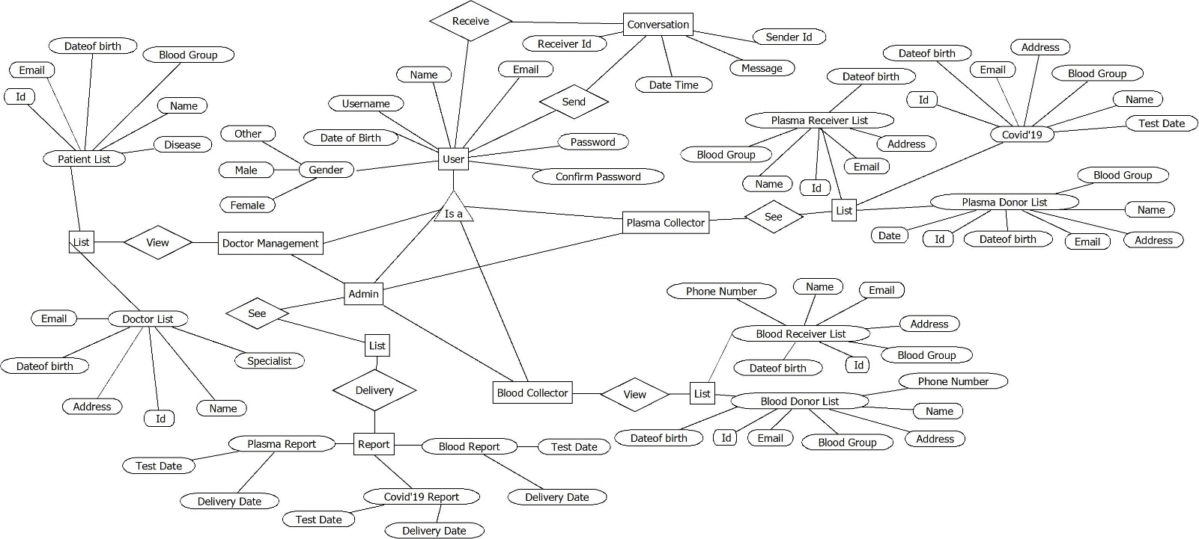

Tools Used:

To develop this project, we have used the following:

• Sublime text
• Google chrome
• Xampp
• My sql server
• Apache server
• GitHub
• Dia tool

System Images against the Specification:

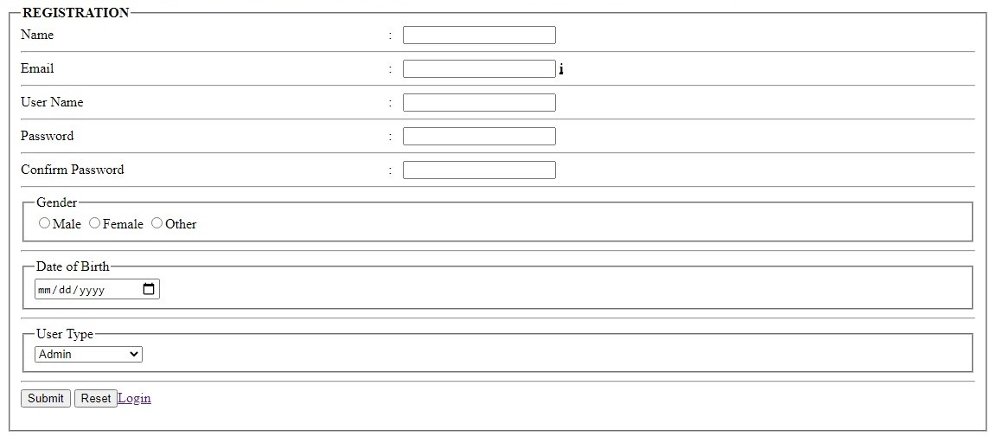

Every user first registration here. User should fill up all the fields and username should be unique otherwise registration not accept. Password and confirm password should be same.

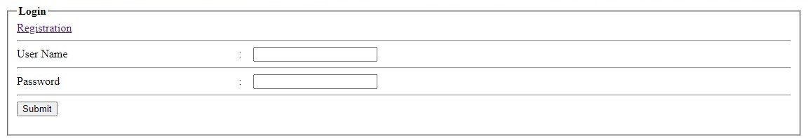

After registration, user login with their username and password.

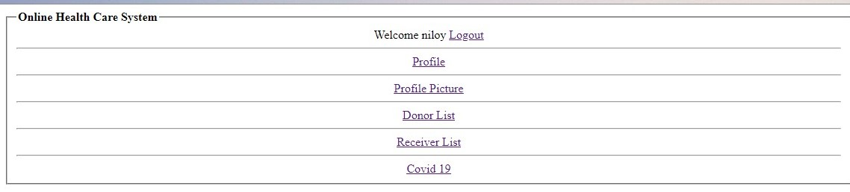

This is admin home page. Admin can see doctor list and patient list and can update her/his profile and logout from this home page and also user can control other 3 users.

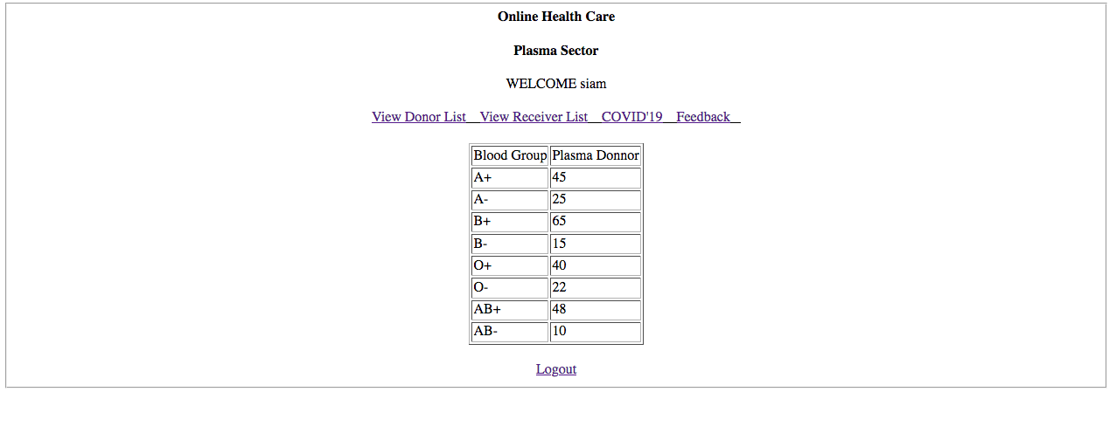

This is plasma collector home page. In home page there are view donor list, view receiver list, Covid’19, Feedback. User can see plasma donor chart and logout from home page.

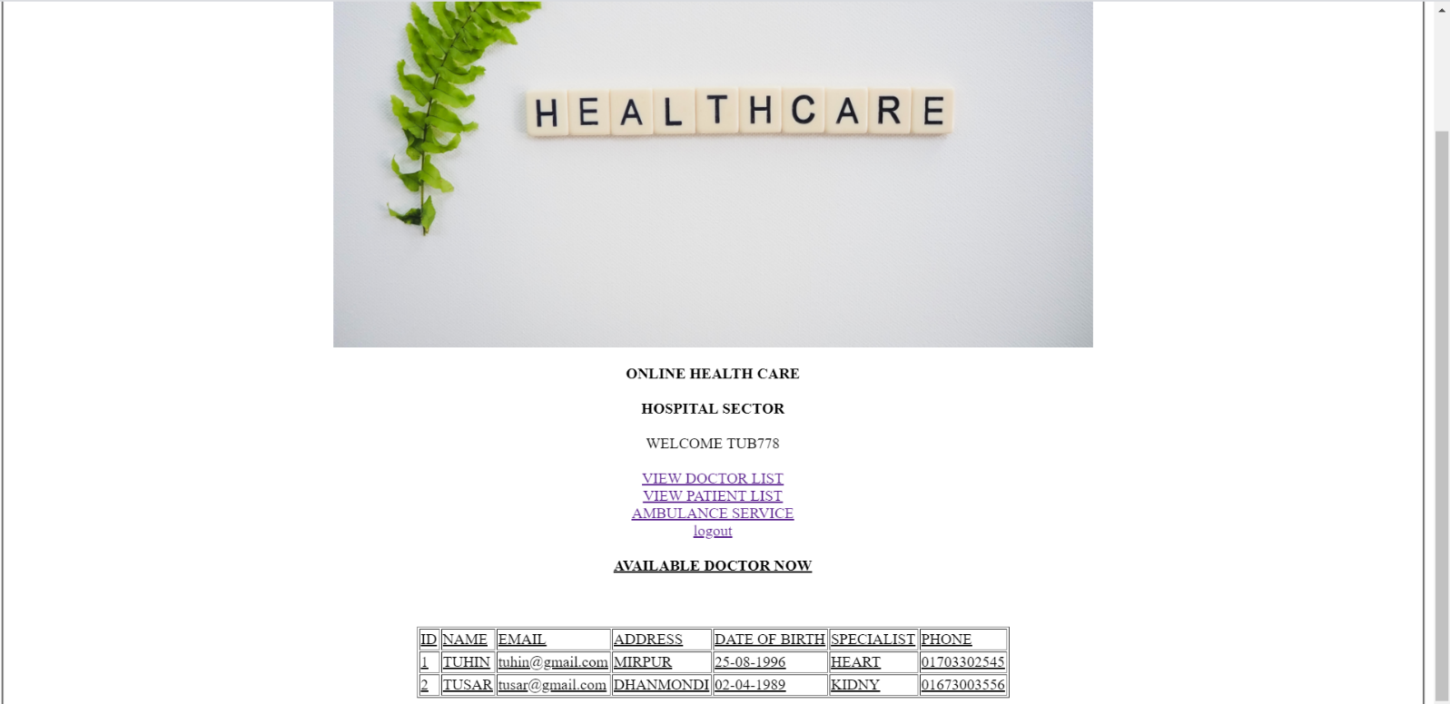

This is the doctor patient home page. In this page we can see that doctor patient list and also ambulance service. When user click view doctor list and view patient list, he can see all doctor and patient list very easily. User can use ambulance service in our system.



This is blood collector home page. In home page there are view donor list, view receiver list. User can see blood donor chart and logout from home page.

Impact of this Project:

We are creating this project because in this covid’19 situation there are many online health cares in this country and they are only serving the doctor service. But in this project, we are serving doctor service, patient service, plasma donor service and also blood bank service. That service makes a covid’19 patient happy and problem free.

Limitations and Possible Future Improvements:

In our system we can not provide doctor service 24/7. In our service doctor schedule doctor available time at 08:00AM - 05:00 PM. Beside in our system patient can not connect doctor with video chat. They just conversation with appointed doctor through text then they can video chat with other through social media. In plasma and blood collector sector we took patient blood sample at 08:00AM - 05:00 PM.
In future we add video conversation and doctor available system 24/7.

CO1.1 and CO2.1 Evaluation: Project Report Evaluation
Project Proposal  (5) | Background  Study  (5) | Requirement Analysis  (5) | Entity  Diagram  (5) | System Images  against the  Specification (5) | Total  (25)

