Usability and Accessibility Analysis: Evaluating Section 508 and WCAG Compliance Across Minnesota Public Sector Web Infrastructure
Abstract
Digital accessibility is a fundamental requirement for public sector web infrastructure, mandated by Section 508 of the Rehabilitation Act and guided by the Web Content Accessibility Guidelines (WCAG) 2.1. Despite these legal and ethical imperatives, ensuring consistent compliance remains a significant technical challenge for government agencies and educational institutions. This study presents a comprehensive automated accessibility audit of 30 public-facing Minnesota state, local, and university websites. Utilizing a headless Chromium browser integrated with the Axe-core accessibility engine via Python and Playwright, we conducted a systematic evaluation of the Document Object Model (DOM) across these domains. Our analysis revealed 241 total accessibility violations across the dataset. Notably, 19 of the 30 evaluated websites contained at least one "Critical" or "Serious" accessibility barrier. The findings highlight systemic failures in semantic HTML structuring—specifically concerning ARIA landmarks—and color contrast ratios. This paper contextualizes these failures within the broader landscape of digital equity, discusses the limitations of automated testing, and proposes continuous integration (CI/CD) remediation strategies to prevent compliance regressions.

1. Introduction
The digital transformation of public services has fundamentally altered how citizens interact with government entities and educational institutions. From applying for state benefits to accessing university course catalogs, digital platforms serve as the primary interface for civic engagement. Consequently, ensuring equitable access to this digital information is not merely a best practice, but a civil rights mandate. Under Section 508 of the Rehabilitation Act, federal and federally-funded infrastructure must comply with rigorous accessibility standards to accommodate elderly citizens and individuals with disabilities.
Despite these regulations, a persistent gap exists between statutory requirements and the actual usability of public web infrastructure. Manual accessibility auditing—while comprehensive—is highly resource-intensive, expensive, and prone to human error. It is often performed infrequently, allowing accessibility barriers to be inadvertently introduced during routine website updates.
To bridge this gap, this paper demonstrates a scalable, automated approach to accessibility auditing. By systematically crawling and evaluating public web domains across Minnesota, this research aims to answer the following core questions:
- What are the most prevalent technical accessibility barriers currently present in Minnesota's public sector web infrastructure?
- How do compliance failure rates and severity levels vary across different types of public institutions (e.g., state agencies vs. universities)?
- How can automated auditing tools be effectively deployed to remediate these issues?

2. Literature Review
The pursuit of digital equity is heavily guided by the World Wide Web Consortium (W3C), which publishes the Web Content Accessibility Guidelines (WCAG). WCAG 2.1 AA is widely recognized as the international gold standard for web accessibility and serves as the technical baseline for Section 508 compliance.
Previous literature analyzing public sector web accessibility consistently indicates high failure rates. Studies evaluating municipal and state government portals frequently reveal pervasive issues with navigation, contrast, and screen-reader compatibility. However, many of these studies rely on manual sampling or static HTML analysis, which fails to account for modern Single Page Applications (SPAs) and dynamic content rendered via JavaScript.
Recent advancements in automated testing, specifically utilizing headless browsers (like Puppeteer or Playwright) paired with robust accessibility rulesets (like Deque Systems' Axe-core), allow researchers to evaluate the fully rendered Document Object Model (DOM). While automated tools are generally estimated to catch only 30% to 50% of total WCAG violations (as they cannot programmatically verify subjective elements, such as the quality or context of an image's alt text), they are highly effective at identifying structural, syntactic, and contrast-based barriers at scale.

3. Methodology

3.1 Target Selection and Sampling
The dataset for this study comprises 30 Minnesota-based public sector websites. The domains were selected using convenience sampling, targeting high-traffic portals essential for civic life, public information, and higher education. The sample was stratified into three primary categories:
- State Government Agencies: (e.g., Department of Natural Resources, Department of Health, Department of Employment and Economic Development).
- Local Municipalities and Transit: (e.g., Metro Transit, City of St. Cloud).
- Public Universities (Minnesota State System): (e.g., St. Cloud State University, Minnesota State University, Mankato, Bemidji State University).

3.2 Automated Audit Architecture
The technical audit was executed using a custom-developed Python testing framework. The playwright library (v.1.x) was utilized to initialize headless Chromium browser sessions. Unlike simple HTTP requests, Playwright executes JavaScript and waits for network idle states, ensuring that the fully rendered DOM was analyzed just as it would appear to an actual user.
Upon successful page load, the axe-playwright-python wrapper was employed to inject the Axe-core accessibility ruleset directly into the browser context. Axe-core evaluated the DOM against WCAG 2.1 AA standards, generating a structured compliance report.

3.3 Data Collection and Processing
The Axe-core engine outputs violations categorized by impact severity (Critical, Serious, Moderate, Minor) as defined by Deque Systems. The raw JSON outputs from the audit were parsed and aggregated into a pandas DataFrame for statistical analysis. To facilitate remediation mapping, the framework specifically extracted the exact CSS selectors (identifying the specific DOM nodes) and the raw failing HTML snippets for every recorded violation.

4. Results

4.1 Aggregate Compliance Landscape
The automated audit successfully analyzed all 30 target domains, identifying a total of 241 discrete accessibility violations. The distribution of these violations by severity underscores a significant volume of moderate-to-severe usability barriers:
- Moderate: 162 violations (67.2%)
- Serious: 58 violations (24.1%)
- Critical: 14 violations (5.8%)
- Minor: 7 violations (2.9%)
The most frequently occurring compliance failure across the entire dataset was "Region" (missing ARIA landmarks), which accounted for 111 violations (50.2% of all errors). The second most prevalent issue was "Color Contrast," accounting for 11.3% of the recorded violations.

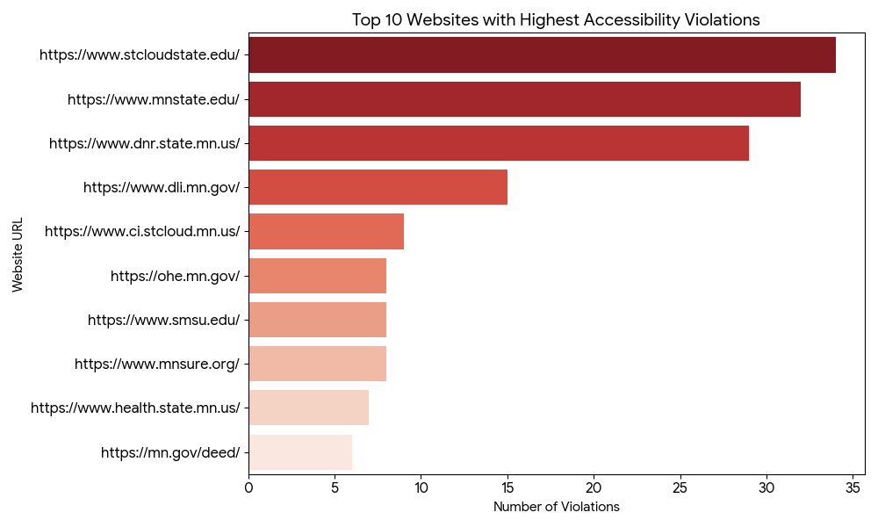
Figure 1. Top 10 public sector websites with the highest total number of accessibility violations. St. Cloud State University recorded the highest overall volume of WCAG 2.1 AA compliance failures during the automated audit.

4.2 Domain-Specific Vulnerabilities
Analysis of individual domains revealed significant variance in compliance adherence. Systemically, 19 of the 30 evaluated websites (63.3%) contained at least one major barrier—defined as a "Critical" or "Serious" violation—that would actively impede or entirely block a user employing assistive technologies.
St. Cloud State University (https://www.stcloudstate.edu/) generated the highest total volume of errors in the dataset, recording 34 distinct violations. However, when evaluating based on severity, the Minnesota Department of Natural Resources (https://www.dnr.state.mn.us/) required the most urgent remediation. The DNR portal exhibited the highest concentration of high-impact barriers, returning a combined total of 20 Critical and Serious violations.

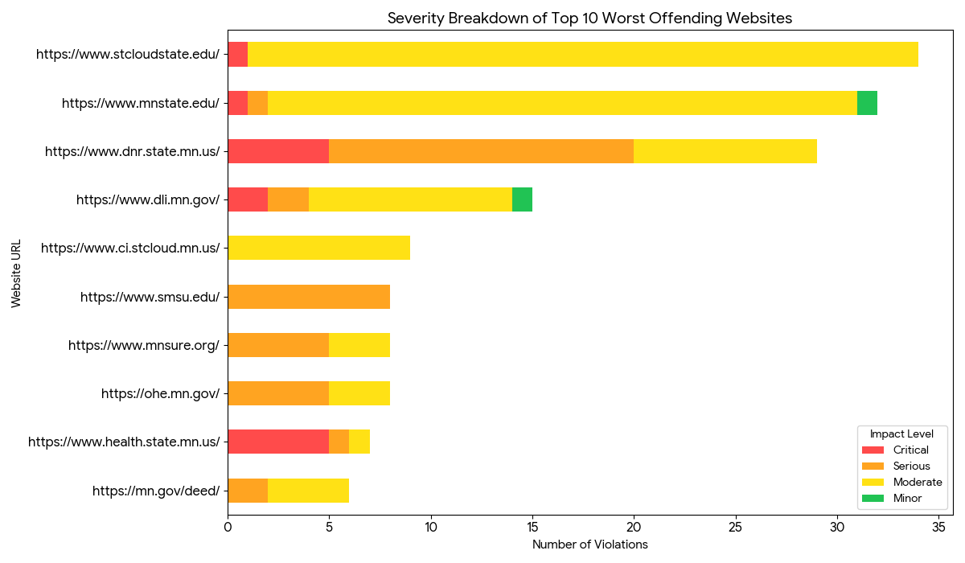
Figure 2. Severity breakdown of accessibility violations across the 10 worst-offending websites. Violations are categorized by Deque Systems' impact levels (Critical, Serious, Moderate, Minor). While other domains had a higher total volume of errors, the Minnesota Department of Natural Resources exhibited the highest concentration of high-impact (Critical and Serious) barriers.

5. Discussion and Remediation Strategies

5.1 Semantic HTML and Navigational Barriers (Region/Landmark Failures)
The overwhelming prevalence of "Region" and "Landmark One Main" errors (comprising over half of all recorded violations) indicates a fundamental, systemic flaw in the semantic structuring of modern public websites. Screen reading software (such as JAWS or NVDA) relies heavily on standard HTML5 Accessible Rich Internet Applications (ARIA) landmarks (e.g., <main>, <nav>, <header>, <footer>) to construct an internal map of the page. Without these landmarks, visually impaired users cannot easily bypass repetitive boilerplate content (like navigation menus) and are forced to listen to the entire page structure sequentially to find primary information.
Remediation: Resolving landmark violations generally requires minimal, low-risk code modifications. Web developers must audit their templating engines (e.g., WordPress themes, React components) to ensure that all page content is contained within an appropriate semantic tag. Specifically, the core content of every page must be uniquely wrapped within a <main></main> tag, and navigation links grouped within <nav> boundaries.

5.2 Visual Accessibility Barriers (Color Contrast Deficiencies)
Color contrast violations constituted the second most common failure and are inherently categorized as "Serious." Low contrast ratios between foreground text and background colors (e.g., light gray text on a white background) disproportionately affect aging populations and individuals with visual impairments such as color blindness or macular degeneration. In a public sector context, this renders critical civic information illegible.
Remediation: Front-end developers and UI/UX designers must systematically audit CSS stylesheets. Hexadecimal and RGB color pairings must meet the WCAG 2 AA minimum contrast ratio thresholds: 4.5:1 for standard text (under 18pt) and 3:1 for large text (18pt or 14pt bold).

5.3 Implications for Public Policy and Development Lifecycles
The findings of this audit emphasize that public sector institutions cannot rely solely on post-deployment manual audits to maintain digital equity. Instead, accessibility must be "shifted left" in the software development lifecycle. By integrating automated Axe-core testing directly into Continuous Integration/Continuous Deployment (CI/CD) pipelines (via GitHub Actions, GitLab CI, or Jenkins), development teams can automatically block code merges that introduce new color contrast or structural semantic violations, effectively halting compliance regressions before they reach production.

6. Limitations and Future Work
While this study successfully demonstrates the efficacy of automated auditing, it is inherently limited by the capabilities of the testing engine. Tools like Axe-core cannot evaluate the meaning of content. For example, while the script can detect if an <img> tag is missing an alt attribute, it cannot determine if an existing alt description actually makes sense in context. Furthermore, automated tools struggle to comprehensively map complex, multi-step keyboard navigation traps. Future research should expand upon this automated baseline by incorporating manual usability testing with neurodivergent users and individuals utilizing assistive hardware, providing a holistic evaluation of the civic user experience.

7. Conclusion
Digital equity requires proactive, continuous technical oversight. This study demonstrates that a significant portion of Minnesota's public sector web infrastructure contains critical and serious Section 508 and WCAG compliance failures, predominantly stemming from improper semantic HTML structures and inadequate color contrast. By adopting scalable, automated testing frameworks utilizing headless browsers, government agencies and public universities can rapidly identify and remediate these foundational accessibility barriers, ensuring equitable access to digital resources and vital public services for all citizens.

References
- United States Access Board. (2017). Information and Communication Technology (ICT) Final Standards and Guidelines (Section 508).
- World Wide Web Consortium (W3C). (2018). Web Content Accessibility Guidelines (WCAG) 2.1.
- Deque Systems. (2026). Axe-core Accessibility Testing Engine Documentation.
- Microsoft. (2026). Playwright Python Documentation.
- Harper, S., & Yesilada, Y. (2008). Web Accessibility: A Foundation for Research. Springer Science & Business Media.
- Lazar, J., Goldstein, P., & Taylor, A. (2015). Ensuring Digital Accessibility through Process and Policy. Morgan Kaufmann.

