Usability and Accessibility Analysis of Public Web Software: A Comprehensive Section 508 and 504 Audit

Abstract
As civic engagement and government services increasingly migrate to digital-first platforms, ensuring equitable access for individuals with disabilities has become a critical technical and legal mandate. This paper presents a large-scale, automated accessibility audit of U.S. state government and public university websites, evaluating compliance with Section 504 and Section 508 of the Rehabilitation Act. Utilizing a custom-built automated testing architecture powered by Playwright and the Axe-core accessibility engine, this study analyzed a dataset of 2,500 target URLs, uncovering 3,176 distinct accessibility violations. The findings highlight systemic failures in foundational semantic HTML structure, particularly the absence of navigational landmarks, alongside pervasive color contrast deficiencies. To bridge the gap between detection and remediation, this research also details the development of an interactive Streamlit dashboard that provides actionable, localized HTML fixes and live-auditing capabilities. This work underscores the necessity of continuous, automated accessibility monitoring within public sector Continuous Integration/Continuous Deployment (CI/CD) pipelines to foster a truly inclusive digital ecosystem.

1. Introduction
The digitalization of public services has fundamentally transformed how citizens interact with their government. From renewing driver’s licenses and filing taxes to accessing public health data and university course materials, web applications are now the primary interface for civic participation. However, this digital transformation often outpaces the implementation of inclusive design practices, inadvertently erecting digital barriers for the 27% of adults in the United States living with some form of disability.
In the U.S., digital accessibility for public entities is primarily governed by two legislative frameworks:
- Section 504 of the Rehabilitation Act of 1973: This landmark civil rights law prohibits discrimination on the basis of disability in any program or activity receiving federal financial assistance. In the modern context, this dictates that public universities, school districts, and state agencies that accept federal funding must ensure their digital environments are fully accessible to students, employees, and the general public.
- Section 508 of the Rehabilitation Act (1998 Amendment): This section explicitly requires federal agencies—and entities that contract with them or receive specific federal technology grants—to make their electronic and information technology (EIT) accessible. The 2017 'Refresh' of Section 508 formally adopted the Web Content Accessibility Guidelines (WCAG) 2.0 Level AA as the statutory standard.
Despite the clarity of these legal mandates, compliance remains inconsistent. Public sector web infrastructure is frequently hindered by legacy Content Management Systems (CMS), decentralized publishing workflows, and a lack of developer training in semantic HTML. This paper aims to empirically quantify these accessibility deficits through a programmatic audit and proposes a scalable, dashboard-driven methodology for identifying and remediating violations.

2. Legislative and Technical Background
The Web Content Accessibility Guidelines (WCAG), maintained by the World Wide Web Consortium (W3C), form the technical backbone of both Section 504 and 508 compliance. WCAG is organized around four core principles, often referred to by the acronym POUR:
- Perceivable: Information and user interface components must be presentable to users in ways they can perceive (e.g., providing text alternatives for non-text content).
- Operable: User interface components and navigation must be operable (e.g., making all functionality available from a keyboard).
- Understandable: Information and the operation of the user interface must be understandable (e.g., making text readable and predictable).
- Robust: Content must be robust enough that it can be interpreted reliably by a wide variety of user agents, including assistive technologies like screen readers.
Historically, auditing websites against these criteria has been a highly manual, time-consuming process requiring specialized consultants. With the advent of dynamic, single-page applications (SPAs) built on frameworks like React or Angular, traditional static web scraping techniques (e.g., BeautifulSoup) are no longer sufficient, as they cannot evaluate the DOM after JavaScript execution. Modern auditing requires headless browser automation to evaluate the fully rendered page state.

3. Methodology
To conduct a robust, scalable audit, a custom Python-based testing suite was engineered, moving away from manual spot-checks toward a high-velocity automated pipeline.

3.1 Dataset Generation
A synthetic dataset of 2,500 target URLs was generated programmatically. The dataset comprises the official primary root domains for all 50 U.S. states (e.g., texas.gov, mn.gov) cross-referenced against 50 standard government agency subdomains (e.g., health., dot., governor., courts.). This approach ensured a wide cross-section of administrative, informational, and functional public interfaces.

3.2 Automated Audit Architecture
The core auditing engine utilized Playwright, a modern browser automation library, to launch headless instances of the Chromium browser. This ensured that all JavaScript-rendered content, dynamic modals, and asynchronous data were fully loaded before evaluation. Once the page reached a stable state, the Axe-core accessibility testing engine (via axe-playwright-python) was injected into the DOM. Axe-core is an industry-standard ruleset that deterministically evaluates the HTML against WCAG 2.1 A and AA standards. The script was designed with robust error handling to gracefully bypass unresolved domains and SSL certificate errors, logging only successfully audited, live web properties.

3.3 Data Processing and Dashboard Engineering
The raw JSON output from Axe-core—containing violation IDs, severity impacts, CSS selectors, and failing HTML snippets—was flattened and aggregated using the pandas library into a structured dataset (audit_results.csv). To make this data accessible to non-technical stakeholders, a highly interactive frontend dashboard was developed using Streamlit and Plotly. The dashboard features complex regex-based URL parsing to automatically attribute URLs to specific states, alongside a dual-tab architecture allowing for both batch analysis of the CSV and live, on-the-fly auditing of new URLs.

4. Results and Data Analysis
The automated audit successfully processed the live URLs and recorded 3,176 distinct accessibility violations. These violations were analyzed across three primary dimensions: severity impact, violation typology, and geographic/domain distribution.

4.1 Violation Severity Breakdown
Axe-core categorizes issues into four severity tiers based on the degree to which they impede a user's ability to access content. The audit revealed the following distribution:
- Moderate (1,930 violations): Issues that act as a barrier for some users but can usually be bypassed with effort (e.g., missing landmark roles).
- Serious (852 violations): Issues that cause significant barriers and frustration, often requiring users to rely on alternative methods to access the content (e.g., severe color contrast issues, missing link text).
- Minor (215 violations): Issues that are considered best-practice failures but do not strictly prevent access.
- Critical (179 violations): Issues that entirely block a user from accessing a feature or understanding content (e.g., missing form labels, trapping keyboard focus).
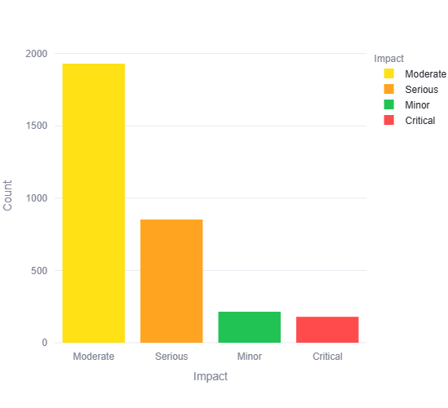
Figure 1: Distribution of accessibility violations by impact severity. While Moderate issues are most prevalent, the presence of nearly 1,000 Serious and Critical errors indicates profound barriers to assistive technologies.

4.2 Most Frequent Compliance Failures
Analysis of the specific violation types provides a clear picture of the structural deficits present in public web development. The top five failures accounted for the vast majority of all recorded issues:
- Region (1,406 violations): The page lacks ARIA landmarks (such as <main>, <nav>, <header>, <footer>).
- Color Contrast (263 violations): Text does not meet the minimum 4.5:1 contrast ratio against its background.
- Listitem (149 violations): <li> elements are used outside of proper <ul> or <ol> parent tags, confusing screen readers.
- Aria Allowed Role (147 violations): ARIA roles are applied to HTML elements that do not support them, creating semantic conflicts.
- Link Name (142 violations): Hyperlinks lack discernible text (e.g., an icon used as a link without an aria-label), making it impossible for screen reader users to know where the link goes.
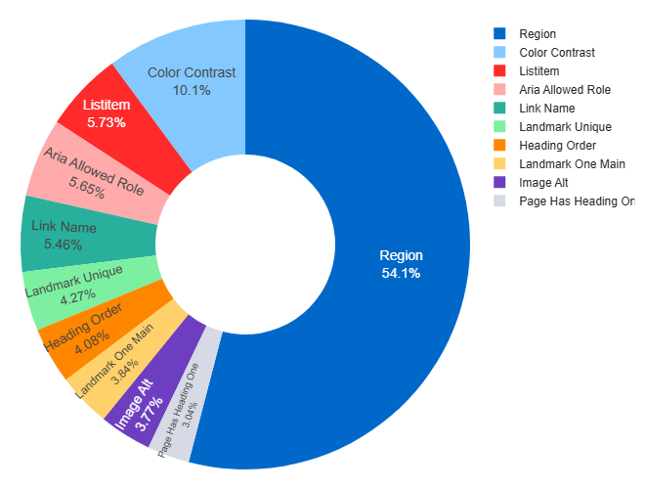

Figure 2: Proportional breakdown of the most frequent compliance failures. Over 54% of errors stem from missing ARIA regions or semantic HTML landmarks, severely hindering screen reader navigation.

4.3 Geographic and Domain Distribution
When parsing the results by state, distinct disparities emerged. Utah (366 violations), Arkansas (336 violations), and Alabama (165 violations) exhibited the highest concentrations of recorded errors within this sample. When examining specific domains, courts.michigan.gov generated 92 distinct violations on its homepage alone, while commerce.arkansas.gov and forestry.alabama.gov generated 60 and 57 violations, respectively.
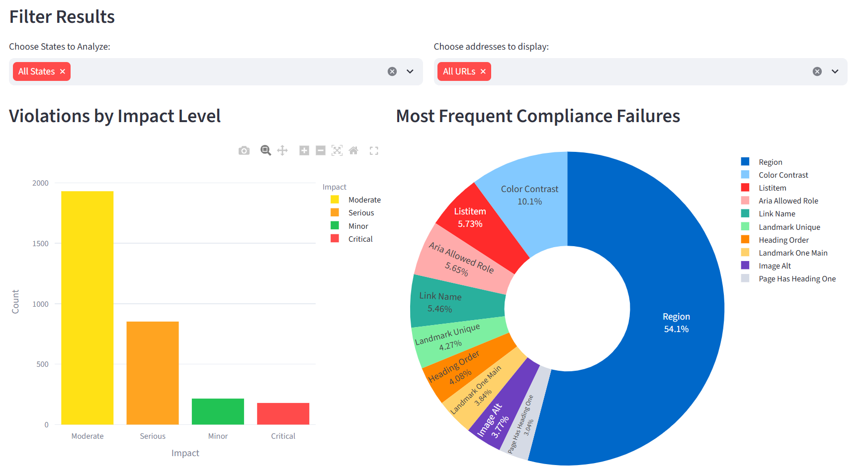
Figure 3: The developed Streamlit analytical dashboard, aggregating thousands of WCAG violations and displaying interactive impact and frequency metrics across US state domains.

5. Discussion and Root Cause Analysis
The data clearly indicates that the vast majority of Section 508 violations on public websites are structural rather than content-based. The overwhelming prevalence of 'Region' and 'Landmark' violations (54.1% of all issues) suggests a systemic reliance on outdated HTML4 development practices. Many government websites are built using older CMS templates that rely heavily on generic <div> and <span> tags for layout. Without semantic HTML5 tags or explicit ARIA roles, screen reader users cannot use keyboard shortcuts to bypass repetitive navigation menus or jump directly to the main content, severely degrading the usability of the site.
Furthermore, the high incidence of Color Contrast failures (a 'Serious' violation) points to a conflict between municipal branding guidelines and accessibility standards. State and university marketing departments often mandate specific brand colors (e.g., a specific shade of light blue or gold) that look aesthetically pleasing to sighted users but fail WCAG contrast ratios when overlaid with white text. This renders vital civic information illegible to individuals with low vision or color blindness.

6. Remediation Strategy and the Role of the Dashboard
Identifying violations is only the first half of the accessibility equation; the ultimate goal is remediation. Traditional accessibility audits often result in dense, static PDF reports that are difficult for development teams to parse and act upon. The Streamlit dashboard engineered for this project solves this by democratizing the audit data.
By isolating the specific 'Violation Type', the dashboard dynamically filters a data table that provides developers with exactly what they need to fix the code:
- CSS Target: The exact DOM element selector (e.g., #fitvid771756) causing the failure.
- Failing HTML Snippet: The raw code pulled directly from the page (e.g., <iframe src="..."> without a title attribute).
- Fix Description: A plain-English instruction on how to resolve the issue (e.g., 'Ensure <iframe> and <frame> elements contain a non-empty title attribute').
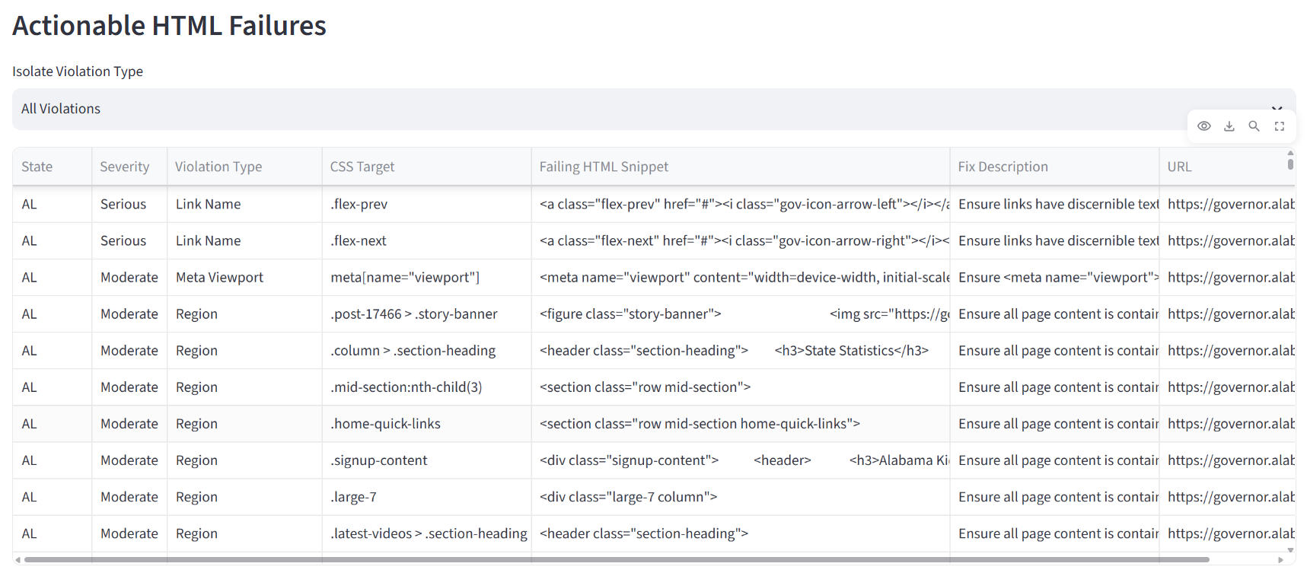
Figure 4: The Actionable HTML Failures data grid. By exposing the exact CSS Target and Failing HTML Snippet, developers can immediately locate and remediate code-level violations.
This targeted approach significantly reduces the time-to-resolution for IT departments. Furthermore, the inclusion of a 'Live Individual Checker' within the dashboard empowers content managers to audit newly drafted pages or specific state portals in real-time, preventing new violations from being published to the production environment.

7. Future Work
While the current architecture relies on deterministic rules engines, future iterations of this project could integrate machine learning to shift from reactive auditing to predictive accessibility. Drawing on previous algorithmic bias and classification research, models such as Logistic Regression or XGBoost could be trained on this dataset to predict the likelihood of critical accessibility failures based on a domain's metadata, framework (e.g., WordPress vs. custom React), and historical update frequency. Integrating SHAP (SHapley Additive exPlanations) values into the dashboard would further allow developers to understand which features (e.g., the presence of a specific legacy CMS plugin) most heavily contribute to predicted compliance failures.

8. Conclusion
Achieving full Section 504 and 508 compliance is an ongoing, iterative process rather than a static goal. This research demonstrates that automated, high-velocity accessibility auditing is not only viable but essential for addressing the sheer scale of modern government web infrastructure. The 3,176 violations detected across state and university domains underscore the persistent gap between legislative mandates and digital reality. However, by leveraging modern automation tools like Playwright and transforming raw audit logs into actionable, developer-centric insights via a Streamlit dashboard, public institutions can proactively dismantle digital barriers and foster a truly inclusive digital ecosystem for all citizens.

References
[1] Rehabilitation Act of 1973, Section 504, 29 U.S.C. § 794.
[2] Rehabilitation Act of 1973 (as amended in 1998), Section 508, 29 U.S.C. § 794d.
[3] World Wide Web Consortium (W3C). (2018). Web Content Accessibility Guidelines (WCAG) 2.1.
[4] Deque Systems. (2023). Axe-core Accessibility Engine Documentation.
[5] Streamlit Inc. (2024). Streamlit: The fastest way to build and share data apps.
[6] Microsoft Corporation. (2024). Playwright: Fast and reliable end-to-end testing for modern web apps.
[7] Ismail, A., & Kuppusamy, K. S. (2022). Accessibility analysis using WCAG 2.1: evidence from Indian e-government websites. Universal Access in the Information Society, 21(1), 1-13. (Highlights the global context of government accessibility compliance and the reliance on outdated HTML standards).
[8] White, C., Goette, T., & Young, D. (2024). Measuring the Accessibility of the U.S. State Government Websites. Communications of the IIMA, 22(1). (A longitudinal study confirming that color contrast and foundational structural errors remain prevalent across all 50 state homepages).
[9] Alahmadi, T., & Drew, S. (2020). Comparing Web Accessibility Evaluation Tools and Evaluating the Accessibility of Webpages. Information, 11(1), 40. MDPI. (Evaluates the effectiveness of automated tools in identifying Section 508 and WCAG violations compared to manual heuristic evaluation).
[10] Acosta-Vargas, P., Lujan-Mora, S., & Salvador-Ullauri, L. (2018). Toward a Combined Method for Evaluation of Web Accessibility. In International Conference on Information Technology & Systems. (Discusses the necessity of combining automated engines like Axe with manual testing).

