**User Guide for queen 2.0**

**John O. Dabiri, California Institute of Technology**

This document is intended as a quick-start guide for queen 2.0. Access to MATLAB version 2009b or higher with the Statistics and Curve Fitting Toolboxes is required to use queen 2.0.

**Description**

queen 2.0 is a MATLAB Graphical User Interface (GUI) for computing pressure fields from 2D or 3D velocity field measurements. The algorithm computes the fully unsteady pressure fields corresponding to a time-series of velocity field measurements or the quasi-steady pressure field corresponding to a single velocity field measurement.

**Files**

**README2.pdf**: this file  
**queen2.p**: main GUI file

**bishop2.p**: main algorithm file  
**parameters2.m**: editable MATLAB file containing the processing parameters

**examples (folder)**: sample input data described below

**Usage**

***Opening the GUI***

Uncompress the software package **queen2.0.zip** and assign the folder containing the files listed above as the Current Folder in MATLAB (e.g. browse from the toolbar at the top of the MATLAB Command Window). At the prompt in the Command Window, run the GUI by typing **queen2;** and pressing return. The GUI will appear:

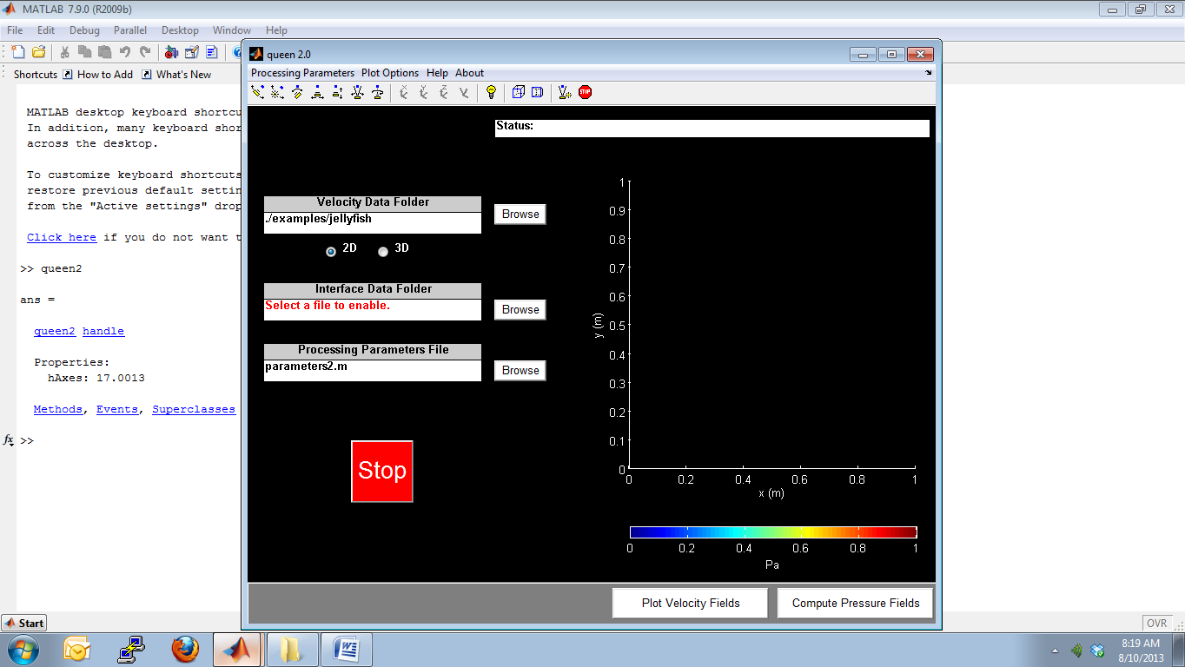

***Velocity Files***

To run the GUI, the user must specify the location of the folder containing the velocity fields to be analyzed. Each velocity field data file must contain the X, Y, U, V (or, for 3D data, X, Y, Z, U, V, W) values for each point in the velocity field in adjacent delimited columns, e.g. for N grid points:

X1, Y1, U1, V1

X2, Y2, U2, V2

...

XN, YN, UN, VN

If a set of more than one velocity field data file is to be analyzed, each file should contain an identical prefix string and a sequential numeric suffix, e.g. jellyfish_00001.dat, jellyfish_00002.dat, etc.

***Interface Files***

The user may also specify Interface Data, which can be used to exclude solid objects in the measurement domain. Each interface data file must contain the X, Y (or, for 3D data, X, Y, Z) values of the coordinates of the fluid-solid interface in adjacent delimited columns, e.g. for M interface coordinates:

X1, Y1

X2, Y2

...

XM, YM

If a set of more than one interface data file is to be analyzed, each file should contain an identical prefix string and a sequential numeric suffix, e.g. interface_1.dat, interface_2.dat, etc. One interface file should be provided per input velocity field data file, and their numerical suffixes must match.

When first running the GUI, the Velocity Data and Interface Data folders will contain default values based on the Processing Parameters specified in **parameters2.m**. These settings can be overridden by using the “Browse” push-buttons:

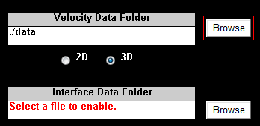

***Processing Parameters***

The Processing Parameters file can be edited in two ways. The first method is by opening the file **parameters2.m** in the MATLAB Text Editor, changing the relevant values, and saving the file. The second method is by selecting “Processing Parameters” from the menu at the top of the GUI window. Upon selecting the “Edit” option, the **parameters2.m** file will automatically open in the MATLAB Text Editor, where changes to the relevant values can be made and saved. To ensure that you have properly saved the desired parameter values, select the “View” option, which will open a separate window displaying the current values of the Processing Parameters.

***Plotting the Input Velocity Data***

To verify that your input velocity data is properly formatted, press the “Plot Velocity Fields” button. The velocity fields will be plotted on the right-hand side of the GUI window, with a time delay between successive velocity fields as specified in the **parameters2.m** file.

For 3D input velocity fields, the mid-plane specified by the **gradientplane** option in the **parameters2.m** file will be plotted (If ‘iso’ is selected, the x-y midplane will be plotted).

For both 2D and 3D input data, the velocity fields can be zoomed, panned, rotated, etc. by selecting the corresponding icons on the toolbar at the top of the GUI window after the last velocity field is displayed or if plotting is terminated early by pressing the “Stop” button.

**Note:** Remember to select the correct dimension for your data using the radio buttons on the left-hand side of the GUI window.

***Computing and Exporting Pressure Data***

Once you have verified that the input velocity data is properly formatted, press the “Compute Pressure Fields” button. The Status bar at the top right-hand side of the GUI window updates the progress of the calculation and provides alerts in the event of program errors. To terminate execution of the program at any time, press the “Stop” button.

The algorithm will first load each of the velocity field data files. If the **smooth_t** option is enabled, which is recommended for time-resolved velocity field measurements, the algorithm will then apply a temporal filter to the velocity field before computing the pressure. This step takes approximately ten minutes for a time series of 128 x 128 velocity fields, but it significantly reduces the influence of measurement noise on the pressure calculation.

The region identified in the interface files as containing a solid body is assigned an undefined pressure (NaN), and therefore appears white in the contour plot of pressure. The shape of the undefined region does not precisely match the interface coordinates because the “blanked” region is determined by the set of velocity field grid points located inside the polygon specified in the interface data.

**Note:** For thin solid objects, ensure that the polygon specified in each interface file encloses at least one node in the velocity field along the full length of the thin feature.

Depending on the current processing parameters in the **parameters2.m** file, the computed pressure fields will be plotted and (optionally) saved.

**Note:** Be sure to select an **outroot** that is the distinct from the **inroot** so that the input files are not overwritten by the exported data.

The columns of data exported for 2D calculations are (units in parenthesis):

x (m), y (m), u (m/s), v (m/s), dp/dx (Pa/m), dp/dy (Pa/m), p (Pa), |p| (Pa)

The columns of data exported for 3D calculations are (units in parenthesis):

x (m), y (m), z (m), u (m/s), v (m/s), w (m/s), p (Pa), |p| (Pa)

The GUI and plot appearance can be edited via the “Plot Options” menu.

**Examples**

***Time-resolved 2D DPIV measurements of a freely swimming jellyfish, Re 1000***

**(courtesy of Brad Gemmell, Sean Colin, and Jack Costello)**

The input velocity fields from DPIV measurements of a freely swimming jellyfish are contained in the **examples/jellyfish** folder (e.g. **jellyfish_00001.dat**). The processing parameters in the **parameters2.m** file for this example are as follows:

args = struct(...

'datafolder' , './examples/jellyfish', ...

'inroot' , 'jellyfish_', ...

'outroot' , 'queen2_jellyfish_', ...

'blanking' , 0, ...

'blankingfolder' , './', ...

'blankingroot' , 'interface_', ...

'first' , 1, ...

'last' , 100, ...

'increment' , 1, ...

'deltaT' , 0.005, ...

'numformat' , '%05d', ...

'fileextension' , '.dat', ...

'separator' , ',', ...

'numheaderlines' , 0, ...

'nodecrop' , 1, ...

'lengthcalib_axis' , 1/1000, ...

'lengthcalib_vel' , 1, ...

'timecalib_vel' , 1, ...

'nu' , 1e-6, ...

'rho' , 1000, ...

'gradientplane' , 'yz', ...

'viscous' , 1, ...

'smooth_t' , 1, ...

'smooth_dp' , 1, ...

'smooth_p' , 1, ...

'plot_delay' , 1, ...

'export_data' , 1, ...

'export_format' , 'ascii' ...

);

Upon selecting the Velocity Data folder and pressing the “Plot Velocity Fields” button, the corresponding velocity vector fields are plotted with a time delay of 1 second between each frame.

Upon pressing the “Compute Pressure Fields” button, the pressure field is computed, displayed, and saved as an ASCII text file.

**Freely swimming jellyfish DPIV (top) and pressure (bottom)**

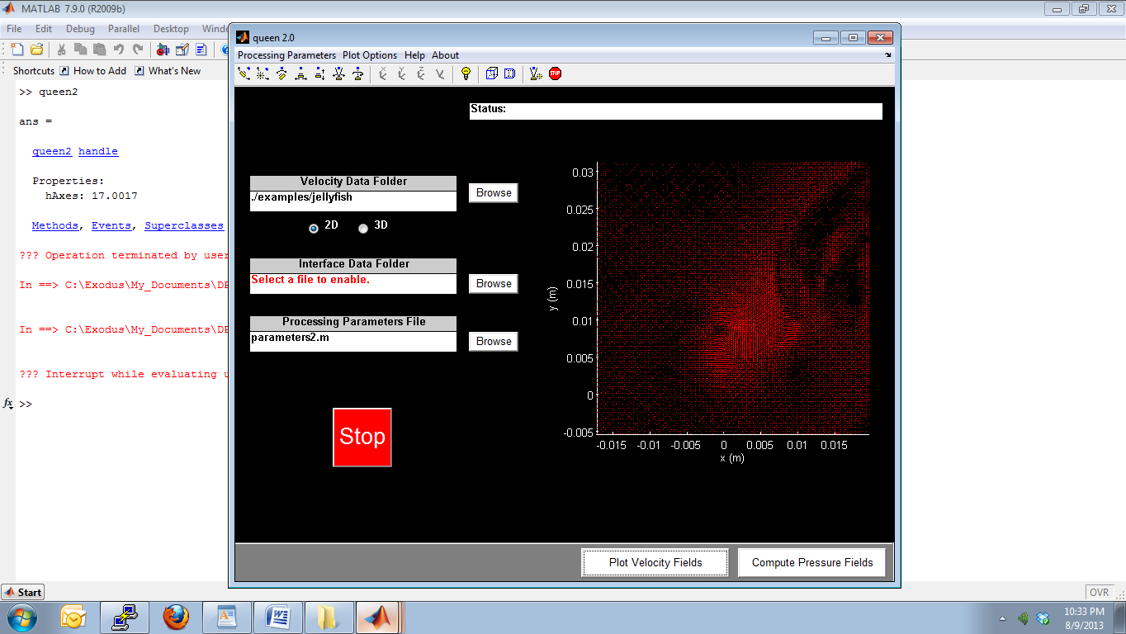

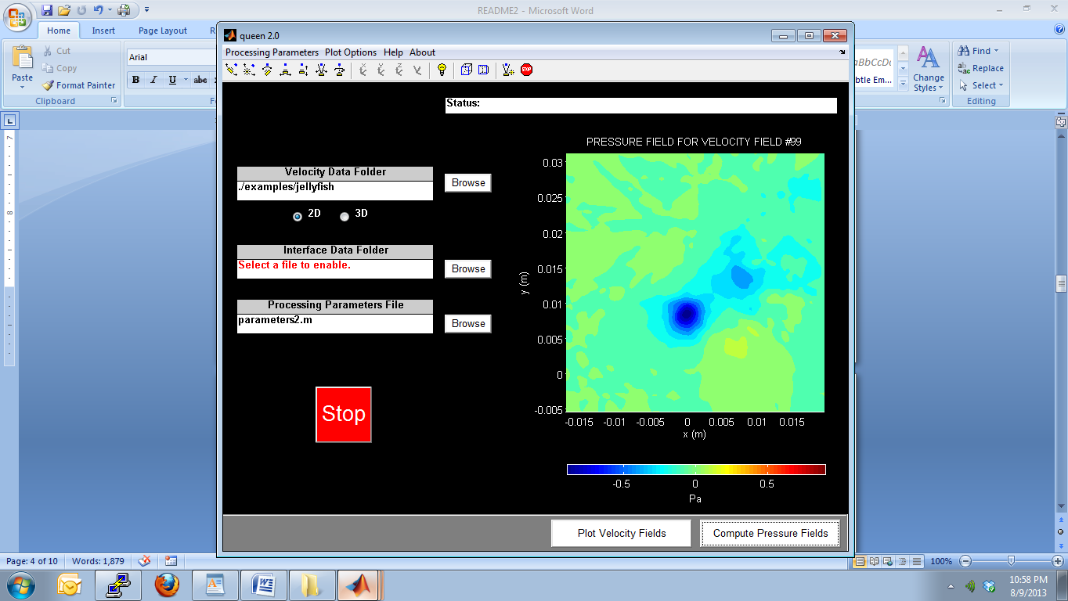

***Time-resolved 2D*** ***DPIV measurements of a freely swimming lamprey, Re 10,000***

**(courtesy of Brad Gemmell, Sean Colin, and Jack Costello)**

The input velocity fields from DPIV measurements of a freely swimming lamprey are contained in the **examples/lamprey** folder (e.g. **lamprey_00001.dat**). Data files containing the coordinates of the interface between the lamprey body and the surrounding water are also contained in the same folder. The processing parameters in the **parameters2.m** file for this example are as follows:

args = struct(...

'datafolder' , './examples/lamprey', ...

'inroot' , 'lamprey_', ...

'outroot' , 'queen2_lamprey_', ...

'blanking' , 1, ...

'blankingfolder' , './examples/lamprey', ...

'blankingroot' , 'interface_', ...

'first' , 1, ...

'last' , 100, ...

'increment' , 1, ...

'deltaT' , 0.004, ...

'numformat' , '%05d', ...

'fileextension' , '.dat', ...

'separator' , ',', ...

'numheaderlines' , 0, ...

'nodecrop' , 1, ...

'lengthcalib_axis' , 1/1000, ...

'lengthcalib_vel' , 1, ...

'timecalib_vel' , 1, ...

'nu' , 1e-6, ...

'rho' , 1000, ...

'gradientplane' , 'yz', ...

'viscous' , 1, ...

'smooth_t' , 1, ...

'smooth_dp' , 1, ...

'smooth_p' , 1, ...

'plot_delay' , 1, ...

'export_data' , 1, ...

'export_format' , 'ascii' ...

);

The analysis procedure is the same as in the previous example. In this case, the region identified as containing the lamprey body is excluded from the pressure calculation by enabling the **blanking** option. Neither the pressure gradient nor the pressure is smoothed in this example to avoid “smearing” the undefined pressure region into the surrounding fluid. This enables clearer visualization of the pressure near the lamprey body.

**Freely swimming lamprey DPIV (top) and pressure (bottom)**

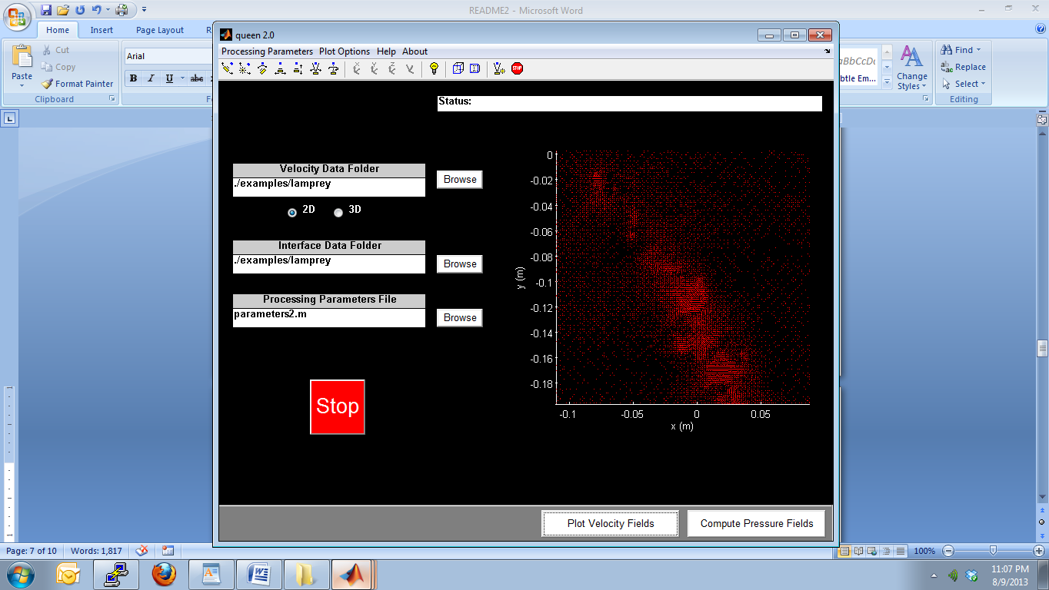

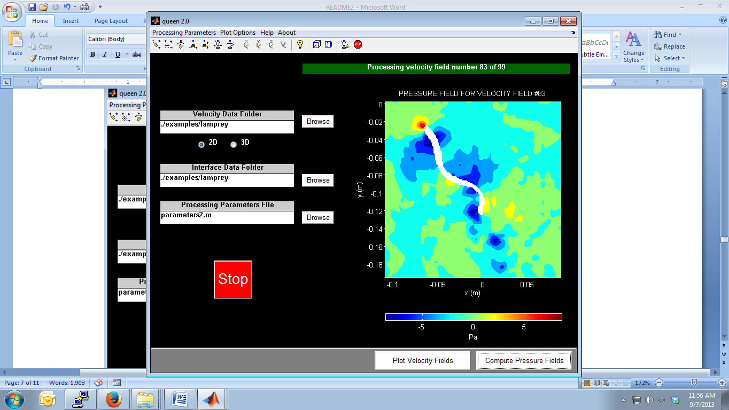

***Mean flow 3D MRV measurements of an inclined jet in crossflow***

**(courtesy of Filippo Coletti and John Eaton)**

The input 3D velocity field for the mean flow of an inclined jet in crossflow is contained in the **examples** folder (**inclinedjet3D_[1,2].dat**). The processing parameters in the **parameters2.m** file for this example are as follows:

args = struct(...

'datafolder' , './examples', ...

'inroot' , 'inclinedjet3D_', ...

'outroot' , 'queen_inclinedjet3D_', ...

'blanking' , 0, ...

'blankingfolder' , './examples', ...

'blankingroot' , 'blanking_', ...

'first' , 1, ...

'last' , 2, ...

'increment' , 1, ...

'deltaT' , 0.001, ...

'numformat' , '%d', ...

'fileextension' , '.dat', ...

'separator' , '', ...

'numheaderlines' , 19, ...

'nodecrop' , 1, ...

'lengthcalib_axis' , 1, ...

'lengthcalib_vel' , 1, ...

'timecalib_vel' , 1, ...

'nu' , 1e-6, ...

'rho' , 1000, ...

'gradientplane' , 'yz', ...

'viscous' , 1, ...

'smooth_t' , 0, ...

'smooth_dp' , 1, ...

'smooth_p' , 1, ...

'plot_delay' , 1, ...

'export_data' , 1, ...

'export_format' , 'tecplot' ...

);

Because a single velocity field corresponding to the mean flow is to be analyzed, the pressure calculation is quasi-steady. For quasi-steady analysis, the input velocity file (and corresponding interface file, if applicable) must be copied into identical files with sequential file names, e.g. **inclinedjet3D_1.dat** and **inclinedjet3D_2.dat**. The parameter **deltaT** should be set to a value much smaller than the ratio *h*/*U*, where *h* is the mean grid spacing and *U* is the maximum flow speed in the domain. Also, the **smooth_t** option should be disabled.

Upon selecting the Velocity Data folder and pressing the “Plot Velocity Fields” button, the corresponding velocity vector field of the x-y midplane is plotted. If ‘yz’ is selected for the **gradientplane**, then the y-z midplane is plotted instead.

Upon pressing the “Compute Pressure Fields” button, the pressure field corresponding to the input velocity field is computed, displayed, and saved as a Tecplot-formatted file.

**3D inclined jet in crossflow (x-y and y-z midplane velocity fields)**

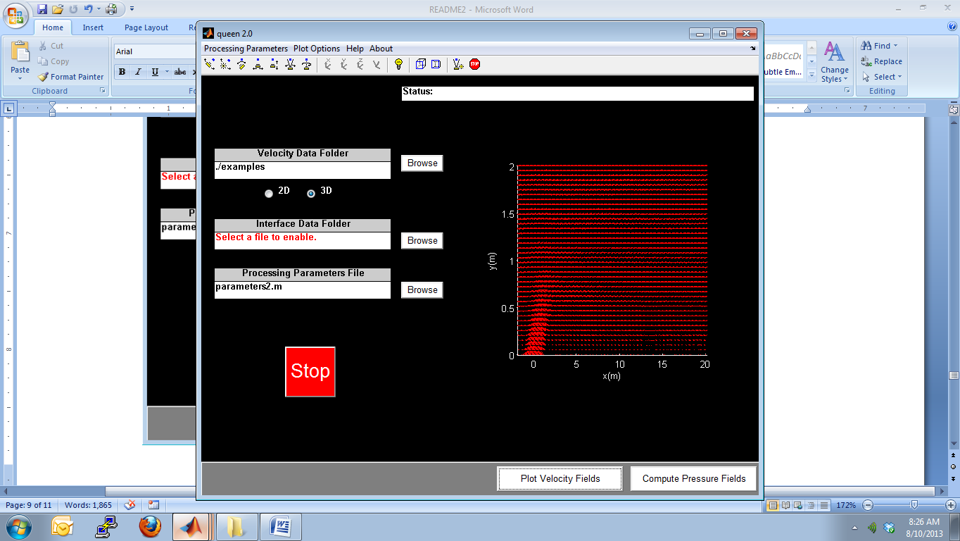

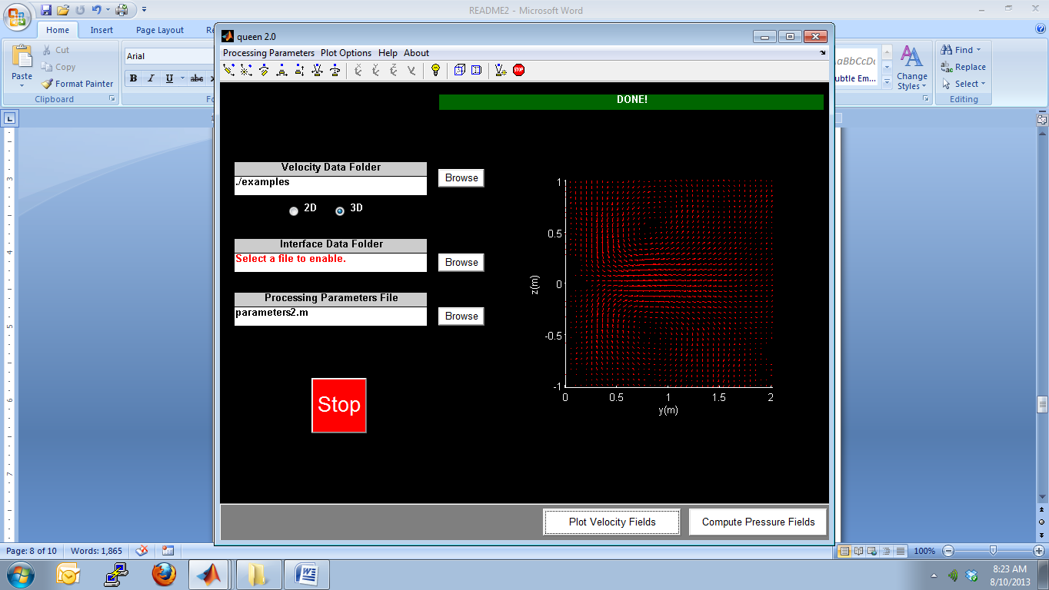

**3D inclined jet in crossflow (pressure field)**

**Note:** The “3D” calculation is formally quasi-3D, as the pressure gradient is computed using only in-plane velocity components. The 3D reconstruction is accomplished by combining integration paths in the x-y, y-z, or both planes (i.e. for **gradientplane** equal to ‘xy’, ‘yz’, or ‘iso’, respectively).

