Power Factory Installation Guide
Before You Start
You will need:
- A registered account on the DIgSILENT website (see Step 1)
- The internal license server's IP address / hostname: ‘win1.ux.uis.no’
- Network access to that server (on campus, or VPN if working remotely)
- Administrator rights on your PC to install software

- First complete the User Registration
Go to the DIgSILENT PowerFactory user registration page: Registration - DIgSILENT
Create an account using your university/student email.
Use the company-ID and Company-Password for registration:
- Company ID: USTV
- Company Password: L4M5N816991
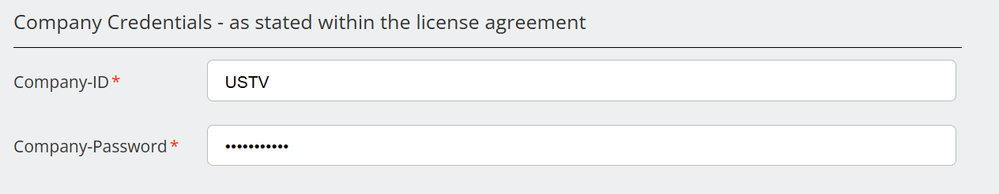

In completing user registration, make sure that you used your UiS email.
For the address part, you may put the university address as follows:
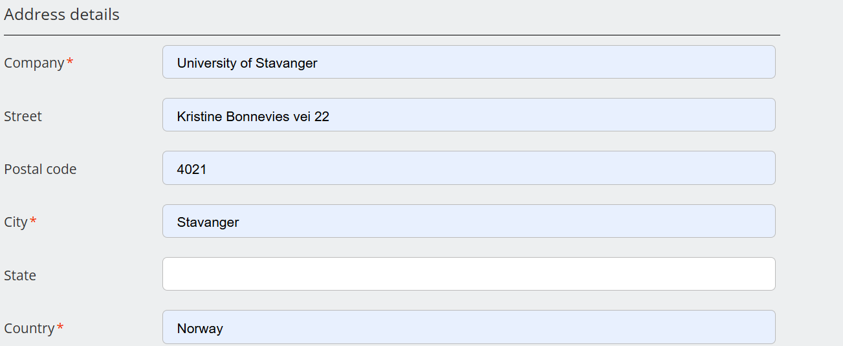
After competing your registration, you will receive confirmation similar to the one below.
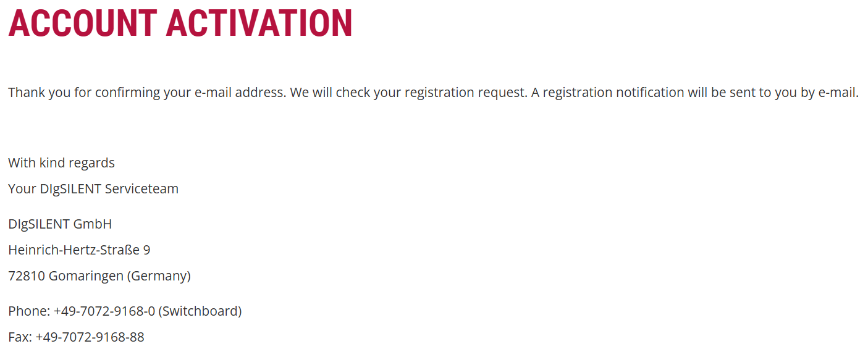
NOTE: confirmation of user registration from powerfactory may need about 24 hours. You may check after few hours if you can login to your account without waiting a separate email.
Once your user registration is confirmed and that you are able to logged in, you will have access to the download areas.
- Download
Please download the "PowerFactory installation package" from the download area2 for registered users. Kindly use the access credentials of one of your registered users (see item 1 of previous section).
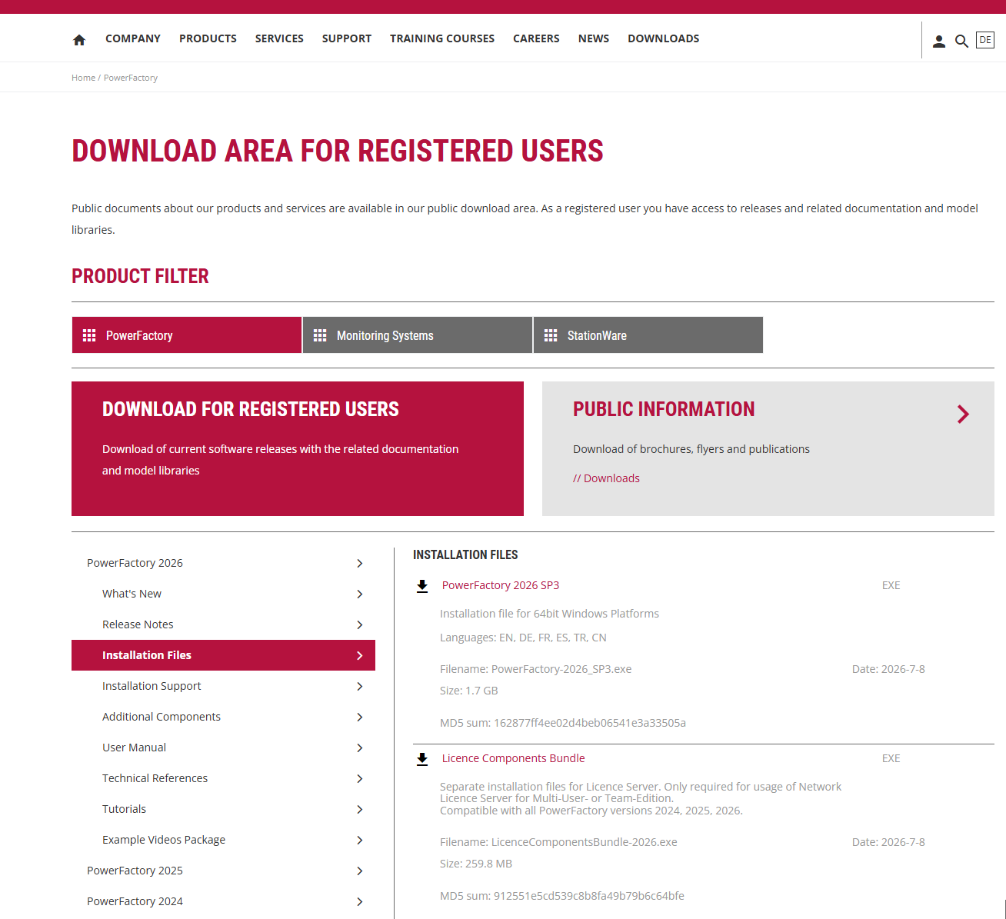
- Installation
Install PowerFactory with the help of this installation program on all client computers.
- License configuration
After the installer finishes a configuration assistant will start.
- Click on ‘Select License’
- From ‘License Access’ area select the radio button ‘network license’
- Write the server name ‘win1.ux.uis.no’ and click refresh which will update the License container. Select the container displayed.
- Once the license information is retrieved and presented in the ‘Selected License’ area then click save. PS. Administrator privilege is required to configure the license. During installation one must be connected to UiS network directly or through VPN.
- You can close the window and start the PowerFactory program.
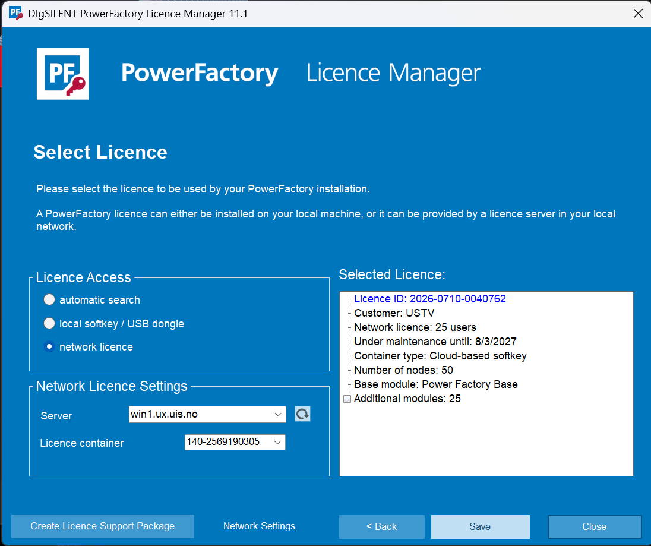

- Connecting Off-Campus
Since floating/offline licenses aren't available on this license type, if you need to work from home:
- Connect to the university VPN before launching PowerFactory.
- Make sure your VPN grants access to the license server's network segment.
- Launch PowerFactory as normal — it will check out a license from the server for your session.

