Computer Architecture
Assignment-3
Submitted by:
Madhav Sood (IMT2021009), Nilay Kamat (IMT2021096) and Anuj Arora (IMT2021050)
Q2a.
Logic used in the code :
- First, we open the trace file using open command. f_contents is a list of all the lines present in the given trace file – “file0.trace”. Each element in f_contents contains the decimal equivalent of the 32-bit address and the branch outcome.

- We then take two counters, one to store mis-predictions in the “Always Taken” branch predictor and one for the “Always Not Taken” branch predictor.

- For the “Always Taken” branch predictor, if the line in trace file shows N, then we increment the number of wrong(mis) predictions, i.e., NotTaken counter by 1.
We then calculate the percentage of the mis-prediction by this branch predictor.

- Now for the “Always Not Taken” branch predictor, we check for the occurrence of T in the list and repeat the same process.

- We then proceed to check which mis-prediction rate was lesser. The branch predictor whose miss rate is lower is more accurate.

- Finally, we outputted the values and result we obtained from the calculations onto the output file – “IMT2021009_IMT2021050_IMT2021096_output_2a.txt”

Output Screenshot :
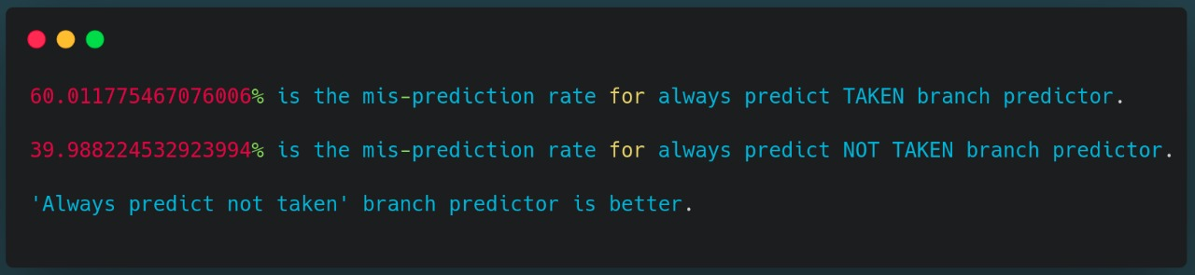
Result and Observation :
We observed the values of mis-prediction to be 60.011% and 39.988% for “Always Taken” and “Always Not Taken” branch predictors respectively. From these observations, we can deduce that the “Always Not Taken” branch predictor is more accurate as its mis-prediction rate is lesser than the “Always Taken” branch predictor.
Q2b.
Logic used in the code :
- Similar to step 1 of Q2a, we open the trace file using open command. f_contents is a list of all the lines present in the given trace file – “file0.trace”. Each element in f_contents contains the decimal equivalent of the 32-bit address and the branch outcome.
- We have to find the miss rates for predictors of size 2^2, 2^3 and so on till 2^20. Variable index_size is used to store the index bits which will be required for these predictors. Number of index bits is the log of the size of the predictor, thus from 2 till 20.
- Initially, we define index_size = 2 and then run a while loop to calculate miss rates for all predictors till index_size = 20. (included)
- We take two counters, namely count_correctP and count_wrongP to store the number of correct predictions and wrong predictions respectively and initialize both to 0 for every predictor. We also create an empty list which has dictionaries of the decimal value of index bits as key and the current prediction as the value.
- As given in the question, we set the initial value of prediction to Strongly Taken(0) for all indices present in the list.
- Now for every element in f_contents we find the index of the space between address and T/N and then calculate the address using string slicing. Then we convert this address(string with numbers in decimal format) into a 32-bit binary string using function getBinary_32().
- Now every predictor has different number of index bits. We use the getIndex() function to extract the required number of bits from the end of the binary string and then convert it into decimal using function BinaryToDecimal(). This stores the value corresponding to which we have to check the following branch predictor states:
0 – Strongly Taken
1 – Weakly Taken
2 - Weakly Not Taken
3 – Strongly Not Taken
- If the branch outcome is T, the prediction is correct if the value corresponding to the index(key) is 0 or 1, that is, weakly taken or strongly taken. In that case, we increment count_correctP. Else, we increment count_wrongP.
- We also have to keep in account that we have to change the state of the predictor value. If the predictor has anything other than Strongly Taken(0), we reduce it by 1 as the branch outcome is T.
- Now if the branch outcome is N, we follow similar steps to change state and increment the counters. Here, we increment count_correctP if the value is 2 or 3, that is, weakly not taken or strongly not taken. Else, we increment count_wrongP. The state is increased by 1 if predictor is in any state other than Strongly Not Taken(3).
- Then we calculated miss and hit rates for the predictor whose index bits are the current index_size. We also calculate the predictor size for the current predictor.(predictor size = 2^index_size).
- Finally, we outputted the values and result we obtained from the calculations into the output file – “IMT2021009_IMT2021050_IMT2021096_output_2b.txt”

Line Plot :

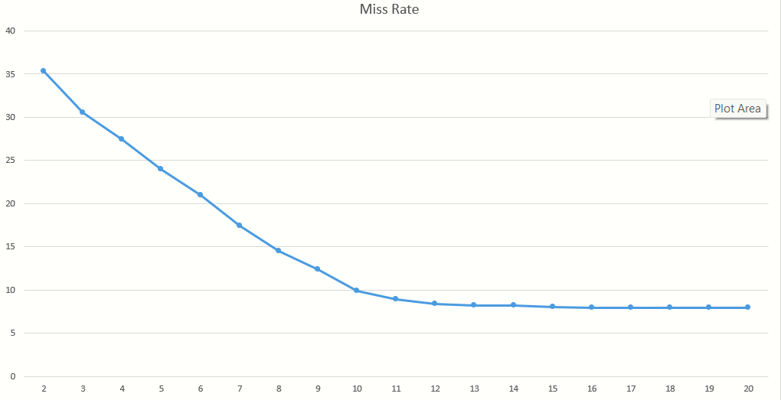
Percentages of branches mis-predicted
Log of predictor size

Output screenshots :

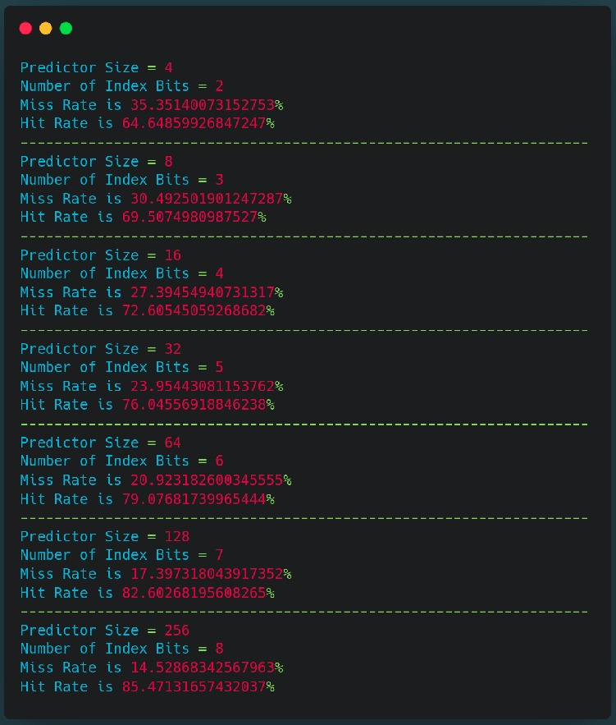
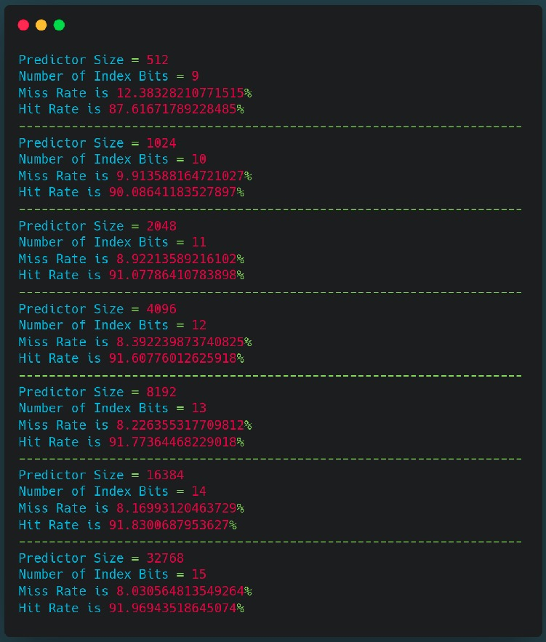
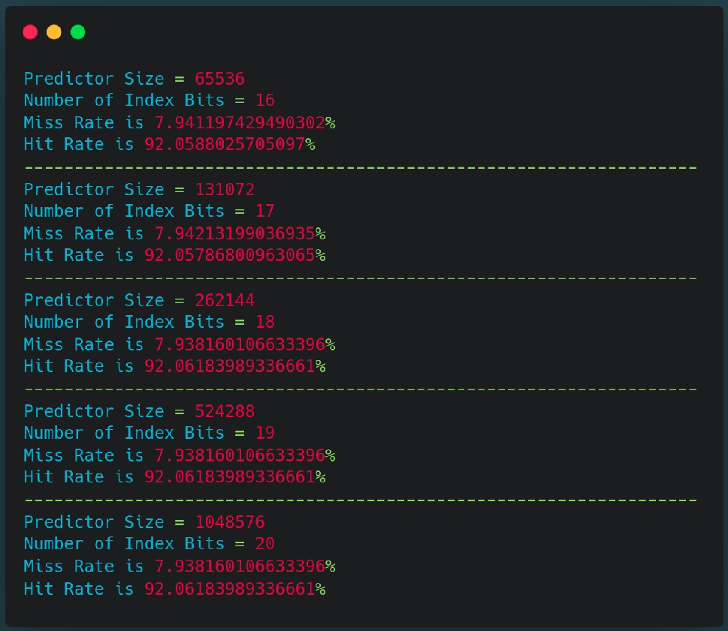

Results and observations :

- The best misprediction rate obtained in the analysis carried out by us was found to be 7.938%(rounded to 3 decimals).
- The better of “Always Taken” and “Always Not Taken” was the latter with a miss rate of 39.988% as calculated in Q2a. A predictor with approximately half mis-predictions would be one with a miss rate of approx. 20%.
From the results we obtained, we can observe that the predictor with 6 index bits or 64 counters has a miss rate of 20.923%. Thus, this is the required predictor.
- From the values of miss rates obtained, we can notice that predictors with index_size as 18, 19 and 20 have the same miss rate of 7.938%. This conclusion is also visible in the line graph as the line flattens as it approaches 20 index bits.

