

Scripting trajectories in HoloEdit

TODO

GMEM

Centre National de Création Musicale
15-17 rue de Cassis
13008 Marseille
Tél. : 04 96 20 60 10
Fax : 04 96 20 60 19

Email : holophon@gmem.org
http://www.gmem.org/

Introduction

This documents present the script functionality in HoloEdit, as well as some script templates that can be found in the directory ‘holo-edit/scripts/templates’.

1. What is a script? 3
2. Scripting interface 3
3. Templates 5
4. Examples 6
a. Spectral-centroïd based generation 6
Cette méthode se révèle particulièrement efficace pour la spatialisation de sons, en permettant par exemple de discriminer spatialement de manière rapide les différents flux présents au sein d’un son complexe. 6
a. Available functions and datas usage 6
4. Scripting 6
5. Script files 6
5. How do I … 6
b. Available functions and data usage 8
5. Getting started with scripting & SDIF 9
a. Spectral-centroïd based generation 9

1. What is a script?

A script is a set of commands to be executed by Holo-Edit in order to perform specific actions, as for example the application of many successive transformations over a trajectory.

Thus, scripts may be particularly useful in different cases:

- Performing repetitive tasks efficiently.
- Applying algorithms with precision on some datas.
- Getting some information about available datas.
- Disposer de multiples fonctions mathématiques.
- Creating libraries for trajectories transformations and generations.
- Algorithms or particular functions fast experimentations.

In HoloEdit, scripts are particularly useful to use the different fields/elements of some SDIF datas for trajectories generation/transformation.

2. Scripting interface

An interface dedicated to scripting is accessible by the menu (Functions -> Script).

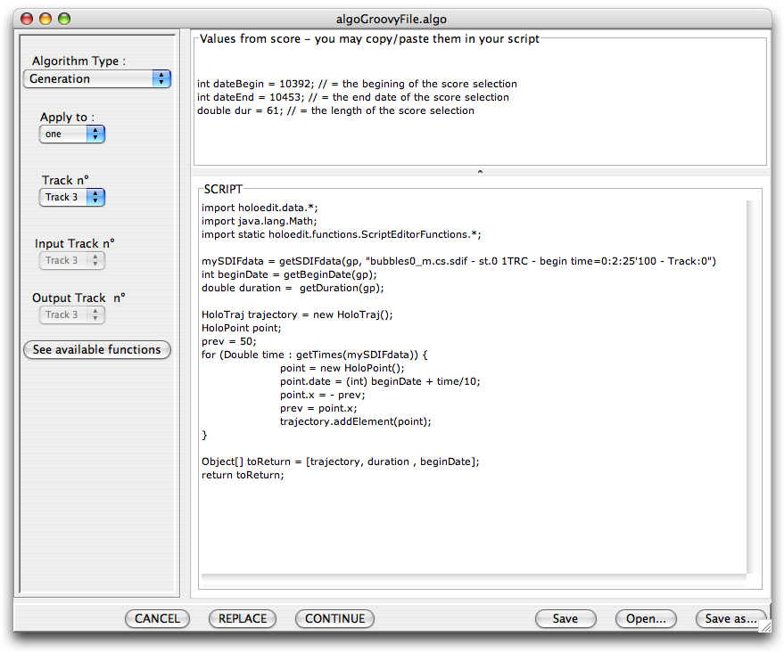
1 – Information about the content of the Score’s time selection
2 – Scripting area
– 3 – Generation/transformation settings area
Holo-Edit scripting interface

This one is divided in three parts:

1- A non-editable text area named ‘Values from Score’, that provides some information from the Score, as :
- The holoDatas contained in the time selection of the Score.
- The current time selection (begin and end times ; duration).

2- An editable text area named ‘Script’ used to write the scripts.

3- An area containing different choice lists and buttons to define the type of script (generative or transformative) and the track(s) where the trajectories have to be written.
This area also contains a button named ‘see available functions’ that open the documentation of two Holo-Edit java classes that contain some useful methods for scripting.

3. Templates

The interface has been conceived to make trajectories generations and transformations by script as easy as possible. The next two templates constitute the minimal code required for (1) a trajectory generation and (2) a trajectory transformation. The "…" represent some fields to be filled.

1. Generative script template :

(This template can be found in the folder ‘templates’ as ‘generation.algo’)

// imports and declarations
...
HoloTraj trajectory = new HoloTraj();// creates a new trajectory
int beginDate = …// trajectory’s begin date
double duration = …// trajectory’s duration

// defines the trajectory by adding some points
for (…) {
HoloPoint point = new HoloPoint();// creates a new point
point.date = ... // point settings…
point.x = ...
point.y = ...
point.z = ...
trajectory.addElement(point);// adds the point to the trajectory
}
// The trajectory, its duration and its begin date must be returned :
Object[] toReturn = [trajectory, duration, beginDate];
return toReturn;

2. Transformative script template :

(This template can be found in the folder ‘templates’ as ‘transformation.algo’)

// imports and declarations
...

HoloPoint point;

// running though the trajectory contained in the current time selection
int trajectoySize = getTrajectorySize();
for (int i = 0 ; i < trajectoySize ; i++) {
// gets a point of the trajectory
point = getTrajectoryPoint(i);
// modifies point settings
point.date = ...
point.x = ...
point.y = ...
point.z = ...
}

    - Available functions and data usage

An abstract java class has been developed to facilitate Score’s data access and scripting with them. The javadoc of this class (named ScriptEditorFunctions) is available by clicking on the 'see available functions' button of the script editor window.

Le bouton 'see available functions' ouvre également la documentation de la classe HoloPoint d'Holo-Edit, qui comporte diverses méthodes utiles pour le paramétrage de points d'une trajectoire.

Il est d'autre part possible d'importer et d'utiliser toute classe de l'API java au sein d'un script. L'utilisateur peut ainsi disposer librement de nombreuses classes utiles telles celles des packages 'java.lang' et 'java.util' par exemple.

5. Getting started with scripting & SDIF

a. Spectral-centroïd based generation

Files can be found in examples\sdif\a-SpectralCentroïdGene.

- 1. Import sound and SDIF files

First, drag-and-drop kobol.aif and kobol.trc.sdif in the sound pool :

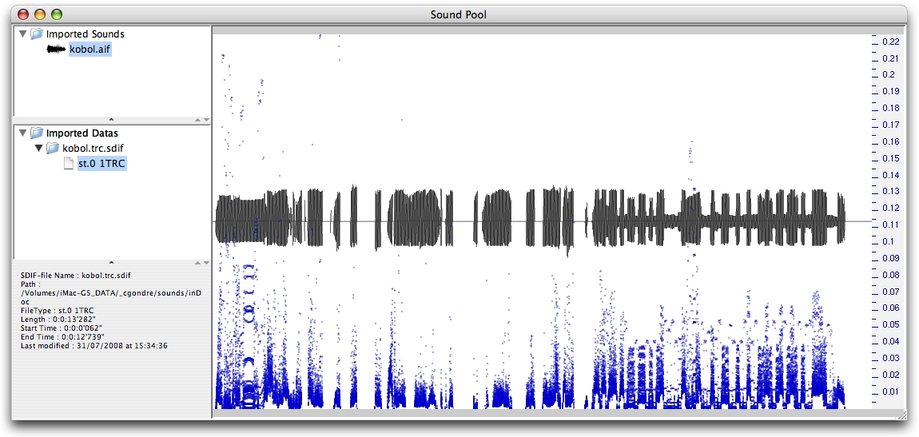

Note : One may change the display field of the SDIF data by the contextual menu (right-click on ‘st.0 1TRC’ -> menu Display ->…).

Then, as we want to manipulate the sound and the data all together, we can link the data to the sound, by dragging ‘st.0 1TRC’, and dropping it on ‘kobol.aif’. The linked data now appears as a child node of the corresponding sound.
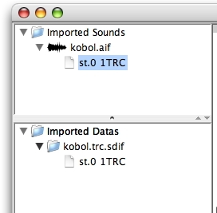

- 2. Add sounds/data to the Score

Before we can access to the data from a script, we now have to import it to the Score, by performing a drag-and-drop of ‘kobol.aif’ into the Score window. This way, both the sound and its linked data are added. Note that the waveform is superimposed over the data representation. The data is surrounded by a thicker line than the sound waveform.

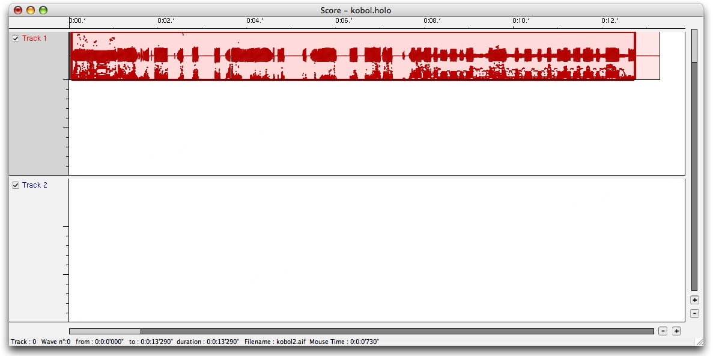

- 3. Set up the time selection

Another condition for a data to be available from a script, is that the time selection of the score must contain a part of the data. Moreover, as the simplest way to control the beginTime and the duration of a trajectory from a script is to use the properties of the time selection, you probably want to set up the time selection all over your sound/data. To do this, just right-click on the waveform, and select “view this waveform”, so that the time selection is automatically map over its duration, as shown below.

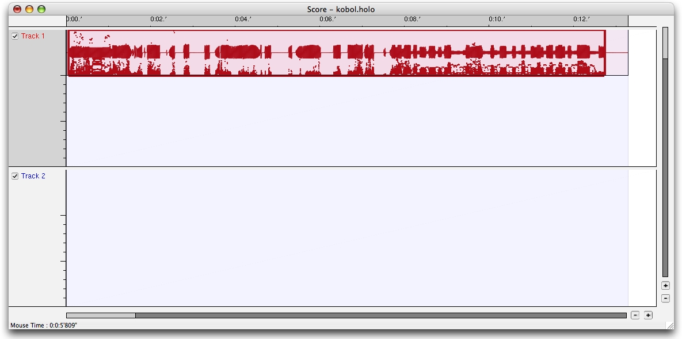

- 4. Open the script editor window
The script editor is available from the menu Functions -> Script (see §2. for a description of the scripting interface).
Click on the ‘open…’ button, and choose the script file ‘sdif_spectralCentroid.algo’.
‘sdif_spectralCentroid.algo’ is a script that can generate a trajectory based on some 1TRC-SDIF data. 1TRC data describes the sound as a set of sinusoidal tracks, that is sinusoids with time-varying frequency, amplitude and phase.

…
…

The spectral centroïd of a sound, which corresponds to the average frequency weighted by amplitude, is known as a good descriptor, particularly to describe the perception of the ‘’brightness’ of a sound.

..
…
…

// TODO
in the top of this window (the ‘Values from Score’ area), you can view a list of the datas contained in the current time selection, described like :

"ooaaoo2.f0.sdif - st.0 1FQ0 - begin time=0:1:25'840 - Track:2"

Then, to get this data in a script, you have to use the getSDIFdata(String dataDescription) method, as shown below :

mySDIFdata = getSDIFdata("ooaaoo2.f0.sdif - st.0 1FQ0 - begin time=0:1:25'840 - Track:2")

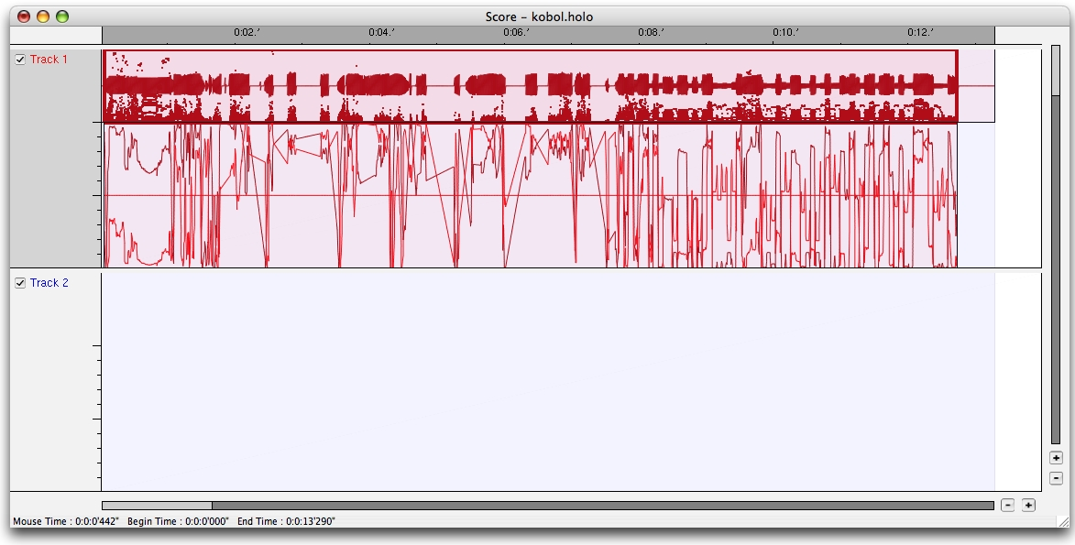

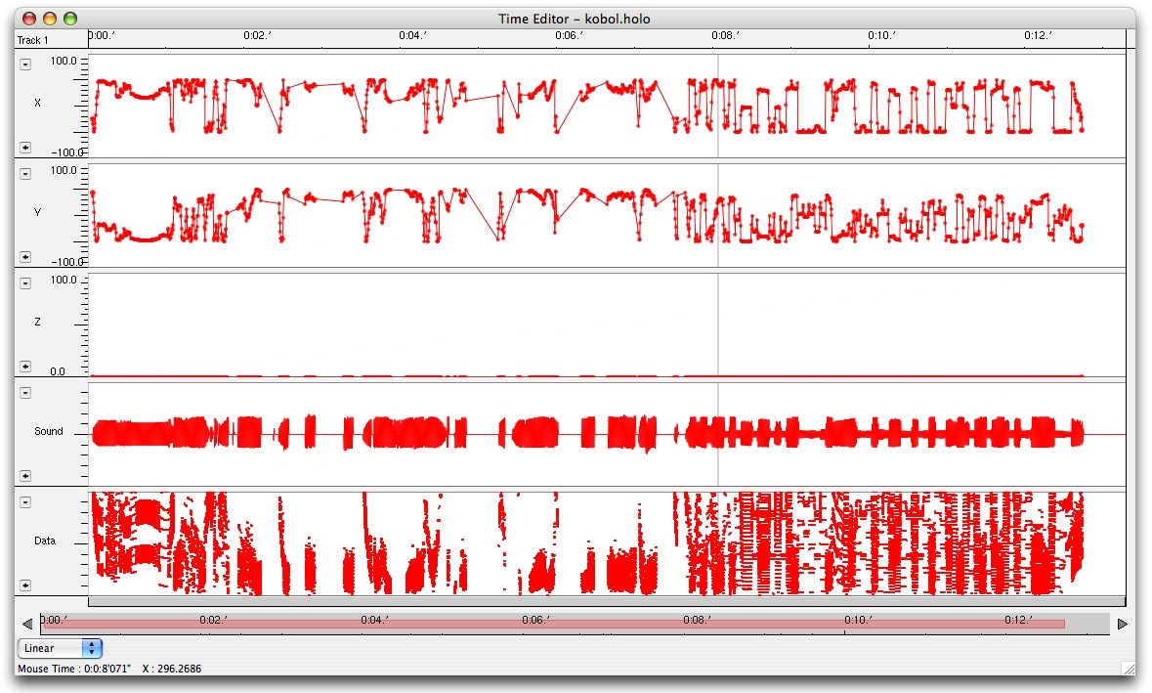

    - faire transformation

6 scripts sans sdif..?

