Shortener .

Concept :

Being able to take an URL and get a short one after the process and still arrive to the right place while using it.

How to use it

First step :

Copy / Paste the URL you want to make a shorter version of it.

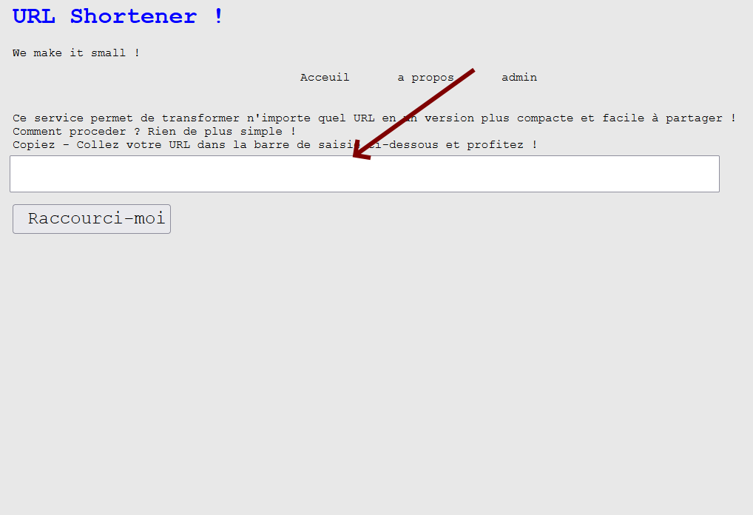

Then Click on <<Raccourci-moi>>

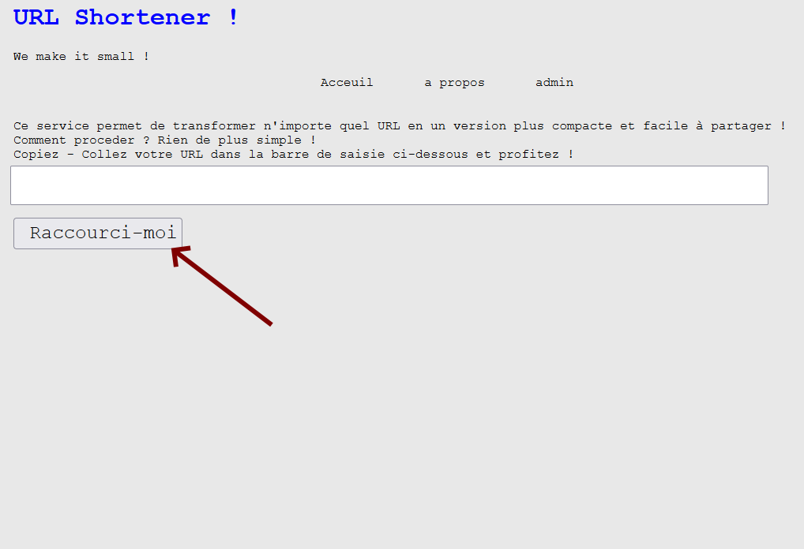

Your URL will appear bellow the Button

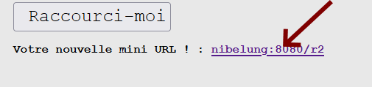

You can copy paste it and use it whenever you want.

You can access different statistics by adding a <<+>> at the end of the URL like : myshortlin.fr/r2**+**

Sending an Email to ask for information :

For that you need to fill the configuration file : Config.php

Then mail can be send to you using this page to ask for information.

Admin

To access the Admin tab you will have to enter a name and password by default they are set to test and test , but if you want to change it you can change it on the configuration file

Here is an example of what you could see.

While clicking on Edit you can change the Long URL and the Short one to a new value

