**FAKE NEWS DETECTION USING NLP**

**PHASE 4: DEVELOPMENT PART2**

**Dataset Link:  https://www.kaggle.com/datasets/clmentbisaillon/fake-and-real-news dataset**

**DATA VISUALIZATION:**

**CODE:**

plt.figure(figsize=(10, 5))

plt.bar('Fake News', len(fake_df), color='orange')

plt.bar('Real News', len(real_df), color='green')

plt.title('Distribution of Fake News and Real News', size=15)

plt.xlabel('News Type', size=15)

plt.ylabel('# of News Articles', size=15)

total_len = len(fake_df) + len(real_df)

plt.figure(figsize=(10, 5))

plt.bar('Fake News', len(fake_df) / total_len, color='orange')

plt.bar('Real News', len(real_df) / total_len, color='green')

plt.title('Distribution of Fake News and Real News', size=15)

plt.xlabel('News Type', size=15)

plt.ylabel('Proportion of News Articles', size=15)

**OUTPUT:**

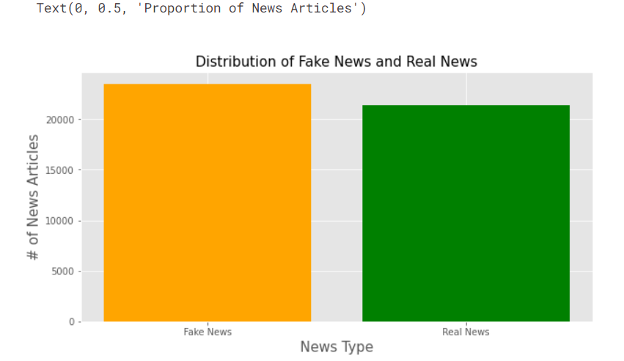

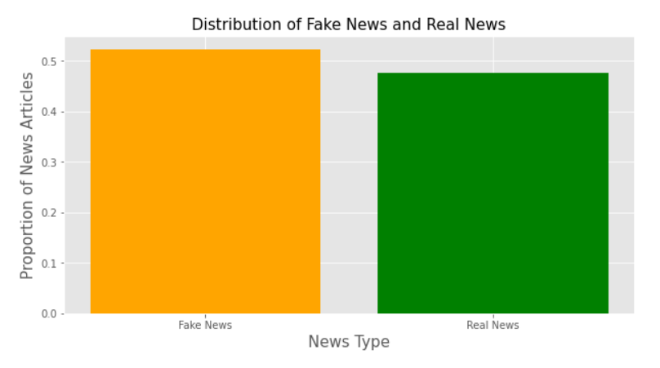

**VECTORIZATION:**

**CODE:**

def normalize(data):

normalized = []

for i in data:

i = i.lower()

# get rid of urls

i = re.sub('https?://\S+|www\.\S+', '', i)

# get rid of non words and extra spaces

i = re.sub('\\W', ' ', i)

i = re.sub('\n', '', i)

i = re.sub(' +', ' ', i)

i = re.sub('^ ', '', i)

i = re.sub(' $', '', i)

normalized.append(i)

return normalized

X_train = normalize(X_train)

X_test = normalize(X_test)

max_vocab = 10000

tokenizer = Tokenizer(num_words=max_vocab)

tokenizer.fit_on_texts(X_train)

# tokenize the text into vectors

X_train = tokenizer.texts_to_sequences(X_train)

X_test = tokenizer.texts_to_sequences(X_test)

X_train = tf.keras.preprocessing.sequence.pad_sequences(X_train, padding='post', maxlen=256)

X_test = tf.keras.preprocessing.sequence.pad_sequences(X_test, padding='post', maxlen=256)

model = tf.keras.Sequential([

tf.keras.layers.Embedding(max_vocab, 128),

tf.keras.layers.Bidirectional(tf.keras.layers.LSTM(64, return_sequences=True)),

tf.keras.layers.Bidirectional(tf.keras.layers.LSTM(16)),

tf.keras.layers.Dense(64, activation='relu'),

tf.keras.layers.Dropout(0.5),

tf.keras.layers.Dense(1)

])

model.summary()

**OUTPUT:**

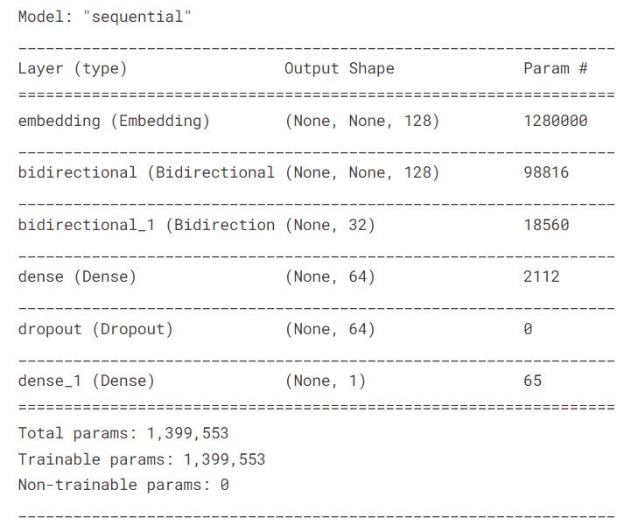

**DATA SPLITTING INTO THE TRAIN AND TEST:**

**CODE:**

model.evaluate(X_test, y_test)

**OUTPUT:**

281/281 [==============================] - 5s 19ms/step - loss: 0.0501 - accuracy: 0.9861

[0.050108399242162704, 0.9860801696777344]

**MODEL EVALUATION:**

**CODE:**

pred = model.predict(X_test)

binary_predictions = []

for i in pred:

if i >= 0.5:

binary_predictions.append(1)

else:

binary_predictions.append(0)

print('Accuracy on testing set:', accuracy_score(binary_predictions, y_test))

print('Precision on testing set:', precision_score(binary_predictions, y_test))

print('Recall on testing set:', recall_score(binary_predictions, y_test))

**OUTPUT:**

Accuracy on testing set: 0.9860801781737194

Precision on testing set: 0.9812413154238073

Recall on testing set: 0.9897220275636534

**CODE:**

matrix = confusion_matrix(binary_predictions, y_test, normalize='all')

plt.figure(figsize=(16, 10))

ax= plt.subplot()

sns.heatmap(matrix, annot=True, ax = ax)

# labels, title and ticks

ax.set_xlabel('Predicted Labels', size=20)

ax.set_ylabel('True Labels', size=20)

ax.set_title('Confusion Matrix', size=20)

ax.xaxis.set_ticklabels([0,1], size=15)

ax.yaxis.set_ticklabels([0,1], size=15)

**OUTPUT:**

