Lab 2

Name : Nimesh Neupane

Section A:

Section B:

On second section I downloaded mysql connector and extracted mysql-connector-j-8.4.0.jar file, copied it and pasted it on lib/ folder of my project. Similarly I created a student database on my localhost. 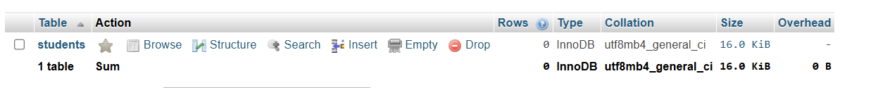

Created a connection file:

Section C:

Section D:

Included the steps in section B

Section E:

Added button Event: Button viewBtn = new Button("View Data");

Added loadData() method:

Section F:

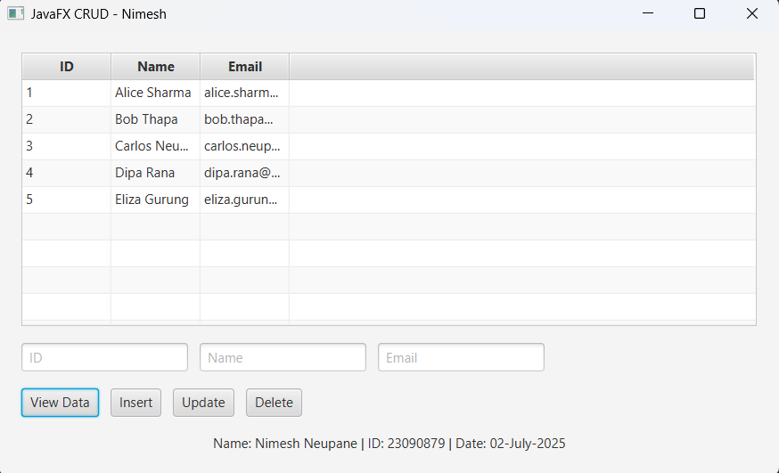

Section G:

Section H:

